# **IT314: Software Engineering**

# **Project Documentation**



**Group: 15 Conference Management System**

| **IDs** | **Name** |
| --- | --- |
| 202001117 | PARVA BHARATKUMAR DHAMI |
| 202001122 | MONPARA SUMIT RAJESHBHAI |
| 202001128 | MEGHABEN RATHWA |
| 202001132 | SONAGARA SARTHAK MOHANBHAI |
| 202001154 | METKEL HARSHKUMAR ANANDBHAI |
| 202001162 | PADHIYAR KARAN HARESHBHAI |
| 202001172 | PATEL VEDANT HARSHADBHAI |
| 202001176 | MANGUKIYA JENISH MAHESHBHAI |
| 202001177 | PRAJAPATI PARTH SURESHBHAI |

Version - 1

**Agenda:** The group mentor for this project was Bhargav Dave**.** He assigned us the task of designing a conference system called **‘FIRE’ Forum For Information Retrieval Evaluation.** For the first version of this system, we had initially proposed having a single University, in this case ‘Goa University, Panjim’ and the conferences organized by it annually, to be featured on our website.

* **Execution:**
* We decided to select the ‘Agile model’ for the designing of our project.
* Under the ‘Sprint Planning’ for the first week, we wrote the features, Use case diagrams and the functional & non-functional requirements.

1. **Features:**

* Classic home page with navigation bar and footer.
* Details of lecturers/speakers that are participating in the conference.
* Display the details about the sponsors of the event.
* Display the social media handle of the organization.
* Schedule Timeline
* Mail Auto generation
* Registration Fee Payment portal
* Editable Navigation bar
* Feedback system
* An Archives section that stores data/details of previous years conferences

1. **Functional Requirements:**

* A website should give all information regarding the conference organization, like venue, schedule, timings, participants and roles.
* A website should give schedule information for all the events/sessions which are part of the conference.
* The registration page should be there for an audience who wants to participate in the conference.
  + Users should be able to register themselves. Upon successful registration**, auto-generated mail containing a receipt** should be sent to them as proof of registration.
* Registration page for organizations, and sponsors for the conference.
  + Organizations should be able to register themselves on the website by providing relevant details.
  + This registration may be paid or unpaid, depending on the conference requirements.
* Details of lecturers/speakers that are participating in the conference.
* Detailed rules and regulations with a deadline for submitting a research paper in the conference.
* A portal to manage the accommodation of participants, where one should be able to register him/herself.
  + Students should be able to track their allocated rooms.
* A portal for students to be able to apply for **travel grants**. So that students residing far away can also get a chance to participate in conferences.
* A website should have a **contact us** page providing all relevant mailing lists.
  + Also, details of all the coordinators/members of committees/organizations should be available.
* Since the conference is conducted every year, the website should also have a feature of **archives** where past data can be accessed.

1. **Non Functional Requirements:**

* The project should be open source and available for everyone.
* Display the timeline of the event to the user.
* The payment gateway of the system should be secure.
* Attendees of the conference should be able to share their thoughts and experiences through feedback.
* The system should be user-friendly and easy to use.
* The system should be fast, responsive, and have low latency.
* It should handle a more significant number of users.
* Registration for the conference should be closed after a maximum number of registrations have been made.
* The system is scalable to accommodate growth and increase the number of users over time.
* The system should protect sensitive data and ensure the privacy of users.
* The system should be available 24/7 and have high uptime.
* The system should be maintainable and easy to update.

1. **Use Case Diagram:**

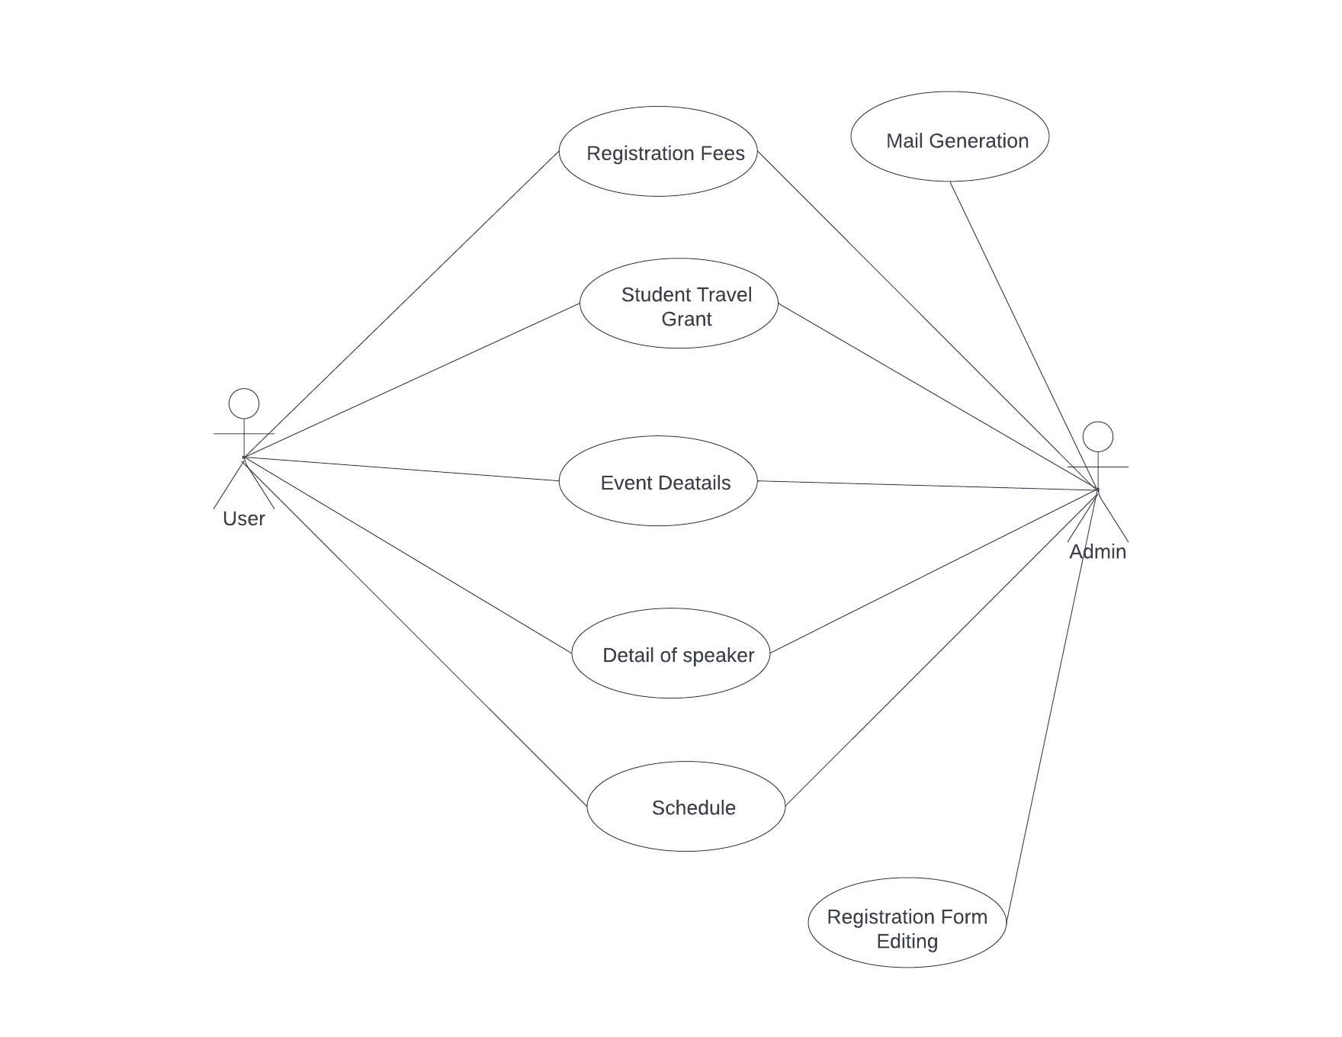

1. **Process model best suited for our course project :**

* After reviewing the needs and requirements of the project, we decided that the **Agile Process Model** is the best suited for our project.
* There are many reasons to use an agile process model.
  + The agile model is an approach to software development that emphasizes iterative, incremental work cycles and close collaboration between development teams and stakeholders.
  + In our project, many requirements can be added as per new requirements. An agile model can easily manage this because it includes iterative development.
  + So, We decided to use Agile because it offers a collaborative, flexible, and effective method for developing software that can result in higher-quality output and greater customer satisfaction.

**Writing of the code for the software:**

1. **Front-end:**

* Designing the Homepage.
* By using HTML and for styling use CSS and JavaScript.
* The Homepage shall consist of a Vertical Navigation bar on the left side of the screen that will have the following options:
  + Call for papers
  + Call for Tracks
  + Organization
  + Contacts
* Next an archive Navigation bar, that contains the database pertaining to previously held conferences:
  + Data
  + Resources
  + Past-Proceedings
  + FIRE Meetings

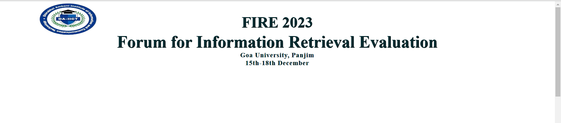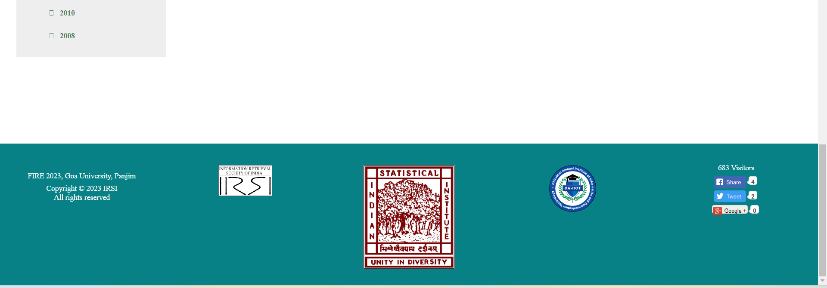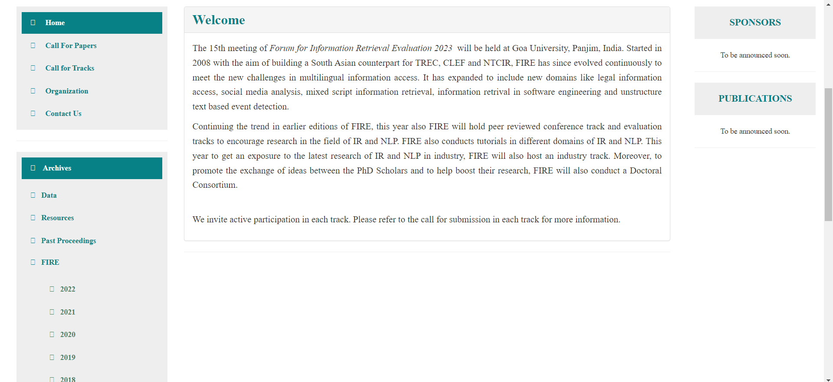

*A screenshot of the Homepage*

1. **Back-end:**

* After the completion of Front-end, for Back-end we proposed to use Django.
* In order to implement it, the basic code was written.
* However, it was during this time that Bhargav Dave ceased to be the mentor. Hence, we decided to move on with a new version of the project.