# **IT314: Software Engineering**

# **Project Documentation**



**Group: 15 Conference Management System**

| **IDs** | **Name** |
| --- | --- |
| 202001117 | PARVA BHARATKUMAR DHAMI |
| 202001122 | MONPARA SUMIT RAJESHBHAI |
| 202001128 | MEGHABEN RATHWA |
| 202001132 | SONAGARA SARTHAK MOHANBHAI |
| 202001154 | METKEL HARSHKUMAR ANANDBHAI |
| 202001162 | PADHIYAR KARAN HARESHBHAI |
| 202001172 | PATEL VEDANT HARSHADBHAI |
| 202001176 | MANGUKIYA JENISH MAHESHBHAI |
| 202001177 | PRAJAPATI PARTH SURESHBHAI |

Version - 2

**Agenda:** This time in addition to the task already accomplished (i.e. the Homepage), we proposed to make a Login/Sign-up system for the user to create an account. Additionally, significant changes have been made for the backend portions.

**Features:**

* Classic home page with navigation bar and footer.
* Details of lecturers/speakers that are participating in the conference.
* Display the details about the sponsors of the event.
* Display the social media handle of the organization.
* Schedule Timeline
* Mail Auto generation
* Registration Fee Payment portal
* Editable Navigation bar
* Feedback system
* An Archives section that stores data/details of previous years conferences

1. **Front-end:**

* For Homepage, an additional button for Login and signup was included.
* A comment section was included for any visitor to drop-in any remarks.
* Some other cosmetic changes were also made regarding the designing and the background.
* Adding Social media handles for following the events.

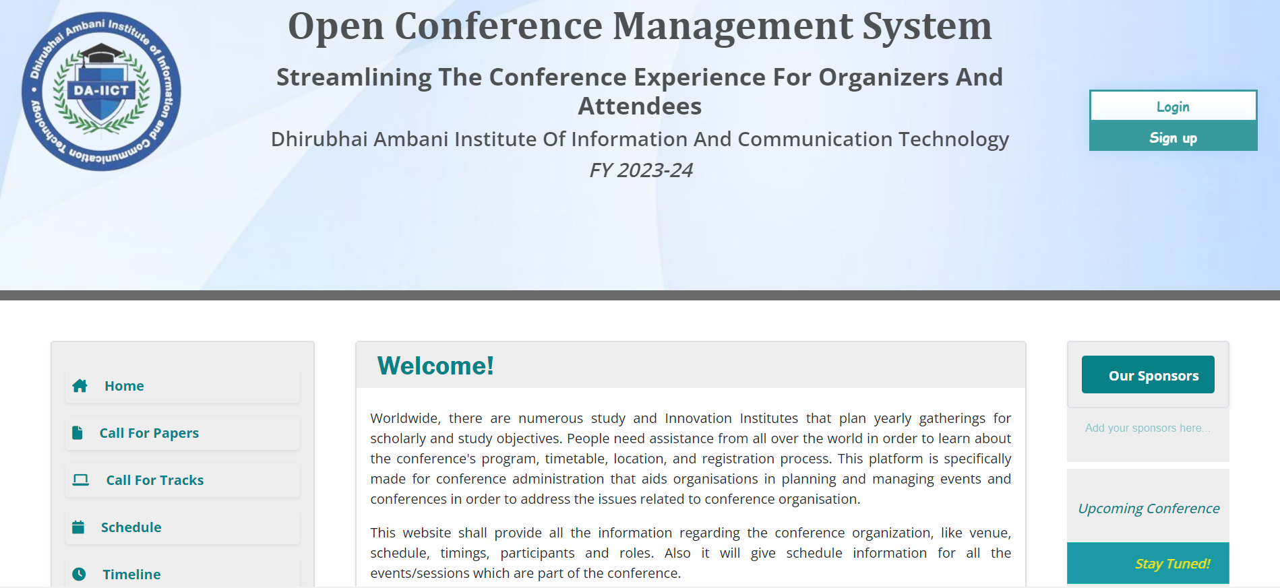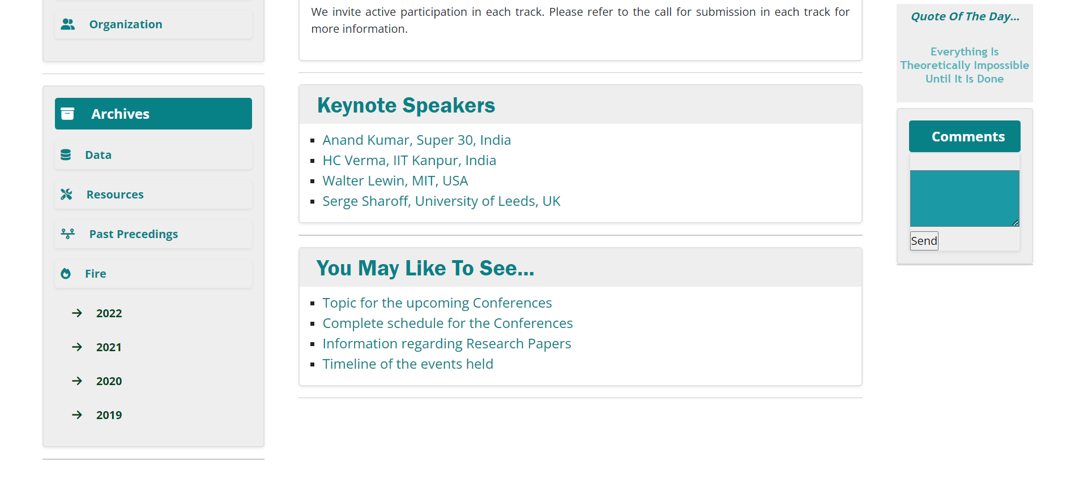

*A screenshot of the new Homepage*

* Next, the ‘Timeline page was designed. The Timeline page will show a brief history of the conferences held over the past years.

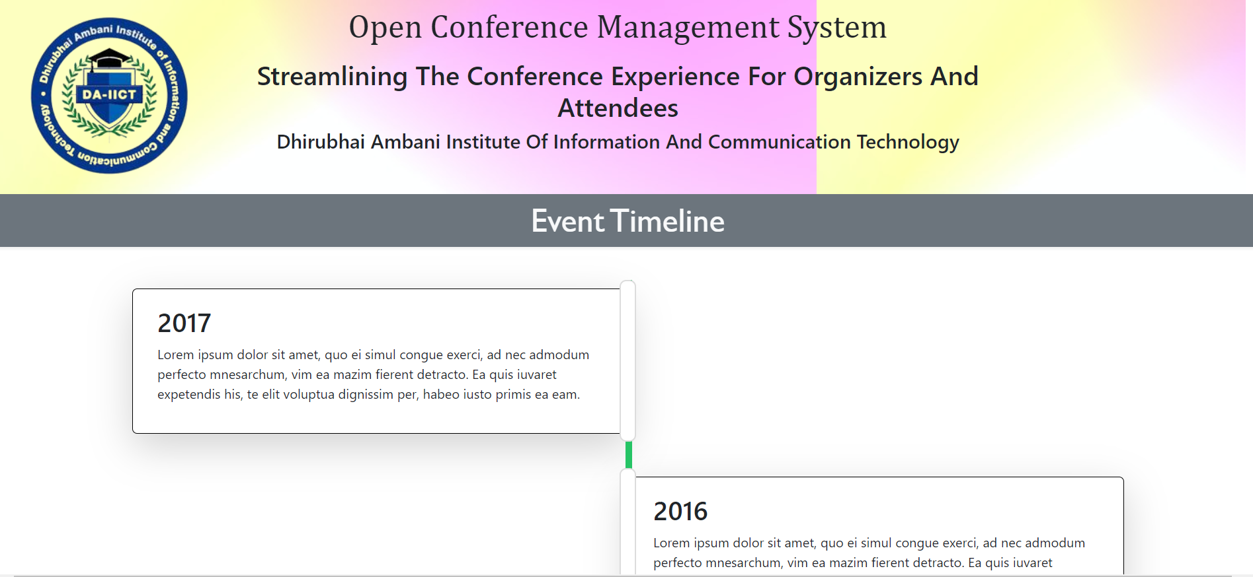

*A screenshot of the Timeline page*

* Then, We designed the Login and the Sign up page for users.

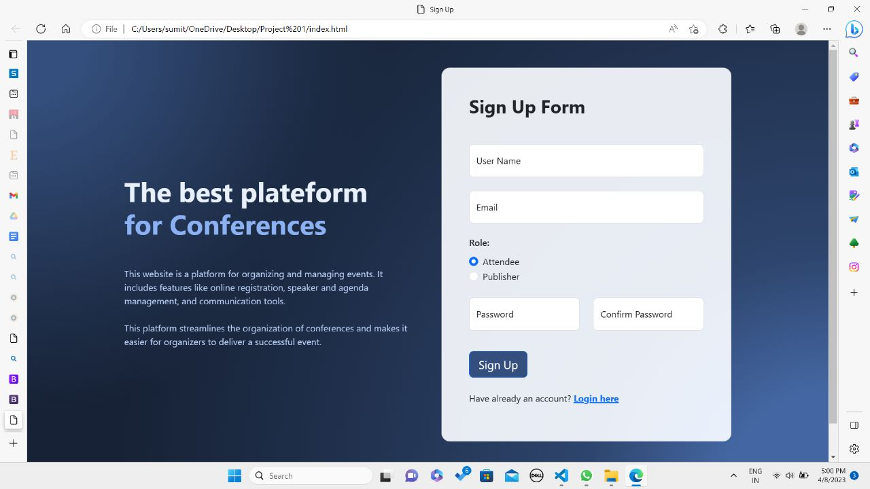

*A screenshot of the Sign Up page*

*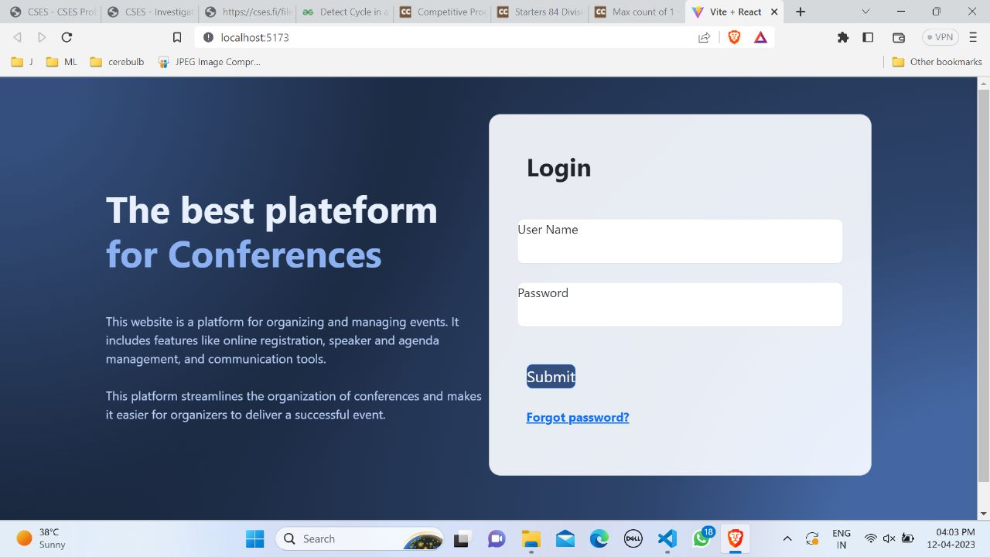A screenshot of the Login page*

* We also made a page for resetting the password.

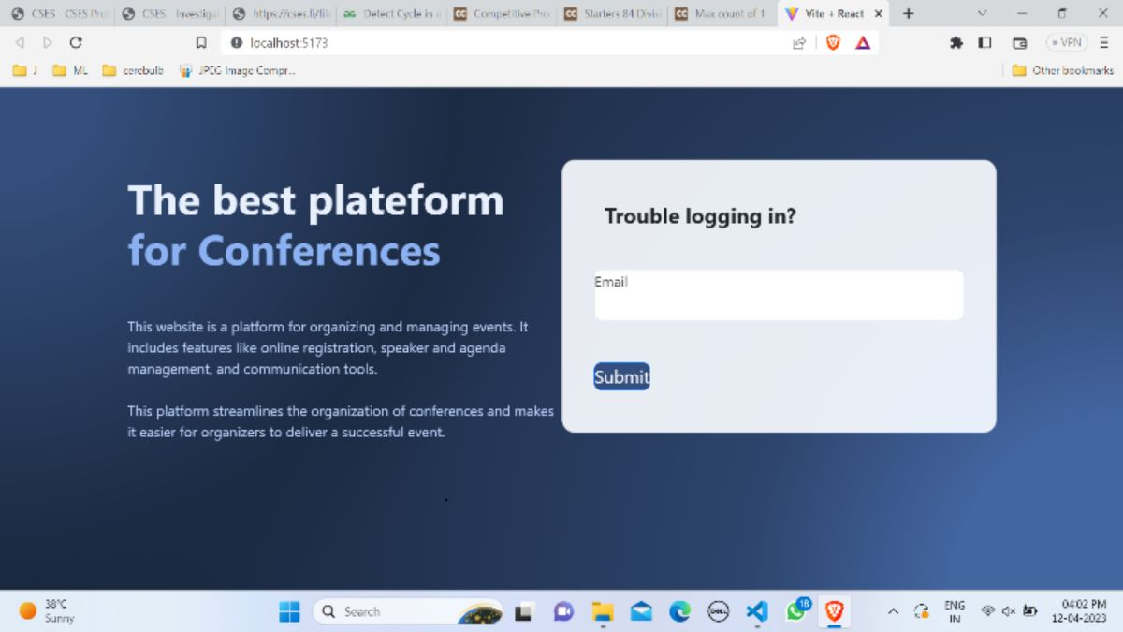

*A screenshot of the password reset page*

1. **Back-end:**

* Instead of using **Django**, for Backend we used **Node.js** and **MongoDB**. MongoDB uses NoSQL for its database. This is more flexible.
* Also, Node.js and MongoDB gel well while we integrate websites.
* For Login/Sign-up security we have used the **JWT** (JSON Web Token) that produces a secret key to authenticate a user’s login credentials.
* For password validation, we used **Validator**.
* There are two interfaces for the website: **User** and **Organization**. For Login/Sign-up we provided 2 options for the user: Attendee and the Admin.
* The attendee shall be participating in the conferences while the Admin shall be giving approval for the same.