Working with Collections: Dictionary, SortedSet.

Concordance.
A common problem in text analysis is determining the frequency and arrangement of words in a text. This information is stored in a concordance where all words are listed alphabetically and each word is provided with an indication of the number of lines in which this word occurs and how many times it occurs in the text.
Consider the following text:
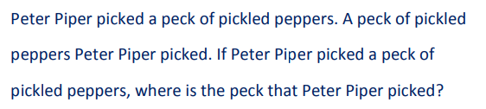
The word "piper" occurs 4 times in lines 1, 2 and 3. The word "pickled" occurs 3 times in lines 1 and 3. The result of processing this text is represented by a list of words in alphabetical order, for each word it is indicated the frequency of its occurrence in the text (number of occurrences) and a list of line numbers in which this word occurs. If a word occurs more than once in a line, then the number of that line should not be duplicated:
a..................................3: 1 2
if...................................1: 2
is...................................1: 3
Of.................................3: 1 2
Peck.............................4: 1 2 3
peppers.......................3: 1 2 3
peter............................4: 1 2 3
picked..........................4: 1 2 3
pickled.........................3: 1 3
piper.............................4: 1 2 3
that...............................1: 3
the.................................1: 3
where............................1: 3

For the Text class implemented in the previous project implement the method that allows to build a concordance for the given text object.

