GENETIC SEARCHING

A protein is a large molecule manufactured in the cell of a living organism to carry out essential functions within the cell. Each protein is uniquely identified by a sequence of amino acids. There are 20 different amino acids with complicated chemical structures. Thus for ease of understanding, the geneticists gave each of these 20 amino acids a letter in the alphabet. The 20 different possible letters are:

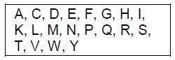
This amino-acid sequence is from the protein: “C-FLIP AMPA glutamate” which is found in Goldfish

Input file descriptions and samples
This project will involve two input files, one containing simple genetic data and another containing the commands that are to be processed. The genetic data input file is sequences.txt. Each record/ line of the input file specifies the name of a protein, name of the organism where it is found and an amino-acid sequence. These three pieces of data are tab delimited (→).
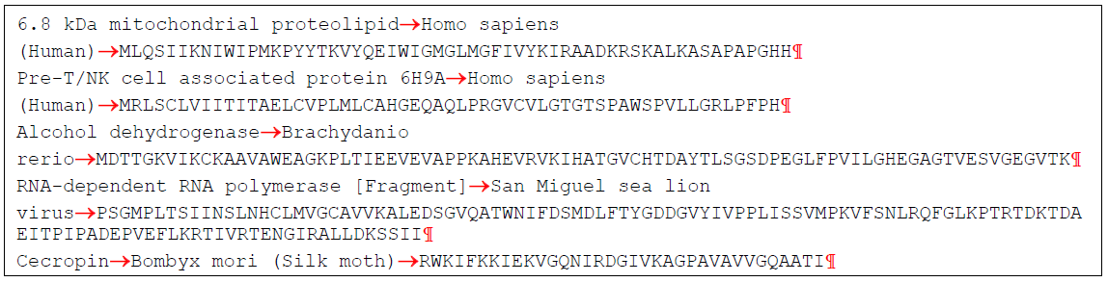
In the input file commands.txt, each line of the file contains the name of an operation that must be performed on the input data of the file sequences.txt. Possible operations are: search, diff, mode. Each operation has parameters.
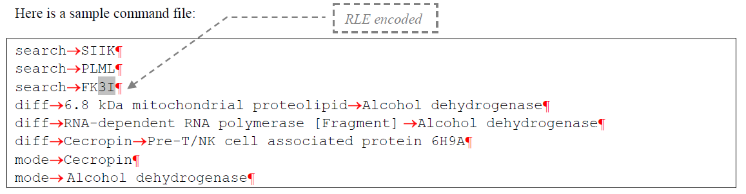
Each record’s amino-acid gene sequence will be encoded using a simple compression saving technique. The compression technique that will be used is Run-Length encoding, (RLE). In RLE runs, (i.e., consecutive sequences, aka runs), of the same data value are stored as a count followed by the data value. Consider the following gene sequence fragment of the common fruit fly:

AAAAAAAATATTTCGCTTTTCAAAAATTGTCAGATGAGAGAAAAAATAAAA
Encoding this fragment using RLE yields:
8ATA3TCGC4TC5ATTGTCAGATGAGAG6AT4A
Note that 1 letter and 2 letter sequences are not preceded by a count since no space savings would occur. RLE will be used in both of the input files. It may be assumed that no protein sequence contains a run greater than 9 letters. It may also be assumed that any decoded RLE amino-acid gene sequence can be stored safely in a string variable.
The only assumption you may make about the number of protein records, (i.e., lines of data in the input file), is that it will be 25 records or less. Your program must be written so that it will detect when it's out of input and terminate correctly.

Your program must read command input from a file named commands.txt. Each record/ line of the command file specifies an operation to be performed upon the previous input file. Each command is to be processed as soon as it is read, so you will not need to read and store all of the commands.

Command search has the following format:
search<tab><amino acid sequence><newline>

Search the genetic data for the specified <amino acid sequence> of a protein. For each protein that contains the <amino acid sequence> as a substring output the containing organism and the matching protein. If no match is found, log an error message. Run-Length encoding may occur in the search command amino acid sequence. In the example below, the amino acid sequence SIIK is found in the Homo sapiens (Human) organism in a 6.8 kDa mitochondrial proteolipid protein.
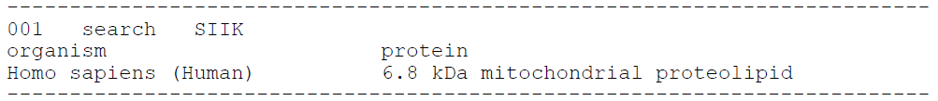
And the following sample output means that the amino acid sequence FKIII is not found in any protein in the input file:
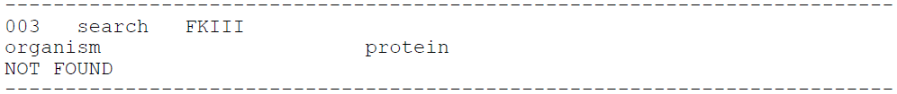
The data displayed at the beginning of the line (001 or 003) are the ordinal numbers of commands as they are read from the commands.txt file.

Command diff has the following format:
diff<tab><protein 1><tab><protein 2><newline>

Performing a diff command means that it is necessary to determine how many amino-acids must be changed to genetically change the first protein into the second protein. This can be easily done by comparing the 2 amino-acid sequences and seeing the number of corresponding places that the 2 sequences differ. For the proteins in the example below, the number of such places is 81.

If either protein cannot be found in the sequences.txt data file then on the line following the “amino-acids difference:” label the message “MISSING: ” followed by the name(s) of the missing protein(s) must be output.

Command mode has the following format:
mode<tab><protein name><newline>
Performing a mode command means that it is necessary to search the genetic data for the specified <protein name>. Once found, search through the amino-acid sequence for the protein for the amino acid that occurs most often. If more than one amino-acid occurs the most number of times display the one that comes first alphabetically. In the example below, the amino acid A occurs most frequently (5 times) in the Cecropin protein. And the amino acid V occurs most frequently (11 times) in the Alcohol dehydrogenase protein.
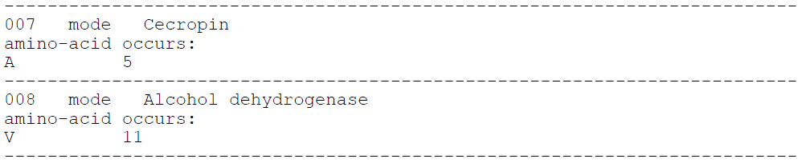
If the protein cannot be found in the sequences data file then on the line following the “amino-acid occurs:” label the message “MISSING: ” followed by the name(s) of the missing protein(s) must be output.
Output file format and example:
Your program should perform all the operations from the commands.txt file on the data from the sequences.txt file and write the result of these operations to the genedata.txt file. When writing to the output file, RLE encoding is not used. That is, if the search operation had an FK3I parameter, then it is written to the output file as FKIII.
The first line of your output/log should include your name only; the second line should include the title “Genetic Searching” only. Then, for each command, the log file will echo the complete command and then the resulting output. The command echo lines must begin with a 3 digit, zero filled count command number. As always, be careful to match the fixed text shown below (e.g., "NOT FOUND"). The output for each command must be delimited for easy reading, as shown by a line of dashes.
For the search operation:
• output the name of the organism and the name of the protein
• if no matches are found, output "NOT FOUND"
For the diff operation:
• output the number of amino acids that distinguish proteins
For the mode operation:
• output the most frequently occurring amino acid and the number of times it occurs in the organism.

Example of input file sequences.txt
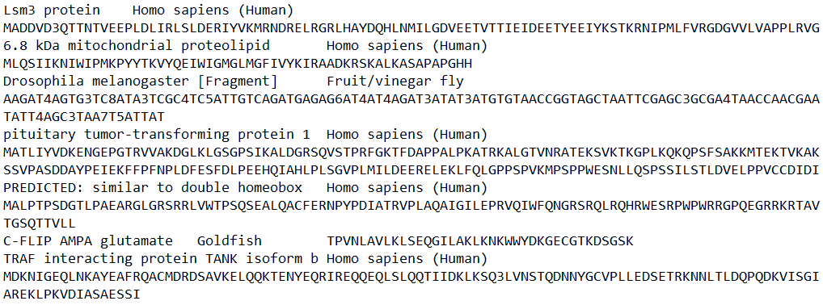
Example of input file commands.txt
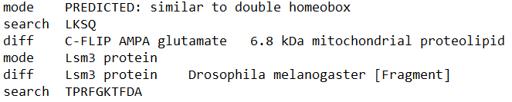
An example of the output file genedata.txt for the input data presented above:
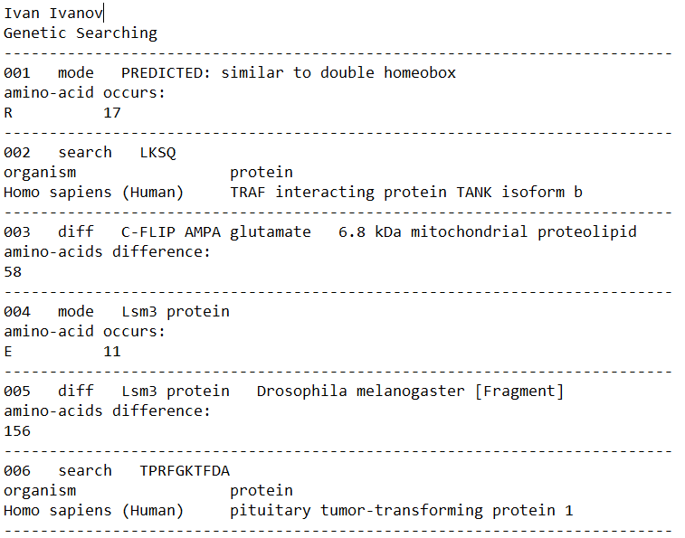
Test your solution on the following input and output data files: sequences.0.txt, commands.0.txt, genedata.0.txt, sequences.1.txt, commands.1.txt, genedata.1.txt, sequences.2.txt, commands.2.txt, genedata.2.txt

Implementation notes: To store protein data, it is advisable to use the List<GeneticData> collection, where GeneticData is a structure that allows storing protein data. The structure must be declared in advance:

struct GeneticData
{
public string protein; //название белка
public string organism; //название организма
public string amino_acids; //цепочка аминоскислот
}

There is no need to save the data about commands from the commands.txt file to a collection/array. The commands are performed as they are read from the file by calling the corresponding method. For this purpose, it is recommended to develop methods for each command.
Do not forget that if the amino acid chain is compressed by the RTE algorithm, it must first be decoded. And vice versa, if there is such a need. For this purpose, it is recommended to develop methods:
static string RLEncoding(string amino_acids)
static string RLDecoding(string amino_acids)
Since the input data is represented by strings, use the methods of the String class to process strings (search in a string, search for a substring, etc.). Keep in mind that each operation to modify a String object creates a new string, the previous version of the string remains in memory and forms so-called garbage (unused objects). In this case, it is more efficient to use the StringBuilder class.

