A hidden threat to low-lying lands: Continuous signal in sea-level acceleration

Global mean sea level has been steadily increasing since 1850s mainly due to anthropogenic climate change. This increase in sea level is consistently modified upward starting a couple of decades ago. Projections of that modification in sea level hint that the acceleration rate will be an impeccable indicator of sea level threats along the vulnerable coasts over the 21st century. Hence, credible and robust regional projections of sea-level accelerations will be key factor for local planners and policy makers. However, starting period of stable acceleration for near-future sea level and its possible regional drivers are not well elucidated yet. Here, we investigate the continuing acceleration rates of regional sea level and their main drivers by using several CMIP5 climate models. Our results indicate that sea level will incrementally rise due to mainly the change of Antarctic Dynamic, Glacier and Ocean components. Most of the regions will be highly affected by forced sea-level acceleration starting from 2030s for the considered, RCP4.5 and RCP8.5, climate scenarios. Non-local characteristics of main drivers point out that mitigation of greenhouse gas emissions at global scale remains crucial for the stability of regional sea-level rise over the 21st century.
In the following figure, you can see starting year of continuous acceleration signals in regional sea level (a) and main driver associated with that specific regional sea-level acceleration(b) for the RCP4.5 scenario. For the Dutch coast, this indicates permanent sea-level acceleration starting from year 2040s mainly due to the impact of Antarctic Ice Sheet Dynamics.

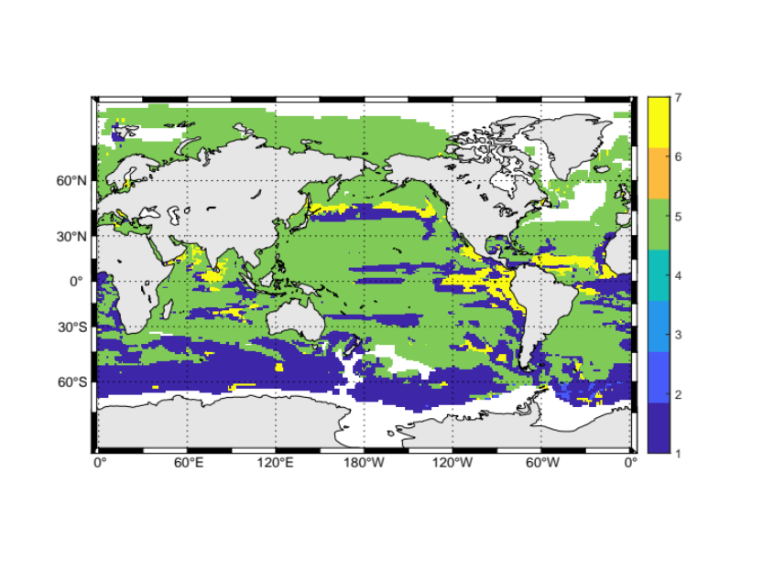
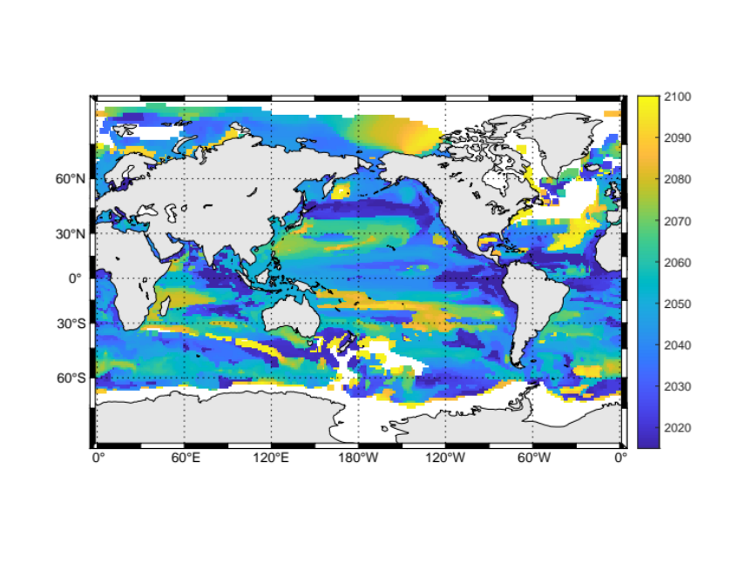
(a)

(b)

(a): Starting year of continuous acceleration signal based on the RCP4.5 scenario over the 21st century. Blank areas on the maps indicate no permanent acceleration.
(b): 1- Glacier, 2- Greenland Surface Mass Balance, 3-Greenland Dynamics, 4-Antarctic Surface Mass Balance, 5- Antarctic Dynamics, 6-Groundwater, 7- Ocean (Ocean Dynamics+Steric).

Sitar Karabil
contact: s.karabil@uu.nl

