Homework # 3

Q1a) If the growth rate is below 1, the population will eventually decline to zero.

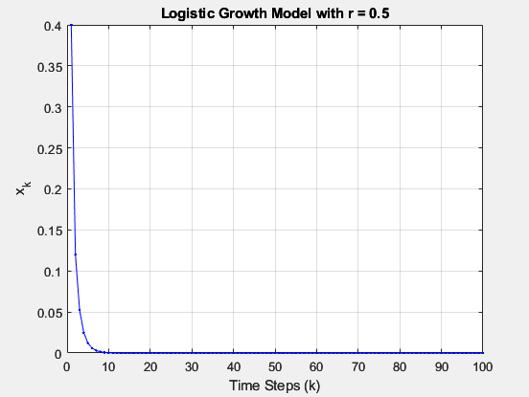

Q1b) At r = 2.9, the system displays initial oscillations, followed by convergence to a final value greater than 0.6. At r = 3.0, the system still converges, although at a slow pace. When r = 3.1, the system oscillates between two equilibrium points. This behavior indicates a supercritical flip bifurcation.

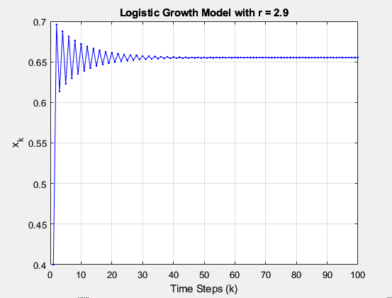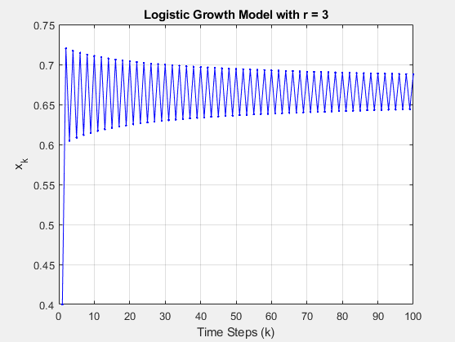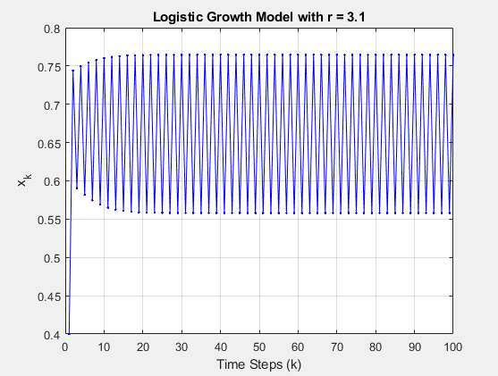

Q1c) Period-doubling bifurcation

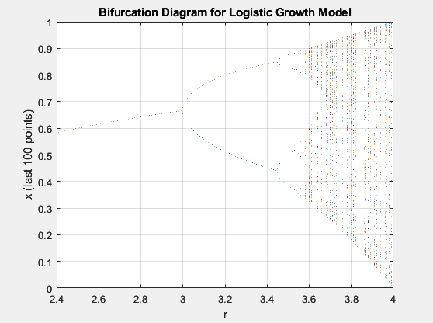

Q2a) There will be three equilibrium points which can be determined by setting x˙ = y˙ = z˙ = 0. For the other two equilibrium points, start by setting x˙ = 0, revealing that x = y. Then, set z˙ = 0 to solve for x∗ and y∗. Finally, set y˙ = 0 to find z∗. The equilibrium points are as follows:

* (0, 0, 0)
* (√bz, √bz, r - 1)
* (-√bz, -√bz, r - 1)

Q2b) The system undergoes a transition from having a single stable equilibrium point to exhibiting two limit cycles.

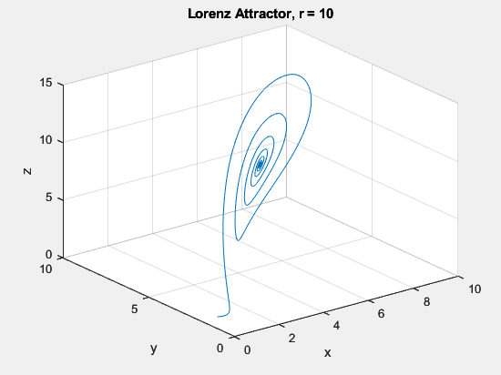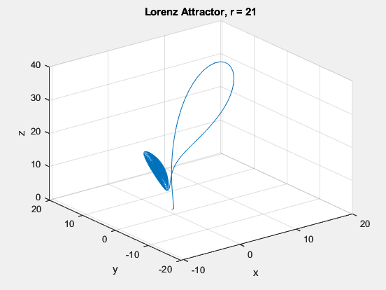

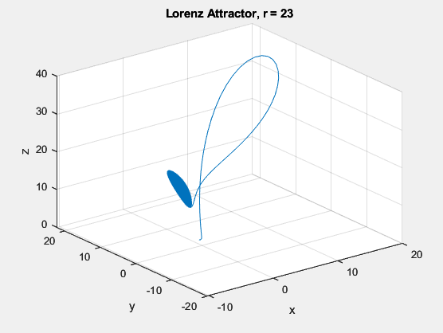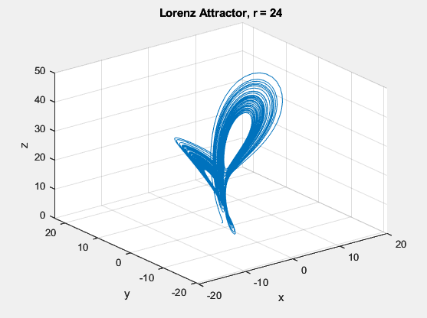

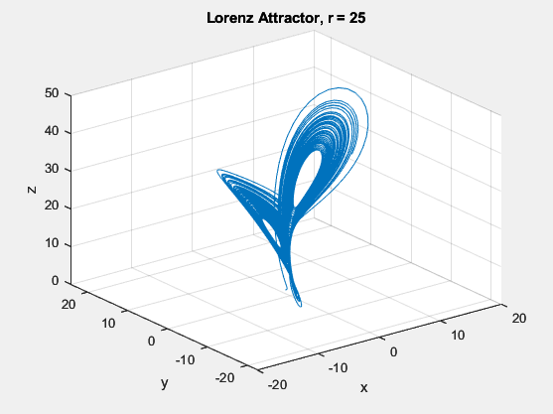

Q2c) The transition takes place from r =23 to 24.

Q2d) The transition from a stable equilibrium point to two limit cycles is indicative of a Hopf bifurcation in the system. During a Hopf bifurcation, the stability of the equilibrium point changes, leading to the emergence of limit cycles as the system parameter crosses a critical value. This bifurcation is associated with the onset of sustained oscillations in the system.

Q3a) A chaotic system is observed at r =3.6.

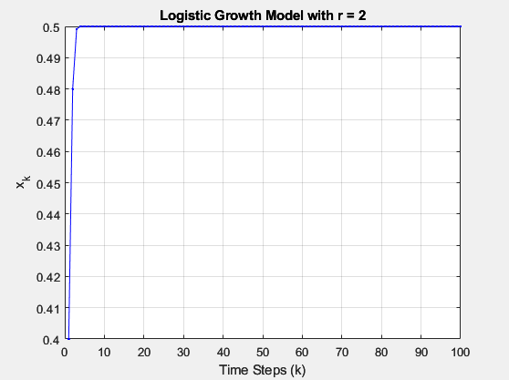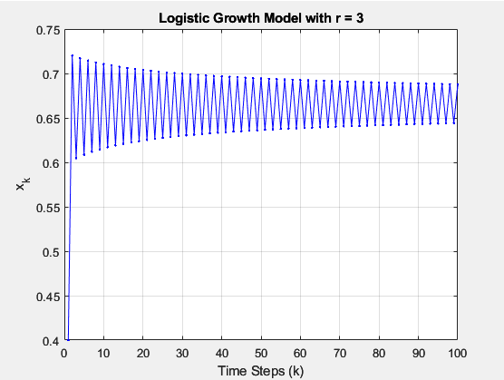

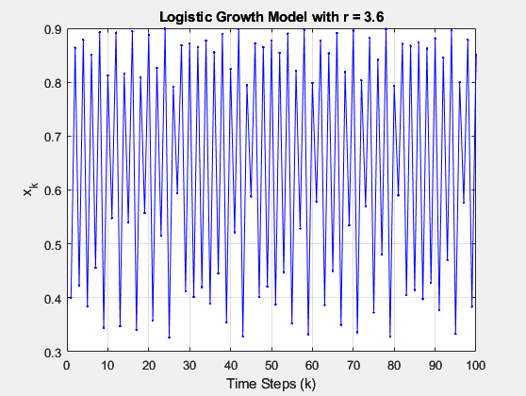

Q3b) As we progress further in time, even a minute alteration in the initial condition leads to significant divergence in the system trajectories.

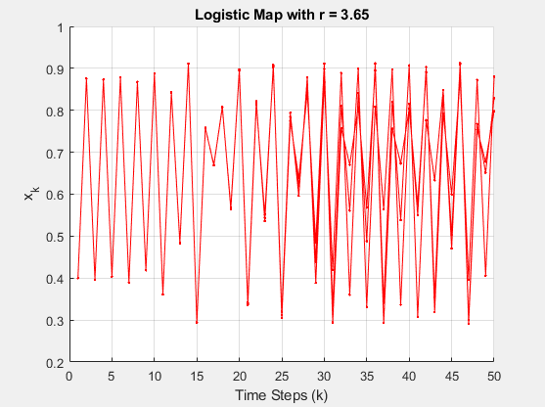

Q3c) As the parameter "r" increases, it becomes evident that the number of equilibrium points doubles, eventually approaching an infinite value as chaos unfolds.

Q3d) Higher convergence is shown at a lower value of y.

For (x, y, z) = (0, 2, 0)

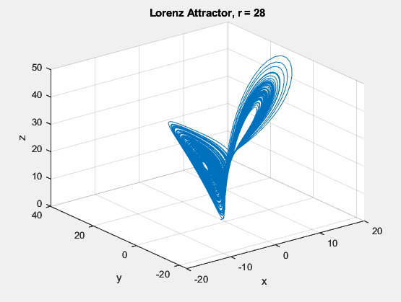

For (x, y, z) = (0, 2.0001, 0)

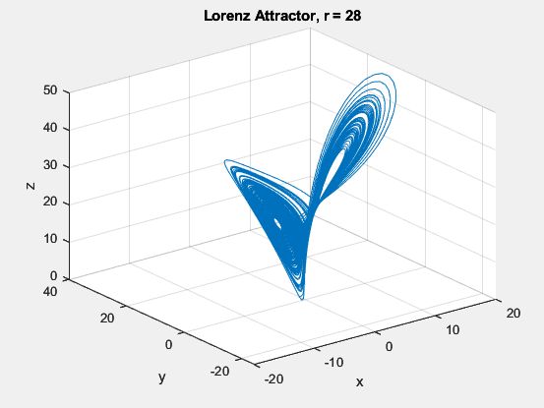

Q4)

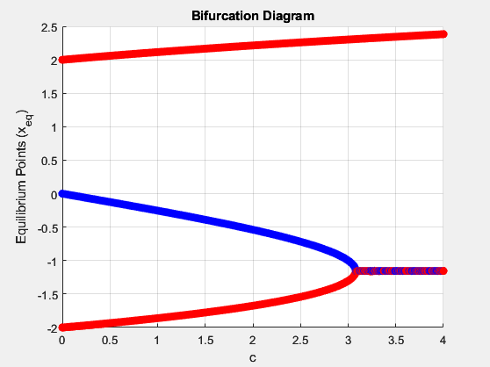

Q5) I have run all the commands/scripts in the graph theory intro file assigned with this homework.

Signature: