Homework # 5

Q1a)

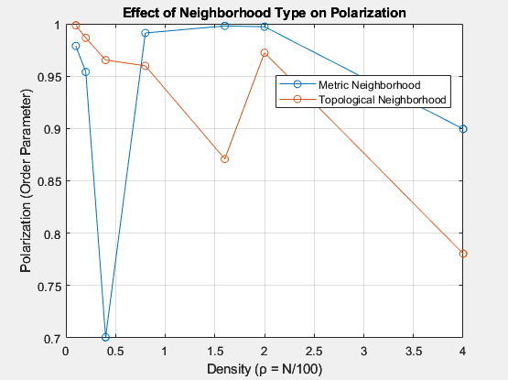

Q1b) In a neighborhood based on distance, as density increases, more agents within a fixed interaction radius lead to cooperative motion. This aligns with the (Vicsek et al., Physical Review Letters, 1995) paper we discussed.

However, for a neighborhood based on nearest neighbors, higher density causes confusion in the dynamic system. This is because an individual's three closest neighbors keep changing, leading to quick orientation switches. At low densities, topological distance acts like a large metric distance, but at high densities, it's similar to a small metric distance.

Q1c)

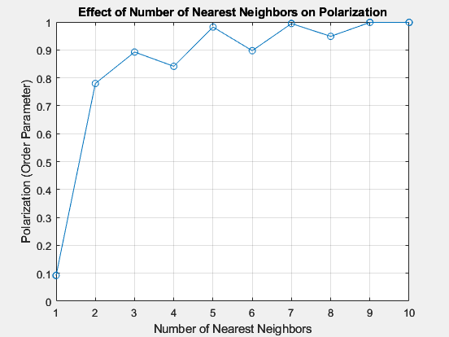

The order parameter rises as the count of nearest neighbors increases in terms of topological distance. This anticipation arises because, at a high density of ρ = 4, it's reasonable to expect that a greater number of nearest neighbors will be required to prevent rapid changes among neighbors within a short time, promoting cooperative motion. The ceiling effect is observed around 7 nearest neighbors, beyond which the order parameter nearly reaches a value of 1.

Q2a)

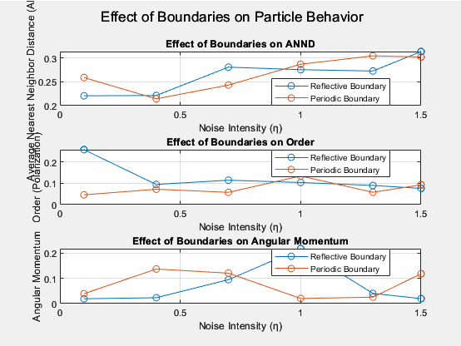

At low noise levels, polarization or order is more pronounced among Vicsek particles within a group when confined by a periodic boundary compared to a reflective boundary. This difference arises due to cooperative movement hindered by occasional disruptions at the reflective boundary. This distinction diminishes as noise intensity increases, yielding similar effects for both boundary types. Similarly, cohesion is stronger for a reflective boundary at low noise intensities, attributed to reflections bringing drifting particles closer together. At high noise levels, cohesion weakens as particles move apart, with both boundary types responding similarly to noise. Normalized angular momentum is higher for a reflective boundary under low noise conditions, as observed in animations depicting coordinated particle motion. For a periodic boundary, angular momentum increases at a specific intensity, indicating a region of cooperative movement. However, as noise intensity rises further, both boundary types experience a decrease in angular momentum.

Q2b)

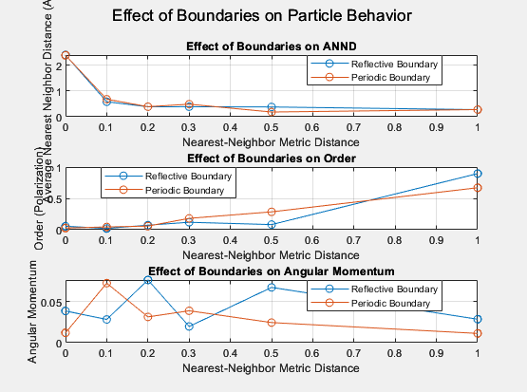

Polarization or order within a group increases as the interaction distance grows for a periodic boundary, as expected. A larger interaction distance implies that most particles will exhibit cooperative movement. In contrast, with an increased interaction distance, a reflective boundary shows notably reduced polarization. This can be explained by the presence of corners in the boundary. Even when particles move together, some experience high noise upon reflection while others continue moving, leading to aggregation near the corners. Observing animations indicates that polarization values may depend on the group's location, with higher polarization away from corners. Regarding cohesion, measured by the Average Nearest Neighbor Distance (ANND), a reflective boundary demonstrates higher cohesion compared to a periodic boundary at high interaction distances. Reflective boundaries gather groups of particles that might otherwise disperse, resulting in a lower ANND. Normalized angular momentum follows a similar trend for both boundaries, except in cases of high interaction radius, where a reflective boundary exhibits significantly higher angular momentum. This can be attributed to the general observation that highly polarized groups tend to have lower angular momentum. Similar reasons as those for polarization apply here as well.

In summary, increasing interaction distance enhances polarization for a periodic boundary, while a reflective boundary with increased interaction distance shows reduced polarization due to corner effects. Reflective boundaries promote higher cohesion at high interaction distances. The trend of normalized angular momentum aligns with the polarization trend, except for cases of high interaction radius where a reflective boundary differs due to polarization effects.

Q3)

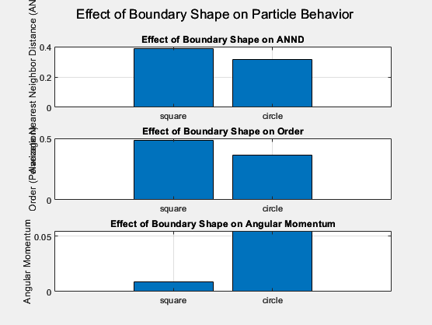

Q4)

Assumptions:

1. Robots can communicate within a specified communication range without delay.

2. Obstacle-free environment is assumed for simplicity.

3. Basic swarming behavior is achieved by adjusting turn rates based on average orientation of neighbors.

A basic approach to achieve swarming behavior is to make each robot move toward the average orientation of its neighbors. I calculated the average orientation and update the turn rates accordingly.

