Individual Team Role Inventory Test

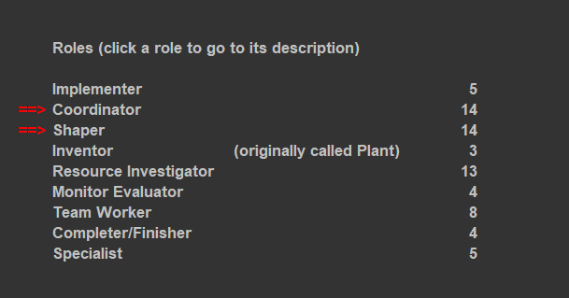
My main roles are Coordinator, Shaper and a bit lowered Resource Investigator

I feel the Coordinator fits me well since I always look in strengths around the team and delegate to whom the parts feel comfortable and steer the group towards the goal so we are all compliant with each other and the work needed to be done. I do not expect the person to which the work was distributed to fully complete it and I would rather know whether they are capable to make progress or not so we can acquire manpower to help on finishing the task. As a weakness I am dynamic, impulsive and hot-headed and do not like things not going my way, that’s why I want to be the one in charge, not because I calmly assess the situation and delegate, but because I have a strong need to steer the direction and make sure things move the way I think they should.
As for the Shaper I like to get things done while I am part of the group since it brings me a sense of responsibility, therefore pushing others so we can finish together without one putting too much more effort than others.
I can be too harsh on people thinking more about the win rather than the consequences reaching that point.

About the lowest scores on the Inventor for example, I would rather build something already done or improving it rather than coming up with a new idea of something no one has thought of before and I am not perfectionist at all, I do think of a good product to have certain flaws and no product can be done in a way that is not too time-consuming to repair every small detail of a problem.

The weakness which can be complemented would be prone to provocation since I am usually pushy getting results overlooking their status and motivation, but this can easily be fixed by promoting the team spirit and making sure the group remains at least rolling while participating in the tasks.
This can be exaggerated into people-pleasing or avoidance in conflicts with the group becoming without direction, because there might be situations in which decisions are though with some decisions not agreed by some of the group. How could we prevent such situations, well just checking in with them so no one stalls the progress and everyone to understand and know about being open giving criticism that is meant to help, not irritate / aggravate the situation. If it happens I would try make pros and cons on each decision taken throughout the team and would make a compromise on the process rather than the outcome of the decisions.

If one of my own strengths are exaggerated like the coordination, this would make be perceived as the manipulative / overly controlling within the group, also as a person with less contribution or similar situation.

