Capstone Project Fish Species Analysis

Introduction to Data Science

Kevin Tajkowski

### Library Calls

Load the necessary packages.

library(readr)  
library(dplyr)  
library(stringr)  
library(ggplot2)  
library(grid)  
library(gridExtra)

### Simple Visualization

Use the Zone_Codes file to generate a plot showing the latitude and longitude of all of the dive sites at Little Cayman.

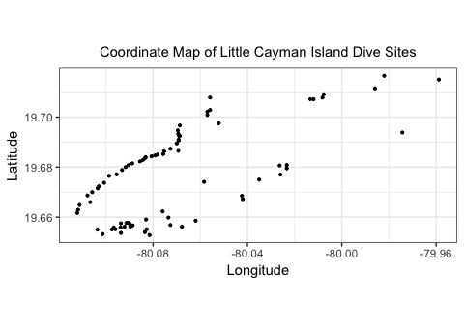

### Data Preparation

Load the data into a data frame. Remove all non-fish species by Family_Name. Non-fish species observed in the data set include sharks, rays, eels, turtles and a dolphin.

Little_Cayman <- read_csv("Little_Cayman.csv")  
non_fish_family <- c("Requiem Shark", "Conger", "Dolphin", "Stingray", "Manta", "Moray", "Eagle Ray", "Snake Eel", "Carpet Shark", "Hammerhead Shark", "Electric Ray", "Round Stingrays", "Sea Turtles", "#N/A")  
LC <- Little_Cayman %>% filter(!(Family_Name %in% non_fish_family))

### Lionfish Exploration

The Red Lionfish, otherwise known as the Common Lionfish, is species 683 and is a member of the Scorpionfish family. Here is a list of the 5 species of Scorpionfish observed at Little Cayman.

## # A tibble: 5 x 2  
## English_Name count  
## <chr> <int>  
## 1 Mushroom Scorpionfish 2  
## 2 Plumed Scorpionfish 2  
## 3 Red Lionfish (aka Common Lionfish) 347  
## 4 Reef Scorpionfish 1  
## 5 Spotted Scorpionfish 144

Generate plots showing Lionfish abundance as a function of time. The following figure shows the Lionfish presence at all dive sites at Little Cayman. A smooth curve with corresponding confidence interval and a trendline are added to the plot on the left side of the figure. A second order (red) polyonomial was then fit to the data as seen on the right side of the figure.

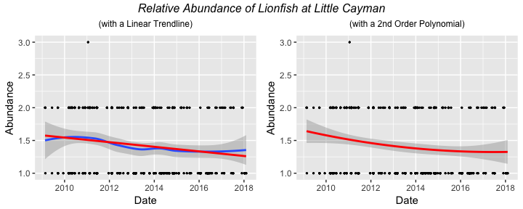

The following series of plots show the Lionfish presence at numerous dive sites at Little Cayman.

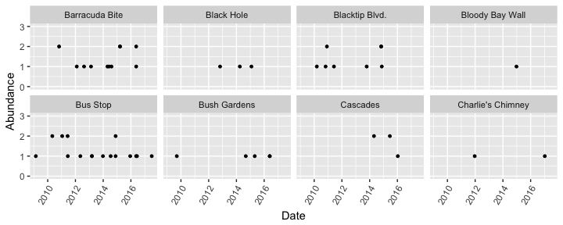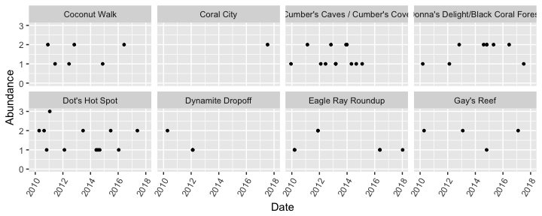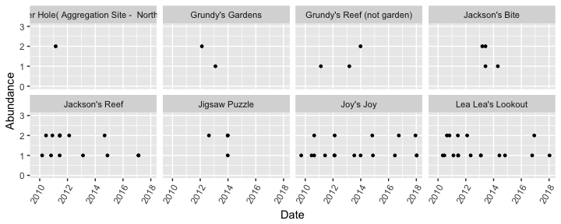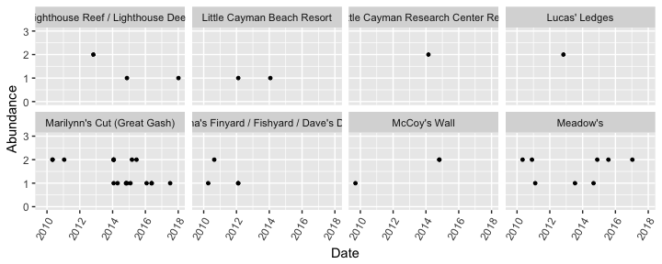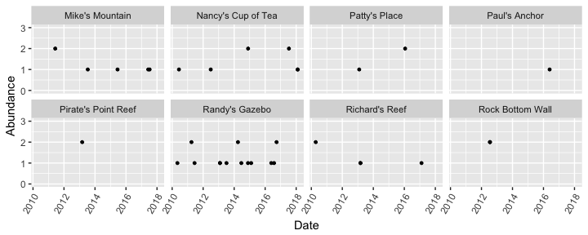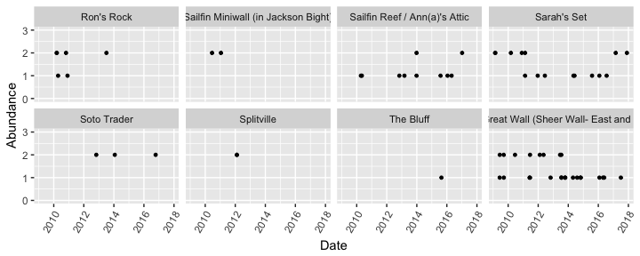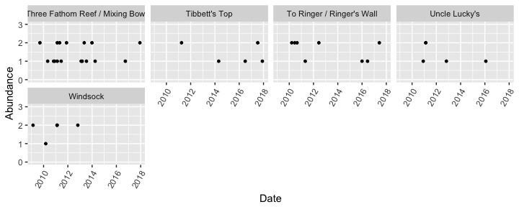

### Fish Family Exploration for all Sites

Generate plots of all fish families at all dive sites around Little Cayman using the Family_Name.

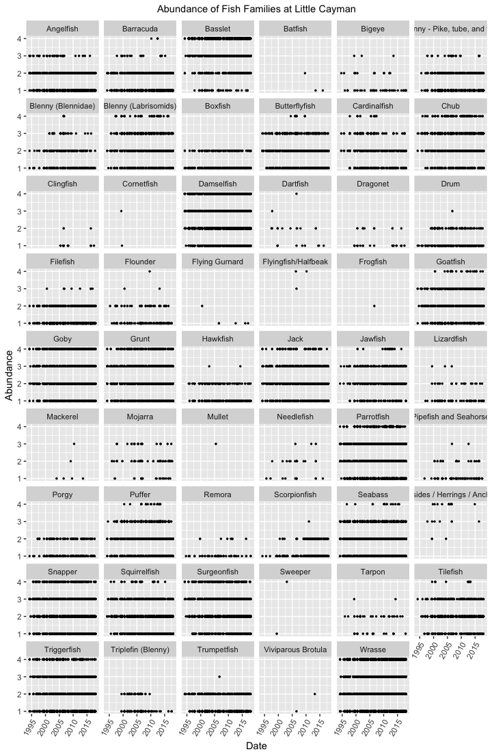

Fish families with less than thirty surveys for all species in the family are identified and removed from the data set. The abundance vs. time of numerous families is then plotted side-by-side with a smooth curve (including confidence interval) added to each family plot.

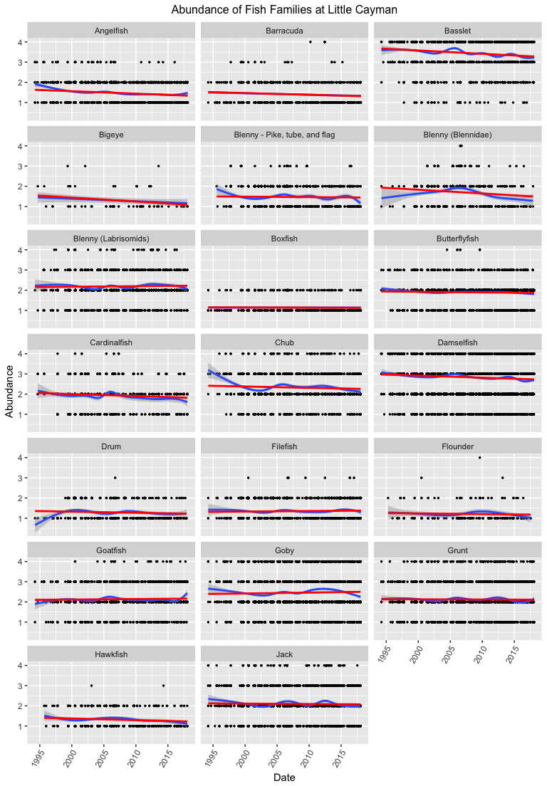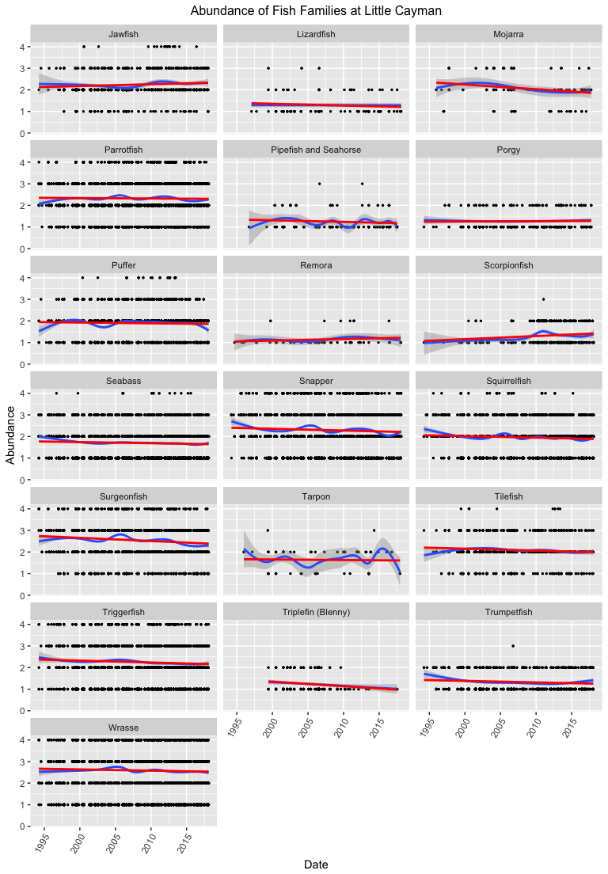

### Fish Species Exploration for Specific Families

The following pairs of plots show the abundance vs. time for specific fish families. The first plot shows the entire family at all sites at Little Cayman. A smooth curve and confidence interval are added to this plot. The second plot shows all of the species within each family.

Grouper and Snapper are prime predators in the Caribbean waters. Grouper are part of the Seabass family. The juveniles of these species, the fish in the Goby family and the fish in the Wrasse family have small, cigar-shaped bodies, ideal prey for the Lionfish.

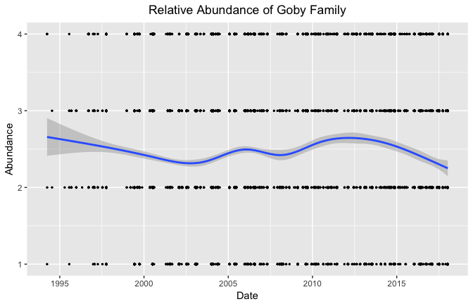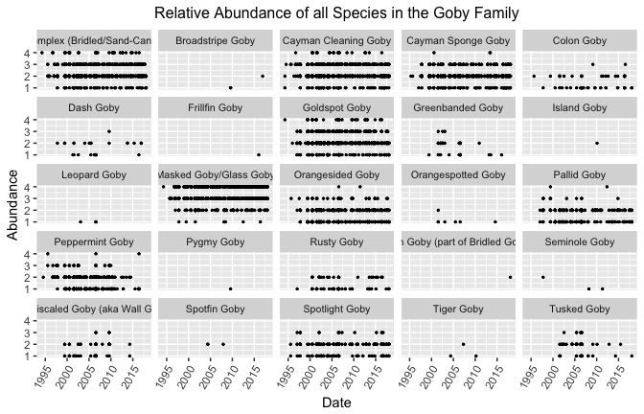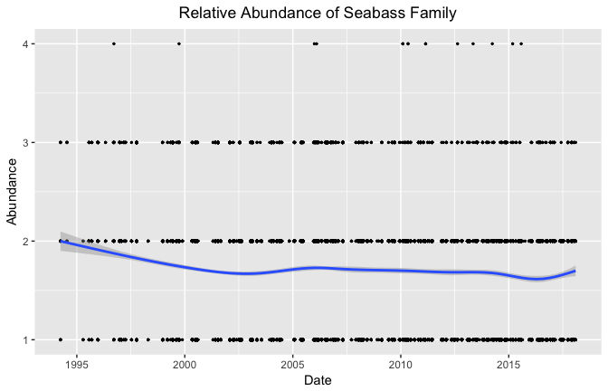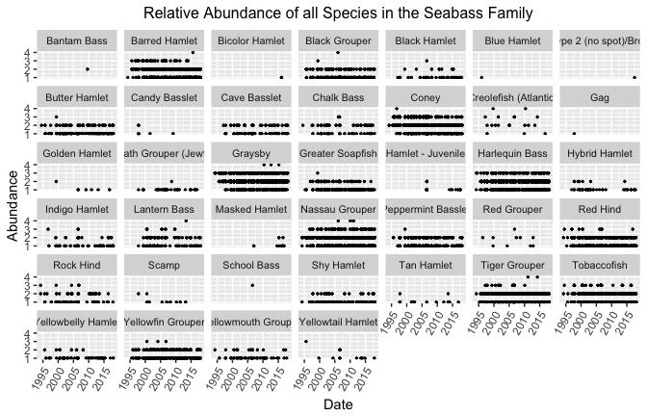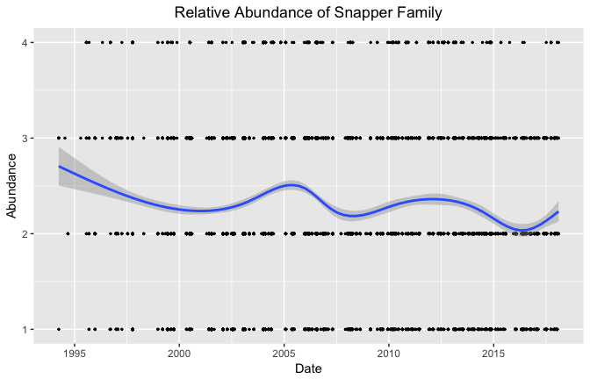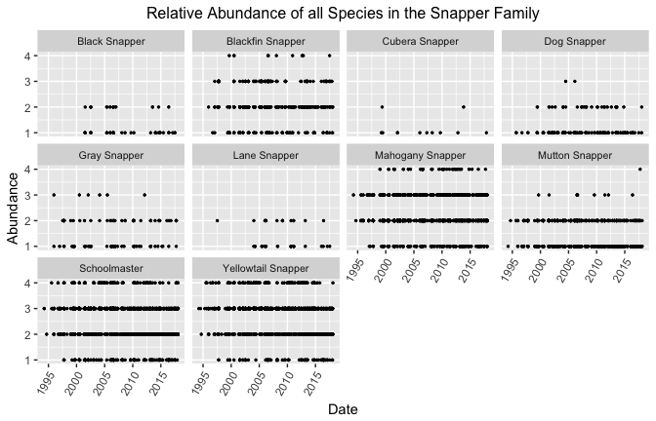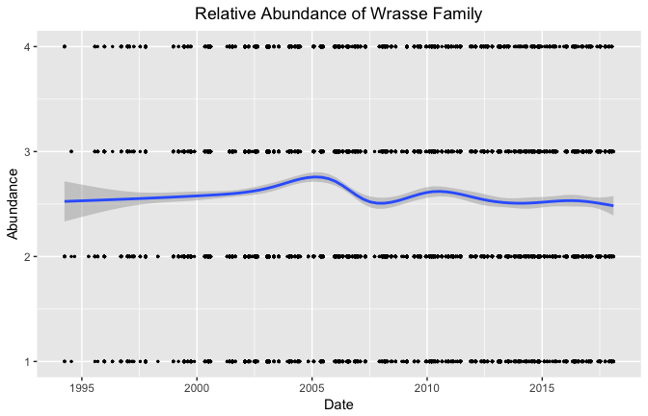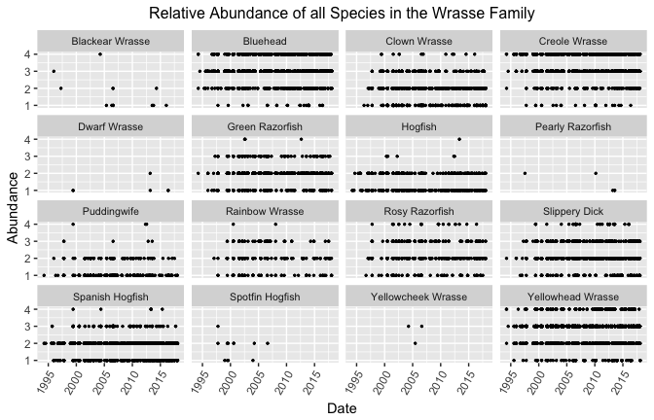

### Exploration of All Families Before and After Lionfish Invasion

The following plots show the survey data for each fish family. The plot on the left shows all the data for the named family, the center plot shows the data from when the surveys began to when the first Lionfish sighting occurred (2009-02-17) and the plot on the right shows the data from the first Lionfish sighting to when the data was obtained. Each sub plot has a corresponding trendline added.

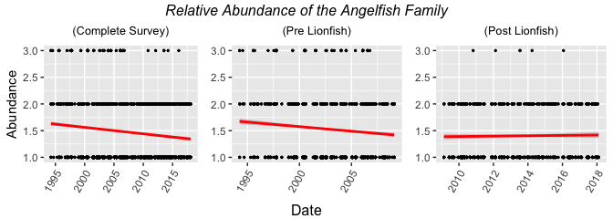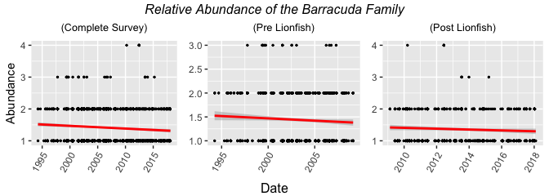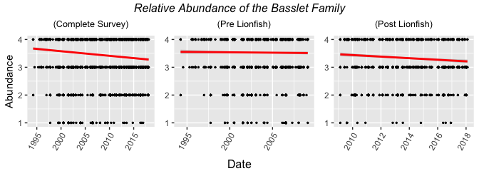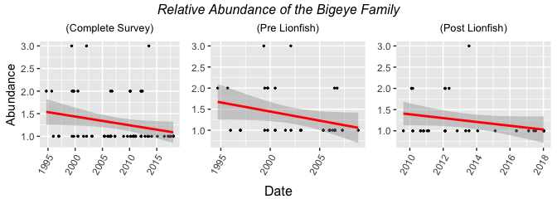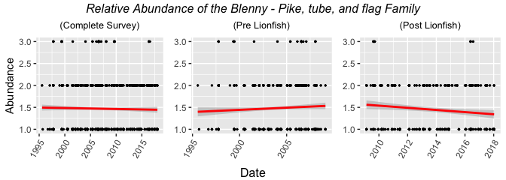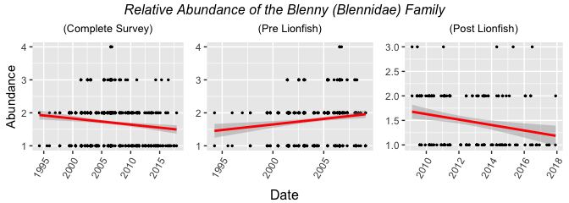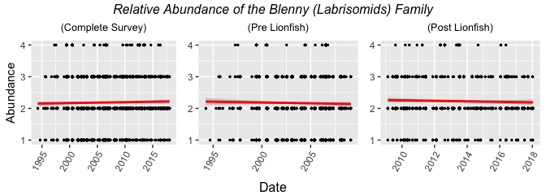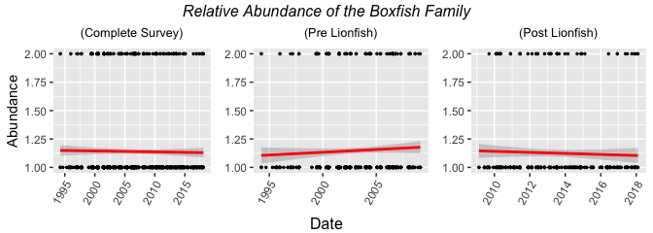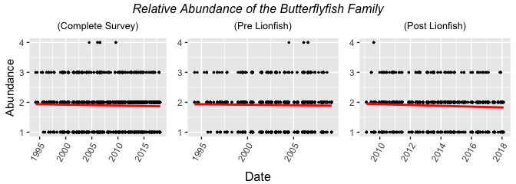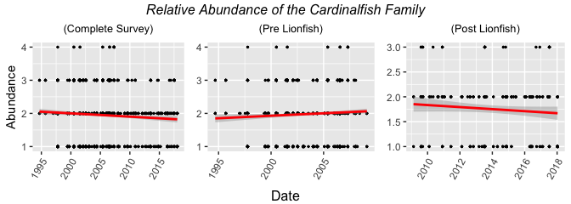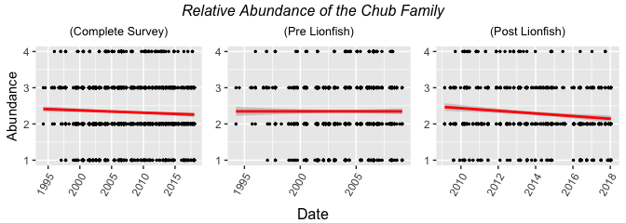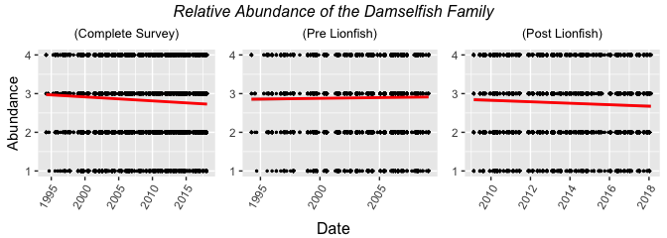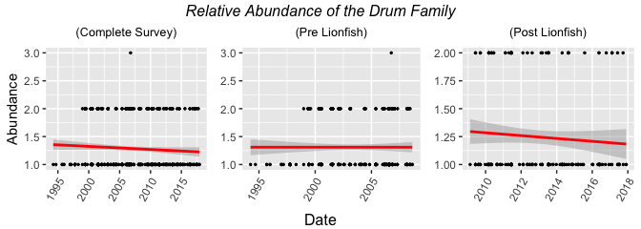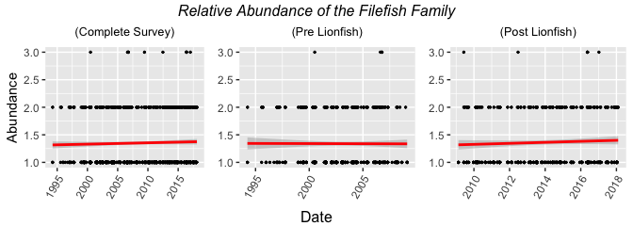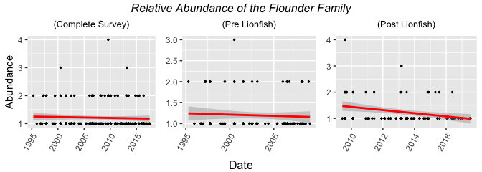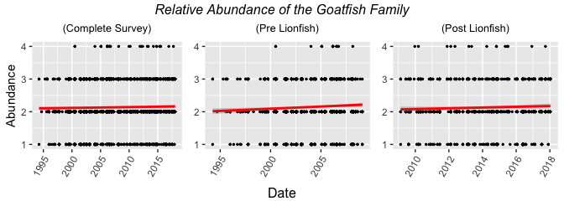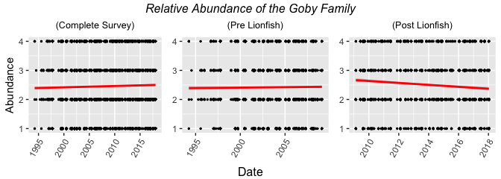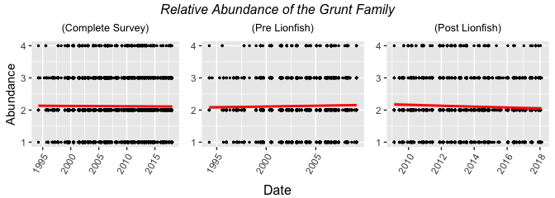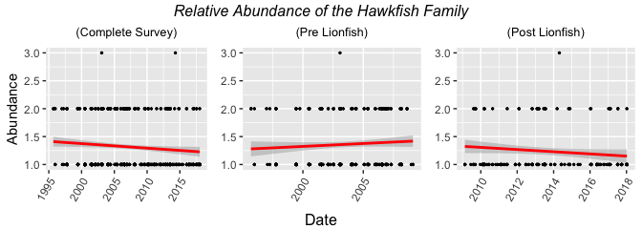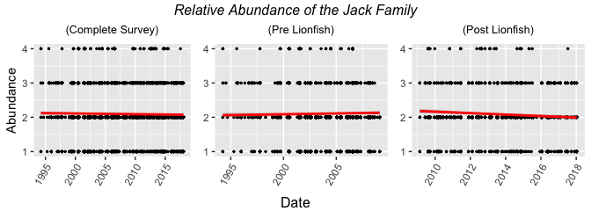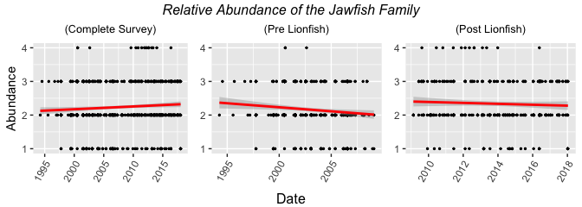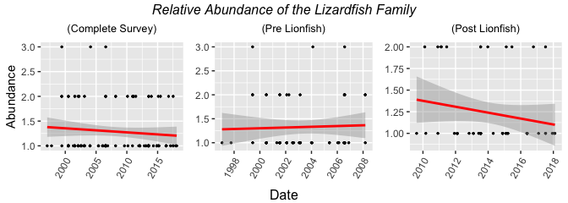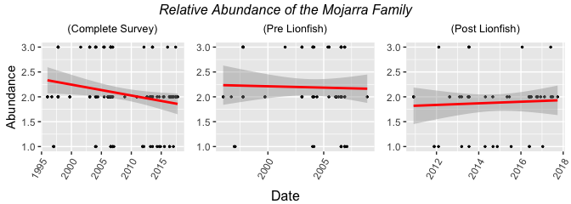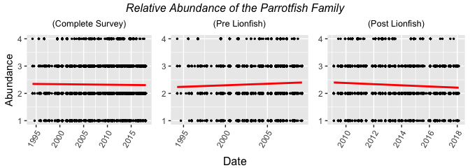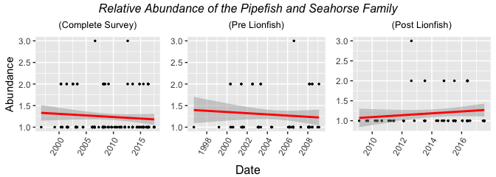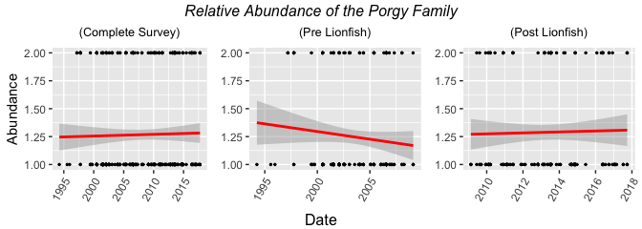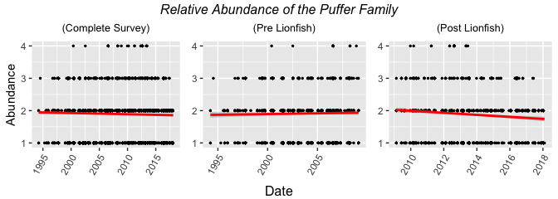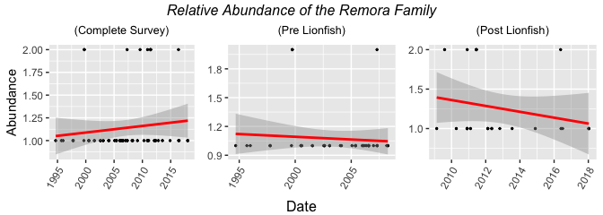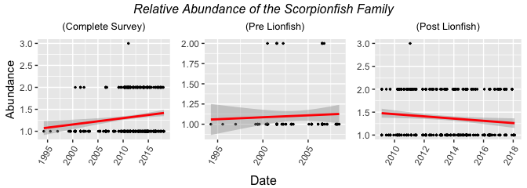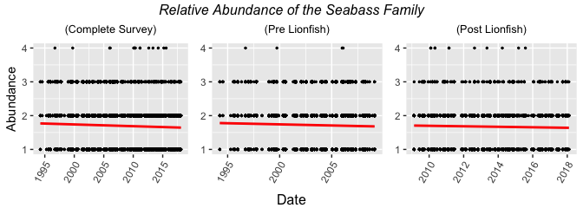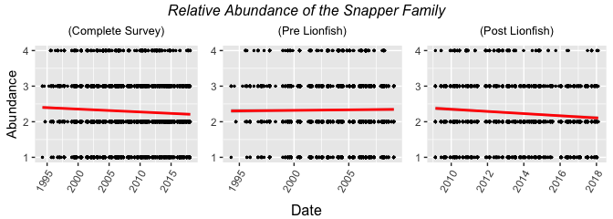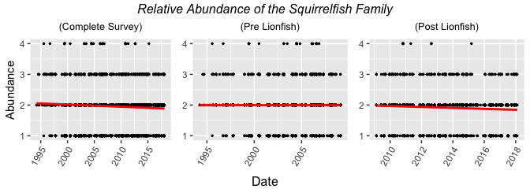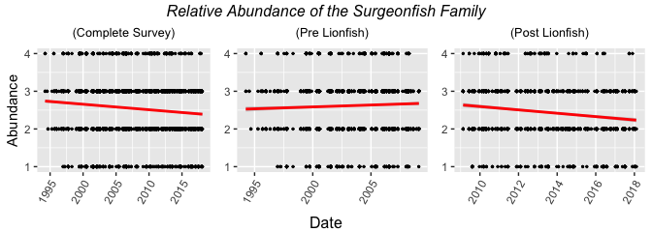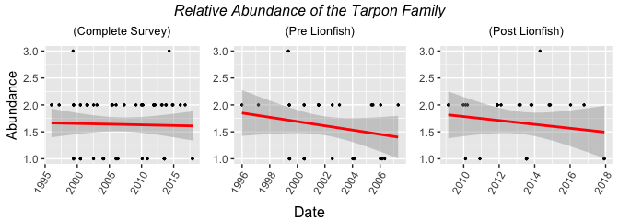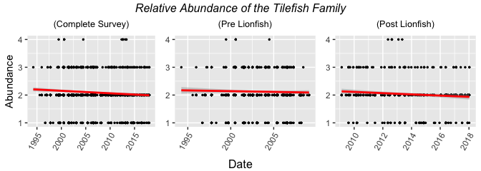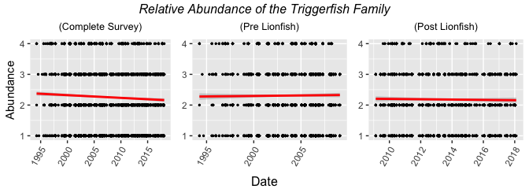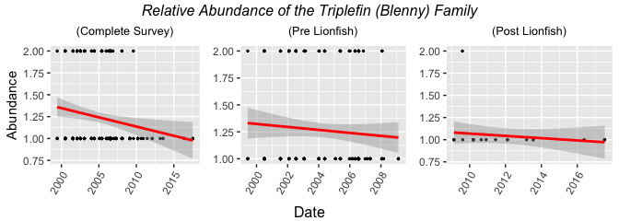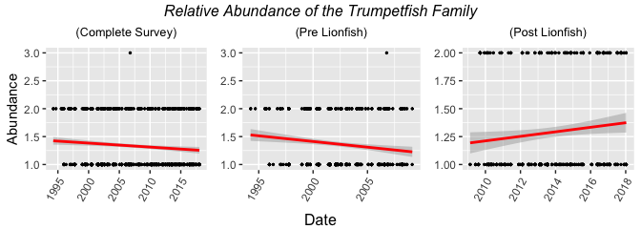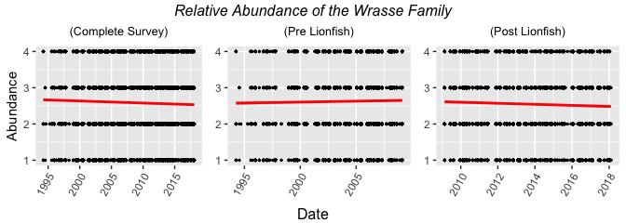

## [[1]]  
## TableGrob (3 x 3) "arrange": 5 grobs  
## z cells name grob  
## 1 1 (2-2,1-1) arrange gtable[layout]  
## 2 2 (2-2,2-2) arrange gtable[layout]  
## 3 3 (2-2,3-3) arrange gtable[layout]  
## 4 4 (1-1,1-3) arrange text[GRID.text.12486]  
## 5 5 (3-3,1-3) arrange text[GRID.text.12487]  
##   
## [[2]]  
## TableGrob (3 x 3) "arrange": 5 grobs  
## z cells name grob  
## 1 1 (2-2,1-1) arrange gtable[layout]  
## 2 2 (2-2,2-2) arrange gtable[layout]  
## 3 3 (2-2,3-3) arrange gtable[layout]  
## 4 4 (1-1,1-3) arrange text[GRID.text.12625]  
## 5 5 (3-3,1-3) arrange text[GRID.text.12626]  
##   
## [[3]]  
## TableGrob (3 x 3) "arrange": 5 grobs  
## z cells name grob  
## 1 1 (2-2,1-1) arrange gtable[layout]  
## 2 2 (2-2,2-2) arrange gtable[layout]  
## 3 3 (2-2,3-3) arrange gtable[layout]  
## 4 4 (1-1,1-3) arrange text[GRID.text.12764]  
## 5 5 (3-3,1-3) arrange text[GRID.text.12765]  
##   
## [[4]]  
## TableGrob (3 x 3) "arrange": 5 grobs  
## z cells name grob  
## 1 1 (2-2,1-1) arrange gtable[layout]  
## 2 2 (2-2,2-2) arrange gtable[layout]  
## 3 3 (2-2,3-3) arrange gtable[layout]  
## 4 4 (1-1,1-3) arrange text[GRID.text.12903]  
## 5 5 (3-3,1-3) arrange text[GRID.text.12904]  
##   
## [[5]]  
## TableGrob (3 x 3) "arrange": 5 grobs  
## z cells name grob  
## 1 1 (2-2,1-1) arrange gtable[layout]  
## 2 2 (2-2,2-2) arrange gtable[layout]  
## 3 3 (2-2,3-3) arrange gtable[layout]  
## 4 4 (1-1,1-3) arrange text[GRID.text.13042]  
## 5 5 (3-3,1-3) arrange text[GRID.text.13043]  
##   
## [[6]]  
## TableGrob (3 x 3) "arrange": 5 grobs  
## z cells name grob  
## 1 1 (2-2,1-1) arrange gtable[layout]  
## 2 2 (2-2,2-2) arrange gtable[layout]  
## 3 3 (2-2,3-3) arrange gtable[layout]  
## 4 4 (1-1,1-3) arrange text[GRID.text.13181]  
## 5 5 (3-3,1-3) arrange text[GRID.text.13182]  
##   
## [[7]]  
## TableGrob (3 x 3) "arrange": 5 grobs  
## z cells name grob  
## 1 1 (2-2,1-1) arrange gtable[layout]  
## 2 2 (2-2,2-2) arrange gtable[layout]  
## 3 3 (2-2,3-3) arrange gtable[layout]  
## 4 4 (1-1,1-3) arrange text[GRID.text.13320]  
## 5 5 (3-3,1-3) arrange text[GRID.text.13321]  
##   
## [[8]]  
## TableGrob (3 x 3) "arrange": 5 grobs  
## z cells name grob  
## 1 1 (2-2,1-1) arrange gtable[layout]  
## 2 2 (2-2,2-2) arrange gtable[layout]  
## 3 3 (2-2,3-3) arrange gtable[layout]  
## 4 4 (1-1,1-3) arrange text[GRID.text.13459]  
## 5 5 (3-3,1-3) arrange text[GRID.text.13460]  
##   
## [[9]]  
## TableGrob (3 x 3) "arrange": 5 grobs  
## z cells name grob  
## 1 1 (2-2,1-1) arrange gtable[layout]  
## 2 2 (2-2,2-2) arrange gtable[layout]  
## 3 3 (2-2,3-3) arrange gtable[layout]  
## 4 4 (1-1,1-3) arrange text[GRID.text.13598]  
## 5 5 (3-3,1-3) arrange text[GRID.text.13599]  
##   
## [[10]]  
## TableGrob (3 x 3) "arrange": 5 grobs  
## z cells name grob  
## 1 1 (2-2,1-1) arrange gtable[layout]  
## 2 2 (2-2,2-2) arrange gtable[layout]  
## 3 3 (2-2,3-3) arrange gtable[layout]  
## 4 4 (1-1,1-3) arrange text[GRID.text.13737]  
## 5 5 (3-3,1-3) arrange text[GRID.text.13738]  
##   
## [[11]]  
## TableGrob (3 x 3) "arrange": 5 grobs  
## z cells name grob  
## 1 1 (2-2,1-1) arrange gtable[layout]  
## 2 2 (2-2,2-2) arrange gtable[layout]  
## 3 3 (2-2,3-3) arrange gtable[layout]  
## 4 4 (1-1,1-3) arrange text[GRID.text.13876]  
## 5 5 (3-3,1-3) arrange text[GRID.text.13877]  
##   
## [[12]]  
## TableGrob (3 x 3) "arrange": 5 grobs  
## z cells name grob  
## 1 1 (2-2,1-1) arrange gtable[layout]  
## 2 2 (2-2,2-2) arrange gtable[layout]  
## 3 3 (2-2,3-3) arrange gtable[layout]  
## 4 4 (1-1,1-3) arrange text[GRID.text.14015]  
## 5 5 (3-3,1-3) arrange text[GRID.text.14016]  
##   
## [[13]]  
## TableGrob (3 x 3) "arrange": 5 grobs  
## z cells name grob  
## 1 1 (2-2,1-1) arrange gtable[layout]  
## 2 2 (2-2,2-2) arrange gtable[layout]  
## 3 3 (2-2,3-3) arrange gtable[layout]  
## 4 4 (1-1,1-3) arrange text[GRID.text.14154]  
## 5 5 (3-3,1-3) arrange text[GRID.text.14155]  
##   
## [[14]]  
## TableGrob (3 x 3) "arrange": 5 grobs  
## z cells name grob  
## 1 1 (2-2,1-1) arrange gtable[layout]  
## 2 2 (2-2,2-2) arrange gtable[layout]  
## 3 3 (2-2,3-3) arrange gtable[layout]  
## 4 4 (1-1,1-3) arrange text[GRID.text.14293]  
## 5 5 (3-3,1-3) arrange text[GRID.text.14294]  
##   
## [[15]]  
## TableGrob (3 x 3) "arrange": 5 grobs  
## z cells name grob  
## 1 1 (2-2,1-1) arrange gtable[layout]  
## 2 2 (2-2,2-2) arrange gtable[layout]  
## 3 3 (2-2,3-3) arrange gtable[layout]  
## 4 4 (1-1,1-3) arrange text[GRID.text.14432]  
## 5 5 (3-3,1-3) arrange text[GRID.text.14433]  
##   
## [[16]]  
## TableGrob (3 x 3) "arrange": 5 grobs  
## z cells name grob  
## 1 1 (2-2,1-1) arrange gtable[layout]  
## 2 2 (2-2,2-2) arrange gtable[layout]  
## 3 3 (2-2,3-3) arrange gtable[layout]  
## 4 4 (1-1,1-3) arrange text[GRID.text.14571]  
## 5 5 (3-3,1-3) arrange text[GRID.text.14572]  
##   
## [[17]]  
## TableGrob (3 x 3) "arrange": 5 grobs  
## z cells name grob  
## 1 1 (2-2,1-1) arrange gtable[layout]  
## 2 2 (2-2,2-2) arrange gtable[layout]  
## 3 3 (2-2,3-3) arrange gtable[layout]  
## 4 4 (1-1,1-3) arrange text[GRID.text.14710]  
## 5 5 (3-3,1-3) arrange text[GRID.text.14711]  
##   
## [[18]]  
## TableGrob (3 x 3) "arrange": 5 grobs  
## z cells name grob  
## 1 1 (2-2,1-1) arrange gtable[layout]  
## 2 2 (2-2,2-2) arrange gtable[layout]  
## 3 3 (2-2,3-3) arrange gtable[layout]  
## 4 4 (1-1,1-3) arrange text[GRID.text.14849]  
## 5 5 (3-3,1-3) arrange text[GRID.text.14850]  
##   
## [[19]]  
## TableGrob (3 x 3) "arrange": 5 grobs  
## z cells name grob  
## 1 1 (2-2,1-1) arrange gtable[layout]  
## 2 2 (2-2,2-2) arrange gtable[layout]  
## 3 3 (2-2,3-3) arrange gtable[layout]  
## 4 4 (1-1,1-3) arrange text[GRID.text.14988]  
## 5 5 (3-3,1-3) arrange text[GRID.text.14989]  
##   
## [[20]]  
## TableGrob (3 x 3) "arrange": 5 grobs  
## z cells name grob  
## 1 1 (2-2,1-1) arrange gtable[layout]  
## 2 2 (2-2,2-2) arrange gtable[layout]  
## 3 3 (2-2,3-3) arrange gtable[layout]  
## 4 4 (1-1,1-3) arrange text[GRID.text.15127]  
## 5 5 (3-3,1-3) arrange text[GRID.text.15128]  
##   
## [[21]]  
## TableGrob (3 x 3) "arrange": 5 grobs  
## z cells name grob  
## 1 1 (2-2,1-1) arrange gtable[layout]  
## 2 2 (2-2,2-2) arrange gtable[layout]  
## 3 3 (2-2,3-3) arrange gtable[layout]  
## 4 4 (1-1,1-3) arrange text[GRID.text.15266]  
## 5 5 (3-3,1-3) arrange text[GRID.text.15267]  
##   
## [[22]]  
## TableGrob (3 x 3) "arrange": 5 grobs  
## z cells name grob  
## 1 1 (2-2,1-1) arrange gtable[layout]  
## 2 2 (2-2,2-2) arrange gtable[layout]  
## 3 3 (2-2,3-3) arrange gtable[layout]  
## 4 4 (1-1,1-3) arrange text[GRID.text.15405]  
## 5 5 (3-3,1-3) arrange text[GRID.text.15406]  
##   
## [[23]]  
## TableGrob (3 x 3) "arrange": 5 grobs  
## z cells name grob  
## 1 1 (2-2,1-1) arrange gtable[layout]  
## 2 2 (2-2,2-2) arrange gtable[layout]  
## 3 3 (2-2,3-3) arrange gtable[layout]  
## 4 4 (1-1,1-3) arrange text[GRID.text.15544]  
## 5 5 (3-3,1-3) arrange text[GRID.text.15545]  
##   
## [[24]]  
## TableGrob (3 x 3) "arrange": 5 grobs  
## z cells name grob  
## 1 1 (2-2,1-1) arrange gtable[layout]  
## 2 2 (2-2,2-2) arrange gtable[layout]  
## 3 3 (2-2,3-3) arrange gtable[layout]  
## 4 4 (1-1,1-3) arrange text[GRID.text.15683]  
## 5 5 (3-3,1-3) arrange text[GRID.text.15684]  
##   
## [[25]]  
## TableGrob (3 x 3) "arrange": 5 grobs  
## z cells name grob  
## 1 1 (2-2,1-1) arrange gtable[layout]  
## 2 2 (2-2,2-2) arrange gtable[layout]  
## 3 3 (2-2,3-3) arrange gtable[layout]  
## 4 4 (1-1,1-3) arrange text[GRID.text.15822]  
## 5 5 (3-3,1-3) arrange text[GRID.text.15823]  
##   
## [[26]]  
## TableGrob (3 x 3) "arrange": 5 grobs  
## z cells name grob  
## 1 1 (2-2,1-1) arrange gtable[layout]  
## 2 2 (2-2,2-2) arrange gtable[layout]  
## 3 3 (2-2,3-3) arrange gtable[layout]  
## 4 4 (1-1,1-3) arrange text[GRID.text.15961]  
## 5 5 (3-3,1-3) arrange text[GRID.text.15962]  
##   
## [[27]]  
## TableGrob (3 x 3) "arrange": 5 grobs  
## z cells name grob  
## 1 1 (2-2,1-1) arrange gtable[layout]  
## 2 2 (2-2,2-2) arrange gtable[layout]  
## 3 3 (2-2,3-3) arrange gtable[layout]  
## 4 4 (1-1,1-3) arrange text[GRID.text.16100]  
## 5 5 (3-3,1-3) arrange text[GRID.text.16101]  
##   
## [[28]]  
## TableGrob (3 x 3) "arrange": 5 grobs  
## z cells name grob  
## 1 1 (2-2,1-1) arrange gtable[layout]  
## 2 2 (2-2,2-2) arrange gtable[layout]  
## 3 3 (2-2,3-3) arrange gtable[layout]  
## 4 4 (1-1,1-3) arrange text[GRID.text.16239]  
## 5 5 (3-3,1-3) arrange text[GRID.text.16240]  
##   
## [[29]]  
## TableGrob (3 x 3) "arrange": 5 grobs  
## z cells name grob  
## 1 1 (2-2,1-1) arrange gtable[layout]  
## 2 2 (2-2,2-2) arrange gtable[layout]  
## 3 3 (2-2,3-3) arrange gtable[layout]  
## 4 4 (1-1,1-3) arrange text[GRID.text.16378]  
## 5 5 (3-3,1-3) arrange text[GRID.text.16379]  
##   
## [[30]]  
## TableGrob (3 x 3) "arrange": 5 grobs  
## z cells name grob  
## 1 1 (2-2,1-1) arrange gtable[layout]  
## 2 2 (2-2,2-2) arrange gtable[layout]  
## 3 3 (2-2,3-3) arrange gtable[layout]  
## 4 4 (1-1,1-3) arrange text[GRID.text.16517]  
## 5 5 (3-3,1-3) arrange text[GRID.text.16518]  
##   
## [[31]]  
## TableGrob (3 x 3) "arrange": 5 grobs  
## z cells name grob  
## 1 1 (2-2,1-1) arrange gtable[layout]  
## 2 2 (2-2,2-2) arrange gtable[layout]  
## 3 3 (2-2,3-3) arrange gtable[layout]  
## 4 4 (1-1,1-3) arrange text[GRID.text.16656]  
## 5 5 (3-3,1-3) arrange text[GRID.text.16657]  
##   
## [[32]]  
## TableGrob (3 x 3) "arrange": 5 grobs  
## z cells name grob  
## 1 1 (2-2,1-1) arrange gtable[layout]  
## 2 2 (2-2,2-2) arrange gtable[layout]  
## 3 3 (2-2,3-3) arrange gtable[layout]  
## 4 4 (1-1,1-3) arrange text[GRID.text.16795]  
## 5 5 (3-3,1-3) arrange text[GRID.text.16796]  
##   
## [[33]]  
## TableGrob (3 x 3) "arrange": 5 grobs  
## z cells name grob  
## 1 1 (2-2,1-1) arrange gtable[layout]  
## 2 2 (2-2,2-2) arrange gtable[layout]  
## 3 3 (2-2,3-3) arrange gtable[layout]  
## 4 4 (1-1,1-3) arrange text[GRID.text.16934]  
## 5 5 (3-3,1-3) arrange text[GRID.text.16935]  
##   
## [[34]]  
## TableGrob (3 x 3) "arrange": 5 grobs  
## z cells name grob  
## 1 1 (2-2,1-1) arrange gtable[layout]  
## 2 2 (2-2,2-2) arrange gtable[layout]  
## 3 3 (2-2,3-3) arrange gtable[layout]  
## 4 4 (1-1,1-3) arrange text[GRID.text.17073]  
## 5 5 (3-3,1-3) arrange text[GRID.text.17074]  
##   
## [[35]]  
## TableGrob (3 x 3) "arrange": 5 grobs  
## z cells name grob  
## 1 1 (2-2,1-1) arrange gtable[layout]  
## 2 2 (2-2,2-2) arrange gtable[layout]  
## 3 3 (2-2,3-3) arrange gtable[layout]  
## 4 4 (1-1,1-3) arrange text[GRID.text.17212]  
## 5 5 (3-3,1-3) arrange text[GRID.text.17213]  
##   
## [[36]]  
## TableGrob (3 x 3) "arrange": 5 grobs  
## z cells name grob  
## 1 1 (2-2,1-1) arrange gtable[layout]  
## 2 2 (2-2,2-2) arrange gtable[layout]  
## 3 3 (2-2,3-3) arrange gtable[layout]  
## 4 4 (1-1,1-3) arrange text[GRID.text.17351]  
## 5 5 (3-3,1-3) arrange text[GRID.text.17352]  
##   
## [[37]]  
## TableGrob (3 x 3) "arrange": 5 grobs  
## z cells name grob  
## 1 1 (2-2,1-1) arrange gtable[layout]  
## 2 2 (2-2,2-2) arrange gtable[layout]  
## 3 3 (2-2,3-3) arrange gtable[layout]  
## 4 4 (1-1,1-3) arrange text[GRID.text.17490]  
## 5 5 (3-3,1-3) arrange text[GRID.text.17491]  
##   
## [[38]]  
## TableGrob (3 x 3) "arrange": 5 grobs  
## z cells name grob  
## 1 1 (2-2,1-1) arrange gtable[layout]  
## 2 2 (2-2,2-2) arrange gtable[layout]  
## 3 3 (2-2,3-3) arrange gtable[layout]  
## 4 4 (1-1,1-3) arrange text[GRID.text.17629]  
## 5 5 (3-3,1-3) arrange text[GRID.text.17630]  
##   
## [[39]]  
## TableGrob (3 x 3) "arrange": 5 grobs  
## z cells name grob  
## 1 1 (2-2,1-1) arrange gtable[layout]  
## 2 2 (2-2,2-2) arrange gtable[layout]  
## 3 3 (2-2,3-3) arrange gtable[layout]  
## 4 4 (1-1,1-3) arrange text[GRID.text.17768]  
## 5 5 (3-3,1-3) arrange text[GRID.text.17769]