Cartoon Transformation

EE 440 Final Project -- Jake Garrison -- 12/5/2015

Table of Contents

Features 1

Functions 2

*Global Controls:* 2

*Effect Parameters:* 3

Transformation 4

Implementation 4

User Guide 4

Comments 4

Future Research 4

# Features

The core of the program relies on a gradient minimization algorithm based the *L*0 gradient minimization concept. This filter generally flattens the color content and removes high frequency noise while still retaining the edges and primary color change. In my experience, the gradient minimization algorithm I implemented preforms better than ‘cartoon filters’ and ‘bilateral filters’ found online which simply combing a blurring filter or bilateral filter with and edge detection. After the gradient minimization, the edges of the original image are extracted and altered using a customizable morphological transformation that serves to thicken the edges and display them in a more ‘hand drawn stroke’ form. After applying the modified edges to the gradient minimization output, the final output is formed after a simple color quantization is applied, reducing the color depth to better represent a cartoon. These stroke and color settings, as well as the gradient minimization parameters are customizable through the GUI.

An additional mode inspired by old newspaper cartoons and the pop art style is also available in the GUI. This mode performs binary operations and color masking to output a simple, binary representation of the input that emphasizes the features present in the input image. As in the cartoon mode, this mode has morphological operations to better simulate human strokes, but the true elegance of this effect comes from its ability to accurately emphasize borders rather than all edges. The border is extracted with a function that scores all edges based off continuity and density to identify possible borders, then gaps in edges are filled in and the resulting fully closed edges are added to the output effectively emphasizing the borders.

The GUI provides a simple, but powerful interface for working with the effects outlined above. It is resizable (responsive design) and allows the user to load an image of choice and save the output to disk. There are also some radio buttons allowing a user to apply addition transformations like inverting or toggle controls such as the morphological transform.

# Functions

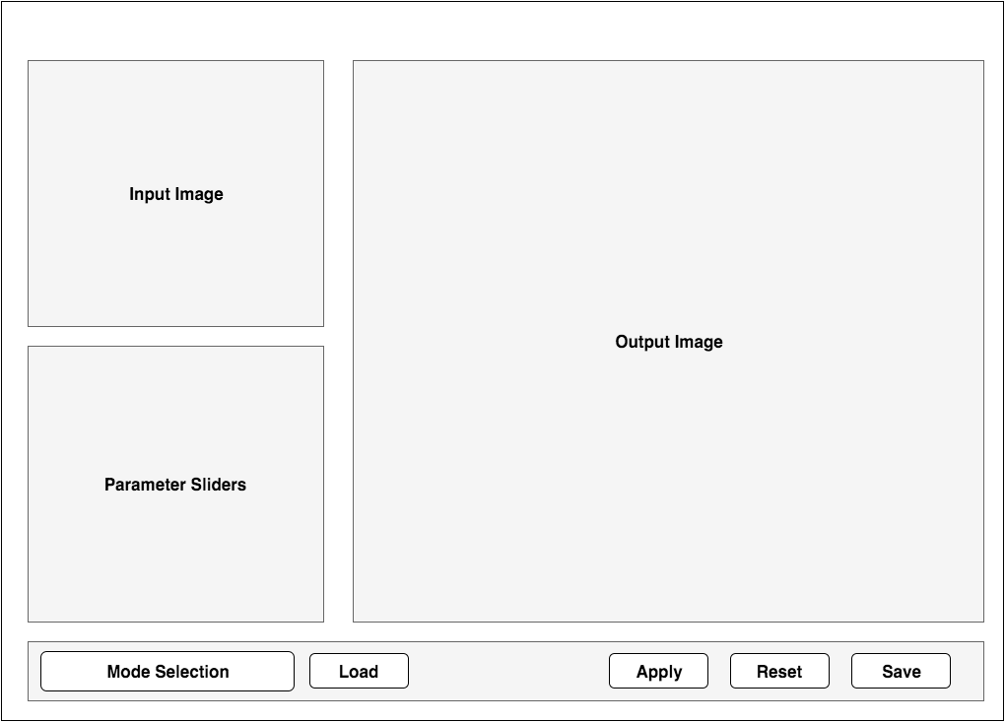

Figure : GUI wireframe

The GUI has many functions and parameters that can be set via sliders. There are also different selectable modes which influence the direct behavior of the sliders.

## Global Controls:

The global parameters are located along the bottom row and are made up of global controls for working with the effects. The functionality is summarized below.

Mode

Toggles between the Color and Binary modes. Color is meant to transform the image into a color, hand drawn cartoon. All color information in the original image is retained and gradient minimization is used along with other edge related effects to produce the output.

In Binary mode, the output is meant to resemble that of a black and white newspaper graphic, or pop art from the ‘60s. Color information is lost; however, color masks can be applied using the Color Tweak slider.

Color Representation

In addition to the mode selection, the output color representation can be further modified with the Invert and BW radio buttons. These toggles are fairly straightforward and work in all modes. In color, BW converts to grayscale, and in binary, removes the colored mask. The Invert option inverts the colors. In binary mode, this essentially exposes the edges.

Load

Prompts the user to load a local image file.

Apply

Applies the current parameters to the image and displays the output.

Reset

Clears the input and output images

Save

Prompts the user to save the output to file

## Effect Parameters:

There are a number of effect sliders that can parameterize the overall transformation applied to the output.

Color Tweak

In Color mode, this adjusts the color *quantization*, spanning from 1 to 255. Lowering this reduces the color gradients and available colors in the display palette.

In Binary mode, this adjusts the *hue* of the mask, spanning from 0 to 255. In BW mode, this slider has no effect.

Smoothness

This is the main parameter for the *gradient minimization*. Increasing this will consequently produce a smoother image with less detail and color gradient, and also require fewer iterations in processing.

Detail

Decreasing this parameter will remove finer details from the output creating a simpler output. Rather than filtering based of gradient and frequency, this parameter is based off feature density. Features that don’t meet the minimum area defined by this parameter are removed.

Morph Toggle

Toggles whether the morphological transformations are applied to the output. The sliders below this are enabled or disabled based on the toggle. The transformation attempts to add a more human style to the extracted borders using erosion for line border thickness, and dilation with a customizable line structuring element.

Stroke Thickness

Controls the thickness of the extracted borders using erosion with a disk structuring element.

Stroke Length

Modulates the length of the line segment used in the dilation process

Stroke Angle

Modulates the angle of the line segment used in the dilation process; from 0 to 360 deg.

# Implementation

We present a new image editing method, particularly effective for sharpening major edges by increasing the steepness of transition while eliminating a manageable degree of low-amplitude structures. The seemingly contradictive effect is achieved in an optimization framework making use of *L*0 gradient minimization, which can globally control how many non-zero gradients are resulted in to approximate prominent structure in a sparsity-control manner. Un- like other edge-preserving smoothing approaches, our method does not depend on local features, but instead globally locates impor- tant edges. It, as a fundamental tool, finds many applications and is particularly beneficial to edge extraction, clip-art JPEG artifact removal, and non-photorealistic effect generation.

# 

# User Guide

# Comments

# Future Research