# Exercise for github
Getting to know github.
Made as an exercise.

This is to try out some stuff.

I got invited to collaborate
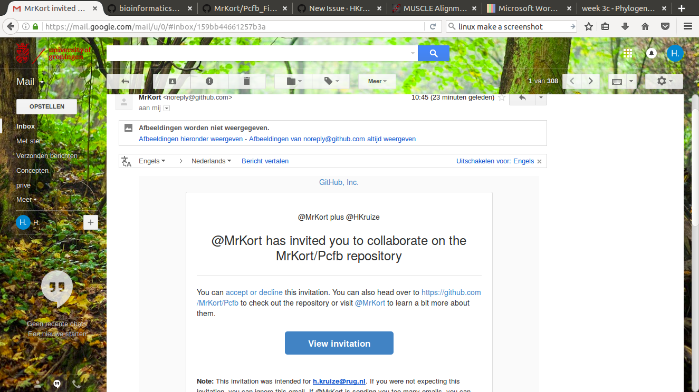

I modified my profile, only added what I want others to know
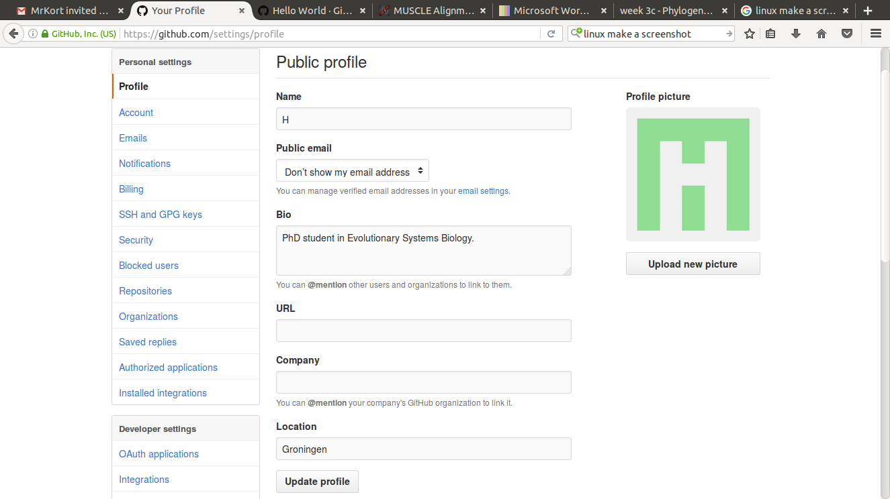

I made a TODO list in issues
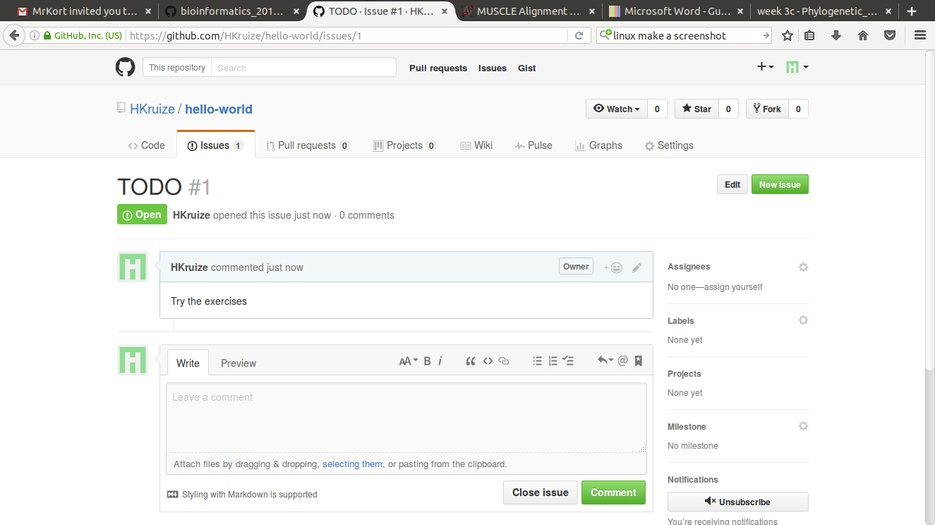

Closed the todo list in issue
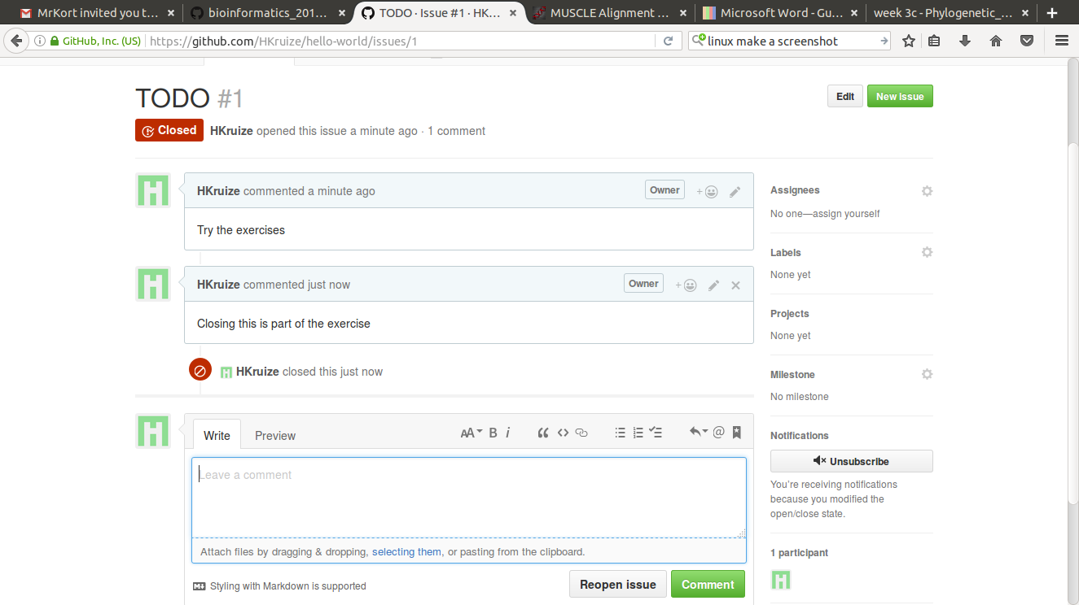

Committed an in between version
commands used: git add README.md; git commit -m “In between version”; git push
Username: Hkruize

Asked to be a collab on Fairytale_test by Lumphie
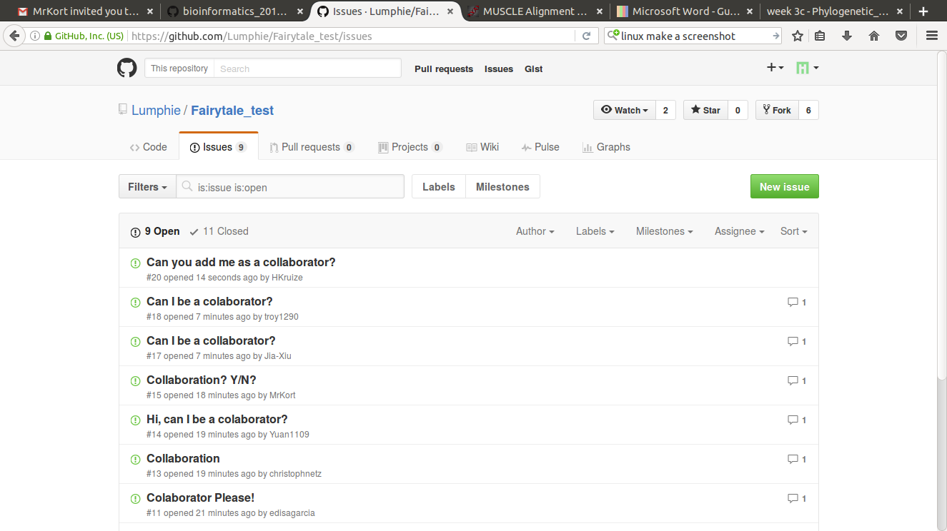

Fixed a merge conflict, forgot to make the screenshot

Branch switching: git checkout -b forhelen origin/forhelen
git checkout master (to go back to master)

