ML – task 3
Q1:
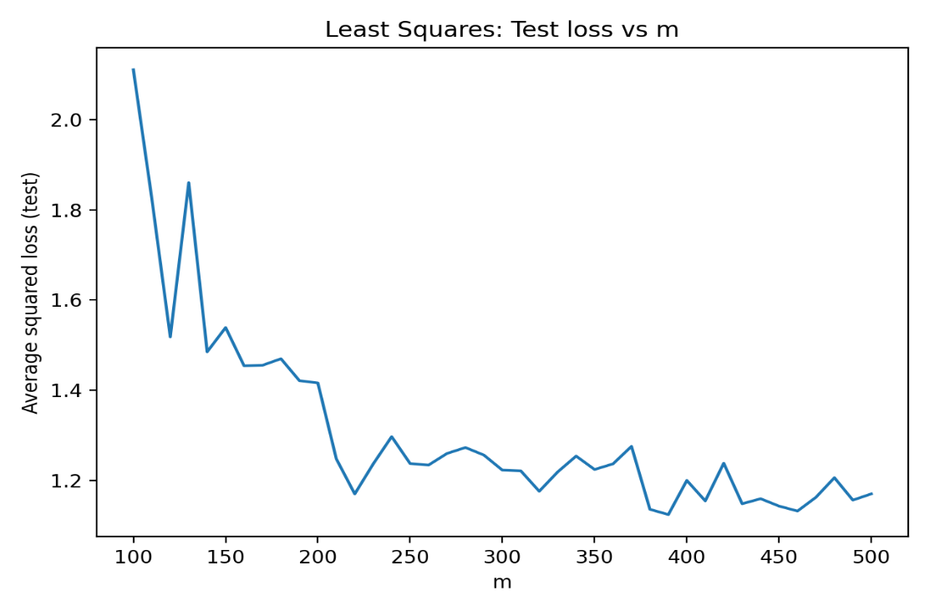
Q1.a.1:

Q1.a.2:
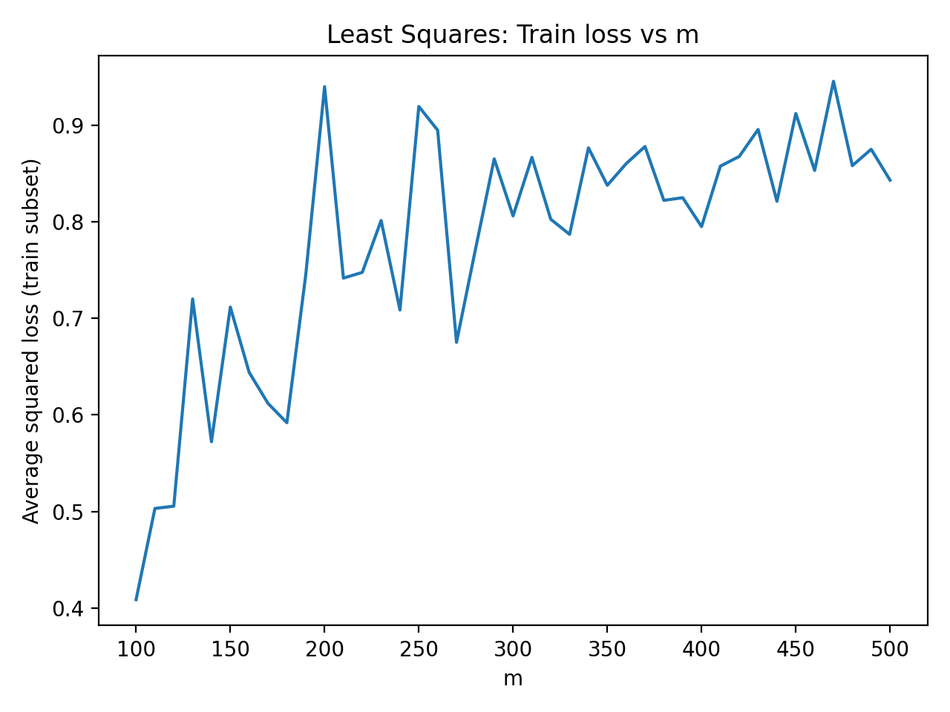

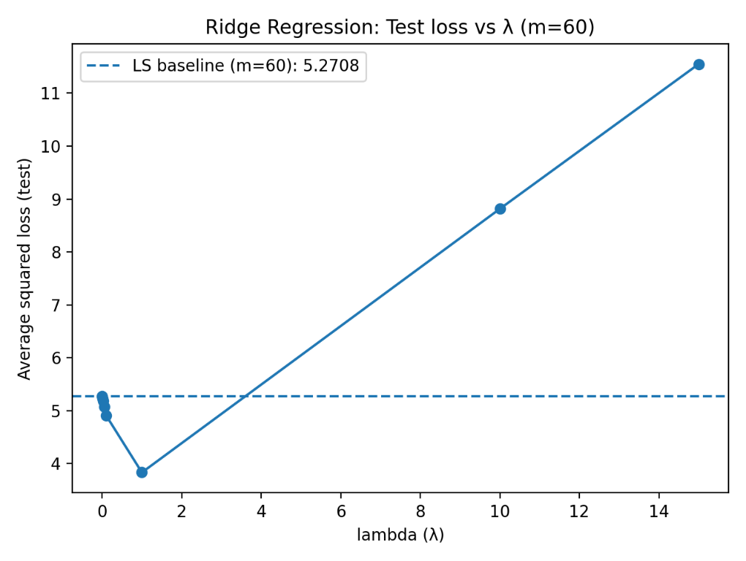
Q1.b.1:

Q1.b.2:
The behavior of the test loss as λ varies :
λ = 0 or close to I similar to least squares calculated with m=60 according to the equation. Since there is a very little (or not at all) value added to the objective function.
λ = 1 gives the optimal solution for this run, meaning that is the best trade of between generalization and learning from the training data.
λ = 10 , 15 gives to much value to the regularization in the objective function so w size will shrink towards 0 so the model becomes underfitting so the test error grows much larger, this is observed in the mean of the square difference between the predictor result to the actual result.

Q1.b.3:
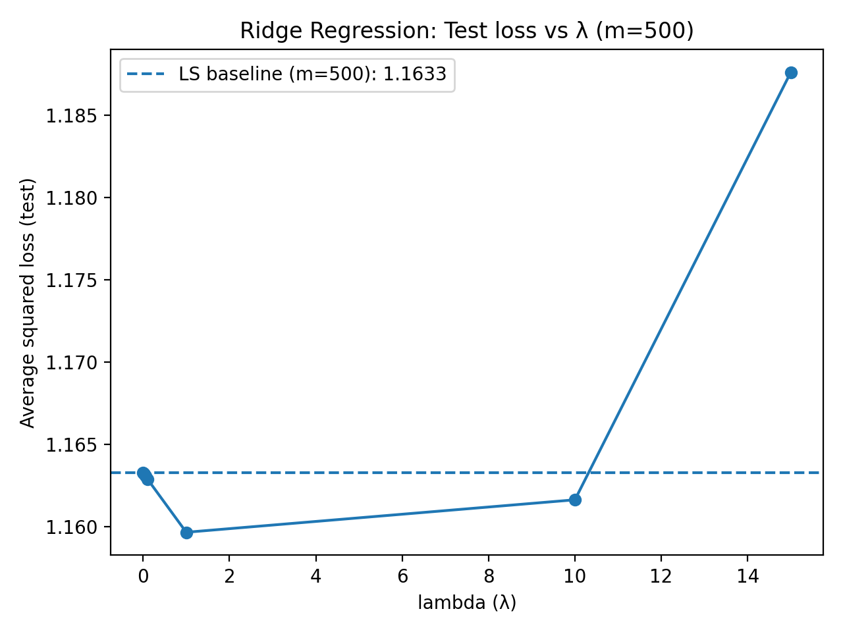

Q1.b.4:
First, we observe that the average squared loss is much lower for $m=500$because the larger training set represents the underlying data distribution more accurately.
For a small training size ($m=60$), the least-squares solution suffers from high variance, meaning it is sensitive to the specific sampled data. Ridge regularization significantly improves generalization in this case by reducing variance, which leads to a lower test loss for small values of $λ$.
For a large training size ($m=500$), the variance of the least-squares estimator is already low, since the data better approximates the true distribution. As a result, ridge regularization provides little benefit. When $λ$becomes large, the regularization term increases the bias of the model, leading to underfitting and a higher test loss.
Finally, for $λ=10$, the negative effect is much smaller when $m=500$because the data-fitting term $∥Xw-y∥^{2}$dominates the objective function. With more data, the influence of the regularization term $λ∥w∥^{2}$is relatively weaker, so large values of $λ$are less harmful than in the small-sample case.
Q2:
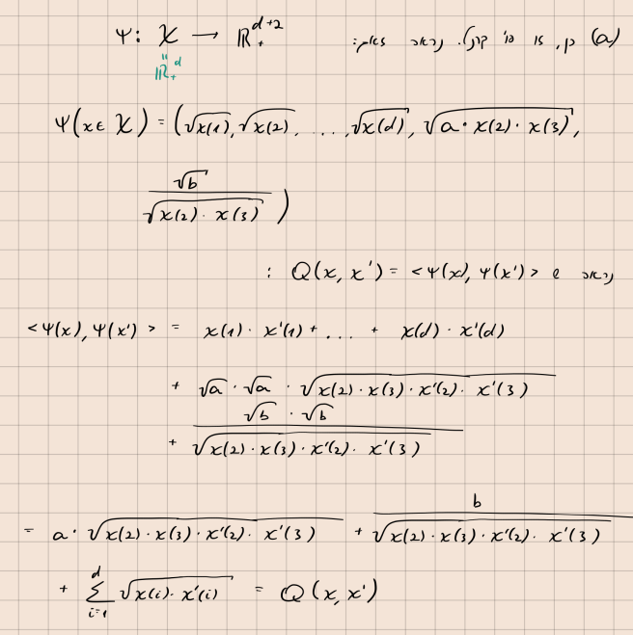

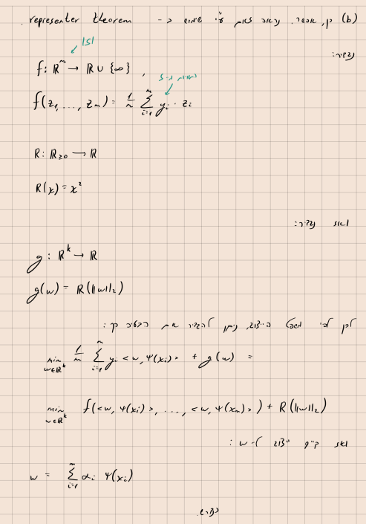

Q3:
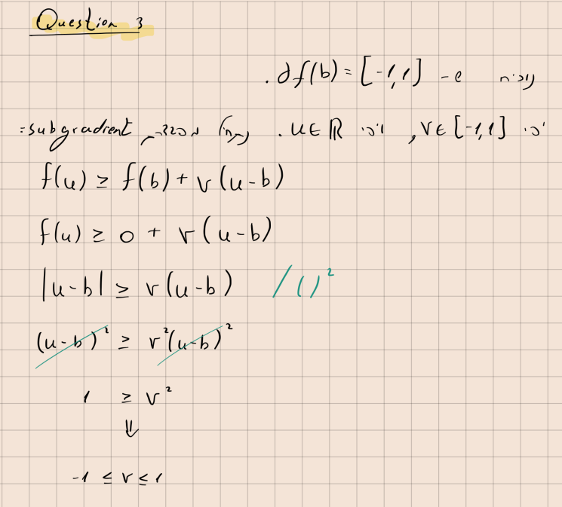

Q4:

