**AIHire Recruitment System Setup Instruction**

## Enbo Sun, Yuzhong Chen, Ruiying Ma, Tianyuan Tan, Yangle Liu, Kaijie Yang

**Testing Accounts:**There are some accounts already set up with resume/job postings for you to test out the functionalities of the system. Here are the testing account details:  
Applicant Testing Account username: 111, password: 111   
HR Testing Account username: 999, password: 999  
Admin Testing Account username: 000, password: 000

There is a quick verification code:000, 222

# **Local Installation:**

You can install the AIHire Recruitment System locally following these steps.

1. Install and Setup Essential Tools including: Java JDK >= 1.8, Maven >= 3.6.3, MySQL >= 8.0.0, Navicat or MySQL Workbench, Redis. JDK and Maven need to be set up in the system’s environment variables and configured in your IDE.
2. Recommended IDE: IntelliJ IDEA, VS Code (lightweight).
3. For the database, our current configuration file defaults to the database username and password of root. If you do not configure them this way, please change them. At the same time, you need to create a database named springbootp0eo6 and run the sql file "COMP208\Mysql\recruitment.sql". The program runs successfully. In this file "recruitWebsitemaster/src/main/resources/

application.yaml", change the local database username, password and other settings. (? preceded by the database name)  
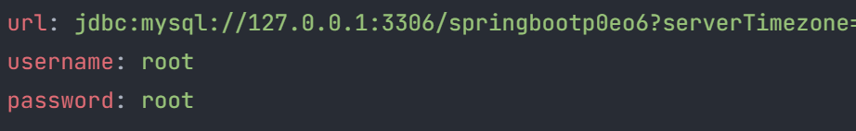

1. Start up Redis for cache management first!!!( Start redis before starting java)
2. You need to start three python programs.(Please configure the Python library environment according to the library reference at the beginning of the program.)  
   "COMP208\AI Implementation\simplify_resume_launch.py",   
   "COMP208\AI Implementation\recommend_resume_launch.py", and   
   "COMP208\AI Implementation\chatbot_launch.py". Please ensure that they run successfully so that the AI ​​function can be carried out.
3. After set up and configure everything correctly, you can run the file “recruitWebsite-master/src/main/java/com/iurac/recruit/RecruitWebsiteApplication.java” to enjoy our AIHire Recruitment System!