Текущая ситуация на дороге дорог без учета временных промежутков и дней недели

|  |  |  |  |  |  |  |  |  |  |
| --- | --- | --- | --- | --- | --- | --- | --- | --- | --- |
| type_of_road | Amurskaya | Gorkogo | Krasnoarmeskaya | Krasnoflotskaya | Lomonosova | Oktyabrskaya | Severnaya | Zeyskaya | bad |
| Gorkogo | 20 | 0 | 19 | 0 | 0 | 20 | 0 | 23 | 23 |
| Lenina_(OKC) | 22 | 0 | 0 | 0 | 0 | 0 | 0 | 23 | 29 |
| Lenina_(ZAGZ) | 0 | 0 | 0 | 14 | 0 | 0 | 0 | 20 | 26 |
| Oktyabrskaya_(50-Ostrovskays) | 0 | 23 | 19 | 0 | 8 | 0 | 4 | 0 | 24 |
| Oktyabrskaya_(Kyznechnaya-Teatralnaya) | 0 | 22 | 21 | 0 | 0 | 0 | 25 | 0 | 24 |

Ситуация на дороге после перекрытия дорог без учета временных промежутков и дней недели

|  |  |  |  |  |  |  |  |  |
| --- | --- | --- | --- | --- | --- | --- | --- | --- |
| type_of_road | Amurskaya | Gorkogo | Krasnoarmeskaya | Krasnoflotskaya | Lomonosova | Oktyabrskaya | Severnaya | Zeyskaya |
| Gorkogo | 32 | 0 | 27 | 0 | 0 | 22 | 0 | 25 |
| Lenina_(OKC) | 43 | 0 | 0 | 0 | 0 | 0 | 0 | 32 |
| Lenina_(ZAGZ) | 0 | 0 | 0 | 33 | 0 | 0 | 0 | 28 |
| Oktyabrskaya_(50-Ostrovskays) | 0 | 33 | 26 | 0 | 13 | 0 | 7 | 0 |
| Oktyabrskaya_(Kyznechnaya-Teatralnaya) | 0 | 34 | 29 | 0 | 0 | 0 | 30 | 0 |

Текущая ситуация на дороге c учета временных промежутков и дней недели

|  |  |  |  |  |  |  |  |
| --- | --- | --- | --- | --- | --- | --- | --- |
| date | ПН | ВТ | СР | ЧТ | ПТ | СБ | ВС |
| ('Gorkogo', 'Amurskaya') | 19 | 21 | 20 | 20 | 18 | 24 | 20 |
| ('Gorkogo', 'Krasnoarmeskaya') | 18 | 19 | 20 | 20 | 20 | 19 | 16 |
| ('Gorkogo', 'Oktyabrskaya') | 22 | 20 | 20 | 18 | 19 | 22 | 20 |
| ('Gorkogo', 'Zeyskaya') | 24 | 24 | 21 | 22 | 22 | 23 | 24 |
| ('Gorkogo', 'bad') | 24 | 22 | 22 | 21 | 23 | 24 | 24 |
| ('Lenina_(OKC)', 'Amurskaya') | 22 | 22 | 22 | 21 | 20 | 25 | 24 |
| ('Lenina_(OKC)', 'Zeyskaya') | 24 | 24 | 23 | 21 | 23 | 23 | 22 |
| ('Lenina_(OKC)', 'bad') | 31 | 31 | 28 | 27 | 29 | 27 | 26 |
| ('Lenina_(ZAGZ)', 'Krasnoflotskaya') | 15 | 10 | 13 | 12 | 17 | 18 | 14 |
| ('Lenina_(ZAGZ)', 'Zeyskaya') | 20 | 21 | 17 | 19 | 21 | 21 | 20 |
| ('Lenina_(ZAGZ)', 'bad') | 26 | 23 | 30 | 25 | 32 | 25 | 21 |
| ('Oktyabrskaya_(50-Ostrovskays)', 'Gorkogo') | 22 | 22 | 28 | 21 | 24 | 21 | 25 |
| ('Oktyabrskaya_(50-Ostrovskays)', 'Krasnoarmeskaya') | 21 | 17 | 17 | 19 | 21 | 19 | 18 |
| ('Oktyabrskaya_(50-Ostrovskays)', 'Lomonosova') | 12 | 7 | 8 | 7 | 8 | 7 | 9 |
| ('Oktyabrskaya_(50-Ostrovskays)', 'Severnaya') | 5 | 4 | 4 | 4 | 4 | 4 | 4 |
| ('Oktyabrskaya_(50-Ostrovskays)', 'bad') | 26 | 25 | 25 | 22 | 26 | 25 | 22 |
| ('Oktyabrskaya_(Kyznechnaya-Teatralnaya)', 'Gorkogo') | 22 | 23 | 22 | 24 | 21 | 20 | 21 |
| ('Oktyabrskaya_(Kyznechnaya-Teatralnaya)', 'Krasnoarmeskaya') | 21 | 23 | 21 | 20 | 22 | 18 | 22 |
| ('Oktyabrskaya_(Kyznechnaya-Teatralnaya)', 'Severnaya') | 25 | 26 | 25 | 24 | 24 | 24 | 25 |
| ('Oktyabrskaya_(Kyznechnaya-Teatralnaya)', 'bad') | 28 | 27 | 24 | 21 | 21 | 26 | 24 |

Ситуация на дороге после перекрытия дорог c учета временных промежутков и дней недели

|  |  |  |  |  |  |  |  |
| --- | --- | --- | --- | --- | --- | --- | --- |
| date | ПН | ВТ | СР | ЧТ | ПТ | СБ | ВС |
| ('Gorkogo', 'Amurskaya') | 27 | 24 | 29 | 28 | 26 | 30 | 27 |
| ('Gorkogo', 'Krasnoarmeskaya') | 19 | 27 | 22 | 22 | 24 | 30 | 18 |
| ('Gorkogo', 'Oktyabrskaya') | 27 | 21 | 26 | 19 | 20 | 26 | 23 |
| ('Gorkogo', 'Zeyskaya') | 36 | 28 | 26 | 30 | 25 | 28 | 30 |
| ('Lenina_(OKC)', 'Amurskaya') | 30 | 34 | 48 | 25 | 34 | 31 | 32 |
| ('Lenina_(OKC)', 'Zeyskaya') | 50 | 42 | 38 | 36 | 30 | 28 | 32 |
| ('Lenina_(ZAGZ)', 'Krasnoflotskaya') | 29 | 19 | 17 | 28 | 26 | 33 | 18 |
| ('Lenina_(ZAGZ)', 'Zeyskaya') | 22 | 25 | 25 | 32 | 28 | 21 | 29 |
| ('Oktyabrskaya_(50-Ostrovskays)', 'Gorkogo') | 36 | 27 | 36 | 27 | 34 | 27 | 27 |
| ('Oktyabrskaya_(50-Ostrovskays)', 'Krasnoarmeskaya') | 34 | 17 | 23 | 22 | 25 | 26 | 18 |
| ('Oktyabrskaya_(50-Ostrovskays)', 'Lomonosova') | 16 | 17 | 13 | 11 | 9 | 11 | 13 |
| ('Oktyabrskaya_(50-Ostrovskays)', 'Severnaya') | 7 | 9 | 14 | 8 | 5 | 17 | 10 |
| ('Oktyabrskaya_(Kyznechnaya-Teatralnaya)', 'Gorkogo') | 36 | 26 | 23 | 24 | 24 | 38 | 30 |
| ('Oktyabrskaya_(Kyznechnaya-Teatralnaya)', 'Krasnoarmeskaya') | 23 | 28 | 34 | 22 | 37 | 28 | 35 |
| ('Oktyabrskaya_(Kyznechnaya-Teatralnaya)', 'Severnaya') | 31 | 30 | 35 | 38 | 29 | 39 | 26 |

Ситуация на дороге после перекрытия без учёта временных промежутков и дней недели

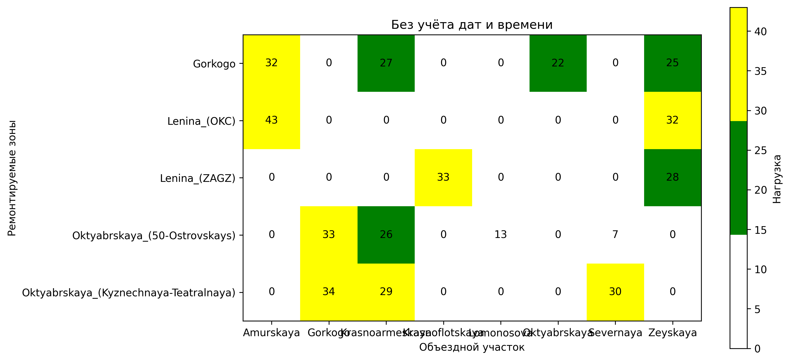

Ситуация на дороге после перекрытия дорог с учетом дней недели

