Текущая ситуация на дороге дорог без учета временных промежутков и дней недели

|  |  |  |  |  |  |  |  |  |  |
| --- | --- | --- | --- | --- | --- | --- | --- | --- | --- |
| Участки дорог | Amurskaya | Gorkogo | Krasnoarmeskaya | Krasnoflotskaya | Lomonosova | Oktyabrskaya | Severnaya | Zeyskaya | bad |
| Gorkogo | 20 | 0 | 19 | 0 | 0 | 20 | 0 | 23 | 23 |
| Lenina_(OKC) | 22 | 0 | 0 | 0 | 0 | 0 | 0 | 23 | 29 |
| Lenina_(ZAGZ) | 0 | 0 | 0 | 14 | 0 | 0 | 0 | 20 | 26 |
| Oktyabrskaya_(50-Ostrovskays) | 0 | 23 | 19 | 0 | 8 | 0 | 4 | 0 | 24 |
| Oktyabrskaya_(Kyznechnaya-Teatralnaya) | 0 | 22 | 21 | 0 | 0 | 0 | 25 | 0 | 24 |

Ситуация на дороге после перекрытия дорог без учета временных промежутков и дней недели

|  |  |  |  |  |  |  |  |  |
| --- | --- | --- | --- | --- | --- | --- | --- | --- |
| Объездные участки | Amurskaya | Gorkogo | Krasnoarmeskaya | Krasnoflotskaya | Lomonosova | Oktyabrskaya | Severnaya | Zeyskaya |
| Gorkogo | 29 | 0 | 25 | 0 | 0 | 27 | 0 | 24 |
| Lenina_(OKC) | 43 | 0 | 0 | 0 | 0 | 0 | 0 | 32 |
| Lenina_(ZAGZ) | 0 | 0 | 0 | 33 | 0 | 0 | 0 | 28 |
| Oktyabrskaya_(50-Ostrovskays) | 0 | 33 | 26 | 0 | 13 | 0 | 7 | 0 |
| Oktyabrskaya_(Kyznechnaya-Teatralnaya) | 0 | 34 | 29 | 0 | 0 | 0 | 30 | 0 |

Текущая ситуация на дороге c учетом дней недели

|  |  |  |  |  |  |  |  |
| --- | --- | --- | --- | --- | --- | --- | --- |
| Дни недели | ПН | ВТ | СР | ЧТ | ПТ | СБ | ВС |
| ('Gorkogo', 'Amurskaya') | 19 | 21 | 20 | 20 | 18 | 24 | 20 |
| ('Gorkogo', 'Krasnoarmeskaya') | 18 | 19 | 20 | 20 | 20 | 19 | 16 |
| ('Gorkogo', 'Oktyabrskaya') | 22 | 20 | 20 | 18 | 19 | 22 | 20 |
| ('Gorkogo', 'Zeyskaya') | 24 | 24 | 21 | 22 | 22 | 23 | 24 |
| ('Gorkogo', 'bad') | 24 | 22 | 22 | 21 | 23 | 24 | 24 |
| ('Lenina_(OKC)', 'Amurskaya') | 22 | 22 | 22 | 21 | 20 | 25 | 24 |
| ('Lenina_(OKC)', 'Zeyskaya') | 24 | 24 | 23 | 21 | 23 | 23 | 22 |
| ('Lenina_(OKC)', 'bad') | 31 | 31 | 28 | 27 | 29 | 27 | 26 |
| ('Lenina_(ZAGZ)', 'Krasnoflotskaya') | 15 | 10 | 13 | 12 | 17 | 18 | 14 |
| ('Lenina_(ZAGZ)', 'Zeyskaya') | 20 | 21 | 17 | 19 | 21 | 21 | 20 |
| ('Lenina_(ZAGZ)', 'bad') | 26 | 23 | 30 | 25 | 32 | 25 | 21 |
| ('Oktyabrskaya_(50-Ostrovskays)', 'Gorkogo') | 22 | 22 | 28 | 21 | 24 | 21 | 25 |
| ('Oktyabrskaya_(50-Ostrovskays)', 'Krasnoarmeskaya') | 21 | 17 | 17 | 19 | 21 | 19 | 18 |
| ('Oktyabrskaya_(50-Ostrovskays)', 'Lomonosova') | 12 | 7 | 8 | 7 | 8 | 7 | 9 |
| ('Oktyabrskaya_(50-Ostrovskays)', 'Severnaya') | 5 | 4 | 4 | 4 | 4 | 4 | 4 |
| ('Oktyabrskaya_(50-Ostrovskays)', 'bad') | 26 | 25 | 25 | 22 | 26 | 25 | 22 |
| ('Oktyabrskaya_(Kyznechnaya-Teatralnaya)', 'Gorkogo') | 22 | 23 | 22 | 24 | 21 | 20 | 21 |
| ('Oktyabrskaya_(Kyznechnaya-Teatralnaya)', 'Krasnoarmeskaya') | 21 | 23 | 21 | 20 | 22 | 18 | 22 |
| ('Oktyabrskaya_(Kyznechnaya-Teatralnaya)', 'Severnaya') | 25 | 26 | 25 | 24 | 24 | 24 | 25 |
| ('Oktyabrskaya_(Kyznechnaya-Teatralnaya)', 'bad') | 28 | 27 | 24 | 21 | 21 | 26 | 24 |

Текущая ситуация на дороге c учетом дней недели

|  |  |  |  |  |  |  |  |
| --- | --- | --- | --- | --- | --- | --- | --- |
| Дни недели | ПН | ВТ | СР | ЧТ | ПТ | СБ | ВС |
| ('Gorkogo', 'Amurskaya') | 20 | 22 | 29 | 23 | 20 | 26 | 21 |
| ('Gorkogo', 'Krasnoarmeskaya') | 23 | 19 | 27 | 23 | 29 | 34 | 23 |
| ('Gorkogo', 'Oktyabrskaya') | 25 | 21 | 23 | 22 | 25 | 27 | 32 |
| ('Gorkogo', 'Zeyskaya') | 31 | 32 | 26 | 27 | 33 | 31 | 27 |
| ('Lenina_(OKC)', 'Amurskaya') | 41 | 28 | 46 | 38 | 40 | 30 | 38 |
| ('Lenina_(OKC)', 'Zeyskaya') | 43 | 53 | 33 | 40 | 45 | 51 | 25 |
| ('Lenina_(ZAGZ)', 'Krasnoflotskaya') | 38 | 21 | 22 | 27 | 19 | 30 | 23 |
| ('Lenina_(ZAGZ)', 'Zeyskaya') | 40 | 24 | 46 | 29 | 30 | 26 | 39 |
| ('Oktyabrskaya_(50-Ostrovskays)', 'Gorkogo') | 24 | 23 | 38 | 31 | 29 | 25 | 27 |
| ('Oktyabrskaya_(50-Ostrovskays)', 'Krasnoarmeskaya') | 29 | 20 | 21 | 27 | 21 | 29 | 24 |
| ('Oktyabrskaya_(50-Ostrovskays)', 'Lomonosova') | 17 | 19 | 11 | 21 | 15 | 15 | 14 |
| ('Oktyabrskaya_(50-Ostrovskays)', 'Severnaya') | 11 | 8 | 6 | 10 | 7 | 11 | 15 |
| ('Oktyabrskaya_(Kyznechnaya-Teatralnaya)', 'Gorkogo') | 30 | 30 | 29 | 28 | 28 | 30 | 26 |
| ('Oktyabrskaya_(Kyznechnaya-Teatralnaya)', 'Krasnoarmeskaya') | 28 | 36 | 36 | 30 | 35 | 21 | 34 |
| ('Oktyabrskaya_(Kyznechnaya-Teatralnaya)', 'Severnaya') | 32 | 36 | 32 | 31 | 36 | 41 | 27 |

Ситуация на дороге до перекрытия дорог c учета временных промежутков

|  |  |  |  |  |  |  |  |  |  |  |  |  |  |  |  |  |  |
| --- | --- | --- | --- | --- | --- | --- | --- | --- | --- | --- | --- | --- | --- | --- | --- | --- | --- |
| Время | 06:00 | 07:00 | 08:00 | 09:00 | 10:00 | 11:00 | 12:00 | 13:00 | 14:00 | 15:00 | 16:00 | 17:00 | 18:00 | 19:00 | 20:00 | 21:00 | 22:00 |
| ('Gorkogo', 'Amurskaya') | 4 | 3 | 10 | 18 | 21 | 22 | 24 | 22 | 23 | 24 | 24 | 25 | 25 | 25 | 25 | 24 | 24 |
| ('Gorkogo', 'Krasnoarmeskaya') | 7 | 7 | 13 | 16 | 21 | 22 | 21 | 20 | 23 | 23 | 22 | 19 | 23 | 22 | 20 | 18 | 17 |
| ('Gorkogo', 'Oktyabrskaya') | 3 | 5 | 12 | 19 | 24 | 24 | 24 | 24 | 22 | 23 | 22 | 23 | 24 | 24 | 25 | 25 | 23 |
| ('Gorkogo', 'Zeyskaya') | 9 | 10 | 20 | 22 | 25 | 25 | 23 | 25 | 27 | 26 | 27 | 26 | 23 | 26 | 27 | 26 | 26 |
| ('Gorkogo', 'bad') | 8 | 5 | 17 | 25 | 25 | 25 | 25 | 26 | 25 | 27 | 26 | 26 | 26 | 26 | 26 | 26 | 24 |
| ('Lenina_(OKC)', 'Amurskaya') | 7 | 10 | 15 | 19 | 25 | 25 | 25 | 26 | 25 | 26 | 25 | 25 | 25 | 26 | 26 | 28 | 23 |
| ('Lenina_(OKC)', 'Zeyskaya') | 11 | 13 | 18 | 23 | 24 | 25 | 25 | 25 | 26 | 27 | 25 | 24 | 25 | 27 | 25 | 22 | 25 |
| ('Lenina_(OKC)', 'bad') | 5 | 9 | 31 | 30 | 32 | 31 | 29 | 34 | 35 | 33 | 28 | 35 | 36 | 31 | 30 | 28 | 27 |
| ('Lenina_(ZAGZ)', 'Krasnoflotskaya') | 0 | 3 | 10 | 17 | 14 | 12 | 19 | 20 | 17 | 16 | 14 | 11 | 17 | 19 | 17 | 18 | 19 |
| ('Lenina_(ZAGZ)', 'Zeyskaya') | 4 | 9 | 14 | 20 | 23 | 24 | 23 | 24 | 25 | 22 | 23 | 22 | 23 | 23 | 21 | 21 | 20 |
| ('Lenina_(ZAGZ)', 'bad') | 3 | 7 | 18 | 28 | 34 | 26 | 34 | 28 | 28 | 25 | 28 | 32 | 33 | 33 | 28 | 25 | 28 |
| ('Oktyabrskaya_(50-Ostrovskays)', 'Gorkogo') | 12 | 15 | 21 | 23 | 25 | 26 | 25 | 23 | 23 | 28 | 26 | 25 | 25 | 25 | 25 | 21 | 25 |
| ('Oktyabrskaya_(50-Ostrovskays)', 'Krasnoarmeskaya') | 1 | 7 | 18 | 20 | 18 | 18 | 25 | 25 | 25 | 23 | 23 | 21 | 25 | 25 | 17 | 15 | 14 |
| ('Oktyabrskaya_(50-Ostrovskays)', 'Lomonosova') | 0 | 3 | 3 | 3 | 0 | 25 | 25 | 25 | 4 | 0 | 1 | 1 | 25 | 25 | 1 | 0 | 1 |
| ('Oktyabrskaya_(50-Ostrovskays)', 'Severnaya') | 0 | 0 | 0 | 0 | 0 | 0 | 25 | 25 | 0 | 0 | 0 | 0 | 0 | 25 | 0 | 0 | 0 |
| ('Oktyabrskaya_(50-Ostrovskays)', 'bad') | 8 | 9 | 25 | 25 | 25 | 25 | 26 | 31 | 31 | 28 | 26 | 25 | 32 | 28 | 25 | 25 | 25 |
| ('Oktyabrskaya_(Kyznechnaya-Teatralnaya)', 'Gorkogo') | 6 | 7 | 14 | 20 | 25 | 26 | 25 | 26 | 26 | 26 | 22 | 26 | 26 | 25 | 27 | 23 | 21 |
| ('Oktyabrskaya_(Kyznechnaya-Teatralnaya)', 'Krasnoarmeskaya') | 10 | 13 | 20 | 21 | 23 | 23 | 23 | 23 | 24 | 22 | 22 | 24 | 23 | 24 | 23 | 22 | 22 |
| ('Oktyabrskaya_(Kyznechnaya-Teatralnaya)', 'Severnaya') | 12 | 11 | 20 | 23 | 26 | 29 | 25 | 25 | 32 | 29 | 29 | 27 | 30 | 25 | 27 | 25 | 25 |
| ('Oktyabrskaya_(Kyznechnaya-Teatralnaya)', 'bad') | 10 | 9 | 15 | 20 | 26 | 25 | 31 | 28 | 29 | 32 | 30 | 28 | 33 | 26 | 25 | 25 | 25 |

Ситуация на дороге после перекрытия дорог c учета временных промежутков

|  |  |  |  |  |  |  |  |  |  |  |  |  |  |  |  |  |  |
| --- | --- | --- | --- | --- | --- | --- | --- | --- | --- | --- | --- | --- | --- | --- | --- | --- | --- |
| Время | 06:00 | 07:00 | 08:00 | 09:00 | 10:00 | 11:00 | 12:00 | 13:00 | 14:00 | 15:00 | 16:00 | 17:00 | 18:00 | 19:00 | 20:00 | 21:00 | 22:00 |
| ('Gorkogo', 'Amurskaya') | 5 | 4 | 11 | 24 | 29 | 36 | 31 | 29 | 35 | 31 | 37 | 36 | 32 | 36 | 28 | 25 | 36 |
| ('Gorkogo', 'Krasnoarmeskaya') | 8 | 9 | 14 | 28 | 25 | 23 | 30 | 26 | 25 | 39 | 24 | 23 | 34 | 25 | 21 | 30 | 20 |
| ('Gorkogo', 'Oktyabrskaya') | 4 | 6 | 13 | 37 | 27 | 24 | 35 | 34 | 28 | 33 | 28 | 25 | 32 | 28 | 40 | 27 | 33 |
| ('Gorkogo', 'Zeyskaya') | 10 | 11 | 26 | 23 | 34 | 27 | 25 | 32 | 33 | 31 | 29 | 26 | 26 | 33 | 27 | 32 | 34 |
| ('Lenina_(OKC)', 'Amurskaya') | 10 | 17 | 21 | 36 | 45 | 40 | 29 | 56 | 53 | 49 | 41 | 44 | 51 | 45 | 29 | 41 | 37 |
| ('Lenina_(OKC)', 'Zeyskaya') | 14 | 17 | 44 | 40 | 45 | 33 | 40 | 30 | 34 | 42 | 37 | 34 | 52 | 55 | 30 | 39 | 38 |
| ('Lenina_(ZAGZ)', 'Krasnoflotskaya') | 0 | 6 | 16 | 26 | 30 | 16 | 29 | 33 | 22 | 31 | 19 | 42 | 46 | 32 | 37 | 33 | 45 |
| ('Lenina_(ZAGZ)', 'Zeyskaya') | 8 | 13 | 22 | 34 | 37 | 47 | 51 | 28 | 51 | 44 | 31 | 53 | 37 | 50 | 32 | 38 | 36 |
| ('Oktyabrskaya_(50-Ostrovskays)', 'Gorkogo') | 14 | 19 | 27 | 25 | 34 | 38 | 32 | 26 | 25 | 45 | 32 | 30 | 26 | 40 | 28 | 25 | 30 |
| ('Oktyabrskaya_(50-Ostrovskays)', 'Krasnoarmeskaya') | 5 | 8 | 20 | 27 | 32 | 29 | 29 | 40 | 25 | 25 | 24 | 27 | 39 | 31 | 19 | 24 | 19 |
| ('Oktyabrskaya_(50-Ostrovskays)', 'Lomonosova') | 0 | 5 | 23 | 9 | 0 | 26 | 27 | 36 | 13 | 0 | 4 | 2 | 28 | 35 | 10 | 0 | 7 |
| ('Oktyabrskaya_(50-Ostrovskays)', 'Severnaya') | 0 | 0 | 0 | 0 | 0 | 0 | 38 | 29 | 0 | 0 | 0 | 0 | 0 | 25 | 0 | 0 | 0 |
| ('Oktyabrskaya_(Kyznechnaya-Teatralnaya)', 'Gorkogo') | 10 | 10 | 19 | 27 | 27 | 32 | 32 | 30 | 51 | 31 | 38 | 29 | 39 | 42 | 29 | 23 | 25 |
| ('Oktyabrskaya_(Kyznechnaya-Teatralnaya)', 'Krasnoarmeskaya') | 16 | 15 | 21 | 29 | 33 | 25 | 33 | 33 | 29 | 33 | 28 | 31 | 28 | 25 | 24 | 32 | 30 |
| ('Oktyabrskaya_(Kyznechnaya-Teatralnaya)', 'Severnaya') | 13 | 12 | 26 | 30 | 33 | 31 | 26 | 44 | 53 | 42 | 34 | 41 | 32 | 30 | 33 | 25 | 33 |

Ситуация на дороге после перекрытия без учёта временных промежутков и дней недели

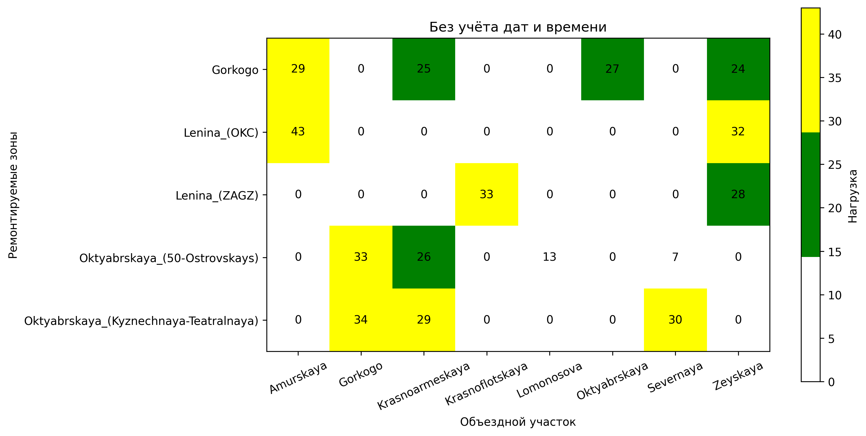

Ситуация на дороге после перекрытия дорог с учетом дней недели

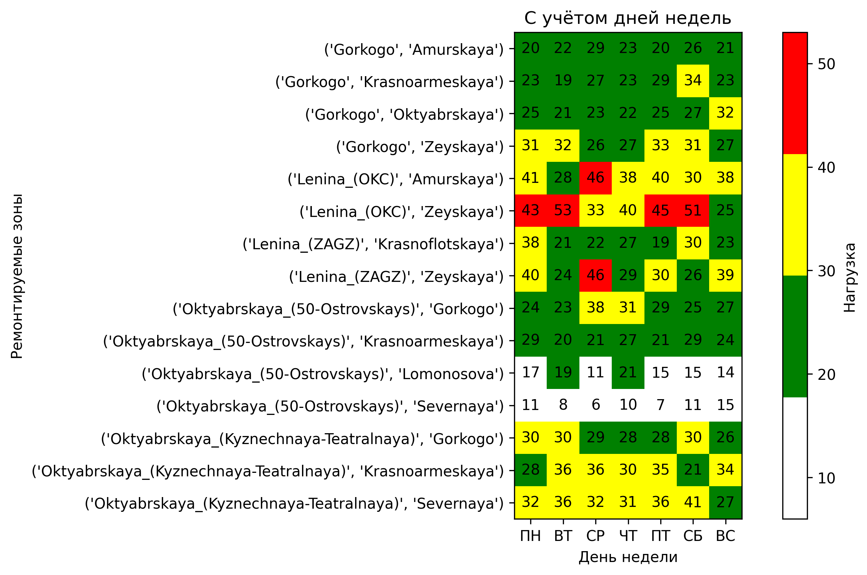

Ситуация на дороге после перекрытия дорог с учетом времени

