# 

# **Husky UR3 Mobile Manipulation Demo (Simulation)**

The Husky UR3 mobile manipulation tutorial will show you how to operate a mobile manipulation robot using Gazebo, RViz, MoveIt, and the UR3 arm. There will be full control and actuation of the robot, and the software written for this robot can be translated into real world actions with the real Husky UR3 robot.

1. Installation

This tutorial assumes you have ROS, Gazebo, and RViz installed on your system.

First, create a catkin workspace

$mkdir -p catkin_ws/src

$cd catkin_ws/src

And put the whole packages into the src directory

$cd ..

$catkin_make

$source devel/setup.bash

$echo “source ~/catkin_ws/devel/setup.bash” >> .bashrc

1. Bring up Gazebo and the Husky

In order to launch the robot, launch the following file

$roslaunch husky_ur3_gazebo husky_ur3.launch

Running the launch file which will bring up Gazebo with the Husky + UR3. which will look like this:

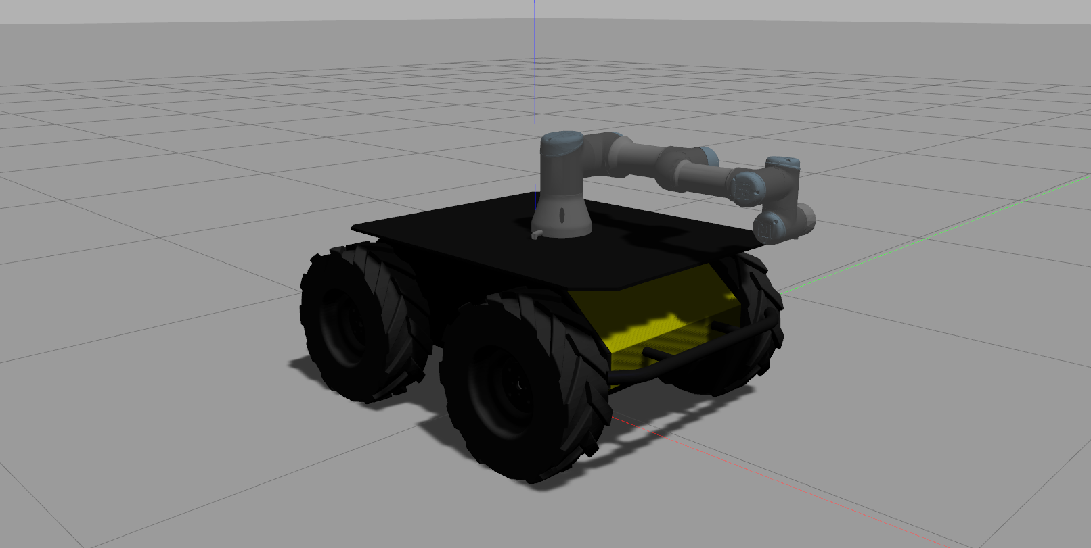

* Driving the husky base using keyboard:

$rosrun teleop_twist_keyboard teleop_twist_keyboard.py

1. Bring Up MoveIt & RViz

To do so:

$ roslaunch husky_ur3_moveit_config demo.launch

Which will bring up a screen that has the Husky like this:

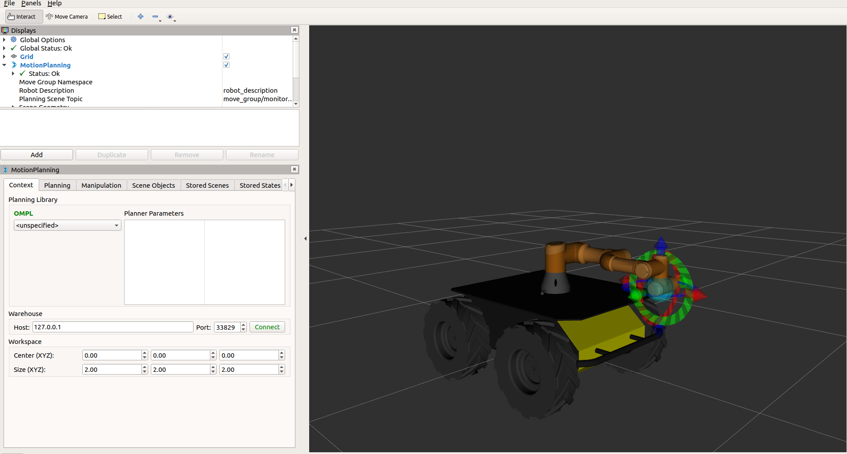

Now click and drag the end effector in RViz which will highlight when your mouse is over it:

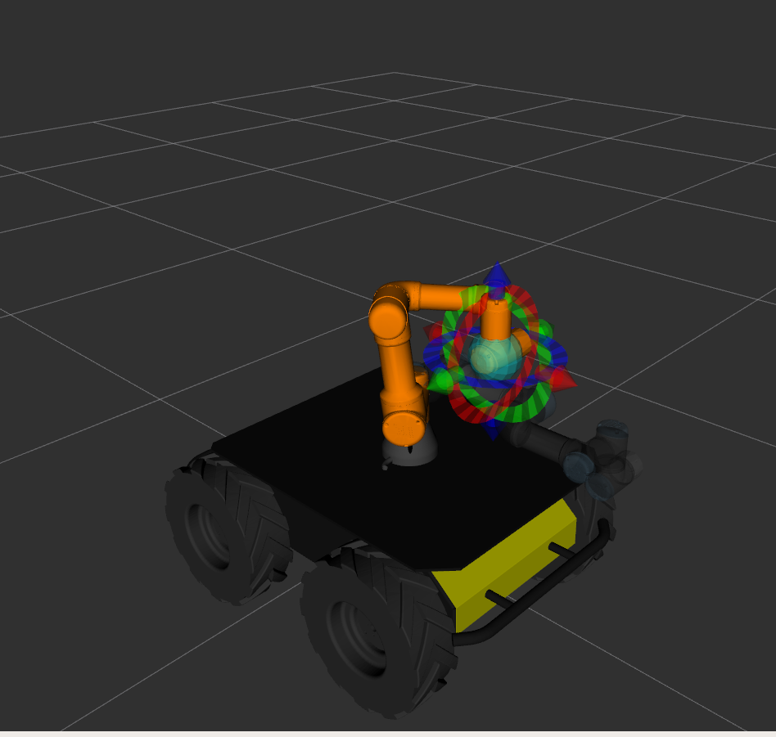

The orange arm is the goal position for the arm.

1. Moving The Husky's arm using MoveIt

After playing with the Husky's movement capabilities, now we can look at how to move its arm. On the left hand side of RViz, you will see a panel that looks like this. Make sure "Planning" is selected.

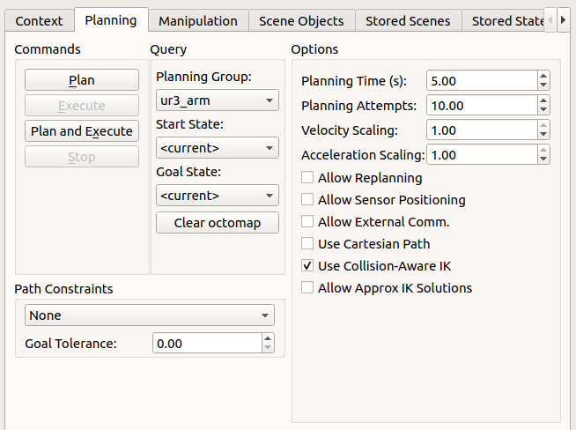

Now, in the planning tab, press plan and execute. This will plan a path for the arm to take to move it to the orange goal state. Execute will interact with the controllers on the robot to move it to that position.