Project Activity 1 – Goal and Requirements

The main goal of this assignment is to present your project goal, requirements and team members roles and tasks in class. The team must prepare the power slides (no more than 10) and conduct the presentation within 10-15 minutes. The grade of assessment is to be taken directly to LMS.

## Team Name: 404

**Project Goal**: What is the business value of your project and objectives your team needed to achieve?

Our project, a Network Device Monitoring and Recovery Simulator, provides a cost-effective and risk-free solution for IT teams and network administrators to simulate real-world network monitoring and recovery scenarios. Since it does not require physical or virtual network devices, it allows organizations to train personnel, test configurations, and improve incident response strategies without impacting live networks:

Cost-Effective Training – Reduces the need for expensive hardware and virtual environments.  
Risk-Free Testing – Allows users to test and validate network configurations without affecting real systems.  
Improved Incident Response – Helps IT teams practice recovery from network failures.  
Scalability – The system can be extended to include more complex scenarios, AI-driven analytics, and integration with other tools.

* Develop a web-based MVP for simulating network monitoring and recovery.
* Create a REST API to manage and analyze virtual network configurations.
* Implement a comparison feature to detect deviations from baseline configurations.
* Enable rollback functionality for configuration recovery.
* Integrate Jenkins for automated testing of recovery scenarios.
* Ensure an intuitive UI for users to interact with simulated network devices.

## Project user stories

Please collect the project requirements in the form of the user stories

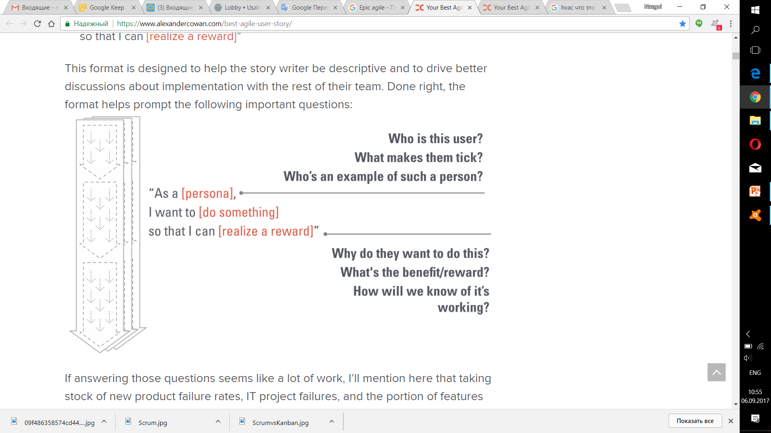

|  |  |
| --- | --- |
| **User Story** | **Description** |
| **As an administrator,**  **I want to view the current configurations of network devices**  so that I can analyze their status. | The web interface displays JSON configurations of virtual network devices. |
| **As an administrator,**  **I want to compare current configurations with reference ones**  so that I can identify deviations. | The built-in analyzer detects differences between current and reference parameters. |
| **As an administrator,**  **I want to restore a configuration to a previous state**  so that I can fix errors. | The system allows rolling back the configuration to a previously saved state. |
| **As a developer,**  **I want to automate the testing of configuration recovery**  so that I can ensure system correctness. | Jenkins is used for automated testing of failure and recovery scenarios. |

Record your team member roles and their goals

|  |  |
| --- | --- |
| **Team member** | **Role and assigned tasks** |
| Abdirakhman Abdizhami | Backend Developer: Develop REST API using Python (Flask/Django), manage configurations in JSON or DB. |
| Zholdasbekkyzy Akmaral | Frontend Developer: Create a web interface using HTML, CSS, JavaScript. |
| Ermek Ali | QA Engineer: Develop tests and log configuration changes. |
| Kurbanov Kairat | DevOps Engineer: Set up Jenkins for automated testing and failure simulation. |

## Proof of concept

Provide a brief description of each team’s member approach to test the assigned tasks success (test driven approach).

**Backend Developer:**

1. Uses Postman to manually test API endpoints.
2. Ensures REST API correctly handles requests for retrieving, updating, and restoring configurations.
3. Implements unit tests with Pytest or Unittest to validate API behavior.
4. Monitors API logs for debugging and error handling.

**Frontend Developer:**

1. Tests UI responsiveness and layout in multiple browsers.
2. Verifies correct data retrieval and visualization from the backend.
3. Uses browser developer tools to debug network requests and frontend logic.
4. Conducts user experience (UX) testing to ensure an intuitive interface.

**DevOps Engineer:**

1. Configures Jenkins pipelines to automate build, test, and deployment processes.
2. Tests CI/CD workflows to ensure smooth integration and delivery.
3. Simulates network failures to assess system recovery efficiency.
4. Implements Docker or virtual environments for consistent testing conditions.

**QA Engineer:**

1. Develops and executes test cases for both frontend and backend components.
2. Performs regression testing to ensure new updates do not break existing functionality.
3. Logs test results and tracks defects using issue management tools (e.g., Jira, GitHub Issues).
4. Conducts stress and load testing to measure system performance under different conditions.

## Using GitHub for Collaboration

What is the link to your GitHub repository?

<https://github.com/MrLaheine/Network-Device-Monitoring-and-Recovery-Simulator.git>

Describe how GitHub was used to:

1. Describe/Create the master branch

It contains only working and tested code.This is the final version of the project that can be deployed.

1. Describe/Create your branch

* backend branch: It employs a Backend Developer.The REST API (Flask/Django) and configuration processing logic are being developed here.
* fronted branch: It employs a Frontend Developer.It creates a web interface (HTML, CSS, JavaScript) for user interaction.It includes working with data visualization and sending requests to the backend.
* devops branch: It employs a DevOps Engineer.It contains scripts for automatic deployment, CI/CD, and Jenkins configurations.Pipelines are tested here and system failures are emulated.
* qa-testing branch: It employs a QA Engineer.It includes automatic test files (Selenium, Py test, etc.).It is used for logging and checking bug fixes.

## Final Deliverables

### Presentation in class

Create a presentation about the project you selected. Your presentation should include:

* Information about your application (objectives, business value, requirements and etc), covering what features your team included
* The reasons that your team decided on these specific features in your application
* The link to GitHub repository, including required comments and documentation. Your comments and documentation should be sufficient for any other team to be able to continue the project if required. Another team should be able to understand the application, your features and how to continue with the project
* List of future enhancements (backlog) if necessary
* Reflection points – what issues have you faced while working on this activity, how did you find solutions, what have you learned, etc.