## 算法训练营

****整体学习安排****

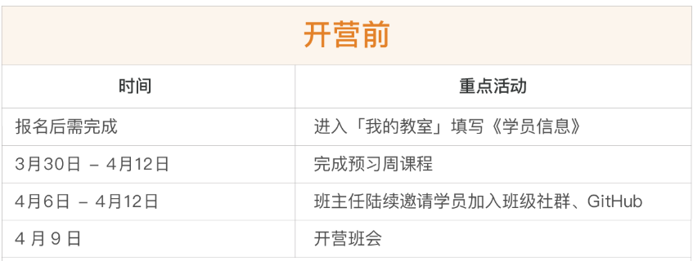

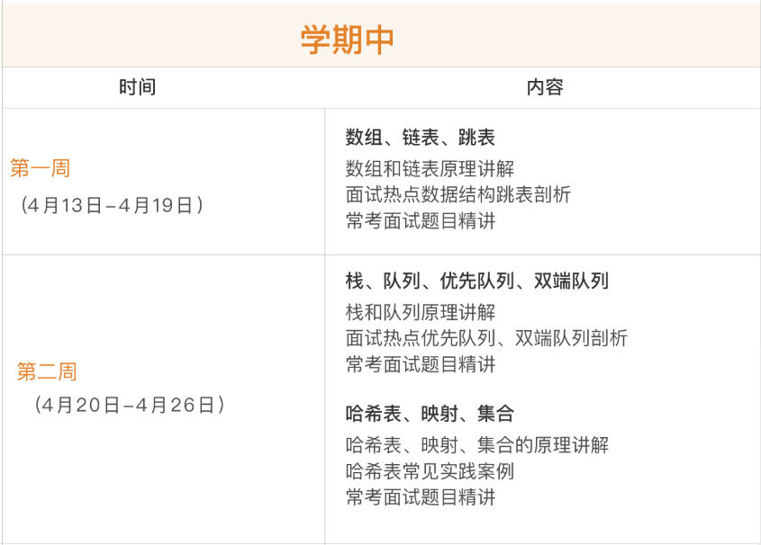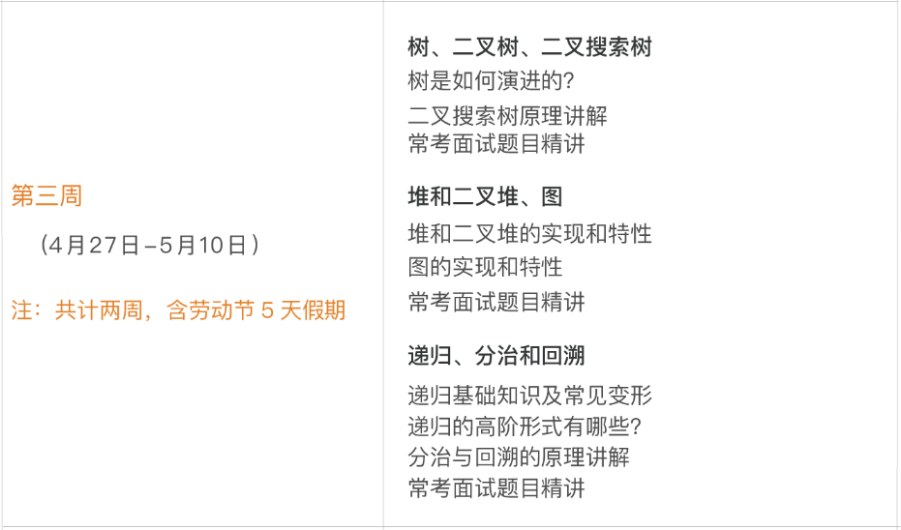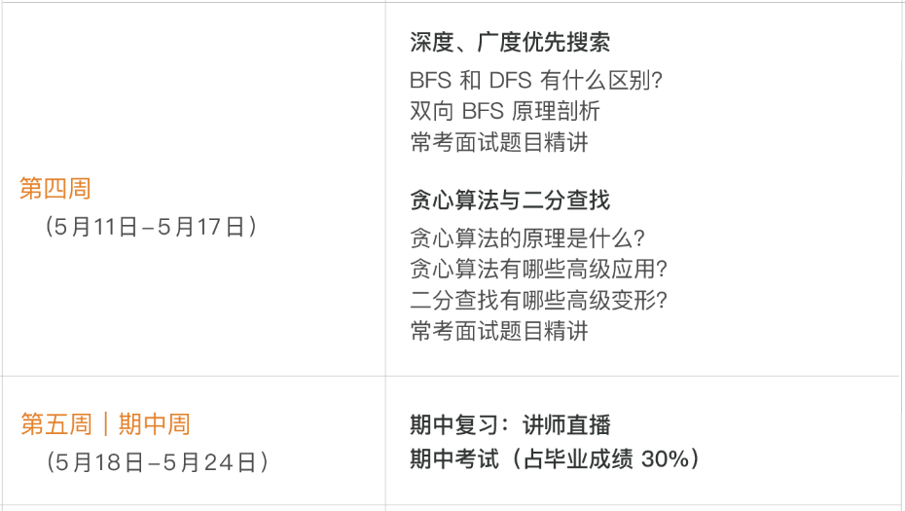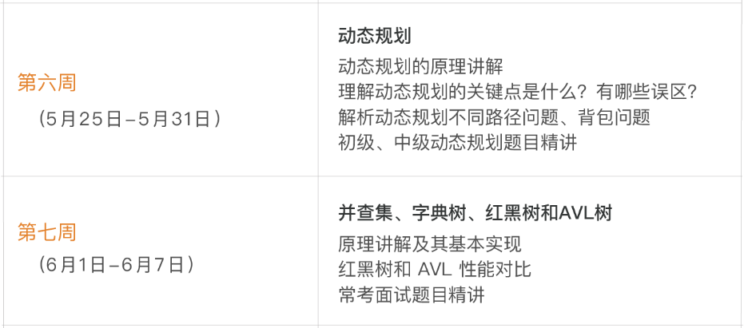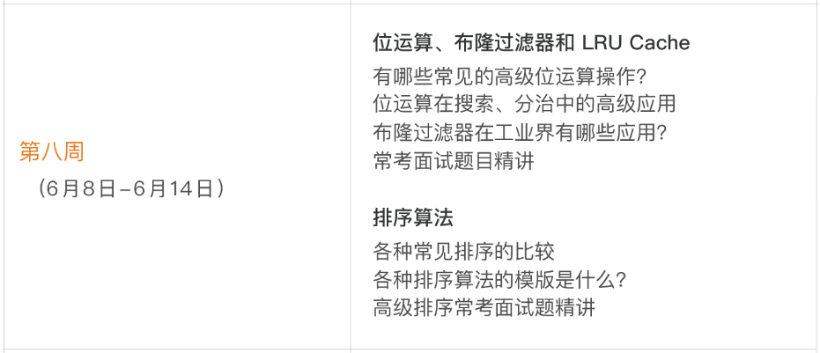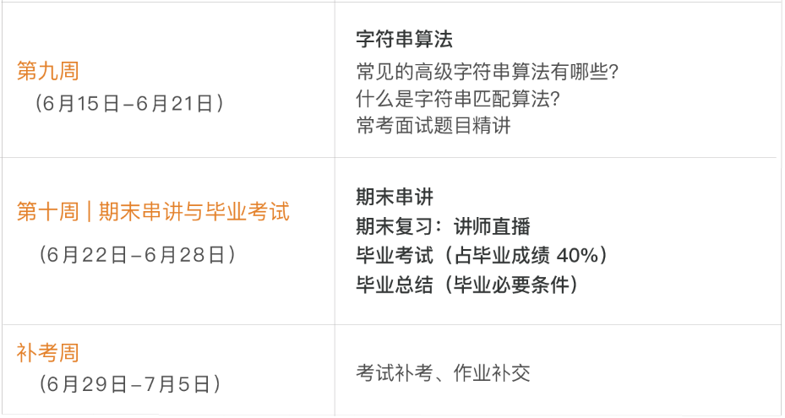

****每周作业****  
从覃超老师布置的题目中，至少完成并提交 2 道  
每周完成一篇学习总结  
每周需要 review 并点评至少 5 位同学的代码作业或学习总结

****作业积分说明****  
日常作业，满分 100 分  
每周没有按时（周日 23:59 前）提交作业，-2 分  
截至毕业，每缺一周学习总结，-4 分  
截至毕业，每缺一周代码作业，-6 分

你的日常作业总分，将占据毕业总成绩的 30%，大家一定要坚持提交作业，不仅是为了毕业，更是为了让自己获得提升（完成作业只是提升过程中的一个可以量化的动作）。

****如何提交作业？****

作业提交平台：****GitHub****

1. 将 GitHub 班级组织的代码仓库 Fork 到自己 GitHub 账号下。  
2. 将 Fork 后的仓库 Clone 到本地。  
3. 在本地仓库内，找到应提交作业的周目录，如：需要提交 week01 的作业，则找到 week01 目录。  
4. 代码 / 项目作业：在应提交作业的周目录内，新建或修改自己的代码 / 项目作业。  
5. 学习总结作业：写在应提交作业的周目录内，NOTE.md 文件中。  
6. 在本地仓库完成以上两项作业后，Push 到自己的 GitHub 远程仓库。

❗️最后，你需要将自己账号下「远程仓库」应提交作业的周目录链接，按格式贴到「班级仓库」当周作业提交 Issue 内。  
❗️提交 issue 请务必按照规定格式进行提交，否则作业统计工具将抓取不到你的作业提交记录。

[请点击查看详细 GitHub 作业提交指南](https://shimo.im/docs/JkyUZeq3Q44rX2p5/" \t "https://u.geekbang.org/lesson/_blank)

****毕业条件（以下三个都需要满足）：****  
1、毕业成绩达到 60 分（毕业成绩构成如下）  
2、完成并提交毕业总结  
3、完成课程中 80% 的视频观看



毕业后将获得极客大学颁发的电子版本毕业证。

如何高效学习算法训练营课程

预习 第一课|数据结构与算法总览

数据结构与算法总览

## 参考链接

* [算法训练营第 4 期学员谭帅的作业](https://pan.baidu.com/s/1rucC3q-9zD-lzs3yBkFU_g" \t "https://u.geekbang.org/lesson/_blank)（提取码：ykyn）

## 课后作业

****绘制自己的数据结构和算法脑图****  
用脑图的方式把知识的脉络串联起来，不管对于学习新知识还是巩固已有知识，都是一种很好的学习方式。同学们可以将目前自己所掌握的数据结构和算法知识绘制成脑图，在绘制过程中可以查阅资料，补充目前掌握欠缺的部分，找到自己薄弱的地方。后面再通过课程的学习和刻意练习，动态地将自己绘制的脑图逐步补充、完善，从而达到真正的融会贯通。

脑图绘制工具不限，同学们需要按时将作业提交到班级 GitHub 中。

预习 第2课| 训练准备和复杂度分析

1. 训练环境设置、编码技巧和Code Style

<https://u.geekbang.org/lesson/13?article=205007&utm_source=infoq_web&utm_medium=GEOBanner&utm_term=GEOBanner>

## 参考链接：

* [Windows Microsoft New Terminal](http://github.com/microsoft/terminal" \t "https://u.geekbang.org/lesson/_blank)
* [VS Code Themes](http://vscodethemes.com/" \t "https://u.geekbang.org/lesson/_blank)
* [教你打造一款颜值逆天的 VS Code](http://toutiao.io/posts/7w5ixl/preview" \t "https://u.geekbang.org/lesson/_blank)
* [炫酷的 VS Code 毛玻璃效果](http://juejin.im/post/5ce1365151882525ff28ed47" \t "https://u.geekbang.org/lesson/_blank)
* [自顶向下的编程方式](http://markhneedham.com/blog/2008/09/15/clean-code-book-review/" \t "https://u.geekbang.org/lesson/_blank)
* [自顶向下编程的 LeetCode 例题](http://leetcode-cn.com/problems/valid-palindrome/" \t "https://u.geekbang.org/lesson/_blank)

2. 时间复杂度和空间复杂度分析

<https://u.geekbang.org/lesson/13?article=205008&utm_source=infoq_web&utm_medium=GEOBanner&utm_term=GEOBanner>

## 参考链接

* [如何理解算法时间复杂度的表示法](http://www.zhihu.com/question/21387264" \t "https://u.geekbang.org/lesson/_blank)
* [Master theorem](http://en.wikipedia.org/wiki/Master_theorem_(analysis_of_algorithms)" \t "https://u.geekbang.org/lesson/_blank)
* [主定理](http://zh.wikipedia.org/wiki/%E4%B8%BB%E5%AE%9A%E7%90%86" \t "https://u.geekbang.org/lesson/_blank)

下周预习

<https://u.geekbang.org/lesson/13?article=206966&utm_source=infoq_web&utm_medium=GEOBanner&utm_term=GEOBanner>

## 预习题目

* [移动零](http://leetcode-cn.com/problems/move-zeroes/" \t "https://u.geekbang.org/lesson/_blank)
* [盛最多水的容器](http://leetcode-cn.com/problems/container-with-most-water/" \t "https://u.geekbang.org/lesson/_blank)
* [爬楼梯](http://leetcode-cn.com/problems/climbing-stairs/" \t "https://u.geekbang.org/lesson/_blank)
* [三数之和](http://leetcode-cn.com/problems/3sum/" \t "https://u.geekbang.org/lesson/_blank)
* [环形链表](http://leetcode-cn.com/problems/linked-list-cycle/" \t "https://u.geekbang.org/lesson/_blank)

第一周 第3课| 数组、链表、跳表

1. 数组、链表、跳表的基本实现和特性

<https://u.geekbang.org/lesson/13?article=206969&utm_source=infoq_web&utm_medium=GEOBanner&utm_term=GEOBanner>

## 参考链接

* [Java 源码分析（ArrayList）](http://developer.classpath.org/doc/java/util/ArrayList-source.html" \t "https://u.geekbang.org/lesson/_blank)
* [Linked List 的标准实现代码](http://www.geeksforgeeks.org/implementing-a-linked-list-in-java-using-class/" \t "https://u.geekbang.org/lesson/_blank)
* [Linked List 示例代码](http://www.cs.cmu.edu/~adamchik/15-121/lectures/Linked Lists/code/LinkedList.java" \t "https://u.geekbang.org/lesson/_blank)
* [Java 源码分析（LinkedList）](http://developer.classpath.org/doc/java/util/LinkedList-source.html" \t "https://u.geekbang.org/lesson/_blank)
* LRU Cache - Linked list：[LRU 缓存机制](http://leetcode-cn.com/problems/lru-cache" \t "https://u.geekbang.org/lesson/_blank)
* Redis - Skip List：[跳跃表](http://redisbook.readthedocs.io/en/latest/internal-datastruct/skiplist.html" \t "https://u.geekbang.org/lesson/_blank)、[为啥 Redis 使用跳表（Skip List）而不是使用 Red-Black？](http://www.zhihu.com/question/20202931" \t "https://u.geekbang.org/lesson/_blank)

2. 实战题目解析：移动零

<https://u.geekbang.org/lesson/13?article=206970&utm_source=infoq_web&utm_medium=GEOBanner&utm_term=GEOBanner>

## Array 实战题目

* [https://leetcode-cn.com/problems/container-with-most-water/](https://leetcode-cn.com/problems/container-with-most-water/" \t "https://u.geekbang.org/lesson/_blank)
* [https://leetcode-cn.com/problems/move-zeroes/](https://leetcode-cn.com/problems/move-zeroes/" \t "https://u.geekbang.org/lesson/_blank)
* [https://leetcode.com/problems/climbing-stairs/](https://leetcode.com/problems/climbing-stairs/" \t "https://u.geekbang.org/lesson/_blank)
* [https://leetcode-cn.com/problems/3sum/](https://leetcode-cn.com/problems/3sum/" \t "https://u.geekbang.org/lesson/_blank)(高频老题）

3. 实战题目解析：盛水最多的容器、爬楼梯

<https://u.geekbang.org/lesson/13?article=206972&utm_source=infoq_web&utm_medium=GEOBanner&utm_term=GEOBanner>

## Array 实战题目

* [https://leetcode-cn.com/problems/container-with-most-water/](https://leetcode-cn.com/problems/container-with-most-water/" \t "https://u.geekbang.org/lesson/_blank)
* [https://leetcode-cn.com/problems/move-zeroes/](https://leetcode-cn.com/problems/move-zeroes/" \t "https://u.geekbang.org/lesson/_blank)
* [https://leetcode.com/problems/climbing-stairs/](https://leetcode.com/problems/climbing-stairs/" \t "https://u.geekbang.org/lesson/_blank)
* [https://leetcode-cn.com/problems/3sum/](https://leetcode-cn.com/problems/3sum/" \t "https://u.geekbang.org/lesson/_blank)(高频老题）

4. 实战题目解析：3数之和、环形链表

<https://u.geekbang.org/lesson/13?article=206974&utm_source=infoq_web&utm_medium=GEOBanner&utm_term=GEOBanner>

两数之和题目：[https://leetcode-cn.com/problems/two-sum/](https://leetcode-cn.com/problems/two-sum/" \t "https://u.geekbang.org/lesson/_blank)

## Array 实战题目

* [https://leetcode-cn.com/problems/container-with-most-water/](https://leetcode-cn.com/problems/container-with-most-water/" \t "https://u.geekbang.org/lesson/_blank)
* [https://leetcode-cn.com/problems/move-zeroes/](https://leetcode-cn.com/problems/move-zeroes/" \t "https://u.geekbang.org/lesson/_blank)
* [https://leetcode.com/problems/climbing-stairs/](https://leetcode.com/problems/climbing-stairs/" \t "https://u.geekbang.org/lesson/_blank)
* [https://leetcode-cn.com/problems/3sum/](https://leetcode-cn.com/problems/3sum/" \t "https://u.geekbang.org/lesson/_blank)(高频老题）

## Linked List 实战题目

* [https://leetcode.com/problems/reverse-linked-list/](https://leetcode.com/problems/reverse-linked-list/" \t "https://u.geekbang.org/lesson/_blank)
* [https://leetcode.com/problems/swap-nodes-in-pairs](https://leetcode.com/problems/swap-nodes-in-pairs" \t "https://u.geekbang.org/lesson/_blank)
* [https://leetcode.com/problems/linked-list-cycle](https://leetcode.com/problems/linked-list-cycle" \t "https://u.geekbang.org/lesson/_blank)
* [https://leetcode.com/problems/linked-list-cycle-ii](https://leetcode.com/problems/linked-list-cycle-ii" \t "https://u.geekbang.org/lesson/_blank)
* [https://leetcode.com/problems/reverse-nodes-in-k-group/](https://leetcode.com/problems/reverse-nodes-in-k-group/" \t "https://u.geekbang.org/lesson/_blank)

## 课后作业

* [https://leetcode-cn.com/problems/remove-duplicates-from-sorted-array/](https://leetcode-cn.com/problems/remove-duplicates-from-sorted-array/" \t "https://u.geekbang.org/lesson/_blank)
* [https://leetcode-cn.com/problems/rotate-array/](https://leetcode-cn.com/problems/rotate-array/" \t "https://u.geekbang.org/lesson/_blank)
* [https://leetcode-cn.com/problems/merge-two-sorted-lists/](https://leetcode-cn.com/problems/merge-two-sorted-lists/" \t "https://u.geekbang.org/lesson/_blank)
* [https://leetcode-cn.com/problems/merge-sorted-array/](https://leetcode-cn.com/problems/merge-sorted-array/" \t "https://u.geekbang.org/lesson/_blank)
* [https://leetcode-cn.com/problems/two-sum/](https://leetcode-cn.com/problems/two-sum/" \t "https://u.geekbang.org/lesson/_blank)
* [https://leetcode-cn.com/problems/move-zeroes/](https://leetcode-cn.com/problems/move-zeroes/" \t "https://u.geekbang.org/lesson/_blank)
* [https://leetcode-cn.com/problems/plus-one/](https://leetcode-cn.com/problems/plus-one/" \t "https://u.geekbang.org/lesson/_blank)

[戳此了解每周课后作业要求及提交方式](https://u.geekbang.org/lesson/11?article=202039" \t "https://u.geekbang.org/lesson/_blank)

第一周 第4课| 栈、队列、优先队列、双端队列

1. 栈和队列的实现与特性

<https://u.geekbang.org/lesson/13?article=224860&utm_source=infoq_web&utm_medium=GEOBanner&utm_term=GEOBanner>

## 参考链接

* [Java 的 PriorityQueue 文档](http://docs.oracle.com/javase/10/docs/api/java/util/PriorityQueue.html" \t "https://u.geekbang.org/lesson/_blank)
* [Java 的 Stack 源码](http://developer.classpath.org/doc/java/util/Stack-source.html" \t "https://u.geekbang.org/lesson/_blank)
* [Java 的 Queue 源码](http://fuseyism.com/classpath/doc/java/util/Queue-source.html" \t "https://u.geekbang.org/lesson/_blank)
* [Python 的 heapq](http://docs.python.org/2/library/heapq.html" \t "https://u.geekbang.org/lesson/_blank)
* [高性能的 container 库](http://docs.python.org/2/library/collections.html" \t "https://u.geekbang.org/lesson/_blank)

1. 实战题目解析：有效的括号、最小栈等问题

<https://u.geekbang.org/lesson/13?article=224862&utm_source=infoq_web&utm_medium=GEOBanner&utm_term=GEOBanner>

## 预习题目

* [https://leetcode-cn.com/problems/valid-parentheses/](https://leetcode-cn.com/problems/valid-parentheses/" \t "https://u.geekbang.org/lesson/_blank)
* [https://leetcode-cn.com/problems/min-stack/](https://leetcode-cn.com/problems/min-stack/" \t "https://u.geekbang.org/lesson/_blank)

## 实战题目

* [https://leetcode-cn.com/problems/largest-rectangle-in-histogram](https://leetcode-cn.com/problems/largest-rectangle-in-histogram" \t "https://u.geekbang.org/lesson/_blank)
* [https://leetcode-cn.com/problems/sliding-window-maximum](https://leetcode-cn.com/problems/sliding-window-maximum" \t "https://u.geekbang.org/lesson/_blank)

## 课后作业

* 用 add first 或 add last 这套新的 API 改写 Deque 的代码
* 分析 Queue 和 Priority Queue 的源码
* [https://leetcode.com/problems/design-circular-deque](https://leetcode.com/problems/design-circular-deque" \t "https://u.geekbang.org/lesson/_blank)
* [https://leetcode.com/problems/trapping-rain-water/](https://leetcode.com/problems/trapping-rain-water/" \t "https://u.geekbang.org/lesson/_blank)

说明：改写代码和分析源码这两项作业，同学们需要在第 1 周的学习总结中完成。如果不熟悉 Java 语言，这两项作业可选做。

本周作业及下周预习

<https://u.geekbang.org/lesson/13?article=206976&utm_source=infoq_web&utm_medium=GEOBanner&utm_term=GEOBanner>

## 本周作业

### 简单：

* 用 add first 或 add last 这套新的 API 改写 Deque 的代码
* 分析 Queue 和 Priority Queue 的源码
* [https://leetcode-cn.com/problems/remove-duplicates-from-sorted-array/](https://leetcode-cn.com/problems/remove-duplicates-from-sorted-array/" \t "https://u.geekbang.org/lesson/_blank)
* [https://leetcode-cn.com/problems/rotate-array/](https://leetcode-cn.com/problems/rotate-array/" \t "https://u.geekbang.org/lesson/_blank)
* [https://leetcode-cn.com/problems/merge-two-sorted-lists/](https://leetcode-cn.com/problems/merge-two-sorted-lists/" \t "https://u.geekbang.org/lesson/_blank)
* [https://leetcode-cn.com/problems/merge-sorted-array/](https://leetcode-cn.com/problems/merge-sorted-array/" \t "https://u.geekbang.org/lesson/_blank)
* [https://leetcode-cn.com/problems/two-sum/](https://leetcode-cn.com/problems/two-sum/" \t "https://u.geekbang.org/lesson/_blank)
* [https://leetcode-cn.com/problems/move-zeroes/](https://leetcode-cn.com/problems/move-zeroes/" \t "https://u.geekbang.org/lesson/_blank)
* [https://leetcode-cn.com/problems/plus-one/](https://leetcode-cn.com/problems/plus-one/" \t "https://u.geekbang.org/lesson/_blank)

### 中等：

* [https://leetcode.com/problems/design-circular-deque](https://leetcode.com/problems/design-circular-deque" \t "https://u.geekbang.org/lesson/_blank)

### 困难：

* [https://leetcode.com/problems/trapping-rain-water/](https://leetcode.com/problems/trapping-rain-water/" \t "https://u.geekbang.org/lesson/_blank)

## 下周预习

### 预习题目：

* [有效的字母异位词](https://leetcode-cn.com/problems/valid-anagram/description/" \t "https://u.geekbang.org/lesson/_blank)
* [二叉树的中序遍历](https://leetcode-cn.com/problems/binary-tree-inorder-traversal/" \t "https://u.geekbang.org/lesson/_blank)
* [最小的 k 个数](https://leetcode-cn.com/problems/zui-xiao-de-kge-shu-lcof/" \t "https://u.geekbang.org/lesson/_blank)

第二周 第5课| 哈希表、映射、集合

1. 哈希表、映射、集合的实现与特性

<https://u.geekbang.org/lesson/13?article=226761&utm_source=infoq_web&utm_medium=GEOBanner&utm_term=GEOBanner>

## 参考链接

* [Java Set 文档](http://docs.oracle.com/en/java/javase/12/docs/api/java.base/java/util/Set.html" \t "https://u.geekbang.org/lesson/_blank)
* [Java Map 文档](http://docs.oracle.com/en/java/javase/12/docs/api/java.base/java/util/Map.html" \t "https://u.geekbang.org/lesson/_blank)

## 课后作业

写一个关于 HashMap 的小总结。  
说明：对于不熟悉 Java 语言的同学，此项作业可选做。

1. 实战题目解析：有效的字母异位词等问题

<https://u.geekbang.org/lesson/13?article=226762&utm_source=infoq_web&utm_medium=GEOBanner&utm_term=GEOBanner>

## 实战题目 / 课后作业

* [https://leetcode-cn.com/problems/valid-anagram/description/](https://leetcode-cn.com/problems/valid-anagram/description/" \t "https://u.geekbang.org/lesson/_blank)
* [https://leetcode-cn.com/problems/group-anagrams/](https://leetcode-cn.com/problems/group-anagrams/" \t "https://u.geekbang.org/lesson/_blank)
* [https://leetcode-cn.com/problems/two-sum/description/](https://leetcode-cn.com/problems/two-sum/description/" \t "https://u.geekbang.org/lesson/_blank)

## 参考链接

* [养成收藏精选代码的习惯（示例）](http://shimo.im/docs/R6g9WJV89QkHrDhr" \t "https://u.geekbang.org/lesson/_blank)

第二周 第6课|树、二叉树、二叉搜索树

1. 树、二叉树、二叉搜索树的实现和特性

<https://u.geekbang.org/lesson/13?article=226763&utm_source=infoq_web&utm_medium=GEOBanner&utm_term=GEOBanner>

## 参考链接

* [二叉搜索树 Demo](https://visualgo.net/zh/bst" \t "https://u.geekbang.org/lesson/_blank)

## 思考题

树的面试题解法一般都是递归，为什么？  
说明：同学们可以将自己的思考写在课程下方的留言区一起讨论，也可以写在第 2 周的学习总结中。

1. 实战题目解析：二叉树的中序遍历

<https://u.geekbang.org/lesson/13?article=226765&utm_source=infoq_web&utm_medium=GEOBanner&utm_term=GEOBanner>

## 参考链接

* [树的遍历 Demo](https://visualgo.net/zh/bst" \t "https://u.geekbang.org/lesson/_blank)

## 实战题目 / 课后作业

* [https://leetcode-cn.com/problems/binary-tree-inorder-traversal/](https://leetcode-cn.com/problems/binary-tree-inorder-traversal/" \t "https://u.geekbang.org/lesson/_blank)
* [https://leetcode-cn.com/problems/binary-tree-preorder-traversal/](https://leetcode-cn.com/problems/binary-tree-preorder-traversal/" \t "https://u.geekbang.org/lesson/_blank)
* [https://leetcode-cn.com/problems/n-ary-tree-postorder-traversal/](https://leetcode-cn.com/problems/n-ary-tree-postorder-traversal/" \t "https://u.geekbang.org/lesson/_blank)
* [https://leetcode-cn.com/problems/n-ary-tree-preorder-traversal/](https://leetcode-cn.com/problems/n-ary-tree-preorder-traversal/description" \t "https://u.geekbang.org/lesson/_blank)
* [https://leetcode-cn.com/problems/n-ary-tree-level-order-traversal/](https://leetcode-cn.com/problems/n-ary-tree-level-order-traversal/" \t "https://u.geekbang.org/lesson/_blank)

第二周 第6课|堆和二叉堆、图

1. 堆和二叉堆的实现和特性

<https://u.geekbang.org/lesson/13?article=215599&utm_source=infoq_web&utm_medium=GEOBanner&utm_term=GEOBanner>

## 参考链接

* [维基百科：堆（Heap）](https://en.wikipedia.org/wiki/Heap_(data_structure)" \t "https://u.geekbang.org/lesson/_blank)
* 堆的实现代码：[https://shimo.im/docs/Lw86vJzOGOMpWZz2/](https://shimo.im/docs/Lw86vJzOGOMpWZz2/" \t "https://u.geekbang.org/lesson/_blank)

1. 实战题目解析：最小的k个数、滑动窗口最大值等问题

<https://u.geekbang.org/lesson/13?article=215600&utm_source=infoq_web&utm_medium=GEOBanner&utm_term=GEOBanner>

## 实战例题

* [https://leetcode-cn.com/problems/zui-xiao-de-kge-shu-lcof/](https://leetcode-cn.com/problems/zui-xiao-de-kge-shu-lcof/" \t "https://u.geekbang.org/lesson/_blank)
* [https://leetcode-cn.com/problems/sliding-window-maximum/](https://leetcode-cn.com/problems/sliding-window-maximum/" \t "https://u.geekbang.org/lesson/_blank)
* [https://leetcode-cn.com/problems/top-k-frequent-elements/](https://leetcode-cn.com/problems/top-k-frequent-elements/" \t "https://u.geekbang.org/lesson/_blank)

## 课后作业

* HeapSort ：自学 [https://www.geeksforgeeks.org/heap-sort/](https://www.geeksforgeeks.org/heap-sort/" \t "https://u.geekbang.org/lesson/_blank)
* [https://leetcode-cn.com/problems/chou-shu-lcof/](https://leetcode-cn.com/problems/chou-shu-lcof/" \t "https://u.geekbang.org/lesson/_blank)
* [https://leetcode-cn.com/problems/top-k-frequent-elements/](https://leetcode-cn.com/problems/top-k-frequent-elements/" \t "https://u.geekbang.org/lesson/_blank)

1. 图的实现和特性

<https://u.geekbang.org/lesson/13?article=215601&utm_source=infoq_web&utm_medium=GEOBanner&utm_term=GEOBanner>

## 思考题

* 自己画一下有向有权图

## 参考链接

* 连通图个数：[https://leetcode-cn.com/problems/number-of-islands/](https://leetcode-cn.com/problems/number-of-islands/" \t "https://u.geekbang.org/lesson/_blank)
* 拓扑排序（Topological Sorting）：[https://zhuanlan.zhihu.com/p/34871092](https://zhuanlan.zhihu.com/p/34871092" \t "https://u.geekbang.org/lesson/_blank)
* 最短路径（Shortest Path）：Dijkstra [https://www.bilibili.com/video/av25829980?from=search&seid=13391343514095937158](https://www.bilibili.com/video/av25829980?from=search&seid=13391343514095937158" \t "https://u.geekbang.org/lesson/_blank)
* 最小生成树（Minimum Spanning Tree）：[https://www.bilibili.com/video/av84820276?from=search&seid=17476598104352152051](https://www.bilibili.com/video/av84820276?from=search&seid=17476598104352152051" \t "https://u.geekbang.org/lesson/_blank)

本周作业及下周预习

## 本周作业

### 简单：

* 写一个关于 HashMap 的小总结。  
  说明：对于不熟悉 Java 语言的同学，此项作业可选做。
* [https://leetcode-cn.com/problems/valid-anagram/description/](https://leetcode-cn.com/problems/valid-anagram/description/" \t "https://u.geekbang.org/lesson/_blank)
* [https://leetcode-cn.com/problems/two-sum/description/](https://leetcode-cn.com/problems/two-sum/description/" \t "https://u.geekbang.org/lesson/_blank)
* [https://leetcode-cn.com/problems/n-ary-tree-preorder-traversal/description/](https://leetcode-cn.com/problems/n-ary-tree-preorder-traversal/description/" \t "https://u.geekbang.org/lesson/_blank)
* HeapSort ：自学 [https://www.geeksforgeeks.org/heap-sort/](https://www.geeksforgeeks.org/heap-sort/" \t "https://u.geekbang.org/lesson/_blank)

### 中等：

* [https://leetcode-cn.com/problems/group-anagrams/](https://leetcode-cn.com/problems/group-anagrams/" \t "https://u.geekbang.org/lesson/_blank)
* [https://leetcode-cn.com/problems/binary-tree-inorder-traversal/](https://leetcode-cn.com/problems/binary-tree-inorder-traversal/" \t "https://u.geekbang.org/lesson/_blank)
* [https://leetcode-cn.com/problems/binary-tree-preorder-traversal/](https://leetcode-cn.com/problems/binary-tree-preorder-traversal/" \t "https://u.geekbang.org/lesson/_blank)
* [https://leetcode-cn.com/problems/n-ary-tree-level-order-traversal/](https://leetcode-cn.com/problems/n-ary-tree-level-order-traversal/" \t "https://u.geekbang.org/lesson/_blank)
* [https://leetcode-cn.com/problems/chou-shu-lcof/](https://leetcode-cn.com/problems/chou-shu-lcof/" \t "https://u.geekbang.org/lesson/_blank)
* [https://leetcode-cn.com/problems/top-k-frequent-elements/](https://leetcode-cn.com/problems/top-k-frequent-elements/" \t "https://u.geekbang.org/lesson/_blank)

## 下周预习

### 预习题目：

* [爬楼梯](https://leetcode-cn.com/problems/climbing-stairs/" \t "https://u.geekbang.org/lesson/_blank)
* [括号生成](https://leetcode-cn.com/problems/generate-parentheses/" \t "https://u.geekbang.org/lesson/_blank)
* [Pow(x, n)](https://leetcode-cn.com/problems/powx-n/" \t "https://u.geekbang.org/lesson/_blank)
* [子集](https://leetcode-cn.com/problems/subsets/" \t "https://u.geekbang.org/lesson/_blank)
* [N 皇后](https://leetcode-cn.com/problems/n-queens/" \t "https://u.geekbang.org/lesson/_blank)

第三周 第7课|泛型递归、树的递归

1. 递归的实现、特性以及思维要点

<https://u.geekbang.org/lesson/13?article=226774&utm_source=infoq_web&utm_medium=GEOBanner&utm_term=GEOBanner>

## 参考链接

* [递归代码模板](https://shimo.im/docs/EICAr9lRPUIPHxsH/" \t "https://u.geekbang.org/lesson/_blank)

2. 实战题目解析：爬楼梯、括号生成等问题

<https://u.geekbang.org/lesson/13?article=226775&utm_source=infoq_web&utm_medium=GEOBanner&utm_term=GEOBanner>

## 实战题目

* [https://leetcode-cn.com/problems/climbing-stairs/](https://leetcode-cn.com/problems/climbing-stairs/" \t "https://u.geekbang.org/lesson/_blank)
* [https://leetcode-cn.com/problems/generate-parentheses/](https://leetcode-cn.com/problems/generate-parentheses/" \t "https://u.geekbang.org/lesson/_blank)
* [https://leetcode-cn.com/problems/invert-binary-tree/description/](https://leetcode-cn.com/problems/invert-binary-tree/description/" \t "https://u.geekbang.org/lesson/_blank)
* [https://leetcode-cn.com/problems/validate-binary-search-tree](https://leetcode-cn.com/problems/validate-binary-search-tree" \t "https://u.geekbang.org/lesson/_blank)
* [https://leetcode-cn.com/problems/maximum-depth-of-binary-tree](https://leetcode-cn.com/problems/maximum-depth-of-binary-tree" \t "https://u.geekbang.org/lesson/_blank)
* [https://leetcode-cn.com/problems/minimum-depth-of-binary-tree](https://leetcode-cn.com/problems/minimum-depth-of-binary-tree" \t "https://u.geekbang.org/lesson/_blank)
* [https://leetcode-cn.com/problems/serialize-and-deserialize-binary-tree/](https://leetcode-cn.com/problems/serialize-and-deserialize-binary-tree/" \t "https://u.geekbang.org/lesson/_blank)

## 每日一课

* [如何优雅地计算斐波那契数列](https://time.geekbang.org/dailylesson/detail/100028406" \t "https://u.geekbang.org/lesson/_blank)

## 课后作业

* [https://leetcode-cn.com/problems/lowest-common-ancestor-of-a-binary-tree/](https://leetcode-cn.com/problems/lowest-common-ancestor-of-a-binary-tree/" \t "https://u.geekbang.org/lesson/_blank)
* [https://leetcode-cn.com/problems/construct-binary-tree-from-preorder-and-inorder-traversal](https://leetcode-cn.com/problems/construct-binary-tree-from-preorder-and-inorder-traversal" \t "https://u.geekbang.org/lesson/_blank)
* [https://leetcode-cn.com/problems/combinations/](https://leetcode-cn.com/problems/combinations/" \t "https://u.geekbang.org/lesson/_blank)
* [https://leetcode-cn.com/problems/permutations/](https://leetcode-cn.com/problems/permutations/" \t "https://u.geekbang.org/lesson/_blank)
* [https://leetcode-cn.com/problems/permutations-ii/](https://leetcode-cn.com/problems/permutations-ii/" \t "https://u.geekbang.org/lesson/_blank)

第三周 第8课|分治、回溯

1. 分治、回溯的实现和特性

<https://u.geekbang.org/lesson/13?article=226776&utm_source=infoq_web&utm_medium=GEOBanner&utm_term=GEOBanner>

## 参考链接

* [分治代码模板](https://shimo.im/docs/zvlDqLLMFvcAF79A/" \t "https://u.geekbang.org/lesson/_blank)
* [括号生成问题](https://leetcode-cn.com/problems/generate-parentheses/" \t "https://u.geekbang.org/lesson/_blank)

1. 实战题目解析：Pow(x,n)、子集

<https://u.geekbang.org/lesson/13?article=226777&utm_source=infoq_web&utm_medium=GEOBanner&utm_term=GEOBanner>

## 预习题目

* [https://leetcode-cn.com/problems/powx-n/](https://leetcode-cn.com/problems/powx-n/" \t "https://u.geekbang.org/lesson/_blank)
* [https://leetcode-cn.com/problems/subsets/](https://leetcode-cn.com/problems/subsets/" \t "https://u.geekbang.org/lesson/_blank)

## 参考链接

* [牛顿迭代法原理](http://www.matrix67.com/blog/archives/361" \t "https://u.geekbang.org/lesson/_blank)
* [牛顿迭代法代码](http://www.voidcn.com/article/p-eudisdmk-zm.html" \t "https://u.geekbang.org/lesson/_blank)

1. 实战题目解析：电话号码的字母组合、N皇后

<https://u.geekbang.org/lesson/13?article=226779&utm_source=infoq_web&utm_medium=GEOBanner&utm_term=GEOBanner>

## 实战题目

* [https://leetcode-cn.com/problems/majority-element/description/](https://leetcode-cn.com/problems/majority-element/description/" \t "https://u.geekbang.org/lesson/_blank)（简单、但是高频）
* [https://leetcode-cn.com/problems/letter-combinations-of-a-phone-number/](https://leetcode-cn.com/problems/letter-combinations-of-a-phone-number/" \t "https://u.geekbang.org/lesson/_blank)
* [https://leetcode-cn.com/problems/n-queens/](https://leetcode-cn.com/problems/n-queens/" \t "https://u.geekbang.org/lesson/_blank)

本周作业及下周预习

## 本周作业

### 中等：

* [https://leetcode-cn.com/problems/lowest-common-ancestor-of-a-binary-tree/](https://leetcode-cn.com/problems/lowest-common-ancestor-of-a-binary-tree/" \t "https://u.geekbang.org/lesson/_blank)
* [https://leetcode-cn.com/problems/construct-binary-tree-from-preorder-and-inorder-traversal/](https://leetcode-cn.com/problems/construct-binary-tree-from-preorder-and-inorder-traversal/" \t "https://u.geekbang.org/lesson/_blank)
* [https://leetcode-cn.com/problems/combinations/](https://leetcode-cn.com/problems/combinations/" \t "https://u.geekbang.org/lesson/_blank)
* [https://leetcode-cn.com/problems/permutations/](https://leetcode-cn.com/problems/permutations/" \t "https://u.geekbang.org/lesson/_blank)
* [https://leetcode-cn.com/problems/permutations-ii/](https://leetcode-cn.com/problems/permutations-ii/" \t "https://u.geekbang.org/lesson/_blank)

## 下周预习

### 预习题目：

* [二叉树的层次遍历](http://leetcode-cn.com/problems/binary-tree-level-order-traversal/" \l "/description" \t "https://u.geekbang.org/lesson/_blank)
* [分发饼干](http://leetcode-cn.com/problems/assign-cookies/description/" \t "https://u.geekbang.org/lesson/_blank)
* [买卖股票的最佳时机 II](http://leetcode-cn.com/problems/best-time-to-buy-and-sell-stock-ii/description/" \t "https://u.geekbang.org/lesson/_blank)
* [跳跃游戏](http://leetcode-cn.com/problems/jump-game/" \t "https://u.geekbang.org/lesson/_blank)
* [x 的平方根](http://leetcode-cn.com/problems/sqrtx/" \t "https://u.geekbang.org/lesson/_blank)
* [有效的完全平方数](http://leetcode-cn.com/problems/valid-perfect-square/" \t "https://u.geekbang.org/lesson/_blank)

第四周 第9课|深度优先搜索和广度优先搜索

1. 深度优先搜索、广度优先搜索的实现和特性

<https://u.geekbang.org/lesson/13?article=230111&utm_source=infoq_web&utm_medium=GEOBanner&utm_term=GEOBanner>

## 参考链接

* [DFS 代码模板（递归写法、非递归写法）](https://shimo.im/docs/UdY2UUKtliYXmk8t/" \t "https://u.geekbang.org/lesson/_blank)
* [BFS 代码模板](https://shimo.im/docs/ZBghMEZWix0Lc2jQ/" \t "https://u.geekbang.org/lesson/_blank)

1. 实战题目解析：二叉树的层次遍历等问题

<https://u.geekbang.org/lesson/13?article=230113&utm_source=infoq_web&utm_medium=GEOBanner&utm_term=GEOBanner>

## 实战题目

* [https://leetcode-cn.com/problems/binary-tree-level-order-traversal/#/description](https://leetcode-cn.com/problems/binary-tree-level-order-traversal/" \l "/description" \t "https://u.geekbang.org/lesson/_blank)
* [https://leetcode-cn.com/problems/minimum-genetic-mutation/#/description](https://leetcode-cn.com/problems/minimum-genetic-mutation/" \l "/description" \t "https://u.geekbang.org/lesson/_blank)
* [https://leetcode-cn.com/problems/generate-parentheses/#/description](https://leetcode-cn.com/problems/generate-parentheses/" \l "/description" \t "https://u.geekbang.org/lesson/_blank)
* [https://leetcode-cn.com/problems/find-largest-value-in-each-tree-row/#/description](https://leetcode-cn.com/problems/find-largest-value-in-each-tree-row/" \l "/description" \t "https://u.geekbang.org/lesson/_blank)

## 课后作业

* [https://leetcode-cn.com/problems/word-ladder/description/](https://leetcode-cn.com/problems/word-ladder/description/" \t "https://u.geekbang.org/lesson/_blank)
* [https://leetcode-cn.com/problems/word-ladder-ii/description/](https://leetcode-cn.com/problems/word-ladder-ii/description/" \t "https://u.geekbang.org/lesson/_blank)
* [https://leetcode-cn.com/problems/number-of-islands/](https://leetcode-cn.com/problems/number-of-islands/" \t "https://u.geekbang.org/lesson/_blank)
* [https://leetcode-cn.com/problems/minesweeper/description/](https://leetcode-cn.com/problems/minesweeper/description/" \t "https://u.geekbang.org/lesson/_blank)

第四周 第10课|贪心算法

贪心的实现、特性及实战题目解析

<https://u.geekbang.org/lesson/13?article=230118&utm_source=infoq_web&utm_medium=GEOBanner&utm_term=GEOBanner>

## 参考链接

* [coin change 题目](https://leetcode-cn.com/problems/coin-change/" \t "https://u.geekbang.org/lesson/_blank)
* [动态规划定义](https://zh.wikipedia.org/wiki/%E5%8A%A8%E6%80%81%E8%A7%84%E5%88%92" \t "https://u.geekbang.org/lesson/_blank)

## 课后作业

* [https://leetcode-cn.com/problems/lemonade-change/description/](https://leetcode-cn.com/problems/lemonade-change/description/" \t "https://u.geekbang.org/lesson/_blank)
* [https://leetcode-cn.com/problems/best-time-to-buy-and-sell-stock-ii/description/](https://leetcode-cn.com/problems/best-time-to-buy-and-sell-stock-ii/description/" \t "https://u.geekbang.org/lesson/_blank)
* [https://leetcode-cn.com/problems/assign-cookies/description/](https://leetcode-cn.com/problems/assign-cookies/description/" \t "https://u.geekbang.org/lesson/_blank)
* [https://leetcode-cn.com/problems/walking-robot-simulation/description/](https://leetcode-cn.com/problems/walking-robot-simulation/description/" \t "https://u.geekbang.org/lesson/_blank)
* [https://leetcode-cn.com/problems/jump-game/](https://leetcode-cn.com/problems/jump-game/" \t "https://u.geekbang.org/lesson/_blank)、[https://leetcode-cn.com/problems/jump-game-ii/](https://leetcode-cn.com/problems/jump-game-ii/" \t "https://u.geekbang.org/lesson/_blank)

第四周 第11课|二分查找

二分查找的实现、特性及实战题目解析

<https://u.geekbang.org/lesson/13?article=230120&utm_source=infoq_web&utm_medium=GEOBanner&utm_term=GEOBanner>

## 参考链接

* [二分查找代码模板](https://shimo.im/docs/xvIIfeEzWYEUdBPD/" \t "https://u.geekbang.org/lesson/_blank)
* [Fast InvSqrt() 扩展阅读](https://www.beyond3d.com/content/articles/8/" \t "https://u.geekbang.org/lesson/_blank)

## 实战题目

* [https://leetcode-cn.com/problems/sqrtx/](https://leetcode-cn.com/problems/sqrtx/" \t "https://u.geekbang.org/lesson/_blank)
* [https://leetcode-cn.com/problems/valid-perfect-square/](https://leetcode-cn.com/problems/valid-perfect-square/" \t "https://u.geekbang.org/lesson/_blank)

## 课后作业

* [https://leetcode-cn.com/problems/search-in-rotated-sorted-array/](https://leetcode-cn.com/problems/search-in-rotated-sorted-array/" \t "https://u.geekbang.org/lesson/_blank)
* [https://leetcode-cn.com/problems/search-a-2d-matrix/](https://leetcode-cn.com/problems/search-a-2d-matrix/" \t "https://u.geekbang.org/lesson/_blank)
* [https://leetcode-cn.com/problems/find-minimum-in-rotated-sorted-array/](https://leetcode-cn.com/problems/find-minimum-in-rotated-sorted-array/" \t "https://u.geekbang.org/lesson/_blank)
* 使用二分查找，寻找一个半有序数组 [4, 5, 6, 7, 0, 1, 2] 中间无序的地方  
  说明：同学们可以将自己的思路、代码写在第 4 周的学习总结中

第4周作业及第6周预习

## 通知

* 因五一假期期间（5 月 4 号）已解锁第 4 周课程，下周无新视频课程解锁。请同学们自觉完成第 3、4 周作业，按时提交：第 3 周作业截止 5 月 10 号 23:59；第 4 周作业截止 5 月 17 号 23:59。
* 第三周作业：[https://u.geekbang.org/lesson/13?article=226895](https://u.geekbang.org/lesson/13?article=226895" \t "https://u.geekbang.org/lesson/_blank)
* 5 月 18 号开始为期中考试周，亦无视频课程，会安排覃超老师进行答疑直播（具体时间以微信班级群通知为准）。请同学们自行复习~

## 本周作业

### 简单：

* [https://leetcode-cn.com/problems/lemonade-change/description/](https://leetcode-cn.com/problems/lemonade-change/description/" \t "https://u.geekbang.org/lesson/_blank)
* [https://leetcode-cn.com/problems/best-time-to-buy-and-sell-stock-ii/description/](https://leetcode-cn.com/problems/best-time-to-buy-and-sell-stock-ii/description/" \t "https://u.geekbang.org/lesson/_blank)
* [https://leetcode-cn.com/problems/assign-cookies/description/](https://leetcode-cn.com/problems/assign-cookies/description/" \t "https://u.geekbang.org/lesson/_blank)
* [https://leetcode-cn.com/problems/walking-robot-simulation/description/](https://leetcode-cn.com/problems/walking-robot-simulation/description/" \t "https://u.geekbang.org/lesson/_blank)
* 使用二分查找，寻找一个半有序数组 [4, 5, 6, 7, 0, 1, 2] 中间无序的地方  
  说明：同学们可以将自己的思路、代码写在第 4 周的学习总结中

### 中等：

* [https://leetcode-cn.com/problems/word-ladder/description/](https://leetcode-cn.com/problems/word-ladder/description/" \t "https://u.geekbang.org/lesson/_blank)
* [https://leetcode-cn.com/problems/number-of-islands/](https://leetcode-cn.com/problems/number-of-islands/" \t "https://u.geekbang.org/lesson/_blank)
* [https://leetcode-cn.com/problems/minesweeper/description/](https://leetcode-cn.com/problems/minesweeper/description/" \t "https://u.geekbang.org/lesson/_blank)
* [https://leetcode-cn.com/problems/jump-game/](https://leetcode-cn.com/problems/jump-game/" \t "https://u.geekbang.org/lesson/_blank)
* [https://leetcode-cn.com/problems/search-in-rotated-sorted-array/](https://leetcode-cn.com/problems/search-in-rotated-sorted-array/" \t "https://u.geekbang.org/lesson/_blank)
* [https://leetcode-cn.com/problems/search-a-2d-matrix/](https://leetcode-cn.com/problems/search-a-2d-matrix/" \t "https://u.geekbang.org/lesson/_blank)
* [https://leetcode-cn.com/problems/find-minimum-in-rotated-sorted-array/](https://leetcode-cn.com/problems/find-minimum-in-rotated-sorted-array/" \t "https://u.geekbang.org/lesson/_blank)

### 困难

* [https://leetcode-cn.com/problems/word-ladder-ii/description/](https://leetcode-cn.com/problems/word-ladder-ii/description/" \t "https://u.geekbang.org/lesson/_blank)
* [https://leetcode-cn.com/problems/jump-game-ii/](https://leetcode-cn.com/problems/jump-game-ii/" \t "https://u.geekbang.org/lesson/_blank)

## 第 6 周预习

### 预习题目：

* [最长公共子序列题目](https://leetcode-cn.com/problems/longest-common-subsequence/" \t "https://u.geekbang.org/lesson/_blank)
* [三角形最小路径和](https://leetcode-cn.com/problems/triangle/description/" \t "https://u.geekbang.org/lesson/_blank)
* [最大子序和](https://leetcode-cn.com/problems/maximum-subarray/" \t "https://u.geekbang.org/lesson/_blank)

第六周 第12课|动态规划

1. 动态规划的实现及关键点

<https://u.geekbang.org/lesson/13?article=232907&utm_source=infoq_web&utm_medium=GEOBanner&utm_term=GEOBanner>

## 参考链接

* [递归代码模板](https://shimo.im/docs/EICAr9lRPUIPHxsH" \t "https://u.geekbang.org/lesson/_blank)
* [分治代码模板](https://shimo.im/docs/zvlDqLLMFvcAF79A" \t "https://u.geekbang.org/lesson/_blank)
* [动态规划定义](https://en.wikipedia.org/wiki/Dynamic_programming" \t "https://u.geekbang.org/lesson/_blank)

1. DP例题解析：Fibonacci数列、路径计数

<https://u.geekbang.org/lesson/13?article=232908&utm_source=infoq_web&utm_medium=GEOBanner&utm_term=GEOBanner>

1. DP例题解析：最长公共子序列

<https://u.geekbang.org/lesson/13?article=232909&utm_source=infoq_web&utm_medium=GEOBanner&utm_term=GEOBanner>

## 参考链接

* [不同路径题目](https://leetcode-cn.com/problems/unique-paths/" \t "https://u.geekbang.org/lesson/_blank)
* [不同路径 2 题目](https://leetcode-cn.com/problems/unique-paths-ii/" \t "https://u.geekbang.org/lesson/_blank)
* [最长公共子序列题目](https://leetcode-cn.com/problems/longest-common-subsequence/" \t "https://u.geekbang.org/lesson/_blank)
* [MIT 动态规划课程最短路径算法](https://www.bilibili.com/video/av53233912?from=search&seid=2847395688604491997" \t "https://u.geekbang.org/lesson/_blank)

1. 实战题目解析：三角形最小路径和

<https://u.geekbang.org/lesson/13?article=232911&utm_source=infoq_web&utm_medium=GEOBanner&utm_term=GEOBanner>

## 实战题目

* [https://leetcode-cn.com/problems/climbing-stairs/description/](https://leetcode-cn.com/problems/climbing-stairs/description/" \t "https://u.geekbang.org/lesson/_blank)
* [https://leetcode-cn.com/problems/triangle/description/](https://leetcode-cn.com/problems/triangle/description/" \t "https://u.geekbang.org/lesson/_blank)
* [https://leetcode.com/problems/triangle/discuss/38735/Python-easy-to-understand-solutions-(top-down-bottom-up)](https://leetcode.com/problems/triangle/discuss/38735/Python-easy-to-understand-solutions-(top-down-bottom-up)" \t "https://u.geekbang.org/lesson/_blank)
* [https://leetcode-cn.com/problems/maximum-subarray/](https://leetcode-cn.com/problems/maximum-subarray/" \t "https://u.geekbang.org/lesson/_blank)
* [https://leetcode-cn.com/problems/maximum-product-subarray/description/](https://leetcode-cn.com/problems/maximum-product-subarray/description/" \t "https://u.geekbang.org/lesson/_blank)
* [https://leetcode-cn.com/problems/coin-change/description/](https://leetcode.com/problems/coin-change/description/" \t "https://u.geekbang.org/lesson/_blank)

1. 实战题目解析：最大子序列和

<https://u.geekbang.org/lesson/13?article=232912&utm_source=infoq_web&utm_medium=GEOBanner&utm_term=GEOBanner>

## 实战题目

* [https://leetcode-cn.com/problems/climbing-stairs/description/](https://leetcode-cn.com/problems/climbing-stairs/description/" \t "https://u.geekbang.org/lesson/_blank)
* [https://leetcode-cn.com/problems/triangle/description/](https://leetcode-cn.com/problems/triangle/description/" \t "https://u.geekbang.org/lesson/_blank)
* [https://leetcode.com/problems/triangle/discuss/38735/Python-easy-to-understand-solutions-(top-down-bottom-up)](https://leetcode.com/problems/triangle/discuss/38735/Python-easy-to-understand-solutions-(top-down-bottom-up)" \t "https://u.geekbang.org/lesson/_blank)
* [https://leetcode-cn.com/problems/maximum-subarray/](https://leetcode-cn.com/problems/maximum-subarray/" \t "https://u.geekbang.org/lesson/_blank)
* [https://leetcode-cn.com/problems/maximum-product-subarray/description/](https://leetcode-cn.com/problems/maximum-product-subarray/description/" \t "https://u.geekbang.org/lesson/_blank)
* [https://leetcode-cn.com/problems/coin-change/description/](https://leetcode.com/problems/coin-change/description/" \t "https://u.geekbang.org/lesson/_blank)

1. 实战题目解析：打家劫舍

<https://u.geekbang.org/lesson/13?article=232913&utm_source=infoq_web&utm_medium=GEOBanner&utm_term=GEOBanner>

## 实战题目

* [https://leetcode-cn.com/problems/house-robber/](https://leetcode-cn.com/problems/house-robber/" \t "https://u.geekbang.org/lesson/_blank)
* [https://leetcode-cn.com/problems/house-robber-ii/description/](https://leetcode-cn.com/problems/house-robber-ii/description/" \t "https://u.geekbang.org/lesson/_blank)
* [https://leetcode-cn.com/problems/best-time-to-buy-and-sell-stock/#/description](https://leetcode-cn.com/problems/best-time-to-buy-and-sell-stock/" \l "/description" \t "https://u.geekbang.org/lesson/_blank)
* [https://leetcode-cn.com/problems/best-time-to-buy-and-sell-stock-ii/](https://leetcode-cn.com/problems/best-time-to-buy-and-sell-stock-ii/" \t "https://u.geekbang.org/lesson/_blank)
* [https://leetcode-cn.com/problems/best-time-to-buy-and-sell-stock-iii/](https://leetcode-cn.com/problems/best-time-to-buy-and-sell-stock-iii/" \t "https://u.geekbang.org/lesson/_blank)
* [https://leetcode-cn.com/problems/best-time-to-buy-and-sell-stock-with-cooldown/](https://leetcode-cn.com/problems/best-time-to-buy-and-sell-stock-with-cooldown/" \t "https://u.geekbang.org/lesson/_blank)
* [https://leetcode-cn.com/problems/best-time-to-buy-and-sell-stock-iv/](https://leetcode-cn.com/problems/best-time-to-buy-and-sell-stock-iv/" \t "https://u.geekbang.org/lesson/_blank)
* [https://leetcode-cn.com/problems/best-time-to-buy-and-sell-stock-with-transaction-fee/](https://leetcode-cn.com/problems/best-time-to-buy-and-sell-stock-with-transaction-fee/" \t "https://u.geekbang.org/lesson/_blank)
* [https://leetcode-cn.com/problems/best-time-to-buy-and-sell-stock/solution/yi-ge-fang-fa-tuan-mie-6-dao-gu-piao-wen-ti-by-l-3/](https://leetcode-cn.com/problems/best-time-to-buy-and-sell-stock/solution/yi-ge-fang-fa-tuan-mie-6-dao-gu-piao-wen-ti-by-l-3/" \t "https://u.geekbang.org/lesson/_blank)

## 高级 DP 实战题目

* [https://leetcode-cn.com/problems/perfect-squares/](https://leetcode-cn.com/problems/perfect-squares/" \t "https://u.geekbang.org/lesson/_blank)
* [https://leetcode-cn.com/problems/edit-distance/](https://leetcode-cn.com/problems/edit-distance/" \t "https://u.geekbang.org/lesson/_blank)（重点）
* [https://leetcode-cn.com/problems/jump-game/](https://leetcode-cn.com/problems/jump-game/" \t "https://u.geekbang.org/lesson/_blank)
* [https://leetcode-cn.com/problems/jump-game-ii/](https://leetcode-cn.com/problems/jump-game-ii/" \t "https://u.geekbang.org/lesson/_blank)
* [https://leetcode-cn.com/problems/unique-paths/](https://leetcode-cn.com/problems/unique-paths/" \t "https://u.geekbang.org/lesson/_blank)
* [https://leetcode-cn.com/problems/unique-paths-ii/](https://leetcode-cn.com/problems/unique-paths-ii/" \t "https://u.geekbang.org/lesson/_blank)
* [https://leetcode-cn.com/problems/unique-paths-iii/](https://leetcode-cn.com/problems/unique-paths-iii/" \t "https://u.geekbang.org/lesson/_blank)
* [https://leetcode-cn.com/problems/coin-change/](https://leetcode-cn.com/problems/coin-change/" \t "https://u.geekbang.org/lesson/_blank)
* [https://leetcode-cn.com/problems/coin-change-2/](https://leetcode-cn.com/problems/coin-change-2/" \t "https://u.geekbang.org/lesson/_blank)

****注意：请大家先消化前面的实战题目，高级 DP 的方法和题解会在课程后面解锁。****

1.爬楼梯dp，每次可以怕1、2或3阶，相邻两次不能爬相同阶。  
2.dp[3][n] 初始dp[0][0] = 1 dp[1][1] = 1 dp[2][2] = 1  
3.列遍历dp每一列，当前值大于0就递推后面情况如：dp[0][0] = 1 推导 dp[1][2]++ dp[2][3]++  
4.第n阶不同走法为dp[0][n-1] + dp[1][n-1] + dp[2][n-1]  
5.具体代码链接 https://github.com/ArtistLu/algorithm008-class01/blob/master/Week_06/course/70/change/main.go

本周作业及下周预习

## 本周作业

### 中等

* [https://leetcode-cn.com/problems/minimum-path-sum/](https://leetcode-cn.com/problems/minimum-path-sum/" \t "https://u.geekbang.org/lesson/_blank)
* [https://leetcode-cn.com/problems/decode-ways](https://leetcode-cn.com/problems/decode-ways" \t "https://u.geekbang.org/lesson/_blank)
* [https://leetcode-cn.com/problems/maximal-square/](https://leetcode-cn.com/problems/maximal-square/" \t "https://u.geekbang.org/lesson/_blank)
* [https://leetcode-cn.com/problems/task-scheduler/](https://leetcode-cn.com/problems/task-scheduler/" \t "https://u.geekbang.org/lesson/_blank)
* [https://leetcode-cn.com/problems/palindromic-substrings/](https://leetcode-cn.com/problems/palindromic-substrings/" \t "https://u.geekbang.org/lesson/_blank)

### 困难

* [https://leetcode-cn.com/problems/longest-valid-parentheses/](https://leetcode-cn.com/problems/longest-valid-parentheses/" \t "https://u.geekbang.org/lesson/_blank)
* [https://leetcode-cn.com/problems/edit-distance/](https://leetcode-cn.com/problems/edit-distance/" \t "https://u.geekbang.org/lesson/_blank)
* [https://leetcode-cn.com/problems/max-sum-of-rectangle-no-larger-than-k/](https://leetcode-cn.com/problems/max-sum-of-rectangle-no-larger-than-k/" \t "https://u.geekbang.org/lesson/_blank)
* [https://leetcode-cn.com/problems/frog-jump/](https://leetcode-cn.com/problems/frog-jump/" \t "https://u.geekbang.org/lesson/_blank)
* [https://leetcode-cn.com/problems/split-array-largest-sum](https://leetcode-cn.com/problems/split-array-largest-sum" \t "https://u.geekbang.org/lesson/_blank)
* [https://leetcode-cn.com/problems/student-attendance-record-ii/](https://leetcode-cn.com/problems/student-attendance-record-ii/" \t "https://u.geekbang.org/lesson/_blank)
* [https://leetcode-cn.com/problems/minimum-window-substring/](https://leetcode-cn.com/problems/minimum-window-substring/" \t "https://u.geekbang.org/lesson/_blank)
* [https://leetcode-cn.com/problems/burst-balloons/](https://leetcode-cn.com/problems/burst-balloons/" \t "https://u.geekbang.org/lesson/_blank)

## 下周预习

### 预习题目：

* [实现 Trie (前缀树)](https://leetcode-cn.com/problems/implement-trie-prefix-tree/" \l "/description" \t "https://u.geekbang.org/lesson/_blank)
* [单词搜索 II](https://leetcode-cn.com/problems/word-search-ii/" \t "https://u.geekbang.org/lesson/_blank)
* [岛屿数量](https://leetcode-cn.com/problems/number-of-islands/" \t "https://u.geekbang.org/lesson/_blank)
* [有效的数独](https://leetcode-cn.com/problems/valid-sudoku/description/" \t "https://u.geekbang.org/lesson/_blank)
* [N 皇后](https://leetcode-cn.com/problems/n-queens/" \t "https://u.geekbang.org/lesson/_blank)
* [单词接龙](https://leetcode-cn.com/problems/word-ladder/" \t "https://u.geekbang.org/lesson/_blank)
* [二进制矩阵中的最短路径](https://leetcode-cn.com/problems/shortest-path-in-binary-matrix/" \t "https://u.geekbang.org/lesson/_blank)

第七周 第13课|字典树和并查集

1. Trie树的基本实现和特性

<https://u.geekbang.org/lesson/13?article=241690&utm_source=infoq_web&utm_medium=GEOBanner&utm_term=GEOBanner>

**字典树Trie**

本节内容：

1、字典树的数据结构

2、字典树的核心思想

3、字典树的基本性质

树Tree

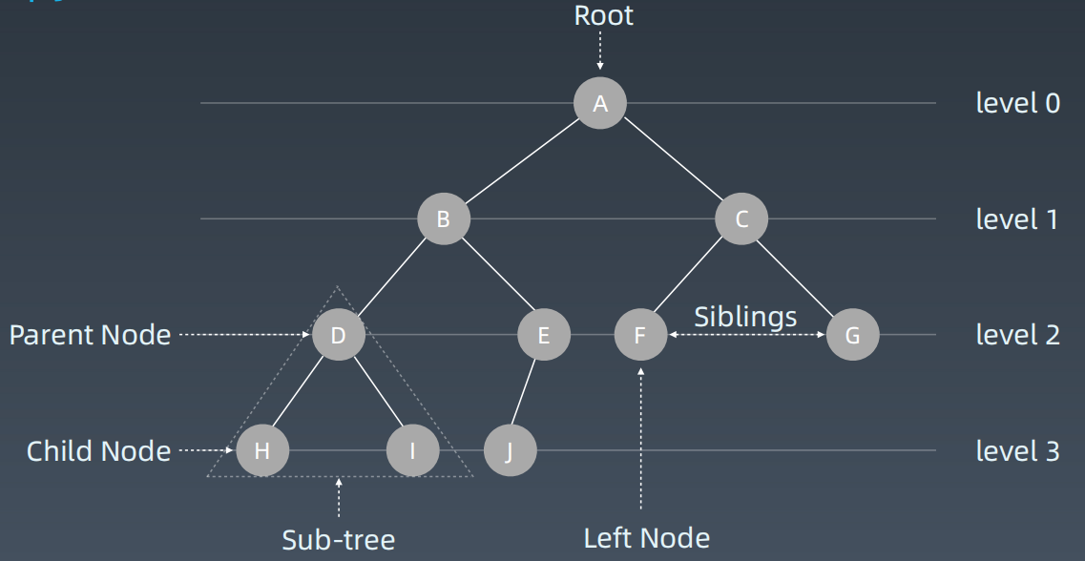

（按层次来打印一棵二叉树，即二叉树的层次遍历，高频老题）

二叉搜索树

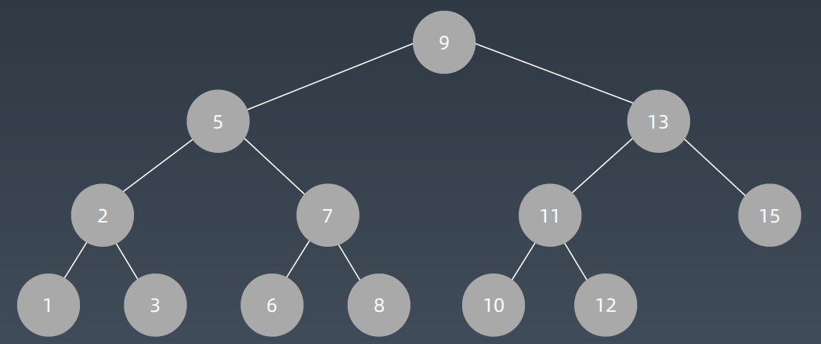

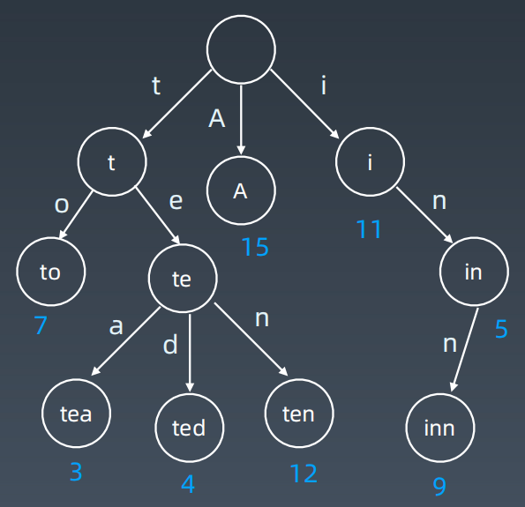Trie的基本结构

字典树，即 Trie 树，又称单词查找树或键树，是一种树形结构。典型应用是用于统计和排序大量的字符串（但不仅限于字符串），所以经常被搜索引擎系统用于文本词频统计。

它的优点是：最大限度地减少无谓的字符串比较，查询效率比哈希表高。

Trie的基本性质

1. 结点本身不存完整单词；

2. 从根结点到某一结点，路径上经过的字符连接起来，为该结点对应的字符串；

3. 每个结点的所有子结点路径代表的字符都不相同。

结点存储额外信息

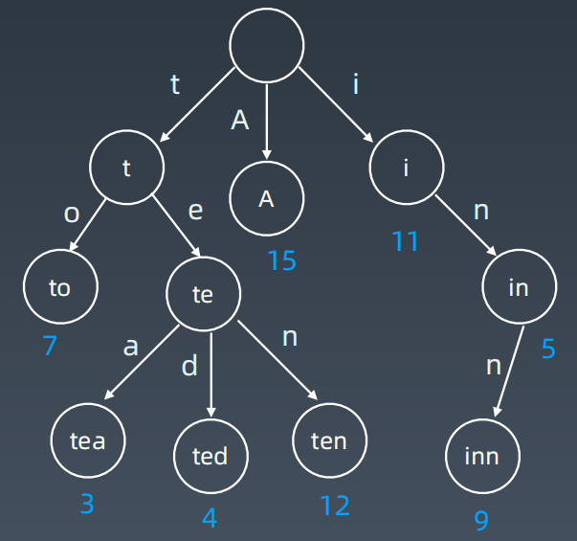

结点的内部实现

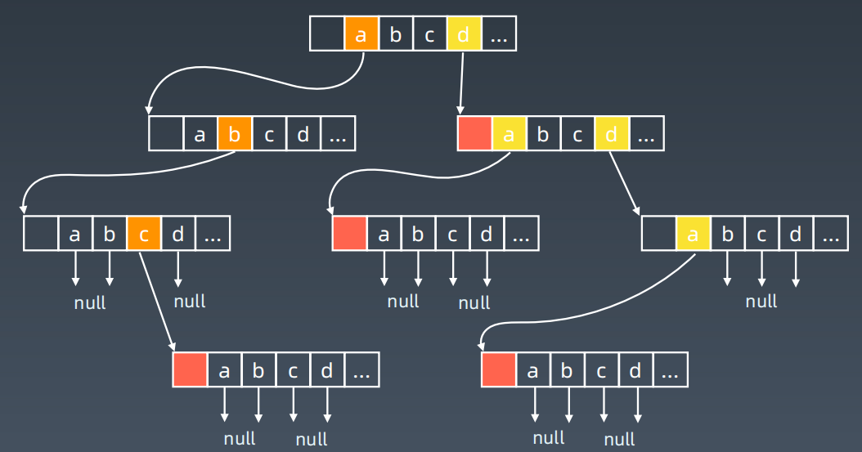

核心思想

Trie 树的核心思想是空间换时间。

利用字符串的公共前缀来降低查询时间的开销以达到提高效率的目的。

## 参考链接

* [二叉树的层次遍历](https://leetcode-cn.com/problems/binary-tree-level-order-traversal/" \t "https://u.geekbang.org/lesson/_blank)
* [实现 Trie](https://leetcode-cn.com/problems/implement-trie-prefix-tree/solution/" \t "https://u.geekbang.org/lesson/_blank)
* [Tire 树代码模板](https://shimo.im/docs/DP53Y6rOwN8MTCQH" \t "https://u.geekbang.org/lesson/_blank)

1. Trie树实战题目解析：单词搜索2

<https://u.geekbang.org/lesson/13?article=241692&utm_source=infoq_web&utm_medium=GEOBanner&utm_term=GEOBanner>

## 实战题目

* [https://leetcode-cn.com/problems/implement-trie-prefix-tree/#/description](https://leetcode-cn.com/problems/implement-trie-prefix-tree/" \l "/description" \t "https://u.geekbang.org/lesson/_blank)
* [https://leetcode-cn.com/problems/word-search-ii/](https://leetcode-cn.com/problems/word-search-ii/" \t "https://u.geekbang.org/lesson/_blank)
* 分析单词搜索 2 用 Tire 树方式实现的时间复杂度，请同学们提交在学习总结中。

1. 并查集的基本实现、特性和实战题目解析

<https://u.geekbang.org/lesson/13?article=241693&utm_source=infoq_web&utm_medium=GEOBanner&utm_term=GEOBanner>

## 参考链接

* [岛屿数量](https://leetcode-cn.com/problems/number-of-islands/" \t "https://u.geekbang.org/lesson/_blank)
* [并查集代码模板](https://shimo.im/docs/VtcxL0kyp04OBHak" \t "https://u.geekbang.org/lesson/_blank)

## 实战题目

* [https://leetcode-cn.com/problems/friend-circles](https://leetcode-cn.com/problems/friend-circles" \t "https://u.geekbang.org/lesson/_blank)
* [https://leetcode-cn.com/problems/number-of-islands/](https://leetcode-cn.com/problems/number-of-islands/" \t "https://u.geekbang.org/lesson/_blank)
* [https://leetcode-cn.com/problems/surrounded-regions/](https://leetcode-cn.com/problems/surrounded-regions/" \t "https://u.geekbang.org/lesson/_blank)

第七周 第14课|高级搜索

1. 剪枝的实现和特性

<https://u.geekbang.org/lesson/13?article=241703&utm_source=infoq_web&utm_medium=GEOBanner&utm_term=GEOBanner>

## 参考链接

* [DFS 代码模板](http://shimo.im/docs/ddgwCccJQKxkrcTq/" \t "https://u.geekbang.org/lesson/_blank)
* [BFS 代码模板](http://shimo.im/docs/P8TqKHGKt3ytkYYd/" \t "https://u.geekbang.org/lesson/_blank)
* [AlphaZero Explained](https://nikcheerla.github.io/deeplearningschool/2018/01/01/AlphaZero-Explained/" \t "https://u.geekbang.org/lesson/_blank)
* [棋类复杂度](https://en.wikipedia.org/wiki/Game_complexity" \t "https://u.geekbang.org/lesson/_blank)

1. 剪枝实战题目解析：数独

<https://u.geekbang.org/lesson/13?article=241705&utm_source=infoq_web&utm_medium=GEOBanner&utm_term=GEOBanner>

## 实战题目

* [https://leetcode-cn.com/problems/climbing-stairs/](https://leetcode-cn.com/problems/climbing-stairs/" \t "https://u.geekbang.org/lesson/_blank)
* [https://leetcode-cn.com/problems/generate-parentheses/](https://leetcode-cn.com/problems/generate-parentheses/" \t "https://u.geekbang.org/lesson/_blank)
* [https://leetcode-cn.com/problems/n-queens](https://leetcode-cn.com/problems/n-queens/" \t "https://u.geekbang.org/lesson/_blank)
* [https://leetcode-cn.com/problems/valid-sudoku/description/](https://leetcode-cn.com/problems/valid-sudoku/description/" \t "https://u.geekbang.org/lesson/_blank)
* [https://leetcode-cn.com/problems/sudoku-solver/#/description](https://leetcode-cn.com/problems/sudoku-solver/" \l "/description" \t "https://u.geekbang.org/lesson/_blank)

1. 双向BFS的实现、特性和题解

<https://u.geekbang.org/lesson/13?article=241707&utm_source=infoq_web&utm_medium=GEOBanner&utm_term=GEOBanner>

## 实战题目

* [https://leetcode-cn.com/problems/word-ladder/](https://leetcode-cn.com/problems/word-ladder/" \t "https://u.geekbang.org/lesson/_blank)
* [https://leetcode-cn.com/problems/minimum-genetic-mutation/](https://leetcode-cn.com/problems/minimum-genetic-mutation/" \t "https://u.geekbang.org/lesson/_blank)

## 课后作业

* 总结双向 BFS 代码模版，请同学们提交在学习总结中。

1. 启发式搜索的实现、特性和题解

<https://u.geekbang.org/lesson/13?article=241708&utm_source=infoq_web&utm_medium=GEOBanner&utm_term=GEOBanner>

## 参考链接

* [A* 代码模板](https://shimo.im/docs/8CzMlrcvbWwFXA8r" \t "https://u.geekbang.org/lesson/_blank)
* [相似度测量方法](https://dataaspirant.com/2015/04/11/five-most-popular-similarity-measures-implementation-in-python/" \t "https://u.geekbang.org/lesson/_blank)
* [二进制矩阵中的最短路径的 A* 解法](https://leetcode.com/problems/shortest-path-in-binary-matrix/discuss/313347/A*-search-in-Python" \t "https://u.geekbang.org/lesson/_blank)
* [8 puzzles 解法比较](https://zxi.mytechroad.com/blog/searching/8-puzzles-bidirectional-astar-vs-bidirectional-bfs/" \t "https://u.geekbang.org/lesson/_blank)

## 实战题目

* [https://leetcode-cn.com/problems/shortest-path-in-binary-matrix/](https://leetcode-cn.com/problems/shortest-path-in-binary-matrix/" \t "https://u.geekbang.org/lesson/_blank)
* [https://leetcode-cn.com/problems/sliding-puzzle/](https://leetcode-cn.com/problems/sliding-puzzle/" \t "https://u.geekbang.org/lesson/_blank)
* [https://leetcode-cn.com/problems/sudoku-solver/](https://leetcode-cn.com/problems/sudoku-solver/" \t "https://u.geekbang.org/lesson/_blank)

第七周 第15课|红黑树和AVL树

AVL树和红黑树的实现和特性

<https://u.geekbang.org/lesson/13?article=241711&utm_source=infoq_web&utm_medium=GEOBanner&utm_term=GEOBanner>

## 参考链接

* [平衡树](https://en.wikipedia.org/wiki/Self-balancing_binary_search_tree" \t "https://u.geekbang.org/lesson/_blank)

本周作业及下周预习

## 本周作业

### 简单

* [https://leetcode-cn.com/problems/climbing-stairs/](https://leetcode-cn.com/problems/climbing-stairs/" \t "https://u.geekbang.org/lesson/_blank)

### 中等

* [https://leetcode-cn.com/problems/implement-trie-prefix-tree/#/description](https://leetcode-cn.com/problems/implement-trie-prefix-tree/" \l "/description" \t "https://u.geekbang.org/lesson/_blank)
* [https://leetcode-cn.com/problems/friend-circles](https://leetcode-cn.com/problems/friend-circles" \t "https://u.geekbang.org/lesson/_blank)
* [https://leetcode-cn.com/problems/number-of-islands/](https://leetcode-cn.com/problems/number-of-islands/" \t "https://u.geekbang.org/lesson/_blank)
* [https://leetcode-cn.com/problems/surrounded-regions/](https://leetcode-cn.com/problems/surrounded-regions/" \t "https://u.geekbang.org/lesson/_blank)
* [https://leetcode-cn.com/problems/valid-sudoku/description/](https://leetcode-cn.com/problems/valid-sudoku/description/" \t "https://u.geekbang.org/lesson/_blank)
* [https://leetcode-cn.com/problems/generate-parentheses/](https://leetcode-cn.com/problems/generate-parentheses/" \t "https://u.geekbang.org/lesson/_blank)
* [https://leetcode-cn.com/problems/word-ladder/](https://leetcode-cn.com/problems/word-ladder/" \t "https://u.geekbang.org/lesson/_blank)
* [https://leetcode-cn.com/problems/minimum-genetic-mutation/](https://leetcode-cn.com/problems/minimum-genetic-mutation/" \t "https://u.geekbang.org/lesson/_blank)

### 困难

* [https://leetcode-cn.com/problems/word-search-ii/](https://leetcode-cn.com/problems/word-search-ii/" \t "https://u.geekbang.org/lesson/_blank)
* [https://leetcode-cn.com/problems/n-queens](https://leetcode-cn.com/problems/n-queens/" \t "https://u.geekbang.org/lesson/_blank)
* [https://leetcode-cn.com/problems/sudoku-solver/#/description](https://leetcode-cn.com/problems/sudoku-solver/" \l "/description" \t "https://u.geekbang.org/lesson/_blank)

## 下周预习题目

* [N 皇后](https://leetcode-cn.com/problems/n-queens/description/" \t "https://u.geekbang.org/lesson/_blank)
* [LRU 缓存机制](https://leetcode-cn.com/problems/lru-cache/" \l "/" \t "https://u.geekbang.org/lesson/_blank)
* [有效的字母异位词](https://leetcode-cn.com/problems/valid-anagram/" \t "https://u.geekbang.org/lesson/_blank)

第八周 第16课|位运算

1. 位运算基础及实战要点

<https://u.geekbang.org/lesson/13?article=243695&utm_source=infoq_web&utm_medium=GEOBanner&utm_term=GEOBanner>

## 参考链接

* [如何从十进制转换为二进制](https://zh.wikihow.com/%E4%BB%8E%E5%8D%81%E8%BF%9B%E5%88%B6%E8%BD%AC%E6%8D%A2%E4%B8%BA%E4%BA%8C%E8%BF%9B%E5%88%B6" \t "https://u.geekbang.org/lesson/_blank)

1. 位运算实战题目解析

<https://u.geekbang.org/lesson/13?article=243697&utm_source=infoq_web&utm_medium=GEOBanner&utm_term=GEOBanner>

## 参考链接

* [N 皇后位运算代码示例](https://shimo.im/docs/YzWa5ZZrZPYWahK2" \t "https://u.geekbang.org/lesson/_blank)

## 实战题目 / 课后作业

* [https://leetcode-cn.com/problems/number-of-1-bits/](https://leetcode-cn.com/problems/number-of-1-bits/" \t "https://u.geekbang.org/lesson/_blank)
* [https://leetcode-cn.com/problems/power-of-two/](https://leetcode-cn.com/problems/power-of-two/" \t "https://u.geekbang.org/lesson/_blank)
* [https://leetcode-cn.com/problems/reverse-bits/](https://leetcode-cn.com/problems/reverse-bits/" \t "https://u.geekbang.org/lesson/_blank)
* [https://leetcode-cn.com/problems/n-queens/description/](https://leetcode-cn.com/problems/n-queens/description/" \t "https://u.geekbang.org/lesson/_blank)
* [https://leetcode-cn.com/problems/n-queens-ii/description/](https://leetcode-cn.com/problems/n-queens-ii/description/" \t "https://u.geekbang.org/lesson/_blank)
* [https://leetcode-cn.com/problems/counting-bits/description/](https://leetcode-cn.com/problems/counting-bits/description/" \t "https://u.geekbang.org/lesson/_blank)

第8周 第17课|布隆过滤器和LRU缓存

1. 布隆过滤器的实现及应用

<https://u.geekbang.org/lesson/13?article=243698&utm_source=infoq_web&utm_medium=GEOBanner&utm_term=GEOBanner>

## 参考链接

* [布隆过滤器的原理和实现](https://www.cnblogs.com/cpselvis/p/6265825.html" \t "https://u.geekbang.org/lesson/_blank)
* [使用布隆过滤器解决缓存击穿、垃圾邮件识别、集合判重](https://blog.csdn.net/tianyaleixiaowu/article/details/74721877" \t "https://u.geekbang.org/lesson/_blank)
* [布隆过滤器 Python 代码示例](https://shimo.im/docs/UITYMj1eK88JCJTH" \t "https://u.geekbang.org/lesson/_blank)
* [布隆过滤器 Python 实现示例](https://www.geeksforgeeks.org/bloom-filters-introduction-and-python-implementation/" \t "https://u.geekbang.org/lesson/_blank)
* [高性能布隆过滤器 Python 实现示例](https://github.com/jhgg/pybloof" \t "https://u.geekbang.org/lesson/_blank)
* [布隆过滤器 Java 实现示例 1](https://github.com/lovasoa/bloomfilter/blob/master/src/main/java/BloomFilter.java" \t "https://u.geekbang.org/lesson/_blank)
* [布隆过滤器 Java 实现示例 2](https://github.com/Baqend/Orestes-Bloomfilter" \t "https://u.geekbang.org/lesson/_blank)

1. LRU Cache的实现、应用和题解

<https://u.geekbang.org/lesson/13?article=243699&utm_source=infoq_web&utm_medium=GEOBanner&utm_term=GEOBanner>

## 参考链接

* [Understanding the Meltdown exploit](https://www.sqlpassion.at/archive/2018/01/06/understanding-the-meltdown-exploit-in-my-own-simple-words/" \t "https://u.geekbang.org/lesson/_blank)
* [替换算法总揽](https://en.wikipedia.org/wiki/Cache_replacement_policies" \t "https://u.geekbang.org/lesson/_blank)
* [LRU Cache Python 代码示例](https://shimo.im/docs/CoyPAyXooGcDuLQo" \t "https://u.geekbang.org/lesson/_blank)

## 实战题目 / 课后作业

* [https://leetcode-cn.com/problems/lru-cache/#/](https://leetcode-cn.com/problems/lru-cache/" \l "/" \t "https://u.geekbang.org/lesson/_blank)

第八周 第18课|排序算法

1. 初级排序和高级排序的实现和特性

<https://u.geekbang.org/lesson/13?article=243700&utm_source=infoq_web&utm_medium=GEOBanner&utm_term=GEOBanner>

## 参考链接

* [十大经典排序算法](https://www.cnblogs.com/onepixel/p/7674659.html" \t "https://u.geekbang.org/lesson/_blank)
* [快速排序代码示例](https://shimo.im/docs/TX9bDbSC7C0CR5XO" \t "https://u.geekbang.org/lesson/_blank)
* [归并排序代码示例](https://shimo.im/docs/sDXxjjiKf3gLVVAU" \t "https://u.geekbang.org/lesson/_blank)
* [堆排序代码示例](https://shimo.im/docs/M2xfacKvwzAykhz6" \t "https://u.geekbang.org/lesson/_blank)

## 课后作业

用自己熟悉的编程语言，手写各种初级排序代码，提交到学习总结中。

1. 特殊排序及实战题目详解

<https://u.geekbang.org/lesson/13?article=243701&utm_source=infoq_web&utm_medium=GEOBanner&utm_term=GEOBanner>

## 参考链接

* [十大经典排序算法](https://www.cnblogs.com/onepixel/p/7674659.html" \t "https://u.geekbang.org/lesson/_blank)
* [9 种经典排序算法可视化动画](https://www.bilibili.com/video/av25136272" \t "https://u.geekbang.org/lesson/_blank)
* [6 分钟看完 15 种排序算法动画展示](https://www.bilibili.com/video/av63851336" \t "https://u.geekbang.org/lesson/_blank)

## 实战题目 / 课后作业

* [https://leetcode-cn.com/problems/relative-sort-array/](https://leetcode-cn.com/problems/relative-sort-array/" \t "https://u.geekbang.org/lesson/_blank)
* [https://leetcode-cn.com/problems/valid-anagram/](https://leetcode-cn.com/problems/valid-anagram/" \t "https://u.geekbang.org/lesson/_blank)
* [https://leetcode-cn.com/problems/design-a-leaderboard/](https://leetcode-cn.com/problems/design-a-leaderboard/" \t "https://u.geekbang.org/lesson/_blank)
* [https://leetcode-cn.com/problems/merge-intervals/](https://leetcode-cn.com/problems/merge-intervals/" \t "https://u.geekbang.org/lesson/_blank)
* [https://leetcode-cn.com/problems/reverse-pairs/](https://leetcode-cn.com/problems/reverse-pairs/" \t "https://u.geekbang.org/lesson/_blank)

本周作业及下周预习

## 本周作业

简单

* [https://leetcode-cn.com/problems/number-of-1-bits/](https://leetcode-cn.com/problems/number-of-1-bits/" \t "https://u.geekbang.org/lesson/_blank)
* [https://leetcode-cn.com/problems/power-of-two/](https://leetcode-cn.com/problems/power-of-two/" \t "https://u.geekbang.org/lesson/_blank)
* [https://leetcode-cn.com/problems/reverse-bits/](https://leetcode-cn.com/problems/reverse-bits/" \t "https://u.geekbang.org/lesson/_blank)
* 用自己熟悉的编程语言，手写各种初级排序代码，提交到学习总结中。
* [https://leetcode-cn.com/problems/relative-sort-array/](https://leetcode-cn.com/problems/relative-sort-array/" \t "https://u.geekbang.org/lesson/_blank)
* [https://leetcode-cn.com/problems/valid-anagram/](https://leetcode-cn.com/problems/valid-anagram/" \t "https://u.geekbang.org/lesson/_blank)

中等

* [https://leetcode-cn.com/problems/lru-cache/#/](https://leetcode-cn.com/problems/lru-cache/" \l "/" \t "https://u.geekbang.org/lesson/_blank)
* [https://leetcode-cn.com/problems/design-a-leaderboard/](https://leetcode-cn.com/problems/design-a-leaderboard/" \t "https://u.geekbang.org/lesson/_blank)
* [https://leetcode-cn.com/problems/merge-intervals/](https://leetcode-cn.com/problems/merge-intervals/" \t "https://u.geekbang.org/lesson/_blank)

困难

* [https://leetcode-cn.com/problems/n-queens/description/](https://leetcode-cn.com/problems/n-queens/description/" \t "https://u.geekbang.org/lesson/_blank)
* [https://leetcode-cn.com/problems/n-queens-ii/description/](https://leetcode-cn.com/problems/n-queens-ii/description/" \t "https://u.geekbang.org/lesson/_blank)
* [https://leetcode-cn.com/problems/reverse-pairs/](https://leetcode-cn.com/problems/reverse-pairs/" \t "https://u.geekbang.org/lesson/_blank)

## 下周预习题目：

* [不同路径](http://leetcode-cn.com/problems/unique-paths/" \t "https://u.geekbang.org/lesson/_blank)
* [最小路径和](http://leetcode-cn.com/problems/minimum-path-sum/" \t "https://u.geekbang.org/lesson/_blank)

第九周 第19课|高级动态规划

1. 动态规划、状态转移方程串讲

<https://u.geekbang.org/lesson/13?article=247851&utm_source=infoq_web&utm_medium=GEOBanner&utm_term=GEOBanner>

## 参考链接

* [爬楼梯](https://leetcode-cn.com/problems/climbing-stairs/" \t "https://u.geekbang.org/lesson/_blank)
* [不同路径](https://leetcode-cn.com/problems/unique-paths/" \t "https://u.geekbang.org/lesson/_blank)
* [打家劫舍](https://leetcode-cn.com/problems/house-robber/" \t "https://u.geekbang.org/lesson/_blank)
* [最小路径和](https://leetcode-cn.com/problems/minimum-path-sum/" \t "https://u.geekbang.org/lesson/_blank)
* [股票买卖](https://leetcode-cn.com/problems/best-time-to-buy-and-sell-stock/" \t "https://u.geekbang.org/lesson/_blank)

## 课后作业

在学习总结中，写出[不同路径 2](https://leetcode-cn.com/problems/unique-paths-ii/" \t "https://u.geekbang.org/lesson/_blank)这道题目的状态转移方程。

1. 高级动态规划题目详解

<https://u.geekbang.org/lesson/13?article=247852&utm_source=infoq_web&utm_medium=GEOBanner&utm_term=GEOBanner>

## 参考链接

* [爬楼梯](https://leetcode-cn.com/problems/climbing-stairs/" \t "https://u.geekbang.org/lesson/_blank)
* [使用最小花费爬楼梯](https://leetcode-cn.com/problems/min-cost-climbing-stairs/" \t "https://u.geekbang.org/lesson/_blank)
* [编辑距离](https://leetcode-cn.com/problems/edit-distance/" \t "https://u.geekbang.org/lesson/_blank)

## 课后作业

* [https://leetcode-cn.com/problems/longest-increasing-subsequence/](https://leetcode-cn.com/problems/longest-increasing-subsequence/" \t "https://u.geekbang.org/lesson/_blank)
* [https://leetcode-cn.com/problems/decode-ways/](https://leetcode-cn.com/problems/decode-ways/" \t "https://u.geekbang.org/lesson/_blank)
* [https://leetcode-cn.com/problems/longest-valid-parentheses/](https://leetcode-cn.com/problems/longest-valid-parentheses/" \t "https://u.geekbang.org/lesson/_blank)
* [https://leetcode-cn.com/problems/maximal-rectangle/](https://leetcode-cn.com/problems/maximal-rectangle/" \t "https://u.geekbang.org/lesson/_blank)
* [https://leetcode-cn.com/problems/distinct-subsequences/](https://leetcode-cn.com/problems/distinct-subsequences/" \t "https://u.geekbang.org/lesson/_blank)
* [https://leetcode-cn.com/problems/race-car/](https://leetcode-cn.com/problems/race-car/" \t "https://u.geekbang.org/lesson/_blank)

第九周 第20课|字符串算法

1. 字符串基础知识和引申题目

<https://u.geekbang.org/lesson/13?article=247854&utm_source=infoq_web&utm_medium=GEOBanner&utm_term=GEOBanner>

## 参考链接

* [不可变字符串](https://lemire.me/blog/2017/07/07/are-your-strings-immutable/" \t "https://u.geekbang.org/lesson/_blank)
* [Atoi 代码示例](https://shimo.im/docs/5kykuLmt7a4DdjSP" \t "https://u.geekbang.org/lesson/_blank)

## 字符串基础问题

* [https://leetcode-cn.com/problems/to-lower-case/](https://leetcode-cn.com/problems/to-lower-case/" \t "https://u.geekbang.org/lesson/_blank)
* [https://leetcode-cn.com/problems/length-of-last-word/](https://leetcode-cn.com/problems/length-of-last-word/" \t "https://u.geekbang.org/lesson/_blank)
* [https://leetcode-cn.com/problems/jewels-and-stones/](https://leetcode-cn.com/problems/jewels-and-stones/" \t "https://u.geekbang.org/lesson/_blank)
* [https://leetcode-cn.com/problems/first-unique-character-in-a-string/](https://leetcode-cn.com/problems/first-unique-character-in-a-string/" \t "https://u.geekbang.org/lesson/_blank)
* [https://leetcode-cn.com/problems/string-to-integer-atoi/](https://leetcode-cn.com/problems/string-to-integer-atoi/" \t "https://u.geekbang.org/lesson/_blank)

## 字符串操作问题

* [https://leetcode-cn.com/problems/longest-common-prefix/description/](https://leetcode-cn.com/problems/longest-common-prefix/description/" \t "https://u.geekbang.org/lesson/_blank)
* [https://leetcode-cn.com/problems/reverse-string](https://leetcode-cn.com/problems/reverse-string" \t "https://u.geekbang.org/lesson/_blank)
* [https://leetcode-cn.com/problems/reverse-string-ii/](https://leetcode-cn.com/problems/reverse-string-ii/" \t "https://u.geekbang.org/lesson/_blank)
* [https://leetcode-cn.com/problems/reverse-words-in-a-string/](https://leetcode-cn.com/problems/reverse-words-in-a-string/" \t "https://u.geekbang.org/lesson/_blank)
* [https://leetcode-cn.com/problems/reverse-words-in-a-string-iii/](https://leetcode-cn.com/problems/reverse-words-in-a-string-iii/" \t "https://u.geekbang.org/lesson/_blank)
* [https://leetcode-cn.com/problems/reverse-only-letters/](https://leetcode-cn.com/problems/reverse-only-letters/" \t "https://u.geekbang.org/lesson/_blank)

## 异位词问题

* [https://leetcode-cn.com/problems/valid-anagram/](https://leetcode-cn.com/problems/valid-anagram/" \t "https://u.geekbang.org/lesson/_blank)
* [https://leetcode-cn.com/problems/group-anagrams/](https://leetcode-cn.com/problems/group-anagrams/" \t "https://u.geekbang.org/lesson/_blank)
* [https://leetcode-cn.com/problems/find-all-anagrams-in-a-string/](https://leetcode-cn.com/problems/find-all-anagrams-in-a-string/" \t "https://u.geekbang.org/lesson/_blank)

## 回文串问题

* [https://leetcode-cn.com/problems/valid-palindrome/](https://leetcode-cn.com/problems/valid-palindrome/" \t "https://u.geekbang.org/lesson/_blank)
* [https://leetcode-cn.com/problems/valid-palindrome-ii/](https://leetcode-cn.com/problems/valid-palindrome-ii/" \t "https://u.geekbang.org/lesson/_blank)
* [https://leetcode-cn.com/problems/longest-palindromic-substring/](https://leetcode-cn.com/problems/longest-palindromic-substring/" \t "https://u.geekbang.org/lesson/_blank)

1. 高级字符串算法

<https://u.geekbang.org/lesson/13?article=247855&utm_source=infoq_web&utm_medium=GEOBanner&utm_term=GEOBanner>

## 最长子串、子序列问题

* [https://leetcode-cn.com/problems/longest-common-subsequence/](https://leetcode-cn.com/problems/longest-common-subsequence/" \t "https://u.geekbang.org/lesson/_blank)
* [https://leetcode-cn.com/problems/edit-distance/](https://leetcode-cn.com/problems/edit-distance/" \t "https://u.geekbang.org/lesson/_blank)
* [https://leetcode-cn.com/problems/longest-palindromic-substring/](https://leetcode-cn.com/problems/longest-palindromic-substring/" \t "https://u.geekbang.org/lesson/_blank)

## 字符串 +DP 问题

* [https://leetcode-cn.com/problems/regular-expression-matching/](https://leetcode-cn.com/problems/regular-expression-matching/" \t "https://u.geekbang.org/lesson/_blank)
* [https://leetcode-cn.com/problems/regular-expression-matching/solution/ji-yu-guan-fang-ti-jie-gen-xiang-xi-de-jiang-jie-b/](https://leetcode-cn.com/problems/regular-expression-matching/solution/ji-yu-guan-fang-ti-jie-gen-xiang-xi-de-jiang-jie-b/" \t "https://u.geekbang.org/lesson/_blank)
* [https://leetcode-cn.com/problems/wildcard-matching/](https://leetcode-cn.com/problems/wildcard-matching/" \t "https://u.geekbang.org/lesson/_blank)
* [https://leetcode-cn.com/problems/distinct-subsequences/](https://leetcode-cn.com/problems/distinct-subsequences/" \t "https://u.geekbang.org/lesson/_blank)

1. 字符串匹配算法

<https://u.geekbang.org/lesson/13?article=247856&utm_source=infoq_web&utm_medium=GEOBanner&utm_term=GEOBanner>

## 参考链接

* [Boyer-Moore 算法](https://www.ruanyifeng.com/blog/2013/05/boyer-moore_string_search_algorithm.html" \t "https://u.geekbang.org/lesson/_blank)
* [Sunday 算法](https://blog.csdn.net/u012505432/article/details/52210975" \t "https://u.geekbang.org/lesson/_blank)
* [字符串匹配暴力法代码示例](https://shimo.im/docs/8G0aJqNL86wWrPUE" \t "https://u.geekbang.org/lesson/_blank)
* [Rabin-Karp 代码示例](https://shimo.im/docs/1wnsM7eaZ6Ab9j9M" \t "https://u.geekbang.org/lesson/_blank)
* [KMP 字符串匹配算法视频](https://www.bilibili.com/video/av11866460?from=search&seid=17425875345653862171" \t "https://u.geekbang.org/lesson/_blank)
* [字符串匹配的 KMP 算法](http://www.ruanyifeng.com/blog/2013/05/Knuth%E2%80%93Morris%E2%80%93Pratt_algorithm.html" \t "https://u.geekbang.org/lesson/_blank)

## 课后作业

* [https://leetcode-cn.com/problems/first-unique-character-in-a-string/](https://leetcode-cn.com/problems/first-unique-character-in-a-string/" \t "https://u.geekbang.org/lesson/_blank)
* [https://leetcode-cn.com/problems/string-to-integer-atoi/](https://leetcode-cn.com/problems/string-to-integer-atoi/" \t "https://u.geekbang.org/lesson/_blank)
* [https://leetcode-cn.com/problems/reverse-string-ii/](https://leetcode-cn.com/problems/reverse-string-ii/" \t "https://u.geekbang.org/lesson/_blank)
* [https://leetcode-cn.com/problems/reverse-words-in-a-string/](https://leetcode-cn.com/problems/reverse-words-in-a-string/" \t "https://u.geekbang.org/lesson/_blank)
* [https://leetcode-cn.com/problems/reverse-words-in-a-string-iii/](https://leetcode-cn.com/problems/reverse-words-in-a-string-iii/" \t "https://u.geekbang.org/lesson/_blank)
* [https://leetcode-cn.com/problems/reverse-only-letters/](https://leetcode-cn.com/problems/reverse-only-letters/" \t "https://u.geekbang.org/lesson/_blank)
* [https://leetcode-cn.com/problems/find-all-anagrams-in-a-string/](https://leetcode-cn.com/problems/find-all-anagrams-in-a-string/" \t "https://u.geekbang.org/lesson/_blank)
* [https://leetcode-cn.com/problems/longest-palindromic-substring/](https://leetcode-cn.com/problems/longest-palindromic-substring/" \t "https://u.geekbang.org/lesson/_blank)
* [https://leetcode-cn.com/problems/isomorphic-strings/](https://leetcode-cn.com/problems/isomorphic-strings/" \t "https://u.geekbang.org/lesson/_blank)
* [https://leetcode-cn.com/problems/valid-palindrome-ii/](https://leetcode-cn.com/problems/valid-palindrome-ii/" \t "https://u.geekbang.org/lesson/_blank)
* [https://leetcode-cn.com/problems/wildcard-matching](https://leetcode-cn.com/problems/wildcard-matching" \t "https://u.geekbang.org/lesson/_blank)
* [https://leetcode-cn.com/problems/longest-valid-parentheses](https://leetcode-cn.com/problems/longest-valid-parentheses" \t "https://u.geekbang.org/lesson/_blank)
* [https://leetcode-cn.com/problems/distinct-subsequences/](https://leetcode-cn.com/problems/distinct-subsequences/" \t "https://u.geekbang.org/lesson/_blank)

## 本周作业

简单

* [https://leetcode-cn.com/problems/first-unique-character-in-a-string/](https://leetcode-cn.com/problems/first-unique-character-in-a-string/" \t "https://u.geekbang.org/lesson/_blank)
* [https://leetcode-cn.com/problems/reverse-string-ii/](https://leetcode-cn.com/problems/reverse-string-ii/" \t "https://u.geekbang.org/lesson/_blank)
* [https://leetcode-cn.com/problems/reverse-words-in-a-string/](https://leetcode-cn.com/problems/reverse-words-in-a-string/" \t "https://u.geekbang.org/lesson/_blank)
* [https://leetcode-cn.com/problems/reverse-words-in-a-string-iii/](https://leetcode-cn.com/problems/reverse-words-in-a-string-iii/" \t "https://u.geekbang.org/lesson/_blank)
* [https://leetcode-cn.com/problems/reverse-only-letters/](https://leetcode-cn.com/problems/reverse-only-letters/" \t "https://u.geekbang.org/lesson/_blank)
* [https://leetcode-cn.com/problems/isomorphic-strings/](https://leetcode-cn.com/problems/isomorphic-strings/" \t "https://u.geekbang.org/lesson/_blank)
* [https://leetcode-cn.com/problems/valid-palindrome-ii/](https://leetcode-cn.com/problems/valid-palindrome-ii/" \t "https://u.geekbang.org/lesson/_blank)

中等

* 在学习总结中，写出[不同路径 2](https://leetcode-cn.com/problems/unique-paths-ii/" \t "https://u.geekbang.org/lesson/_blank)这道题目的状态转移方程。
* [https://leetcode-cn.com/problems/longest-increasing-subsequence/](https://leetcode-cn.com/problems/longest-increasing-subsequence/" \t "https://u.geekbang.org/lesson/_blank)
* [https://leetcode-cn.com/problems/decode-ways/](https://leetcode-cn.com/problems/decode-ways/" \t "https://u.geekbang.org/lesson/_blank)
* [https://leetcode-cn.com/problems/string-to-integer-atoi/](https://leetcode-cn.com/problems/string-to-integer-atoi/" \t "https://u.geekbang.org/lesson/_blank)
* [https://leetcode-cn.com/problems/find-all-anagrams-in-a-string/](https://leetcode-cn.com/problems/find-all-anagrams-in-a-string/" \t "https://u.geekbang.org/lesson/_blank)
* [https://leetcode-cn.com/problems/longest-palindromic-substring/](https://leetcode-cn.com/problems/longest-palindromic-substring/" \t "https://u.geekbang.org/lesson/_blank)

困难

* [https://leetcode-cn.com/problems/longest-valid-parentheses/](https://leetcode-cn.com/problems/longest-valid-parentheses/" \t "https://u.geekbang.org/lesson/_blank)
* [https://leetcode-cn.com/problems/race-car/](https://leetcode-cn.com/problems/race-car/" \t "https://u.geekbang.org/lesson/_blank)
* [https://leetcode-cn.com/problems/wildcard-matching](https://leetcode-cn.com/problems/wildcard-matching" \t "https://u.geekbang.org/lesson/_blank)
* [https://leetcode-cn.com/problems/longest-valid-parentheses](https://leetcode-cn.com/problems/longest-valid-parentheses" \t "https://u.geekbang.org/lesson/_blank)
* [https://leetcode-cn.com/problems/distinct-subsequences/](https://leetcode-cn.com/problems/distinct-subsequences/" \t "https://u.geekbang.org/lesson/_blank)

第十周 期末串讲与毕业考试

期末串讲

<https://u.geekbang.org/lesson/13?article=247859&utm_source=infoq_web&utm_medium=GEOBanner&utm_term=GEOBanner>

## 参考链接

* [Big O Cheat Sheet](https://www.bigocheatsheet.com/" \t "https://u.geekbang.org/lesson/_blank)
* [算法训练营第 4 期学员谭帅的脑图作业](https://pan.baidu.com/s/1rucC3q-9zD-lzs3yBkFU_g" \t "https://u.geekbang.org/lesson/_blank)（提取码：ykyn）
* [Steve Jobs 演讲](https://www.youtube.com/watch?v=Hd_ptbiPoXM" \t "https://u.geekbang.org/lesson/_blank)

另外，如果你想换工作，不知道怎么写简历，可以看下[这篇文章](https://time.geekbang.org/column/article/81990" \t "https://u.geekbang.org/lesson/_blank)。

毕业刷题路线

先，恭喜各位同学从极客大学算法训练营毕业，相信 70 天的刻意练习给你带来了不少改变。但是毕业后的练习还不能停止，除了课上老师讲授的题目和布置的作业，这里还有一份“左耳朵耗子”陈皓老师和超哥分享的毕业刷题路线，助你在训练营结束后持续练习。

## 基础

* [两数之和](http://leetcode-cn.com/problems/two-sum" \t "https://u.geekbang.org/lesson/_blank)（简单）
* [有效的括号](http://leetcode-cn.com/problems/valid-parentheses/" \t "https://u.geekbang.org/lesson/_blank)（简单）
* [字符串解码](http://leetcode-cn.com/problems/decode-string/" \t "https://u.geekbang.org/lesson/_blank)（中等）
* [LRU 缓存机制](http://leetcode-cn.com/problems/lru-cache/submissions/" \t "https://u.geekbang.org/lesson/_blank)（困难）
* [实现 Trie（前缀树）](http://leetcode-cn.com/problems/implement-trie-prefix-tree/" \t "https://u.geekbang.org/lesson/_blank)（中等）
* [添加与搜索单词 - 数据结构设计](http://leetcode-cn.com/problems/add-and-search-word-data-structure-design/" \t "https://u.geekbang.org/lesson/_blank)（中等）
* [单词搜索 II](http://leetcode-cn.com/problems/word-search-ii/" \t "https://u.geekbang.org/lesson/_blank)（困难）
* [找不同](http://leetcode-cn.com/problems/find-the-difference/" \t "https://u.geekbang.org/lesson/_blank)（简单）
* [单词规律](http://leetcode-cn.com/problems/word-pattern/" \t "https://u.geekbang.org/lesson/_blank)（简单）
* [字符串中的第一个唯一字符](http://leetcode-cn.com/problems/first-unique-character-in-a-string" \t "https://u.geekbang.org/lesson/_blank)（简单）
* [无重复字符的最长子串](http://leetcode-cn.com/problems/longest-substring-without-repeating-characters" \t "https://u.geekbang.org/lesson/_blank)（中等）
* [最小覆盖子串](http://leetcode-cn.com/problems/minimum-window-substring/" \t "https://u.geekbang.org/lesson/_blank)（困难）
* [合并两个有序链表](http://leetcode-cn.com/problems/merge-two-sorted-lists" \t "https://u.geekbang.org/lesson/_blank)（简单）
* [环形链表](http://leetcode-cn.com/problems/linked-list-cycle" \t "https://u.geekbang.org/lesson/_blank)（简单）
* [环形链表 II](http://leetcode-cn.com/problems/linked-list-cycle-ii" \t "https://u.geekbang.org/lesson/_blank)（中等）
* [反转链表](http://leetcode-cn.com/problems/reverse-linked-list" \t "https://u.geekbang.org/lesson/_blank)（简单）
* [反转链表 II](http://leetcode-cn.com/problems/reverse-linked-list-ii" \t "https://u.geekbang.org/lesson/_blank)（中等）
* [旋转链表](http://leetcode-cn.com/problems/rotate-list" \t "https://u.geekbang.org/lesson/_blank)（中等）
* [排序链表](http://leetcode-cn.com/problems/sort-list/" \t "https://u.geekbang.org/lesson/_blank)
* [链表中倒数第 k 个节点](http://leetcode-cn.com/problems/lian-biao-zhong-dao-shu-di-kge-jie-dian-lcof/" \t "https://u.geekbang.org/lesson/_blank)
* [两两交换链表中的节点](http://leetcode-cn.com/problems/swap-nodes-in-pairs" \t "https://u.geekbang.org/lesson/_blank)（中等）
* [按奇偶排序数组](http://leetcode-cn.com/problems/sort-array-by-parity/" \t "https://u.geekbang.org/lesson/_blank)（简单）
* [按奇偶排序数组 II](http://leetcode-cn.com/problems/sort-array-by-parity-ii/" \t "https://u.geekbang.org/lesson/_blank)（简单）
* [有序数组的平方](http://leetcode-cn.com/problems/squares-of-a-sorted-array/" \t "https://u.geekbang.org/lesson/_blank)（简单）
* [山脉数组的峰顶索引](http://leetcode-cn.com/problems/peak-index-in-a-mountain-array" \t "https://u.geekbang.org/lesson/_blank)（简单）
* [搜索旋转排序数组](http://leetcode-cn.com/problems/search-in-rotated-sorted-array" \t "https://u.geekbang.org/lesson/_blank)（困难）
* [搜索旋转排序数组 II](http://leetcode-cn.com/problems/search-in-rotated-sorted-array-ii/" \t "https://u.geekbang.org/lesson/_blank)（中等）
* [寻找旋转排序数组中的最小值](http://leetcode-cn.com/problems/find-minimum-in-rotated-sorted-array/" \t "https://u.geekbang.org/lesson/_blank)（中等）
* [寻找旋转排序数组中的最小值 II](http://leetcode-cn.com/problems/find-minimum-in-rotated-sorted-array-ii/" \t "https://u.geekbang.org/lesson/_blank)（困难）
* [搜索二维矩阵](http://leetcode-cn.com/problems/search-a-2d-matrix" \t "https://u.geekbang.org/lesson/_blank)（中等）
* [等式方程的可满足性](http://leetcode-cn.com/problems/satisfiability-of-equality-equations/" \t "https://u.geekbang.org/lesson/_blank)（中等）
* [朋友圈](http://leetcode-cn.com/problems/friend-circles/" \t "https://u.geekbang.org/lesson/_blank)（中等）
* [账户合并](http://leetcode-cn.com/problems/accounts-merge/" \t "https://u.geekbang.org/lesson/_blank)（中等）

## 深度优先搜索

* [二叉树的最大深度](http://leetcode-cn.com/problems/maximum-depth-of-binary-tree" \t "https://u.geekbang.org/lesson/_blank)（简单）
* [路径总和](http://leetcode-cn.com/problems/path-sum/" \t "https://u.geekbang.org/lesson/_blank)（简单）
* [路径总和 II](http://leetcode-cn.com/problems/path-sum-ii/" \t "https://u.geekbang.org/lesson/_blank)（中等）
* [被围绕的区域](http://leetcode-cn.com/problems/surrounded-regions/" \t "https://u.geekbang.org/lesson/_blank)（中等）
* [岛屿数量](http://leetcode-cn.com/problems/number-of-islands/" \t "https://u.geekbang.org/lesson/_blank)（中等）
* [岛屿的最大面积](http://leetcode-cn.com/problems/max-area-of-island/" \t "https://u.geekbang.org/lesson/_blank)（中等）
* [在二叉树中分配硬币](http://leetcode-cn.com/problems/distribute-coins-in-binary-tree/" \t "https://u.geekbang.org/lesson/_blank)（中等）

## 回溯

* [括号生成](http://leetcode-cn.com/problems/generate-parentheses/" \t "https://u.geekbang.org/lesson/_blank)（中等）
* [N 皇后](http://leetcode-cn.com/problems/n-queens/" \t "https://u.geekbang.org/lesson/_blank)（困难）
* [N 皇后 II](http://leetcode-cn.com/problems/n-queens-ii/" \t "https://u.geekbang.org/lesson/_blank)（困难）
* [解数独](http://leetcode-cn.com/problems/sudoku-solver/" \t "https://u.geekbang.org/lesson/_blank) （中等）
* [不同路径 III](http://leetcode-cn.com/problems/unique-paths-iii/" \t "https://u.geekbang.org/lesson/_blank)（困难）
* [单词搜索](http://leetcode-cn.com/problems/word-search/" \t "https://u.geekbang.org/lesson/_blank)（中等）

## 分治

* [搜索二维矩阵 II](http://leetcode-cn.com/problems/search-a-2d-matrix-ii/" \t "https://u.geekbang.org/lesson/_blank)（中等）
* [合并 K 个排序链表](http://leetcode-cn.com/problems/merge-k-sorted-lists" \t "https://u.geekbang.org/lesson/_blank)（中等）
* [为运算表达式设计优先级](http://leetcode-cn.com/problems/different-ways-to-add-parentheses" \t "https://u.geekbang.org/lesson/_blank)（中等）
* [给表达式添加运算符](http://leetcode-cn.com/problems/expression-add-operators" \t "https://u.geekbang.org/lesson/_blank)（困难）
* [数组中的第 K 个最大元素](http://leetcode-cn.com/problems/kth-largest-element-in-an-array" \t "https://u.geekbang.org/lesson/_blank)（中等）
* [最接近原点的 K 个点](http://leetcode-cn.com/problems/k-closest-points-to-origin/" \t "https://u.geekbang.org/lesson/_blank)（中等）
* [鸡蛋掉落](http://leetcode-cn.com/problems/super-egg-drop/" \t "https://u.geekbang.org/lesson/_blank)（困难）

## 动态规划

* [使用最小花费爬楼梯](http://leetcode-cn.com/problems/min-cost-climbing-stairs" \t "https://u.geekbang.org/lesson/_blank)（简单）
* [爬楼梯](http://leetcode-cn.com/problems/climbing-stairs" \t "https://u.geekbang.org/lesson/_blank)（简单）
* [不同路径](http://leetcode-cn.com/problems/unique-paths/" \t "https://u.geekbang.org/lesson/_blank)（简单）
* [最小路径和](http://leetcode-cn.com/problems/minimum-path-sum/" \t "https://u.geekbang.org/lesson/_blank) （中等）
* [最大子序和](http://leetcode-cn.com/problems/maximum-subarray/" \t "https://u.geekbang.org/lesson/_blank) （简单）
* [乘积最大子数组](http://leetcode-cn.com/problems/maximum-product-subarray/" \t "https://u.geekbang.org/lesson/_blank)（中等）
* [买卖股票的最佳时机](http://leetcode-cn.com/problems/best-time-to-buy-and-sell-stock" \t "https://u.geekbang.org/lesson/_blank)（简单）
* [买卖股票的最佳时机 II](http://leetcode-cn.com/problems/best-time-to-buy-and-sell-stock-ii/" \t "https://u.geekbang.org/lesson/_blank)（简单）
* [买卖股票的最佳时机 III](http://leetcode-cn.com/problems/best-time-to-buy-and-sell-stock-iii/" \t "https://u.geekbang.org/lesson/_blank)（困难）
* [买卖股票的最佳时机 IV](http://leetcode-cn.com/problems/best-time-to-buy-and-sell-stock-iv/" \t "https://u.geekbang.org/lesson/_blank)（困难）
* [最佳买卖股票时机含冷冻期](http://leetcode-cn.com/problems/best-time-to-buy-and-sell-stock-with-cooldown/" \t "https://u.geekbang.org/lesson/_blank)（中等）
* [买卖股票的最佳时机含手续费](http://leetcode-cn.com/problems/best-time-to-buy-and-sell-stock-with-transaction-fee" \t "https://u.geekbang.org/lesson/_blank)（中等）
* [零钱兑换](http://leetcode-cn.com/problems/coin-change" \t "https://u.geekbang.org/lesson/_blank) （中等）
* [零钱兑换 II](http://leetcode-cn.com/problems/coin-change-2" \t "https://u.geekbang.org/lesson/_blank)（中等）
* [编辑距离](http://leetcode-cn.com/problems/edit-distance" \t "https://u.geekbang.org/lesson/_blank)（困难）
* [不同的子序列](http://leetcode-cn.com/problems/distinct-subsequences/" \t "https://u.geekbang.org/lesson/_blank)（困难）
* [柱状图中最大的矩形](http://leetcode-cn.com/problems/largest-rectangle-in-histogram/" \t "https://u.geekbang.org/lesson/_blank)（困难）
* [最大矩形](http://leetcode-cn.com/problems/maximal-rectangle/" \t "https://u.geekbang.org/lesson/_blank)（困难）
* [最大正方形](http://leetcode-cn.com/problems/maximal-square/" \t "https://u.geekbang.org/lesson/_blank)（中等）
* [最低票价](http://leetcode-cn.com/problems/minimum-cost-for-tickets/" \t "https://u.geekbang.org/lesson/_blank)（中等）
* [区域和检索 - 数组不可变](http://leetcode-cn.com/problems/range-sum-query-immutable/" \t "https://u.geekbang.org/lesson/_blank)（简单）
* [二维区域和检索 - 矩阵不可变](http://leetcode-cn.com/problems/range-sum-query-2d-immutable/" \t "https://u.geekbang.org/lesson/_blank)（中等）
* [最长上升子序列](http://leetcode-cn.com/problems/longest-increasing-subsequence" \t "https://u.geekbang.org/lesson/_blank) （中等）
* [鸡蛋掉落](http://leetcode-cn.com/problems/super-egg-drop/" \t "https://u.geekbang.org/lesson/_blank)（困难）