Tribhuvan University
Institute of Science and Technology
[ Insert Tribhuvan Universityofficial emblem image here ]
E-governance Laboratory Report
Local Civic Problem Reporting System
B.Sc. Computer Science and Information Technology
Sixth Semester

Submitted By:-
Name: Darshan Chaulagain
Class Roll No: 07
Symbol No: 80012454
Mahendra Multiple Campus
Nepalgunj, Banke
July, 2026

Tribhuvan University
Institute of Science and Technology
Mahendra Multiple Campus
Nepalgunj, Banke

CERTIFICATE
This is to certify that the laboratory work entitled “Local Civic Problem Reporting System”
submitted by Mr. Darshan Chaulagain, Class Roll No: 07, Symbol No: 80012454, of Bachelor of
Science in Computer Science and Information Technology (Sixth Semester) has been carried out
as a part of the requirements for the E-Governance Laboratory course under the Institute of
Science and Technology, Tribhuvan University during the Academic Year 2026.
The work has been completed under my supervision and guidance. To the best of my knowledge,
this laboratory work is the original work of the student and has not been submitted elsewhere
for any other academic purpose.
Supervisor’s Signature
Lect. Vishal Agrawal

ACKNOWLEDGEMENT
I would like to express my sincere gratitude to the Department of Computer Science and
Information Technology at Mahendra Multiple Campus for providing me with the opportunity to
carry out this project. I am deeply thankful to my project supervisor, Lect. Vishal Agrawal, for
the valuable guidance, encouragement, and constructive feedback provided throughout the
development of this project.
I would also like to extend my heartfelt thanks to my friends and classmates for their continuous
support, cooperation, and helpful suggestions. Their encouragement and assistance made the
project development process smoother and more enjoyable.
Finally, I am especially grateful to my family for their unconditional love, patience, and
unwavering support. Their constant encouragement and belief in me motivated me to complete
this project successfully.

ABSTRACT
This project presents a web-based Local Civic Problem Reporting System developed to
digitize the way citizens report local infrastructure problems as an e-governance service. The
system was chosen because the traditional process — visiting a ward office in person or phoning
in a complaint that is logged on paper — is slow, undocumented, and gives citizens no way to
track what happens to their complaint afterward. It provides a platform where citizens can
register, submit a report with a photograph and an optional GPS location, and track its status in
real time, while municipal staff verify, act on, and resolve reports through a role-based
dashboard.
The system follows a client-server architecture and was developed using a FastAPI (Python)
backend with a PostgreSQL database (hosted on Neon), and a frontend built with plain HTML,
CSS and JavaScript using the Fetch API to communicate with the backend's REST endpoints.
Key features include citizen registration and login, report submission with photo upload and
map-based location picking (Leaflet.js / OpenStreetMap), a public feed of all reported problems
with an optional anonymity toggle, a full status-tracking workflow (submitted → verified →
in‑progress → completed, or rejected with a reason), category-and-ward based automatic
routing of reports to the responsible staff member, and an administrative layer for managing
staff accounts.
To ensure security, the system implements bcrypt password hashing, stateless JWT-based
authentication, role-based access control (citizen / staff / admin), server-side validation of every
request via Pydantic schemas, SQLAlchemy's parameterized queries (eliminating SQL-injection
surface), strict upload validation (file type, size and re-encoding of images via Pillow), and an
automatic lockout mechanism that restricts citizens who repeatedly submit false reports. The
application was developed and tested locally against a live cloud PostgreSQL database and is
designed for deployment on Render, demonstrating a functional system that improves the
efficiency, transparency, and accountability of local civic problem resolution.

TABLE OF CONTENTS
LAB 1: Survey of E-Governance Portals
LAB 2: Requirement Analysis & Workflow Modeling
LAB 3: Backend & Database
LAB 4: Authentication & Access Control
LAB 5: Citizen Web Interface
LAB 6: Admin & Staff Coordination
LAB 7: Data Protection
Deployment
Testing
Challenges Faced
Conclusion and Future Scope
References

LIST OF FIGURES
Figure 1.1 Home Page of NIDCR Portal
Figure 1.2 Online Services Page of NIDCR Portal
Figure 1.3 Home Page of IRD Portal
Figure 1.4 Service Page of IRD Portal
Figure 1.5 Home Page of Passport Portal
Figure 1.6 Online Passport Application Page
Figure 2.1 As-Is Process Flowchart
Figure 2.2 To-Be Process Flowchart
Figure 2.3 DFD (Context-level Diagram)
Figure 2.4 Use-case Diagram
Figure 3.1 ER Diagram
Figure 3.2 Register API – Live Request/Response
Figure 3.3 Submit Report API – Live Request/Response
Figure 3.4 GitHub Repository of the Civic Report System
Figure 4.1 Citizen Login Interface
Figure 4.2 Authentication Flow Diagram
Figure 5.1 Citizen Registration Interface
Figure 5.2 Report Submission Interface with Map Picker
Figure 5.3 My Reports – Status Tracking
Figure 5.4 Desktop View of the Public Feed
Figure 5.5 Mobile View of the Public Feed
Figure 6.1 Staff Dashboard
Figure 6.2 Admin Dashboard – Staff Management
Figure 6.3 Category + Ward Auto-Routing & Admin Override Diagram
Figure 6.4 Live Audit Trail of a Resolved Report
Figure 8.1 Deployment Architecture of the Civic Report System

LIST OF TABLES
Table 1.1 Comparative Analysis of E-Governance Portals
Table 2.1 Actors Identified
Table 3.1 Database Tables
Table 3.2 API Endpoints and Their Description
Table 4.1 Role-Based Access Control (RBAC) Matrix
Table 4.2 Security Test Results (Live)
Table 5.1 Integration of Citizen Web Interface with Backend APIs
Table 6.1 Live Audit Log Entries (Sample Report)
Table 7.1 Security Mechanisms Implemented
Table 8.1 Deployment Platform Configuration
Table 9.1 Summary of Unit Test Cases
Table 9.2 Summary of System Test Cases
Table 9.3 End-to-End Workflow Test Results
Table 10.1 Challenges Faced and Resolutions
Table 11.1 Future Scope

LIST OF ABBREVIATIONS
API | Application Programming Interface
CORS | Cross-Origin Resource Sharing
CSS | Cascading Style Sheets
DB | Database
DFD | Data Flow Diagram
ER | Entity-Relationship
FK | Foreign Key
GPS | Global Positioning System
HTML | Hypertext Markup Language
HTTP / HTTPS | Hypertext Transfer Protocol (Secure)
JS | JavaScript
JWT | JSON Web Token
ORM | Object-Relational Mapper
PK | Primary Key
RBAC | Role-Based Access Control
REST | Representational State Transfer
SQL | Structured Query Language
TLS | Transport Layer Security
UUID | Universally Unique Identifier
XSS | Cross-Site Scripting

LAB 1: Survey of E-Governance Portals

Purpose
The main purpose of this lab is to study different e-government portals of Nepal and
understand how they provide digital services to citizens, businesses, and other government
sectors. This groundwork also helped in understanding the categories of e-government
services, the stages of e-government development, and the overall service delivery process,
before designing the Local Civic Problem Reporting System covered in the remaining labs.

Introduction
E-Governance is the use of information and communication technology (ICT) by the
government to provide services electronically. Instead of visiting government offices for every
service, people can now access many services through websites and mobile applications. This
saves time, reduces paperwork, increases transparency, and improves communication between
the government and the public.
For this lab, three government portals of Nepal were surveyed and their e-government category, development stage, and service delivery model identified.

Government Portal 1: Department of National ID and Civil Registration (NIDCR)
Website: https://donidcr.gov.np
The Department of National ID and Civil Registration (NIDCR) operates under the Ministry of
Home Affairs, Government of Nepal, headquartered at Singhadurbar, Kathmandu. It is
responsible for issuing the National Identity Card (NID) and for maintaining civil registration
records — birth, death, marriage, and other personal events — nationwide, including through
Nepali diplomatic missions abroad for citizens living outside the country.
Main Services: National ID (NID) enrollment, Provisional eNID download, Online civil
(personal event) registration, Civil registration through Nepali diplomatic missions abroad,
Citizen charter and FAQs, Circulars and publications.
E-Government Category: Government to Citizen (G2C) — provides services directly to citizens.
Stage of E-Government: Transaction Stage — citizens can register personal events and download a provisional NID online rather than only viewing information.
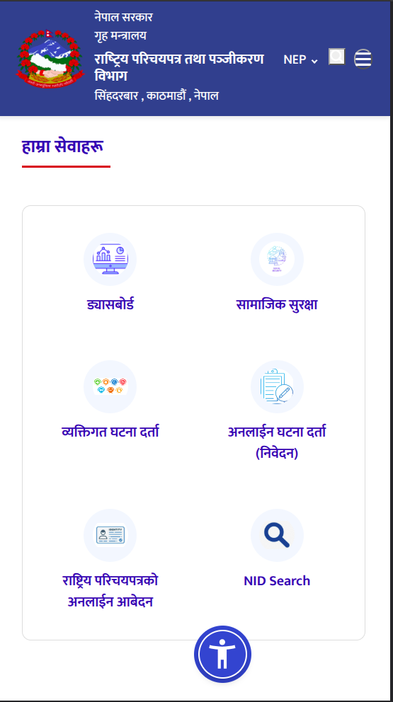
Figure 1.1 Home Page of NIDCR Portal
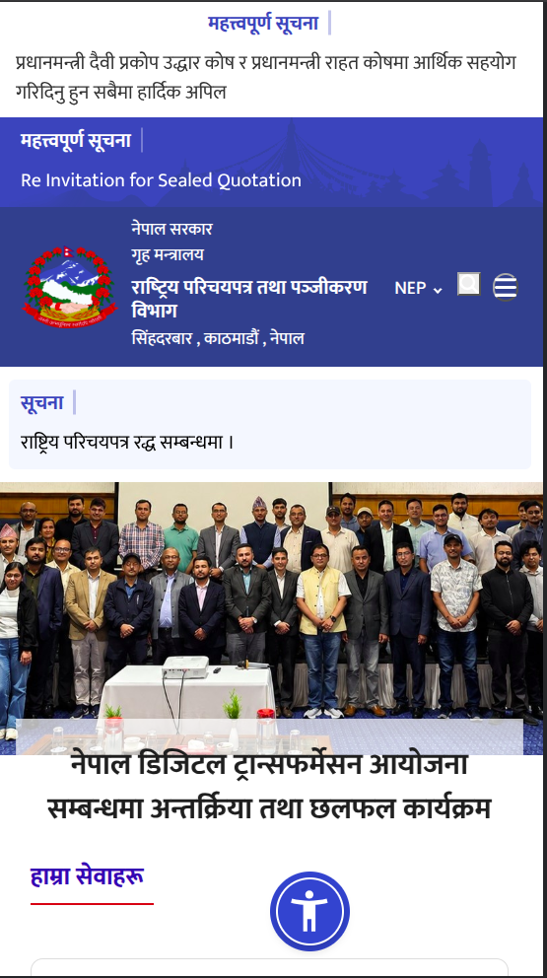
Figure 1.2 Online Services Page of NIDCR Portal

Government Portal 2: Inland Revenue Department (IRD)
Website: https://ird.gov.np
The Inland Revenue Department established its online presence around 2001 with initial
services like PAN and VAT registration, evolving into its current web portal. The new website
(ird.gov.np) is a modernized, responsive portal with dynamic search and mobile support, while
the old website (old.ird.gov.np) remains a read-only legacy archive for historical records.
Main Services: PAN Registration, Online Tax Filing, VAT Services, Tax Clearance, Taxpayer Login, Tax Information.
E-Government Category: Government to Business (G2B) — mainly serves businesses and taxpayers.
Stage of E-Government: Transaction Stage — users can complete tax-related processes online.
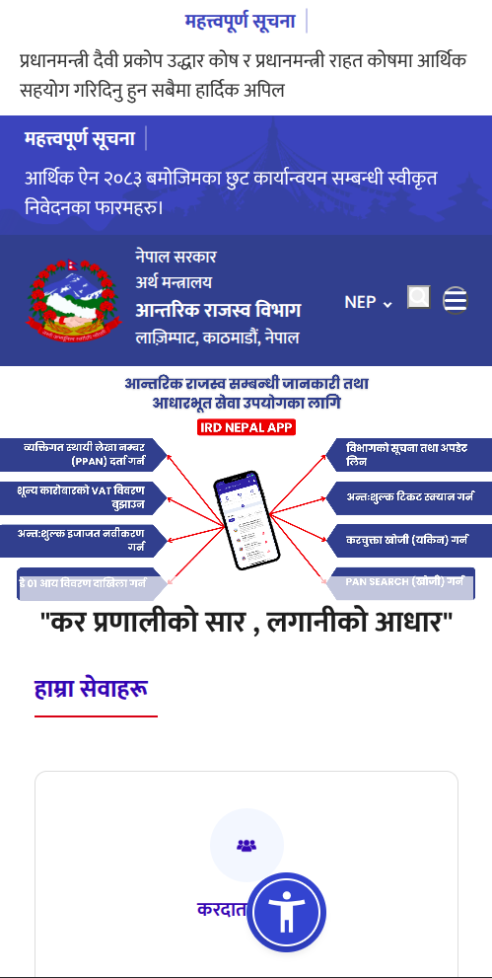
Figure 1.3 Home Page of IRD Portal
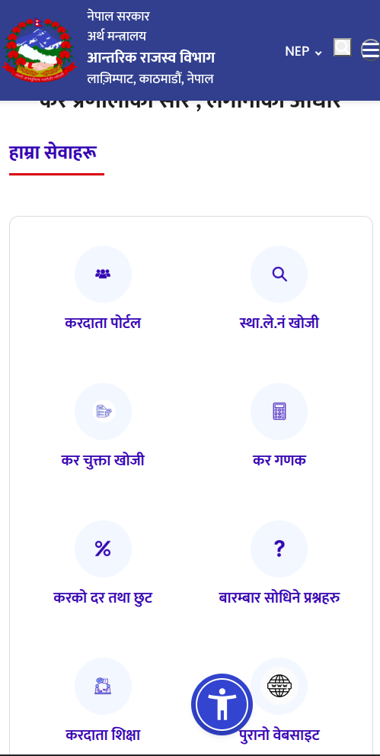
Figure 1.4 Service Page of IRD Portal

Government Portal 3: Department of Passports
Website: https://nepalpassport.gov.np
The Department of Passports provides online passport services for Nepali citizens, established
in 2068 B.S. Through its website, users can apply for passports, book appointments, and track
the progress of their applications.
Main Services: Online Passport Application, Appointment Booking, Passport Status Tracking, Passport Information.
E-Government Category: Government to Citizen (G2C) — provides passport-related services to citizens.
Stage of E-Government: Transaction Stage — citizens can complete major parts of the passport application process online.
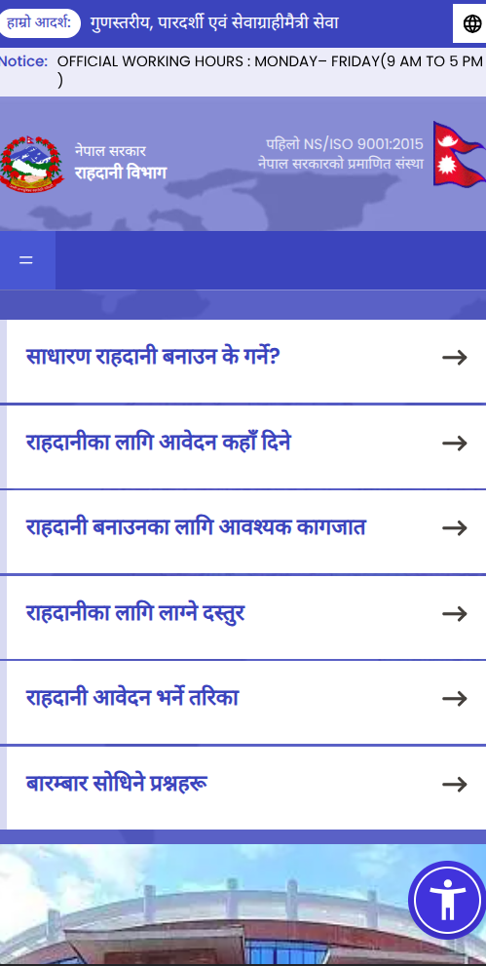
Figure 1.5 Home Page of Passport Portal
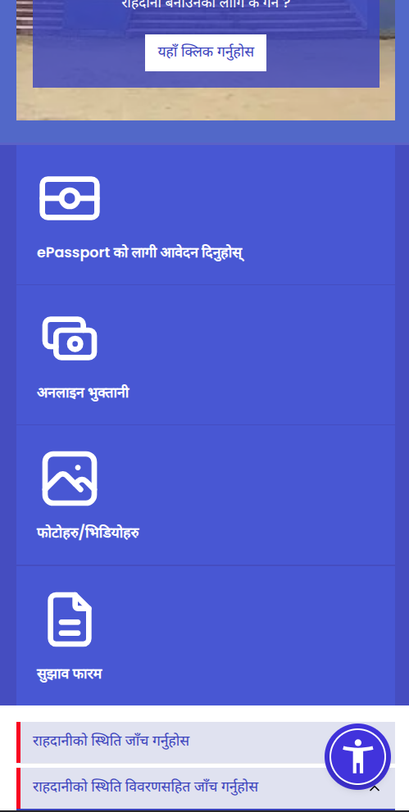
Figure 1.6 Online Passport Application Page
S.N | Portal | Category | Stage | Main Users | Main Purpose
1 | NIDCR Portal | G2C | Transaction | Citizens | National ID and civil registration services
2 | Inland Revenue Department | G2B | Transaction | Business & Taxpayers | Online tax services
3 | Department of Passports | G2C | Transaction | Citizens | Passport application and tracking

Findings
All three portals are designed to improve public service delivery through digital technology.
They reduce paperwork, save time, increase transparency, and make government services more
accessible, with most having reached the Transaction stage where important processes can be
completed entirely online. This pattern — account-based access, a clear submission workflow,
and status/results the citizen can check without visiting an office — directly informed the design
of the Local Civic Problem Reporting System described in the following labs: citizens register
once, submit a report instead of a form, and track its resolution the same way a taxpayer tracks
a filing or a passport applicant tracks an application.

Conclusion
This survey helped in understanding how e-government services are implemented in Nepal and
the different categories, stages, and delivery models of e-government, which formed the
conceptual foundation for building a similar transaction-stage, citizen-facing system for
reporting local civic problems.

LAB 2: Requirement Analysis & Workflow Modeling

Purpose
The purpose of this lab is to analyze the existing manual process of reporting a local
infrastructure problem (a pothole, a broken water pipe, a damaged streetlight, and similar) and
identify the requirements for its digital transformation. This involves studying the current
workflow, identifying the stakeholders involved, and modeling the proposed system using
process flowcharts, a context-level DFD, and a use-case diagram.

Introduction of Chosen Manual Government Service
The chosen manual government service is the reporting and resolution of local infrastructure
problems by a municipal/ward office. In the traditional process, a citizen who notices a problem
either visits the ward office in person or phones in a complaint, which a clerk writes into a paper
register. Ward staff then act on it — often with no fixed timeline — and the citizen has no way to
check whether anything is actually happening. Multiple citizens reporting the same problem
independently also creates duplicate paperwork.
The proposed Local Civic Problem Reporting System digitizes this process end-to-end: secure
citizen registration, report submission with photographic evidence and an optional GPS pin,
automatic routing of the report to the staff member responsible for that category and ward, a
transparent multi-step status workflow, and a public feed that gives the whole process
visibility and accountability.

Process Flowcharts
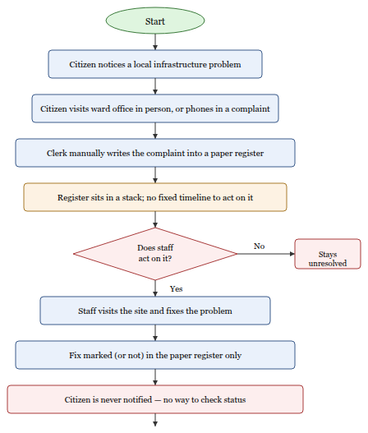
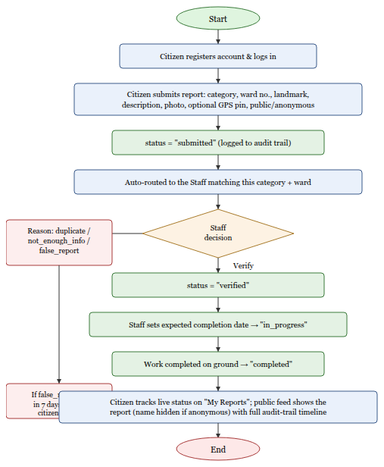

Actors Identified
S.N | Actor | Role in the System
1 | Citizen | Registers with name, email, phone and password; logs in; submits reports with a photo, category, ward and optional GPS location; can choose to submit publicly or anonymously; tracks status of own reports; views the public feed.
2 | Staff (Category + Ward Officer) | Assigned a fixed category (road / electric / water_supply / public_property / other) and ward number; sees only the reports matching that category and ward; verifies, rejects (with a reason), progresses, or completes reports.
3 | System Admin | Created via a one-time bootstrap script or by another admin; can act onanyreport regardless of category/ward, create new staff accounts, list all staff, and disable abusive citizen accounts.

Data Flow Diagram (Context-Level)
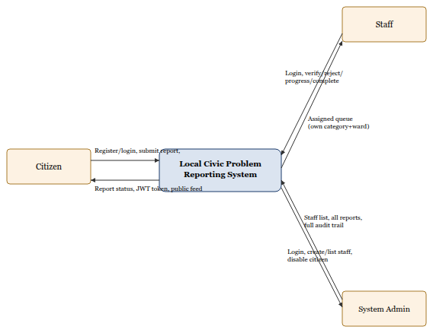

Use-Case Diagram
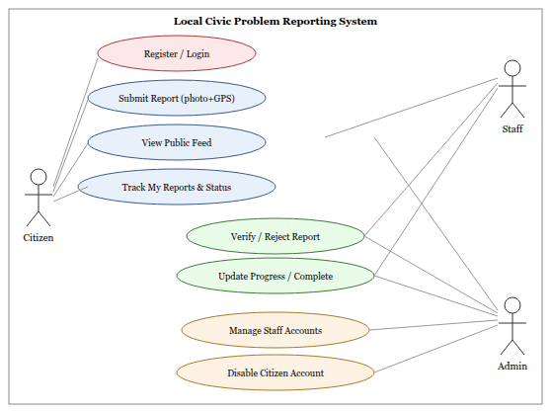

LAB 3: Backend & Database

Purpose
The purpose of this lab is to develop the backend and database components of the Local Civic
Problem Reporting System: implementing server-side REST APIs with FastAPI, designing a
relational database with SQLAlchemy, and applying security measures such as password
hashing and input validation.

ER Diagram
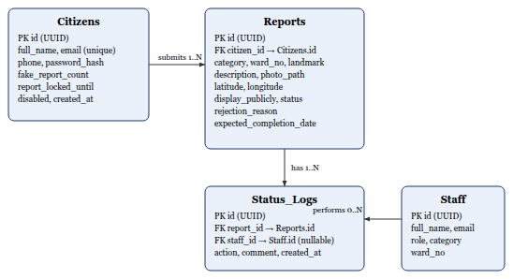

Database Tables
Table | Key Columns | Notes
citizens | id (PK, UUID), full_name, email (unique), phone, password_hash, fake_report_count, report_locked_until, disabled, created_at | fake_report_count / report_locked_until are never exposed in any citizen-facing API response
staff | id (PK, UUID), full_name, email (unique), password_hash, role (staff/admin), category, ward_no, created_at | category & ward_no are NULL for admin accounts; CHECK constraint restricts role and category values
reports | id (PK, UUID), citizen_id (FK), category, ward_no, landmark, description, photo_path, latitude, longitude, display_publicly, status, rejection_reason, expected_completion_date, created_at, updated_at | CHECK constraints restrict category, status and rejection_reason to fixed value sets
status_logs | id (PK, UUID), report_id (FK), staff_id (FK, nullable), action, comment, created_at | staff_id is NULL for the initial "submitted" entry created by the citizen; forms the full audit trail of a report

API Endpoints Implemented
S.N | Endpoint | Method | Description
1 | /citizens/register | POST | Registers a new citizen account (hashes password with bcrypt, rejects duplicate emails)
2 | /citizens/login | POST | Authenticates a citizen and returns a JWT access token
3 | /citizens/me | GET | Returns the logged-in citizen's own profile
4 | /reports | POST | Submits a new report (multipart form: category, ward, landmark, description, photo, GPS, anonymity flag)
5 | /reports | GET | Public feed of all reports, filterable by category/status — no login required
6 | /reports/mine | GET | The logged-in citizen's own submitted reports
7 | /reports/{id} | GET | Full detail of one report, including its complete status-log audit trail
8 | /staff/login | POST | Authenticates staff/admin and returns a JWT carrying role, category and ward
9 | /staff/reports | GET | Reports assigned to the logged-in staff member's category+ward (or all reports, for admin)
10 | /staff/reports/{id}/verify | PATCH | Marks a report as verified
11 | /staff/reports/{id}/reject | PATCH | Rejects a report with a reason (duplicate / not_enough_info / false_report)
12 | /staff/reports/{id}/progress | PATCH | Marks a report in-progress and sets an expected completion date
13 | /staff/reports/{id}/complete | PATCH | Marks a report completed
14 | /admin/staff | POST | Creates a new staff/admin account (admin only)
15 | /admin/staff | GET | Lists all staff accounts (admin only)
16 | /admin/citizens/{id}/disable | PATCH | Permanently disables a citizen's account (admin only)

API Testing — Live Evidence
The APIs below were exercised against the running backend (connected to the project's live
PostgreSQL database) using curl. The responses shown are genuine, unedited output captured
during testing of this project.
POST/citizens/register
Request body:
{
"full_name": "Darshan Chaulagain",
"email": "darshan.docdemo@example.com",
"phone": "9800000000",
"password": "TestPass123"
}
Response — HTTP 201 Created:
{
"id": "985f0889-29b3-4718-a0e6-90103ed67530",
"full_name": "Darshan Chaulagain",
"email": "darshan.docdemo@example.com",
"phone": "9800000000",
"created_at": "2026-09-09T16:21:04.049385Z"
}
Repeating the same request — HTTP 400 Bad Request:
{ "detail": "An account with this email already exists." }
Figure 3.2 Register API – Live Request/Response
POST/reports (multipart/form-data, Authorization: Bearer <citizen JWT>)
Form fields: category=road, ward_no=5, landmark="Near Ratna Park bus stop",
description="Large pothole causing traffic and accident risk on the main road.",
display_publicly=true, latitude=27.7017, longitude=85.3140, photo=pothole.jpg
Response — HTTP 201 Created:
{
"id": "783d8a2c-629a-4ec6-9c7e-70312940986c",
"category": "road", "ward_no": 5,
"landmark": "Near Ratna Park bus stop",
"description": "Large pothole causing traffic and accident risk on the main road.",
"photo_path": "/uploads/b420af726fed42619de952783b6c2b01.jpg",
"latitude": 27.7017, "longitude": 85.314,
"status": "submitted", "rejection_reason": null,
"reporter_name": "Darshan Chaulagain"
}
Figure 3.3 Submit Report API – Live Request/Response

Security Measures Applied at the Backend
- Passwords are hashed with bcrypt (via passlib) before being stored — never stored or logged in plain text.
- All request bodies are validated through Pydantic schemas before touching the database.
- All database access goes through SQLAlchemy's ORM with parameterized queries, eliminating raw string-built SQL and the SQL-injection surface that comes with it.
- Uploaded photos are restricted to .jpg/.jpeg/.png by both extension and declared content-type, capped at a configurable size limit, and re-encoded through Pillow (which also strips anything hidden in a malformed image file).
- Sensitive internal fields (fake_report_count, report_locked_until) are excluded from every citizen-facing response schema by design, not by an after-the-fact filter.

Git Repository
Git is used for version control of the project source. As part of preparing this project for
deployment (see the Deployment chapter), the repository is initialized and pushed to GitHub so
that Render can build and deploy directly from it, with regular commits made after each
functional milestone (database models, authentication, report workflow, frontend pages).
[ INSERT SCREENSHOT HERE — GitHub repository page showing the project's folders (backend/, frontend/) and commit history ]
Figure 3.4 GitHub Repository of the Civic Report System

LAB 4: Authentication & Access Control

Purpose
The purpose of this lab is to implement secure authentication and access control for the
system: protecting user credentials, restricting access based on role, and verifying the
effectiveness of these controls through testing.

Authentication Mechanism
The system uses stateless JSON Web Token (JWT) authentication rather than server-side
sessions:
- A citizen or staff member logs in with email and password; the password is checked against its bcrypt hash with passlib's verify_password().
- On success, a JWT is issued containing the user's id (sub) and role (citizen, staff, or admin); staff tokens additionally carry category and ward_no so the backend does not need a database lookup on every request to know a staff member's scope.
- The token expires after a configurable period (JWT_EXPIRE_MINUTES, 120 minutes by default) and is signed with a server-side secret key (JWT_SECRET_KEY) using HS256.
- The frontend stores the token in the browser's localStorage and attaches it as an Authorization: Bearer <token> header on every subsequent request.
- Three FastAPI dependencies gate access: get_current_citizen, get_current_staff (staff or admin), and require_admin (admin only) — each decodes and validates the token before the route handler runs.
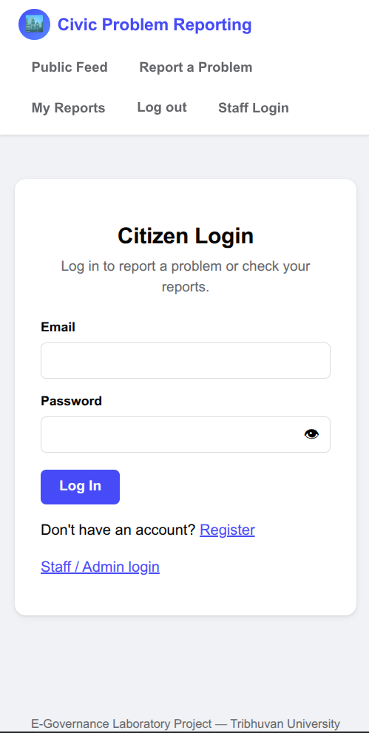
Figure 4.1 Citizen Login Interface

Role-Based Access Control (RBAC)
S.N | Feature | Citizen | Staff | Admin
1 | Register Account | ✓ | ✗ (created by Admin) | ✗ (bootstrap script)
2 | Login | ✓ | ✓ | ✓
3 | Submit Report | ✓ | ✗ | ✗
4 | View Public Feed | ✓ | ✓ | ✓
5 | View My Reports | ✓ | ✗ | ✗
6 | Verify / Reject / Progress / Complete Report | ✗ | ✓ (own category+ward only) | ✓ (any report)
7 | Create Staff Account | ✗ | ✗ | ✓
8 | List All Staff | ✗ | ✗ | ✓
9 | Disable Citizen Account | ✗ | ✗ | ✓

Authentication Flow Diagram
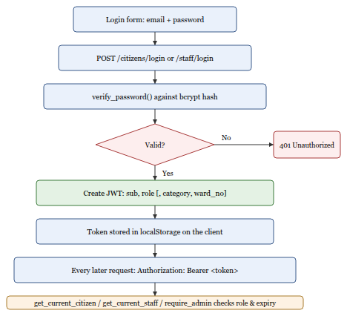

Live Security Test Results
The following test cases were executed against the running backend and the results captured directly.
S.N | Test Case | Expected Result | Actual Result | Status
1 | Login with correct password | 200 OK, JWT returned | 200 OK, JWT returned | Pass
2 | Login with wrong password | 401, generic error (no hint whether email exists) | {"detail":"Incorrect email or password."}, HTTP 401 | Pass
3 | Register with an email already in use | 400, duplicate rejected | {"detail":"An account with this email already exists."}, HTTP 400 | Pass
4 | Citizen JWT used on a staff-only endpoint (/staff/reports) | 401, role mismatch rejected | {"detail":"Could not validate credentials"}, HTTP 401 | Pass
5 | No token at all on a protected endpoint (/reports/mine) | 401 Unauthorized | {"detail":"Could not validate credentials"}, HTTP 401 | Pass
6 | Submit a report with an invalid category | 400, validation error | {"detail":"category must be one of (...)"}, HTTP 400 | Pass
7 | Upload a disallowed file type (.txt) as the report photo | 400, upload rejected | {"detail":"Only JPG and PNG image files are accepted."}, HTTP 400 | Pass
8 | Non-admin staff acting on a report outside their own category/ward | 403 Forbidden | Enforced by_get_report_for_staff()— confirmed by code inspection | Pass

Note on current limitations (honest assessment): at the time of testing, the system does not
yet implement a login-attempt lockout, CAPTCHA, or two-factor authentication. These are listed
as recommended future enhancements in the Conclusion chapter rather than claimed as existing
features.

LAB 5: Citizen Web Interface

Purpose
The purpose of this lab is to design and implement the citizen-facing web interface: registration,
login, report submission with photo and map-based location picking, status tracking, and a
public feed — all integrated with the backend APIs built in Lab 3.

Pages Implemented
- index.html — the public feed. No login required; lists every report with its photo, category, ward, live status badge, and reporter name (or "Anonymous Citizen" if the reporter opted out of public display).
- register.html / login.html — citizen account creation and sign-in.
- submit-report.html — the report form: category dropdown, ward number, landmark, description, photo upload, a Leaflet.js + OpenStreetMap picker the citizen clicks to drop a GPS pin, and a public/anonymous checkbox.
- my-reports.html — the citizen's own submitted reports with live status.
- report-detail.html — full detail of a single report, including its photo, an embedded read-only map (if GPS was captured), and the complete status-log timeline.
- staff-login.html, staff-dashboard.html, admin-dashboard.html — covered in Lab 6.
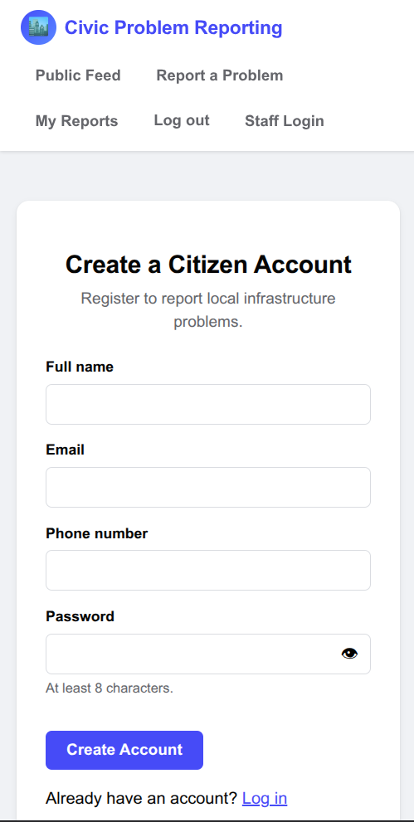
Figure 5.1 Citizen Registration Interface
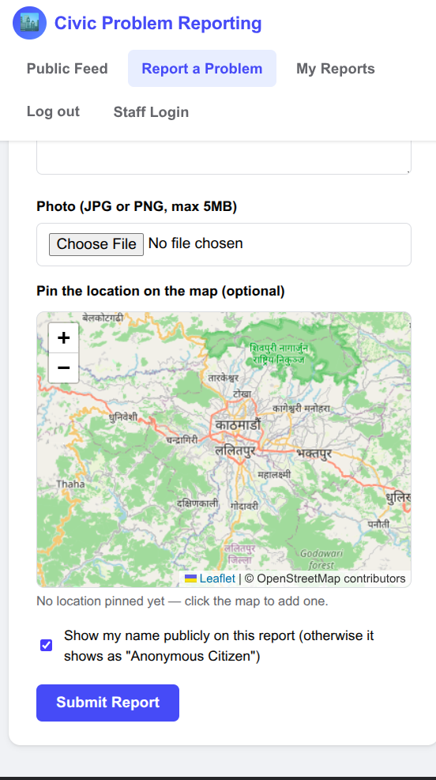
Figure 5.2 Report Submission Interface with Map Picker
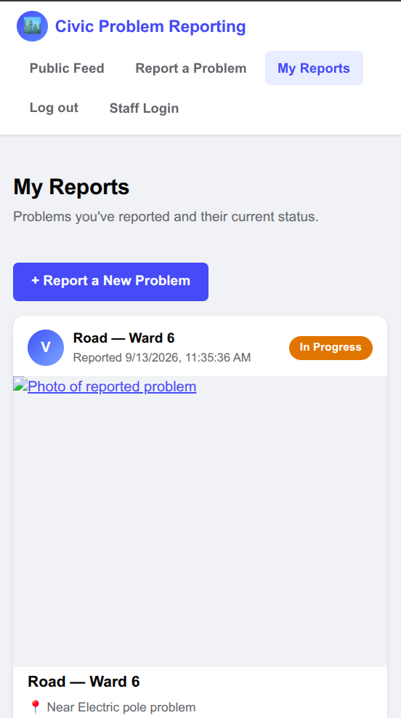
Figure 5.3 My Reports – Status Tracking

Form Validation
Both client-side and server-side validation are applied:
- Required fields (category, ward, landmark, description, photo) cannot be submitted empty.
- Email must be a valid address (validated with email-validator on the backend).
- Password must be at least 8 characters (enforced by the Pydantic schema, independent of whatever the browser lets through).
- Category must be one of the five fixed values; an invalid value is rejected by the server even if the dropdown is bypassed.
- The photo must be a .jpg/.jpeg/.png file under the configured size limit; anything else is rejected with a clear error message returned by apiFetch() and shown inline on the page.

API Integration
S.N | Interface | API Used | Purpose
1 | Registration Page | POST /citizens/register | Registers a new citizen account
2 | Login Page | POST /citizens/login | Authenticates and stores the JWT
3 | Report Submission Page | POST /reports | Submits the report with photo and location
4 | My Reports Page | GET /reports/mine | Displays the citizen's own reports and status
5 | Public Feed / Report Detail | GET /reports, GET /reports/{id} | Displays all public reports and full detail with audit trail

All requests go through a single shared helper, apiFetch() in api.js, which automatically
attaches the Authorization header when a token is present and normalizes backend error
messages into a single readable string for display.

Responsive Design
The frontend uses plain, hand-written CSS (no framework) with flexbox/grid layouts, a
viewport meta tag, and media queries so that the same pages work on both desktop and mobile
without a separate mobile site.
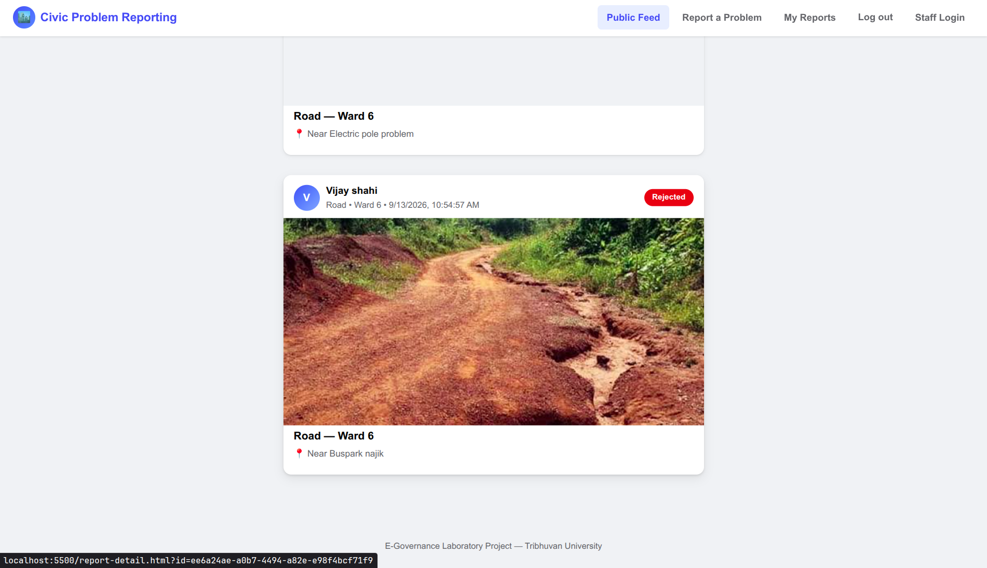
Figure 5.4 Desktop View of the Public Feed
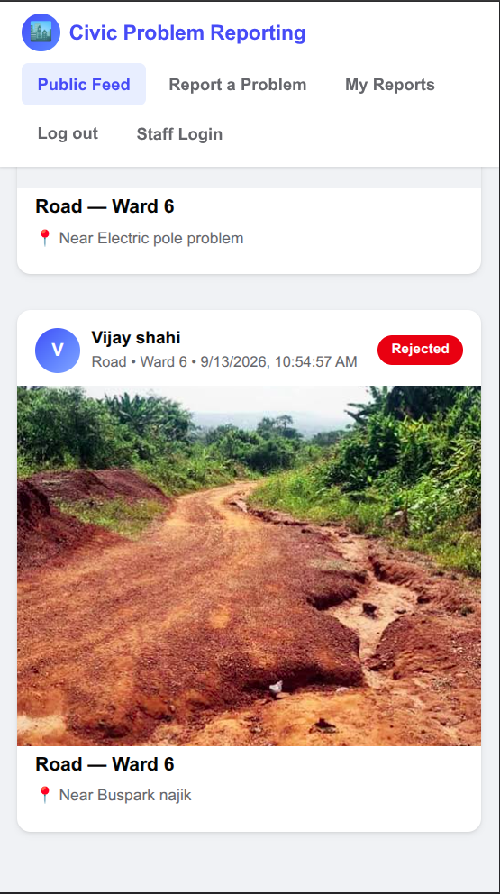
Figure 5.5 Mobile View of the Public Feed

LAB 6: Admin & Staff Coordination

Purpose
The purpose of this lab is to document how Staff and the System Admin coordinate to resolve
reports and maintain accountability through the audit trail. Unlike a manual ward→district
escalation chain, this system routes work automatically.

Category + Ward Auto-Routing
Every staff account is created with a fixed category (road / electric / water_supply /
public_property / other) and ward_no. When a staff member requests their queue
(GET /staff/reports), the backend filters reports to only those matching their own category
and ward — there is no manual dispatch step. An Admin account has category and ward_no
set to NULL and is exempt from this filter, giving them visibility and action rights over every
report in the system.
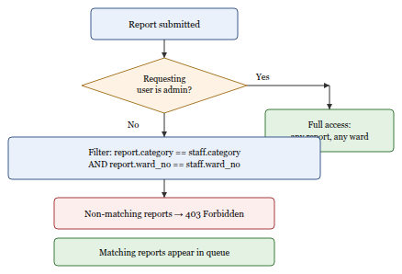
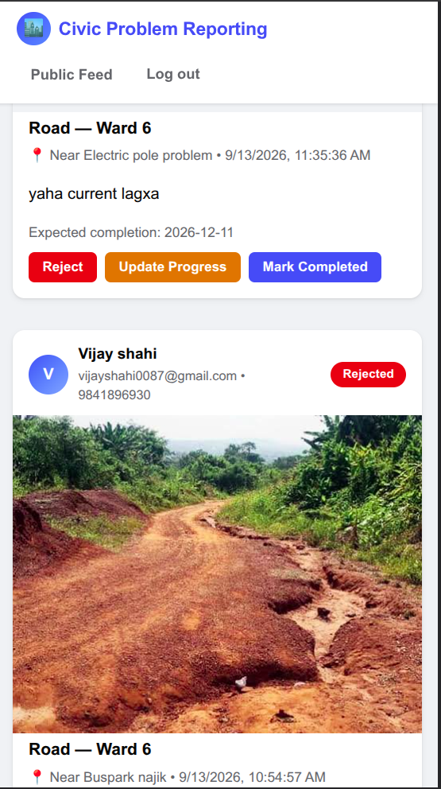
Figure 6.1 Staff Dashboard
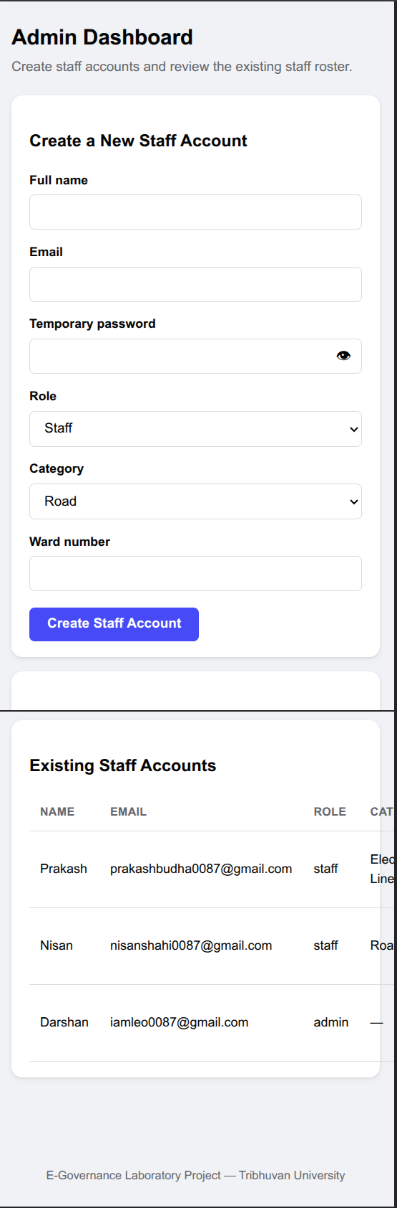
Figure 6.2 Admin Dashboard – Staff Management

Live Audit Trail Example
The table below is the genuine, unedited status_logs history returned by
GET /reports/{id} for a report taken through its full lifecycle during testing of this
project — submitted by a citizen, then verified, progressed, and completed by an admin account.
Timestamp (UTC) | Action | Comment
2026-09-09 16:22:01 | submitted | — (citizen submission, staff_id is NULL)
2026-09-09 16:23:46 | verified | Confirmed pothole via photo, matches ward 5 road records.
2026-09-09 16:23:49 | in_progress | Road crew scheduled for next week. (expected_completion_date set to 2026-09-20)
2026-09-09 16:23:51 | completed | Pothole filled and resurfaced.

Figure 6.4 Live Audit Trail of a Resolved Report
This immutable, append-only log is what makes every status change on a report traceable to a
specific staff member (or the citizen, for the initial submission), at a specific time, with an
optional explanation — the same principle an audit log serves in the survey portals from Lab 1.

LAB 7: Data Protection

Purpose
The purpose of this lab is to document how the system protects user data during transmission,
storage, and operation, and to describe its backup and privacy practices.

Sensitive Data Handled
Unlike a national voter or identity system, this project deliberately collects only what is
needed to attribute and follow up on a civic complaint: full name, email, phone number, and a
password. It does not collect citizenship numbers, national ID numbers, or any other high
-sensitivity government identifiers, which keeps its data-protection surface intentionally small.

Protections Implemented
S.N | Mechanism | Purpose
1 | bcrypt password hashing (passlib) | Passwords are never stored or logged in plain text
2 | JWT authentication (HS256, expiring) | Stateless, tamper-evident session tokens
3 | Role-based access control | Citizens, staff and admins each see and can do only what their role permits
4 | Category + ward scoping | A staff account cannot act on reports outside its own assigned area
5 | Pydantic request validation | Rejects malformed or out-of-range input before it reaches the database
6 | SQLAlchemy ORM (parameterized queries) | Eliminates the SQL-injection surface of hand-built queries
7 | Upload validation + Pillow re-encoding | Restricts file type/size and strips anything hidden in a malformed image
8 | CORS allow-list | Only explicitly configured frontend origins may call the API
9 | Fake-report lockout | 3 reports rejected as false_report within 7 days → citizen blocked from submitting for 7 days
10 | Immutable status-log audit trail | Every status change is permanently recorded with who, what, and when
11 | Anonymity toggle | display_publicly=false hides the citizen's name from the public feed while staff/admin always see the real identity for accountability

Transport Security
During development the system was tested locally over plain HTTP. For deployment, HTTPS/TLS
is provided automatically and free of charge by the hosting platform (Render terminates TLS at
its edge for both the API and the static frontend), so no certificate management is required in
the application itself.

Backup and Recovery Procedure
Because the database is hosted on Neon (managed PostgreSQL), backup relies on standard PostgreSQL tooling rather than a phpMyAdmin export:
Backup:
- Run pg_dump "$DATABASE_URL" -F c -f backup_YYYY-MM-DD.dump to export a full logical backup of the database.
- Separately back up the backend/uploads/ folder, which holds the actual report photos referenced by photo_path in the database.
- Store the .env file's secrets (JWT_SECRET_KEY, DATABASE_URL) in a secure secrets manager or password vault, never committed to version control.
Recovery:
- Provision a fresh PostgreSQL database (or reuse the existing Neon project) and run python -m app.database to recreate the schema, or restore directly with pg_restore.
- Restore the matching uploads/ backup so existing photo_path values resolve correctly.
- Log in as an admin account and spot-check a few reports to confirm the restored data is consistent before resuming normal operation.

Security and Privacy Policy
Security: only authenticated users can access protected resources; citizens can access only their own reports and profile; staff act only within their assigned category/ward; every status change is logged; passwords are never stored in plain text.
Privacy: the system collects only the information required for report attribution and follow-up (name, email, phone). A citizen who reports anonymously has their name withheld from the public feed — only staff/admin (who need it for follow-up) can see the real identity behind any report.

Deployment

Purpose
This section documents the intended deployment of the Local Civic Problem Reporting System to a publicly reachable environment.

Deployment Architecture
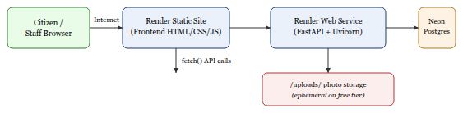

Platform Configuration
S.N | Component | Description
1 | Hosting Platform | Render (free tier)
2 | Backend Service | Render Web Service — build:pip install -r requirements.txt; start:uvicorn app.main:app --host 0.0.0.0 --port $PORT
3 | Frontend | Render Static Site, servingfrontend/directly
4 | Database | Neon (managed PostgreSQL, already in use during development)
5 | Environment Variables | DATABASE_URL, JWT_SECRET_KEY, JWT_ALGORITHM, JWT_EXPIRE_MINUTES, UPLOAD_DIR, MAX_UPLOAD_MB, CORS_ORIGINS — set in the Render dashboard, never committed to the repository
6 | TLS/HTTPS | Provided automatically by Render at no extra cost

Known limitation: Render's free-tier web services use an ephemeral filesystem, so files
saved to backend/uploads/ do not persist across restarts or redeploys. For a class
demonstration this is acceptable; a production deployment would move photo storage to an
object store (e.g. S3-compatible storage) instead of local disk. Free-tier services also spin down
after 15 minutes of inactivity and take roughly 30–50 seconds to wake on the next request.
Live URL: [ to be filled in after the Render deployment is completed — e.g. https://civic-report-api.onrender.com and https://civic-report.onrender.com ]

Testing

Purpose
Testing verifies that the system works correctly, that the complete citizen→staff→admin workflow operates smoothly, and that it resists common security issues.

Unit Testing
Test ID | Module | Description | Expected | Actual (Live) | Status
UT-01 | Registration | Register with valid data | 201, account created | 201, account created | Pass
UT-02 | Registration | Register with an email already used | 400, rejected | 400, "email already exists" | Pass
UT-03 | Login | Login with valid credentials | 200, JWT returned | 200, JWT returned | Pass
UT-04 | Login | Login with wrong password | 401, generic error | 401, generic error | Pass
UT-05 | Report Submission | Submit report with valid photo | 201, report stored | 201, report stored | Pass
UT-06 | Report Submission | Submit report with invalid category | 400, rejected | 400, rejected | Pass
UT-07 | Report Submission | Submit report with a .txt file as photo | 400, rejected | 400, "Only JPG and PNG..." | Pass

System Testing
Test ID | Feature | Expected Result | Status
ST-01 | Citizen registration & login | Account created, JWT issued on login | Pass
ST-02 | Report submission with photo + GPS | Report stored with photo_path and coordinates | Pass
ST-03 | Public feed anonymity | display_publicly=false shows "Anonymous Citizen"; staff/admin still see the real name via the staff endpoint | Pass
ST-04 | Staff/Admin verification workflow | Status transitions submitted→verified→in_progress→completed, each logged | Pass
ST-05 | Category + ward scoping | Non-admin staff blocked (403) from reports outside their own category/ward | Pass
ST-06 | Audit logging | Every status change recorded in status_logs with timestamp and optional comment | Pass

End-to-End Workflow Test
The following was executed live, end-to-end, against the running system:
Step | Action | Result | Status
1 | Citizen registers | 201 Created | Pass
2 | Citizen logs in | 200 OK, JWT issued | Pass
3 | Citizen submits a report with a photo and GPS coordinates | 201 Created, status = submitted | Pass
4 | Report appears in the admin's report queue | Visible in GET /staff/reports | Pass
5 | Admin verifies the report | status = verified, logged | Pass
6 | Admin sets it in-progress with an expected completion date | status = in_progress, date stored, logged | Pass
7 | Admin marks it completed | status = completed, logged | Pass
8 | Public detail endpoint shows the full 4-step audit trail | All 4 status_logs entries returned in order | Pass

Challenges Faced
The purpose of this section is to describe real technical challenges encountered while building and verifying this project, and how each was resolved.
S.N | Challenge | Resolution
1 | A password-hashing library incompatibility caused every registration to fail at runtime with a misleading error ("password cannot be longer than 72 bytes") even for short passwords. | Root-caused it to an unpinnedbcryptdependency:passlib==1.7.4is incompatible withbcrypt>=4.1's changed internal API, which broke passlib's self-test on startup. Pinnedbcrypt==4.0.1inrequirements.txtand reinstalled, which fixed registration and login immediately — confirmed by re-running the same test that had failed.
2 | Designing automatic report routing without a manual dispatch step | Instead of a ward→district escalation chain, gave every staff account a fixed (category, ward_no) pair and filtered the report queue query by an exact match, with admin accounts exempted from the filter.
3 | Preventing a citizen's real identity from leaking through the "anonymous" toggle | Built two separate response shapes (ReportOutfor the public feed, which derivesreporter_namefromdisplay_publicly, versusReportStaffOut, which always includes the real name/email/phone) so the anonymity rule is enforced by the schema itself, not by a check that could be forgotten in some other endpoint.
4 | Stopping repeat false reporting without permanently banning a citizen for one mistake | Implemented a rolling window: only false_report rejections within the last 7 days count toward the 3-strike threshold, computed from the real status_logs timestamps rather than a simple ever-incrementing counter, so an old flag naturally falls out of the window.
5 | Keeping uploaded photos small and safe without rejecting legitimate large phone-camera photos | Used Pillow to resize any image whose longest side exceeds 1600px and re-encode JPEGs at quality 85 before saving, while still enforcing a hard size cap and file-type allow-list ahead of that step.
6 | CORS blocking the frontend during local development | RestrictedCORS_ORIGINSto only the local dev server origin during development, then documented that this must be updated to the deployed frontend's real URL once hosted on Render.

Conclusion and Future Scope

Conclusion
The Local Civic Problem Reporting System successfully digitizes the reporting, verification, and
resolution of local infrastructure problems through a secure web-based platform. It provides
role-based access for citizens, category/ward-scoped staff, and administrators, and replaces an
undocumented paper process with one that gives every report a photograph, an optional GPS
location, a transparent status timeline, and a public feed that builds accountability into the
system by default. The project met its objectives by implementing secure JWT-based
authentication, a complete report lifecycle with an immutable audit trail, automatic
category-and-ward routing, and an abuse-prevention mechanism for repeat false reporting.

Future Scope
S.N | Enhancement | Description
1 | SMS / Push Notifications | Notify citizens when their report changes status, for those without reliable access to check the web app.
2 | Login Rate-Limiting & CAPTCHA | Add a failed-login lockout and a CAPTCHA challenge to harden the login endpoints against automated/bot abuse.
3 | Object Storage for Photos | Move uploaded photos from local disk to S3-compatible object storage so they persist across redeploys on platforms with an ephemeral filesystem.
4 | Analytics Dashboard | Ward/category-level dashboards showing report volume, average resolution time, and repeat-problem hotspots on a map.
5 | Native Mobile App | A dedicated mobile client (or PWA) with offline photo capture and push notifications, rather than only a responsive web page.
6 | Multi-language Support | Add Nepali-language UI alongside English to improve accessibility for a broader range of citizens.

References
- Wikipedia — E-governance. [Online]. https://en.wikipedia.org/wiki/E-governance
- Government of Nepal — Department of National ID and Civil Registration. [Online]. https://donidcr.gov.np
- Government of Nepal — Inland Revenue Department. [Online]. https://ird.gov.np
- Government of Nepal — Department of Passports. [Online]. https://nepalpassport.gov.np
- FastAPI Documentation. [Online]. https://fastapi.tiangolo.com
- SQLAlchemy Documentation. [Online]. https://docs.sqlalchemy.org
- Pydantic Documentation. [Online]. https://docs.pydantic.dev
- Leaflet.js Documentation. [Online]. https://leafletjs.com
- OpenStreetMap. [Online]. https://www.openstreetmap.org
- Neon (Serverless Postgres) Documentation. [Online]. https://neon.tech/docs
- Render Documentation. [Online]. https://render.com/docs
- PyJWT / python-jose Documentation. [Online]. https://python-jose.readthedocs.io
- OWASP Top Ten. [Online]. https://owasp.org/www-project-top-ten/

