**SPMP**

**Easy Track**

**Lesley Hernandez**

**Table of contents**

|  |  |
| --- | --- |
| Content | Page |
| Project Objectives | 3 |
| Documents | 4 |
| Timeline | 4 |
| Scope | 6 |
| Part 1 | 7 |
| Part 2 | 9 |
| Part 3 | 10 |
| Part 4 | 11 |
| WBS | 12 |
| Gantt Chart | 13 |

**Project Objective**

|  |  |
| --- | --- |
| Easy Track | 06/30/2021 |
| Objective | * Allows user to take picture on mobile application in order to send it in order to record location * Allows user to log into account * Should allow user to login in order to be paid * The website should contain an admin login in order for admin to access data from the employee that day. * Website consists of different sections, such as salary, view image, view location, add an employee, and logout. * This should allow admin to verify the productivity of employees to ensure proper payment * The website will give proper coordinates and demonstrate them on a map (like google maps) * The website needs to be able to receive data from the application in order to apply it to the employee. * The website will allow user to change password to account as an option when viewing data. |

**Documents**

|  |  |
| --- | --- |
| Deliverables | Content |
| 1 | Use Cases/Requirements |
| 2 | SPMP |
| 3 | Design Documents |

**Timeline**

|  |  |
| --- | --- |
| Week Number | Content |
| 1,2,3 | Planning |
| 4,5 | Execution/testing |
| 7,8,9 | Evaluation |

**Scope**

|  |  |
| --- | --- |
| Start Date | 05/24/2021 |
| Launch Date | 07/20/2021 (Estimate |
| End Date | 08/02/2021 |
| Progress dates | 06/30/2021 - Review  07/12/2021 - Tech presentation  07/20/2021 - expected launch date  07/26/2021 - Presentation  08/02/2021 - final day for project |
| Budget | $300 |
| Constraints | Utilization of proper frontend and backend languages which can depend on if management decides to start from scratch or look for sources. |
| Estimated Hours & weeks | 50 hours is expected  10 weeks for project |

**Part 1- Introduction**

**1.1 Project Overview**

A client has expressed their desire to incorporate the following two ideas of combining payroll with the establishment of location for fieldworkers. They have contracted me in order to create a user friendly experience in allowing the admin to access this information through a database online. This website will allow the admin to do the following:

* Add an employee
* View salary
* View location
* View Images

This allows the field worker to interact with an application on their phones to which they take pictures as a form of clocking in, which then saves precise location in order to receive payroll.

**1.2 Project Deliverables**

* Use cases
* Requirements
* Software Project Management Process
* Repo

**1.3 Evolution of the SPMP**

This project is under constant change, the only anticipated change that is going to occur is the possible changes in the development process and estimated dates that have been set. Unanticipated change could vary from dissatisfaction from the client to improper function from the website.

**1.4 Reference Materials**

As of now, no materials have been referenced. Once they are, the list will be updated.

**1.5 Definitions and Acronyms**

This is a list of possible acronyms in the text that might help understand this document, however most of the content will be specifically described.

* SPMP - Software Project Management Plan
* QA - Quality Assurance
* UI - User Interface
* UX - User Experience
* HTML - Hypertext Markup Language
* CSS - Cascading Style Sheets
* JS - JavaScript
* MySQL - Structured Query Language
* HTTPS - Hypertext Transfer Protocol Secure
* WBS - Work Breakdown Structure

**Part 2 - Project Organization**

**2.1 Process Model**

We were planning on using agile, the management team found Version One which will allow us to manage everything from there.

**2.2 Organization Structure**

* Internal Structure/ Members
* Lesley Hernandez

**2.3 Organization Interfaces**

* Github
* Version One
* Word Press

**2.4 Project Responsibilities**

As far as development to designer and tester, the only member working on everything is Lesley.

**Part 3 Managerial Process**

**3.1 Management Objectives and Priorities**

The budget put in place is about $300 for this project. Management would like to stay under but going over wouldn’t necessarily disappoint the client. Management has a strong philosophy for being able to create an easy and friendly user experience. Our priorities lie within being able to meet deadlines, as late projects reflect poorly on us.

**3.2 Assumptions, Dependencies, and Constraints**

Some external events that might affect project dependency is ensuring we receive licensing for any outsourced code or plug in on time in order to stay ahead of deadlines. Other events are ensuring code selected works properly for what the client desires. Constraints can vary on factors such as budget which directly affects the timeline of the project.

**3.3 Risk Management**

We have to ensure we stay within the budget limit in case the client runs out of money for the project, thus leaving us with an incomplete website. It’s important to establish an accurate size for this project to avoid budget overflow and to stay on time. In order to manage risk, we have to communicate with our client in regards to every aspect they want for this project so we do not have multiplying requirements. Multiplying requirements tends to extend the timeline which then requires more money. If our client doesn’t like the prototype, we have no choice but to accommodate their needs, however this can be avoided through constant communication.

**3.4 Staffing Plan**

The only personnel working on this project is Lesley alongside with management.

**3.5 Monitoring and Controlling Mechanisms**

We plan on meeting with our client in regards to any reports or issues.

**Part 4 Technical Process**

**4.1 Methods, Tools and Techniques**

As far as front end languages, HTML, CSS, or Javascript are being considered and won’t be decided upon until the beginning of the execution process. We will be needing to host our website, therefore Godaddy might work for that.

**4.2 Software Documentation**

There is a readme file within the repository that will contain all of the proper documentation.

**4.3 Project Support Function**

Plans for ensuring Quality

* Testing any code or plugins used
* Ensuring cases are used
* HTTPS

**Part 5 Description of Work packages**

**5.1 WBS**

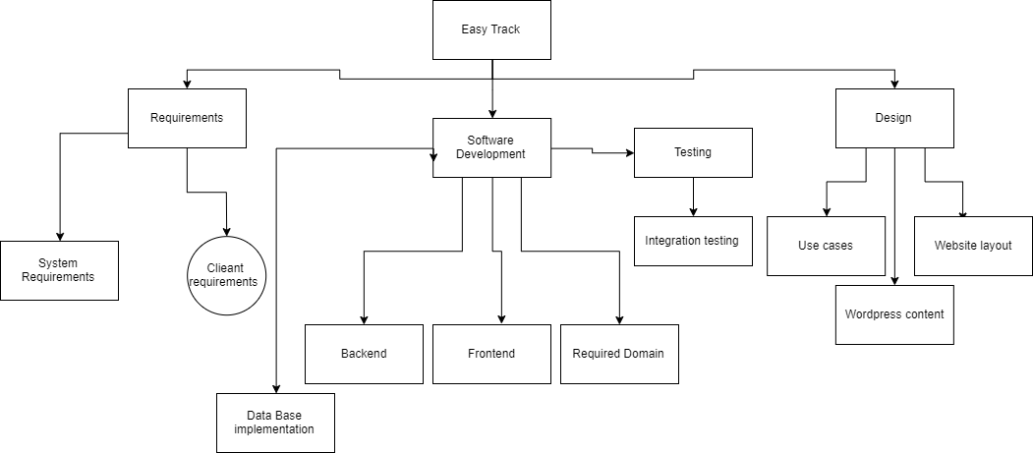

**5.2 Gantt Chart**

