**Price Point**

**Overview:**

This project is a simple game you can play with friends. Players will take turns being the “Price Fixer”. All other players will then be informed they are “Bidders”. The Price Fixer is responsible for searching through online stores (such as Amazon, Fiverr, Craigslist, etc.) to find strange items and their prices. After the Price Fixer selects and submits an item, control of the game is transferred to the Bidders. The Bidders all will get the chance to guess what that item costs. Once all Bidders have submitted a quote, the following rules will determine the winner:

* The player with the closest guess without going over wins one point.
* If a player guesses within %10 of the item’s real value, they get 5 points.
* If all the guessers go over the price of the item, the poster gets 10 points.
* Players can choose how many points wins the game.

Some friends and I got together and played this game using discord to send the images and place the guesses as an experiment. It was a lot of fun.

**Mock-ups:**

The game can be playable from both desktop browsers and phones, so there will be two distinct interfaces to connect to the game service.

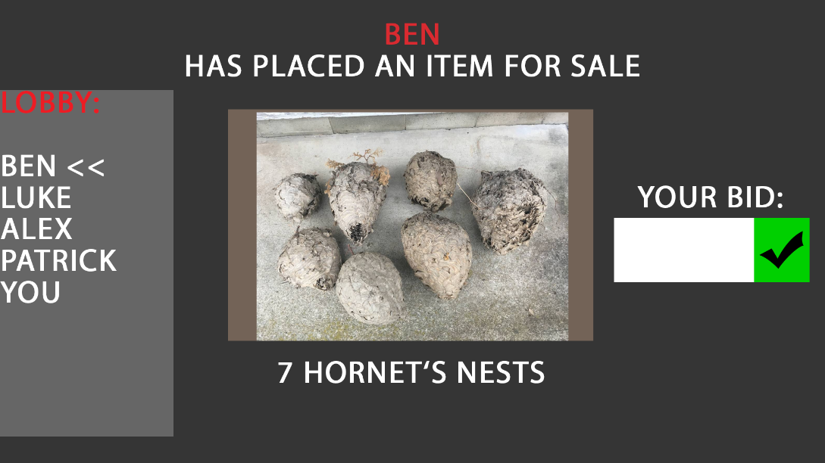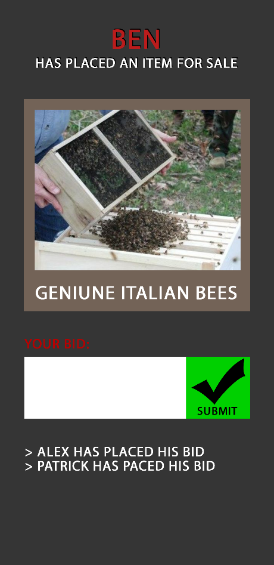Mobile: Desktop:

**Functionality:**

The game is intended to be extremely flexible and simple. Players should be able to connect to a web site, and be able to start, join, and play games with their friends.

The intended flow is as follows:

1. Some friends decide they want to play Price Point
2. They all connect to a website running Price Point
3. One person starts a lobby for their group, and hands out an invite code
4. Everyone else uses that code, and is connected to their friends
5. Once everyone is in, someone can hit the “Start Game” button.
6. Once the game starts, one Price Fixer will be chosen at a time
7. The Price Fixer can upload an image, and a price
8. The Bidders can then guess the value of that item
9. Once all bids are in, the winner is announced.
10. A new Price Fixer is chosen and steps 7 -> 10 repeat

**Design:**

The backbone of this project will rely on SignalR, an ASP.Net library maintained by Microsoft. SignalR works on a Hub / Client architecture, where the Hub is a web service written in C# that can then call JavaScript methods embedded in the client’s web browser. SignalR is extremely powerful, and easy to use.

**PricePointHub:**

The PricePointHub is the SignalR hub that controls the behavior of every connected client. Specifically, the PricePointHub is responsible for:

* Initializing and maintaining the game state on the server
* Providing clients access to read and modify the game state
* Providing an interface to facilitate a lobby chat functionality for connected players
* Providing controls for clients to trigger game events (I.E providing bids)
* Providing controls to update clients in response to game events (I.E Starting new rounds with a new price fixer)

**The Client:**

The game client is responsible for providing an interface for the players to see and play Price Point. It will include an HTML front end, with two user interfaces. Mobile players will see the Mobile Interface, and Desktop players will see a Desktop interface.

The backend for both interfaces will be identical, and will provide the following functionalities:

* Provide methods for the game hub to call to manipulate the user interface
* Provide mechanisms for capturing user input
* Provide methods for forwarding user input to the server to allow the player to interact with the game

**The PricePointGame:**

The PricePointGame class will be C# object maintained by the server that tracks the game’s state for all the connected clients. This class should track information and rules like:

* Who is connected to the game?
* Has the game started?
* Who is the current Price Fixer?
* How does the server transition between rounds?