

**PROJECT:** Excell-On Service

**GROUP NO:** 04 **BATCH**: T1.2112.E0

# SYSTEM REQUIREMENTS:

|  |  |  |
| --- | --- | --- |
| **Sr.** | **Item** | **Description** |
| 1. | Operating system | Windows 7, 8, or higher |
| 2. | Hardware | CPU Cores or better with 2 Gigabytes of RAM or better |
| 3. | Web Browser | Version in later of: Edge, Firefox, Chrome, etc… |
| 4. | Fonts | Standard font Unicode: Arial, Tahoma, Lucida Console, Times New Roman, etc… |
| 5. | Other requirement | Node JS, Git, Visual Studio | A working internet connection. |

1. **Program Instrallation**

## Step 1. Clone Project to Computer

- *Open* ***Command Prompt*** *(****cmd – Figure H1)***

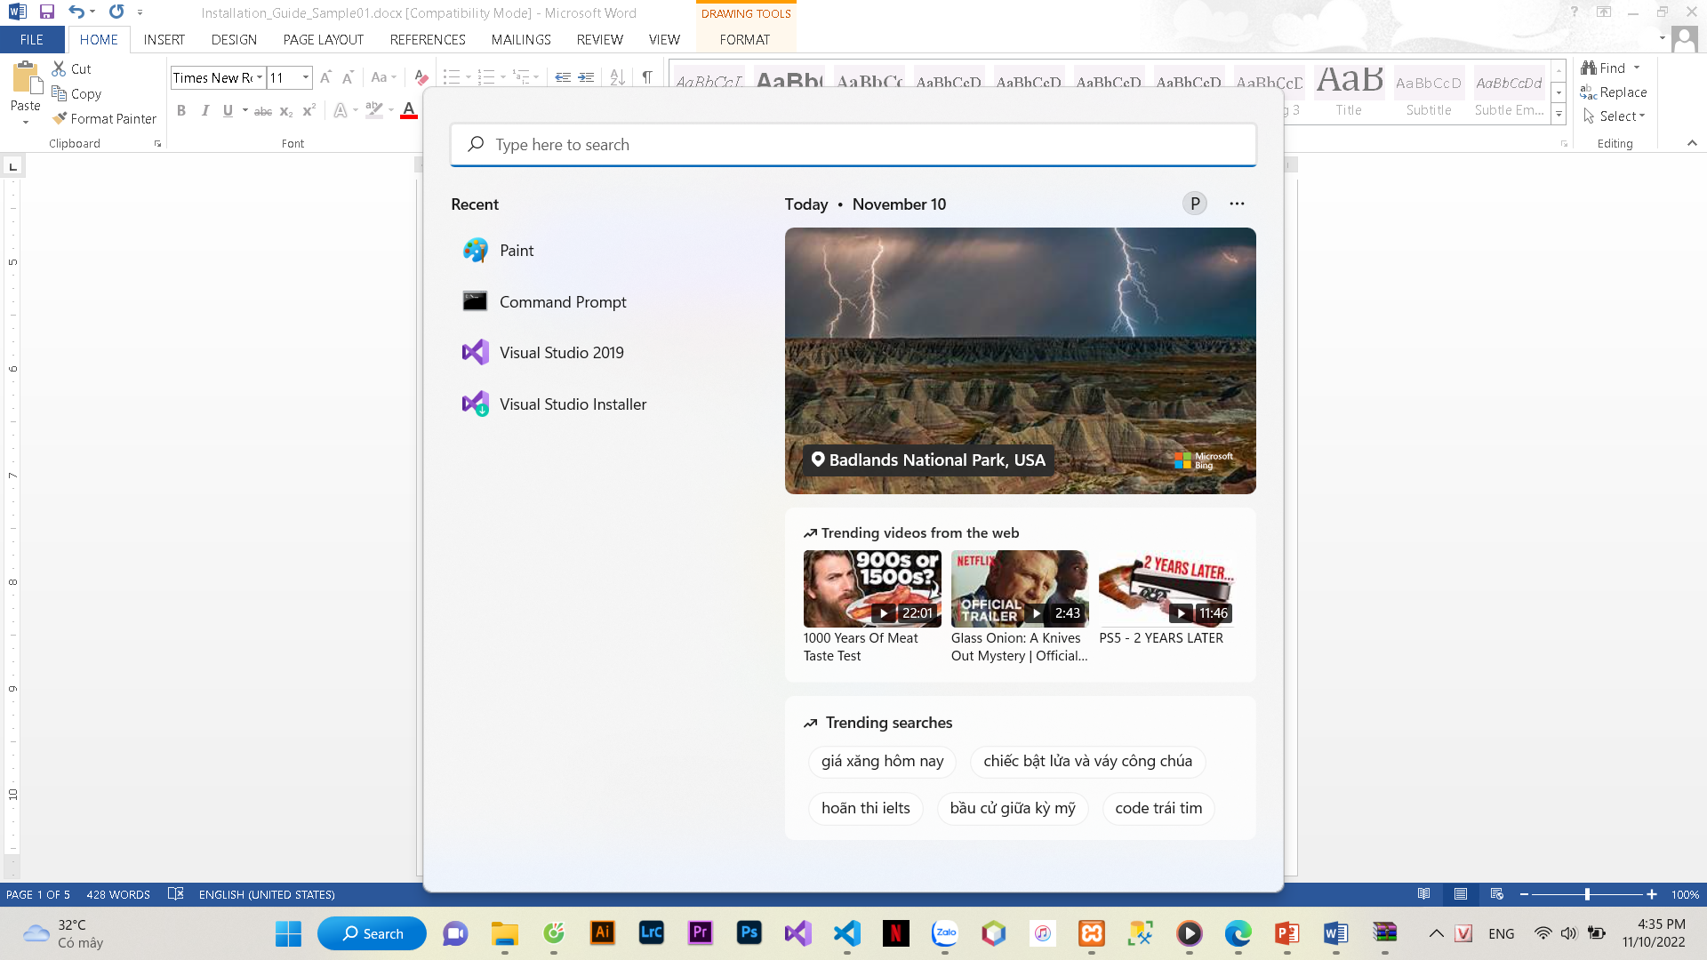

**Figure H1**

(*) - Installation documentation is included with the installation disc, should follow the proper format which have clear and complete content for anyone to perform.

* + *The Center performs the installation and give a notification of the protection list for successfully. Project not successfully installed is Fail.*
    - ***Go to htdocs folder*** and ***Clone*** *the Project with* ***syntax*** *as the* ***figure H2***
    - 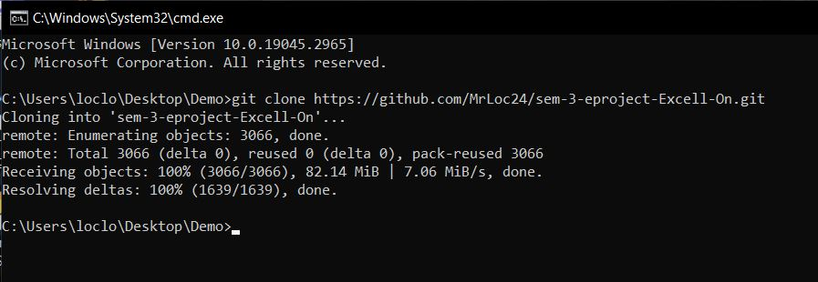**Git clone** [**https://github.com/MrLoc24/sem-3-eproject-Excell-On.git**](https://github.com/MrLoc24/sem-3-eproject-Excell-On.git)

**Figure H2**

## Step 2. Install Dependencies*Visual Studio, open excell_on solution.*

* 1. *Open solution*

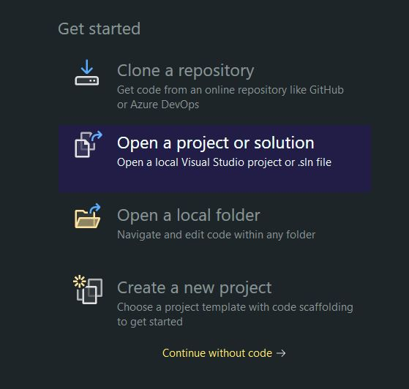

**Figure H3**

* 1. *Add solution to your workspace*

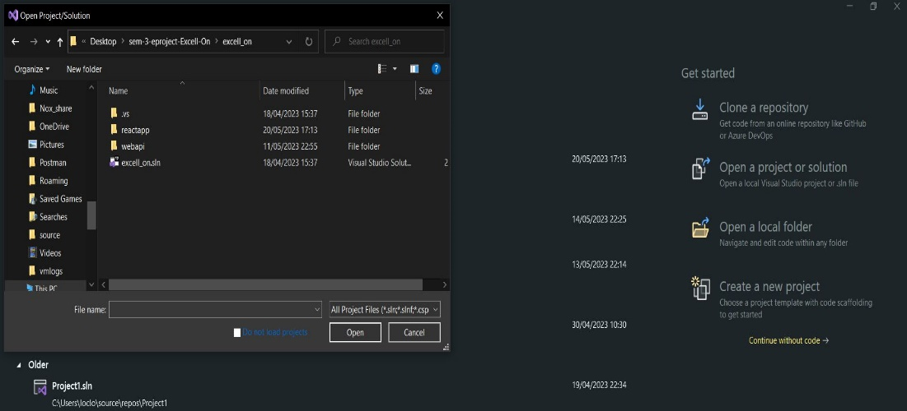

**Figure H4**

## Step 3. Setup Database

* *In this project we use Azure Cloud Database so you don’t have to set up database manually, but just in case we are out of money, there is a backup database script in project folder*
* *Open your Microsoft SQL Server Management Studio*
* *Add query from Documentations/Database/script.sql*

## Step 4. Run Project

## -*After add solution to Visual Studio, just click start*

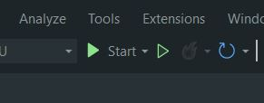

**Figure H5**

* + *Open Web Browser, type localhost:3000/admin* (Username: loc, Password: 12345)*.*
  + *Homepage should be displayed as described in the documentation Figure H6 for admin. H7 for user.*

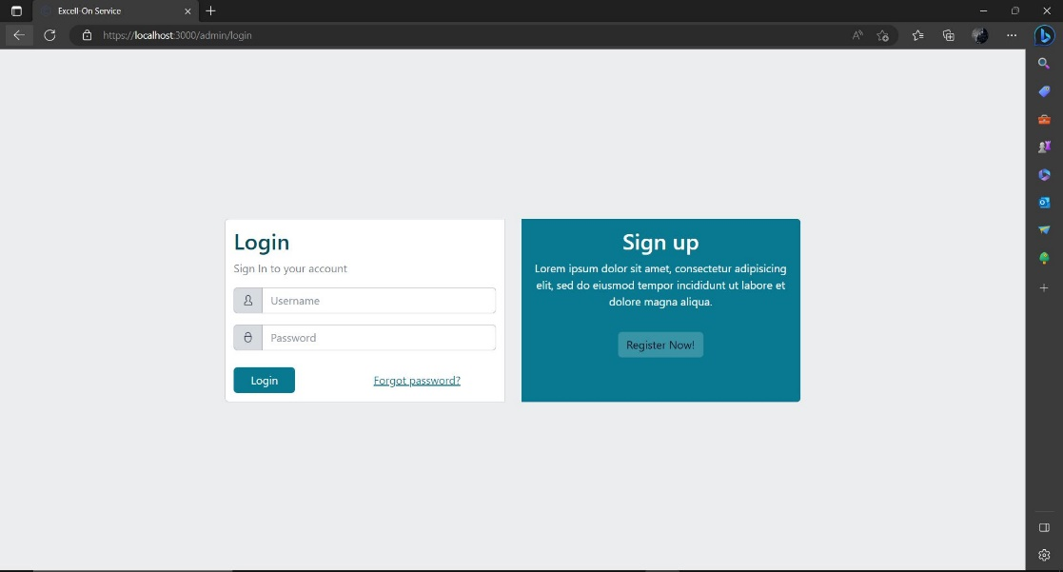

**Figure H6**

**Figure H7**