Slurigma Version 0.0.1 (BETA MALE!… I mean BETA TEST)

Description:
Slurigma is a chrome extension that lets you use the brilliant make bad words safe tool from http://www.slurmachine.fun right from any page in chrome. Slurigma adds a context (right-click) menu named “Slurigma” with two sub-menus ‘Encode’ and ‘Decode’.

Use:
To Encode (make NPC safe):
Select the text you’d like to encode. Right-click and from the Slurigma click the sub-menu ‘Encode’.
An alert box will pop up showing you the encoded text and will copy that text to the clipboad. Right click the selected text again and click ‘paste’ and there you go: NPC safe speak.
To Decode:
Select the encodeD text. Right-click and from the Slurigma menu click the sub-menu ‘Decode’. An alert box will pop up showing you what the sender really intended to say. So Problematic. The decode

Limitations:
Decode currently only decodes ‘Today’s Words’ working on implementing allow decoding message back to the beginning of http://www.slurmachine.fun

There are some features still a work in progress:
Encode replaces selected text with encoded text without a pop up window and the need to paste it.
Make it pretty and available on the Chrome Store.

If you have any suggestions or questions hit me up at MrLowVolt@gmx.com. Or https://twitter.com/Charlie64318803

Load extension to Chrome:
Since this is a beta you can’t get this extension from the chrome webstore. You’ll have to load it in ‘Developer Mode’ with the following steps:

[1] Open Chrome and Type ‘chrome://extensions’ into the address bar and hit enter. Select the slider in the top right of the page ‘Developer Mode’ and you should have a page similar to the following:

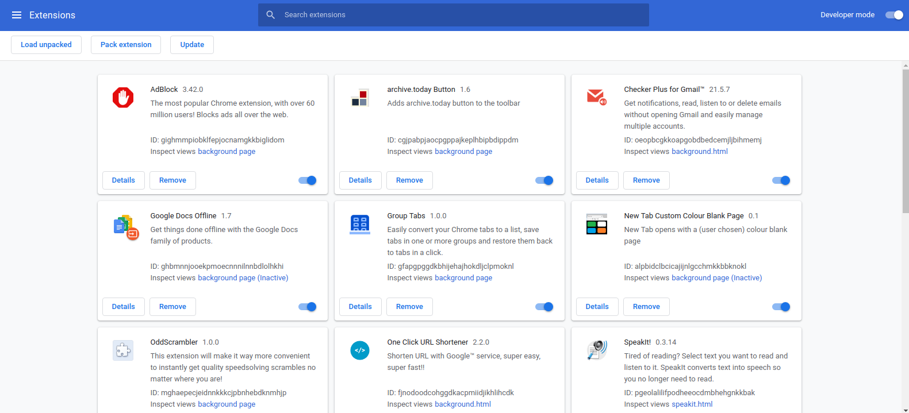
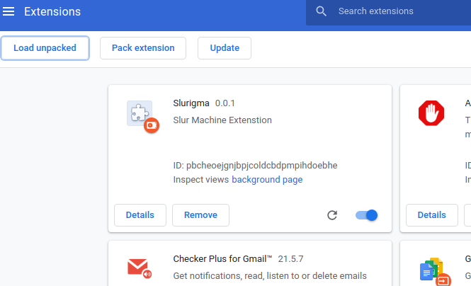
[2] Click ‘Load unpack’. Chrome will open a file dialog box. Navigate to where you unzipped the extension and select the folder ‘Slurigma’. You should now have the following extension on your list:
That’s it, now you’re ready to use Slurigma.

