NAME SAMMY DAVIS ADM NO 8031 CLASS HARVARD
ST. THERESE MBOONI GIRLS HIGH SCHOOL
451/1
COMPUTER STUDIES
FORM 2 EXAM

END TERM 1-2025

INSTRUCTIONS TO CANDIDATES
- Write your name and index number in the spaces provided above.
- Answer ALL the questions .
- All answers should be written in the spaces provided on the question paper.

- Give any two peripheral devices which get their power supply from the system unit through ports. (2marks)
Mouse
Keyboard
- Raphael selected a paragraph in word processing. Explain what happened after pressing the following keys on the keyboard. (3 marks)
- Ctrl + I : Italicize
- Ctrl + U : Underline
- Ctrl + B: Bold
- Outline the functions of the following units/ devices in a computer system. (3 marks)
- Input devices.
Convert physical data to digital data
- Output devices.
Displays out the output of the processing
c) Memory.
Store information after processing and before processing

- A worksheet contains the data as shown below.
 | A | B | C | D | E | F | G
1 | 8 |  | 20
2 | 11 |  | 45
3 | 14 |  | 52
4

- The formula = COUNTIF (CI: C3,>=”20”) was entered at GI. Write down the value that was displayed.
(1mk)
2
- Write down the formula that would be entered at cell B7 to sum the values in column A whose values are greater or equal to 5. (2mks)
=SumIF(A1: A3, >= 5)

- Explain the following terms as used in the word processing (4 Marks)
  - Indenting
This is positioning text away from the left margin
  - Alignment
This is a feature in word. that enables a user to position text on the margin, center of the page or right margin

  - Foot note
This is text that appears at the end of the document giving a brief summery about the document.
  - Endnote
This is text that appears at the end of the page.
- Identify the type of page orientation shown in the figure below. (2 marks)

Landscape Portrait

- The following symbols represent certain computer interface ports. Identify the ports for each symbol respectively (3mks)
-  | USB
- 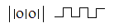 | PS/2
-  | Parallel Port (LPT)

- Machakos county government would want to create a poster to advertise Machakos people’s park recreation center. The poster will be placed on a billboard .Name the most convenient device to print the poster and give a reason for your answer. (2 marks)
……………………………………………………………………………………………………………………………………………………………………………………………………………………………………
- a) Write the abbreviation “UPS” in full? (1mk)
…………………………………………………………………………..…………………………..
b) State two functions of a UPS. (2mks) …………………………………………………………………………………………………........…………………………………………………………………………………………………........………………
10. a) Define the term computer program. (2mks) ………………………………………………………………………………………........………………………………………………………………………………………….……………………………………
b) List any four factors to be considered when selecting software. (4 mks) ......…………………………………………………………………………………………….………......…………………………………………………………………………………………….…......……………………………………………………………………………………………….….......…………………………………………………………………………………………………………..…………………..…
c) Explain what the term “portability” means in relation to hardware. (2mk) ......…………………………………………………………………………………………….……......………………………………………………….……………………………………………………….……
11. Name three different types of Human Computer Interfaces. (3 mks) …………………………………………………………………………………………………........…………………………………………………………………………………………………………………………
12. The diagram below shows as example of a secondary
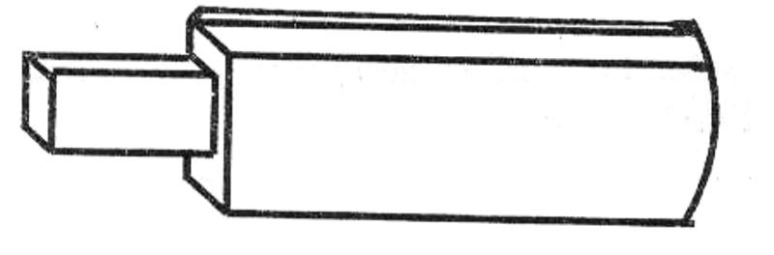

(i)Identify the name of the device. (1mk)
………........…………………………………………………………………………………….……..
(ii) List down two advantages of this device over a floppy disk in storage. (2mks) ……………........………………………………………………………………………………..……………........……………………………………………….………………………………………………..……
13. Explain the following terms in reference to word processing. (2mks)
i)Formatting ……………........…………………………………………………………………………………………………........……………………………………………….…………………………………………………………
ii)Editing ……………........…………………………………………………………………………………………………........…………………………………………………………………………………….……………………
14. Define the following display terminologies. (3 marks)
i. Resolution ……………………………………………………………………………………………………………
ii. Colour depth ……………………………………………………………………………………………………………
iii. Pixel …………………………………………………………………………………………………………
15. a) Sate two differences between CD and DVD. (2 Marks)
………………………………………………………………………………………………………………………………………………………………………………………………………………………………………………………………………………………………………………………………………
- Distinguish between bus and register and give one example for each. (4 marks) …………………………………………………………………………………………………………………………………………………………………………………………………………………………………………………………………………………………………………………………………………………………………………………………………………………………………………………..
- Differentiate between in house developed software and vendor off the shelf software. (2 marks) ………………………………………………………………………………………………………………………………………………………………………………………………………………………………………………………………………………………………………………….……………………………………………………………………………………………………………..
- Describe the following system software. (2 marks)
          - Firmware ………………………………………………………………………………………………………………………………………………………………………………………………………..
          - Networking software ………………………………………………………………………………………………………………………………………………………………………………………………………….
- a) Define the following terms: (2 Marks)
- Deadlock
……………………………………………………………………………………………………………………………………………………………………….…………………………………………………
- Interrupt
…………………………………………………………………………………………………………………………………………………………………………………………………………………………
  - A teacher in your school is writing CDs and troubleshooting computer hardware. In his laptop files are scattered all over his computer screen.
          - Name the technique you will advise him to use in order to bring files together. (1 mark) …………………………………………………………………………………………………
ii. Differentiate the technique named in (a) above with disk partitioning. (2 Marks) ………………………………………………………………………………………………………………………………………………………………………………………………………………………………………………………………………………………………………………………………
19. (a) Mutai wants to format his laptop so as to install a new operating system.
(i) Which precautions must Mutai take before beginning the format process (2 marks)
……………….
ii) State THREE factors which he should consider when selecting an operating system for his laptop. (3 marks)
……………
………………
20. (a) Study the table below and answer the questions that follow
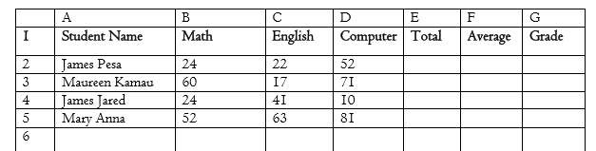
(i) Write down the formula that
(a) Calculate the total marks for Maureen Kamau. (2marks) ……………………………………………………………………………………………………
(b) Calculate the total marks for students with more than 50 and above in Maths. (2marks) ……………………………………………………………………………………………………………
(c) Get the mean score for Computer. (2mark) ……………………………………………………………………………………………………………

(ii) The grading system is a shown in the table below .Write a function that will assign grades as reflected in the table below (3marks)
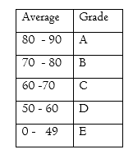……………………………………………………………………………………………………………
(iii) Write a formula using named cell reference that counts the total number of students who have scored more than 50 in computer. (2marks) …………………………………………………………………………………………………………………………………………………………………………………………………………………….….
(b) Describe three features that make spreadsheet application suitable for mathematical applications (3marks)
………………………………………………………………………………………………………………………………………………………………………………………………………………………………………………………………………………………………………………………………………..
(c) A formula = B$2+$C2 was typed in cell C2 the copied to cell C3 and the finally to D3. State how the formula will appear in D3 (2 marks)
……………………………………………………………………………………………………………

