Lab 1:

Part 4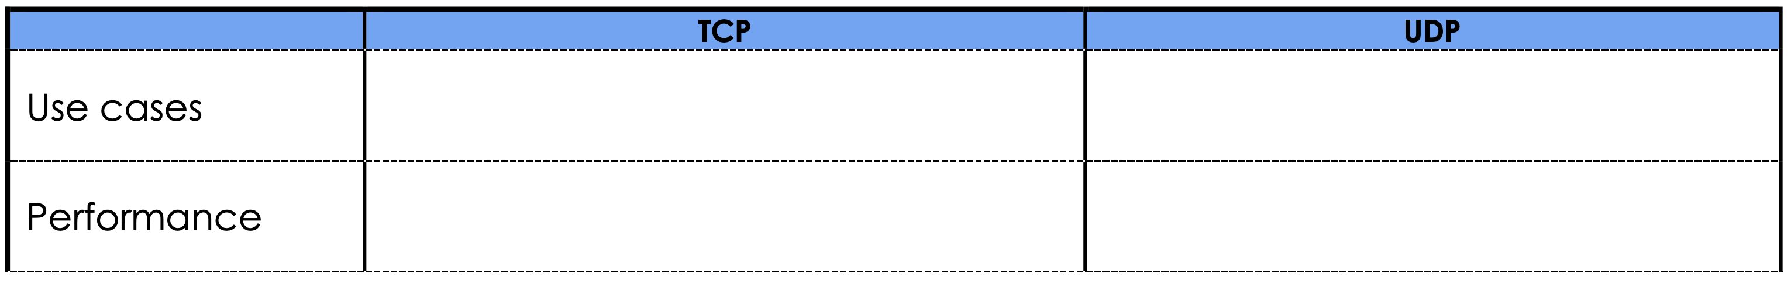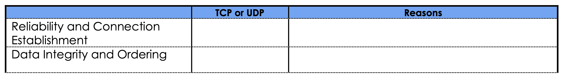

TCP It establish a connection, uses acknowledgment and retransmission

TCP uses checksum to check data loses and ack-seq for ordering

File Transfer, Email, Remote access Gaming, Streaming

Moderate Fast ( risk of lost data )