Part 1: Problem Definition
This project is a supervised machine learning classification problem. The dataset contains several financial and demographic features describing each customer, along with a labeled target variable that indicates whether the customer defaulted on their loan or successfully repaid it. Because the dataset already includes known outcomes, the model can learn from these historical examples to predict future credit risk more accurately. All data preprocessing, model training, and analysis for this project were performed in a Google Colab Notebook, which provided an organized and efficient environment for developing, testing, and evaluating multiple machine learning models.

The dataset includes important features that can influence a customer's ability to repay a loan. These features include Age, Income, Credit Score, Debt-to-Income Ratio, Number of Existing Accounts, Employment Length, Education Level, and Past Delinquency History. Each feature offers valuable insight into the customer's financial behavior and stability. For example, customers with higher income, strong credit scores, or longer employment history are generally more likely to repay their loans, while those with high debt ratios or a history of late payments are at greater risk of defaulting.

The target variable in this dataset is “default”, which indicates whether the customer failed to meet loan repayment obligations. This column is categorical (0 = no default, 1 = default) and was used directly as the output label for the classification algorithms. The main objective of this project is to use these input features to predict whether a customer will default on a loan and to identify the most influential factors affecting credit risk, enabling more accurate and responsible financial decision-making.
Part 2: Data Preprocessing and Feature Engineering
The dataset used in this project belongs to the finance field and contains real-world credit risk information. It includes data about loan applicants, their demographic characteristics, financial background, credit history, and loan details. A series of preprocessing and feature-engineering steps were applied to ensure the dataset was clean, consistent, and fully prepared for machine learning model training. These steps helped improve data quality, handle missing values, encode categorical variables, scale numerical features, and make the dataset ready for accurate and reliable predictions of loan status.
1\ Loading the Dataset Code:
from google.colab import files
uploaded = files.upload()
import pandas as pd
# Automatically detect the uploaded file name
filename = list(uploaded.keys())[0]
# Load the dataset into a DataFrame
df = pd.read_csv(io.BytesIO(uploaded[filename]))
# Display the first rows to verify the load
df.head()

Explanation:
- files.upload() opens a file selector so you can upload the CSV file from your device.
- filename = list(uploaded.keys())[0] automatically retrieves the uploaded filename.
- pd.read_csv() reads the CSV file into a DataFrame named df.

- df.head() displays the first five rows to confirm that the dataset loaded correctly.

Result
The dataset is now successfully loaded into memory and ready for inspection and preprocessing.

2\ Inspecting the Dataset

Before cleaning or transforming the data, it is important to understand its structure. This includes viewing the number of rows/columns, identifying data types, and reviewing basic statistics.

# Check dataset shape
print("Dataset Shape:", df.shape)

# Check data types and non-null counts
df.info()

# Summary statistics for numerical columns
df.describe()

Explanation

- shape shows the total number of records and features.
- info() reveals data types and missing value counts.
- describe() provides statistical summaries (mean, min, max, standard deviation) for numerical columns.

Result

We now have a clear understanding of the dataset structure, variable types, and basic descriptive statistics, which helps guide preprocessing decisions.

3\ Checking Missing Values

Machine learning models require clean data. Missing values can negatively affect training, so we must detect which columns contain null values.

df.isnull().sum().sort_values(ascending=False)

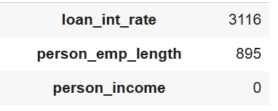
Explanation
This code counts the number of missing values in each column, sorted from most to least.

Result
You will see the specific columns that contain missing values, such as:
- person_emp_length
- loan_int_rate

4/ Handling Missing Values
After identifying which columns contain missing values, the next step is to handle them properly. Missing values can reduce model accuracy or cause errors during training. In this dataset, the missing values appear mostly in numerical columns such as:
- person_emp_length
- loan_int_rate

To ensure data consistency, we fill missing values using appropriate statistical methods. Median is often used for skewed numerical data, while mean is used for more normally distributed values.
# Fill missing values in employment length using the median
df['person_emp_length'].fillna(df['person_emp_length'].median(), inplace=True)

# Fill missing values in interest rate using the mean
df['loan_int_rate'].fillna(df['loan_int_rate'].mean(), inplace=True)

# Verify that no missing values remain
df.isnull().sum()

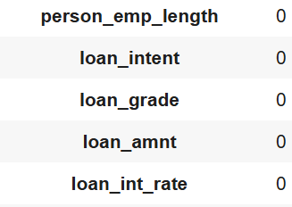

Explanation
- Median is used for person_emp_length because employment length usually has outliers (e.g., people with 0 or 40 years of experience), and the median is more robust.
- Mean is used for loan_int_rate, since interest rates tend to follow a smoother distribution.
- inplace=True ensures that the DataFrame is updated directly.
- The last line checks again to confirm that all missing values have been successfully handled.
Result
All missing values in the dataset are now replaced, and the data is complete. This ensures the dataset is ready for the next stages of preprocessing, such as encoding categorical features and scaling numerical values.

5/ Splitting Features (X) and Target (y)
Before applying encoding or scaling, the dataset must be separated into features (X) and the target variable (y). This step ensures that preprocessing is applied only to the input variables and not to the target, preventing data leakage and maintaining the integrity of the modeling process.
In this project, the target variable is loan_status, which indicates whether the applicant defaulted or not. All remaining columns are treated as input features.
Code:
TARGET_COL = "loan_status"
# Separate features and target
X = df.drop(columns=[TARGET_COL]).copy()
y = df[TARGET_COL].copy()

Explanation
- y contains only the target values (loan_status).
- X contains all other independent variables.
- This separation is required before encoding, scaling, and model training.
- Prevents accidental transformation of the target variable.

Result
- After splitting:
  - X includes all predictor features.
  - y includes the target values only.
  - The dataset is now correctly structured for preprocessing and modeling.
6/ Outlier Detection and Removal
Outliers are extreme values that can negatively affect model performance. In this dataset, the feature person_emp_length contained unusually large employment-length values that were not realistic. To prevent these extreme values from distorting the feature scaling and training process, outliers were removed before any encoding or scaling.

The Interquartile Range (IQR) method was used to detect and remove values outside the acceptable range:

Code:
Q1 = df['person_emp_length'].quantile(0.25)
Q3 = df['person_emp_length'].quantile(0.75)
IQR = Q3 - Q1
lower = Q1 - 1.5 * IQR
upper = Q3 + 1.5 * IQR
df = df[(df['person_emp_length'] >= lower) & (df['person_emp_length'] <= upper)]
Explanation
- Q1 and Q3 define the middle 50% of the data.
- Values below or above the IQR range are considered outliers.
- Only rows with unrealistic employment lengths were removed.
- This was done before encoding and scaling to ensure clean preprocessing.

Result
- After outlier removal:
  - No extreme values remain in person_emp_length.
  - The feature scales correctly (no abnormal Z-scores like 28).
  - The dataset becomes cleaner and more suitable for training

7/ Encoding Categorical Variables
The dataset contains several categorical columns such as loan_intent, person_home_ownership, and cb_person_default_on_file. Machine learning models cannot process text values directly, so categorical features must be converted into numeric representations. Label Encoding assigns a unique integer to each category.
Code:
from sklearn.preprocessing import LabelEncoder
label_encoders = {}
# Identify categorical columns in X only
categorical_cols = X.select_dtypes(include=['object']).columns

print("Categorical columns to encode:", list(categorical_cols))
print("\nEncoding results:\n")
for col in categorical_cols:
le = LabelEncoder()
X[col] = le.fit_transform(X[col].astype(str))
label_encoders[col] = le
print(f"Column: {col}")
print("Unique encoded values:", X[col].unique()[:10]) # First 10 values only
print("-" * 40)
print("\nDtypes after encoding:")
print(X.dtypes)
print("\nFirst 5 rows after encoding:")
X.head()
Output:
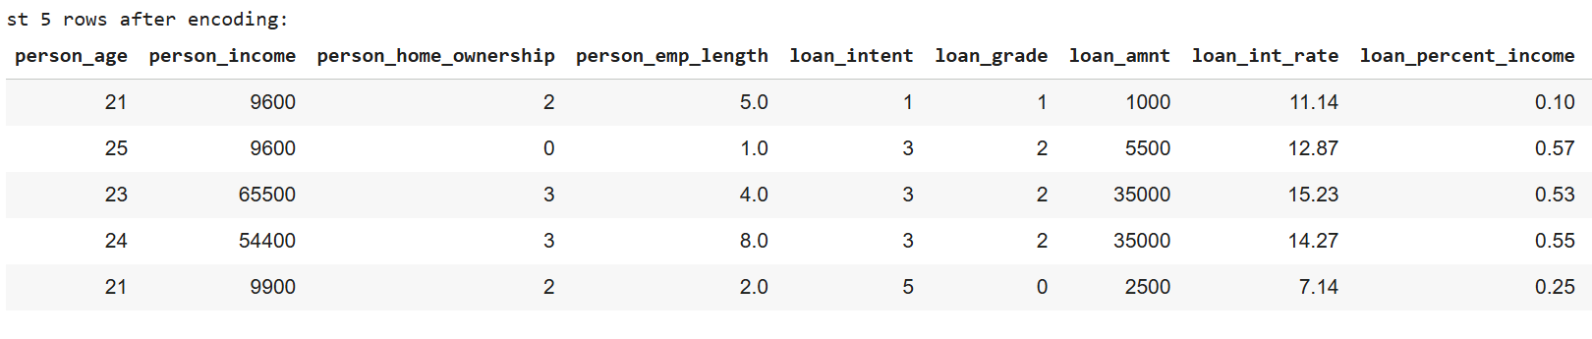

Explanation
- We first identify all non-numeric columns.
- Each column is transformed using LabelEncoder.
- Example:
- RENT → 0
- OWN → 1
- MORTGAGE → 2
Result
StandardScaler was applied to standardize the numerical features so they share a similar scale. This ensures that no feature dominates the training process, helping models—especially Support Vector Machines and Neural Networks—train more efficiently and achieve better performance.

8/ Scaling Numeric Features
To improve model performance, we scale the features so they have a similar range. StandardScaler standardizes the data to have mean 0 and standard deviation 1.
Code:
from sklearn.model_selection import train_test_split
from sklearn.preprocessing import StandardScaler

# 1. Split the data
X_train, X_test, y_train, y_test = train_test_split(
X, y, test_size=0.2, random_state=42 , stratify=y
)

# 2. Scale the data
scaler = StandardScaler()

X_train_scaled = scaler.fit_transform(X_train)
X_test_scaled = scaler.transform(X_test)

print(X_train_scaled.shape, X_test_scaled.shape)

9\ Exploratory Data Analysis (EDA)

Exploratory Data Analysis (EDA) was conducted to understand the distribution of the features and to explore how different variables relate to the target variable loan_status.
This step helps identify important trends, potential patterns, and feature relationships that may influence model performance.
Several visualizations were generated, including distribution plots for numeric features and count plots for categorical variables. These visualizations help highlight how the characteristics of individuals—such as income, age, employment length, loan grade, and home ownership—differ between applicants who defaulted and those who did not.

Code:
import matplotlib.pyplot as plt
import seaborn as sns
# 1. Distribution of numerical features
numeric_features = ['person_age', 'person_income', 'person_emp_length',
'loan_amnt', 'loan_int_rate', 'loan_percent_income']
for col in numeric_features:
plt.figure(figsize=(6,4))
sns.histplot(df[col], kde=True)
plt.title(f"Distribution of {col}")
plt.show()

# 2. Categorical features vs the target variable
categorical_features = ['person_home_ownership', 'loan_intent', 'loan_grade', 'cb_person_default_on_file']

for col in categorical_features:
plt.figure(figsize=(6,4))
sns.countplot(data=df, x=col, hue='loan_status')
plt.title(f"{col} vs loan_status")
plt.xticks(rotation=30)
plt.show()

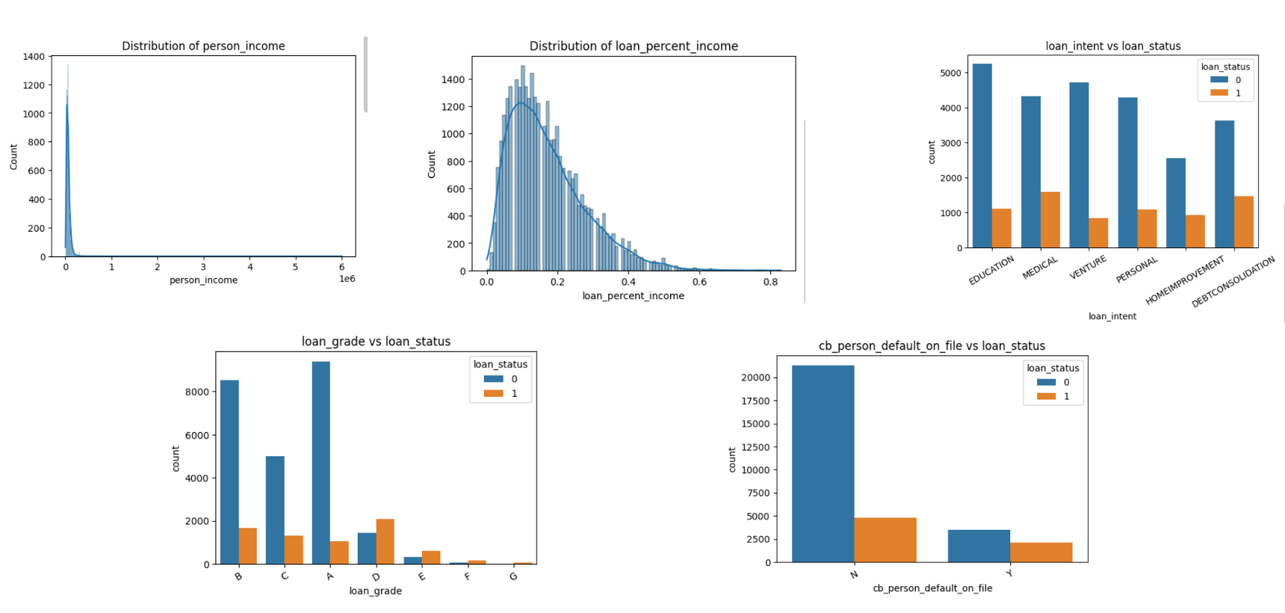
Output:

Explanation:
1/ Distribution of person_income
The distribution of the person_income variable shows a strong right-skewed pattern, where most applicants have relatively low to moderate income levels. Only a small portion of individuals fall into the high-income range, creating a long tail on the right side of the distribution. This is typical behavior in real-world income data, where high-income earners are rare compared to the general population. The plot helps highlight that the dataset is not normally distributed, which justifies the need for scaling before training a machine-learning model.
2\ Distribution of loan_percent_income
The loan_percent_income distribution illustrates how much of a person's income is represented by the requested loan amount. Most applicants have loan requests that represent between 5% and 25% of their income, creating a peak in this range. The distribution gradually declines toward higher ratios, with a few cases where the loan amount makes up a significant portion of the applicant’s income. This pattern suggests that higher loan-to-income ratios may indicate greater financial risk, making this feature potentially informative for predicting loan default.
3\ loan_intent vs loan_status
This plot compares different types of loan intentions with the loan repayment status. The results show clear differences between categories: certain loan purposes, such as PERSONAL, EDUCATION, and MEDICAL, have noticeably higher counts of defaulted loans compared to others. This indicates that the purpose behind taking a loan can influence the likelihood of repayment. In contrast, categories like VENTURE and DEBTCONSOLIDATION show relatively fewer defaults, suggesting they are associated with lower risk. This relationship provides valuable insight into how borrower motivation affects loan performance.
4\ loan_grade vs loan_status
The relationship between loan_grade and loan_status is one of the strongest observed in the dataset. Higher grades (such as A and B) are associated with a significantly lower number of defaults, while lower grades (such as D and E) show a higher proportion of defaulted loans. This trend aligns with real-world lending practices, where loan grade reflects the borrower’s creditworthiness. The plot clearly demonstrates that loan grade is a strong predictor of repayment behavior and will likely play a key role in the model’s performance.

5\ cb_person_default_on_file vs loan_status
This plot shows whether applicants have previously defaulted on a loan and how it relates to their current loan status. Applicants marked with “Y” (indicating a prior default) show a much higher rate of new defaults compared to those with “N.” This relationship is intuitive—borrowers who struggled with repayments in the past are more likely to struggle again. The clear difference between the two categories confirms that prior default history is an important indicator of financial risk and a meaningful feature for model training.

Part 3: Model Selection and Training
In this project, we will use several distinct machine-learning algorithms to perform the classification task of predicting whether a loan applicant will default. These models were selected because they represent different learning approaches and allow us to capture various relationships between the input features and the target variable. By training multiple models, we ensure that we evaluate not only simple linear relationships but also more complex nonlinear patterns within the data.
After training all models, we compare their performance using the F1-score, which is the primary evaluation metric in this study. The F1-score provides a balanced measure between precision (how many predicted defaults were correct) and recall (how many actual defaults the model successfully detected). This makes it especially suitable for loan-default prediction, where correctly identifying risky applicants is just as important as avoiding false alarms. Finally, the model achieving the highest F1-score will be selected as the best-performing model.

Strengths and weaknesses of each algorithm:
Algorithm | Strengths | Weaknesses
Logistic Regression | - Simple and highly interpretable (important in finance)  - Performs well with linear relationships  - Fast to train, good for large datasets | - Performs poorly with complex nonlinear patterns  - Sensitive to multicollinearity and outliers  - Limited ability to capture feature interactions
Decision Tree Classifier | - Easy to understand and interpret  - Handles nonlinear relationships naturally  - Requires little data preprocessing | - Prone to overfitting  - Sensitive to small changes in the data (high variance)  - Less accurate compared to ensemble methods
Random Forest Classifier | - Handles nonlinear patterns and interactions well  - Robust to noise and outliers  - Provides feature importance automatically | - Less interpretable (“black box”)  - Can overfit if not tuned  - Slower to train on very large datasets
Support Vector Machine (SVM) | - Effective in high-dimensional feature spaces  - Can model nonlinear boundaries via kernels  - Performs well with clearly separated classes | - Computationally expensive for large datasets  - Kernel and parameter selection is difficult  - Less interpretable
Neural Network (MLPClassifier) | - Capable of learning complex nonlinear relationships  - Works well for high-dimensional data  - Flexible architecture (hidden layers, neurons) | - Requires careful tuning (layers, learning rate, activation)  - Computationally expensive for large datasets  - Less interpretable (“black box”)

10/ Split Train/Test
We chose to split the dataset using an 80/20 ratio because it provides an effective balance between model training and evaluation. Allocating 80% of the data for training ensures that the models have enough information to learn meaningful patterns and relationships, especially in classification tasks where capturing variability is important. The remaining 20% is kept as an independent testing set to evaluate the model’s ability to generalize to unseen data. This ratio is widely used in machine learning because it avoids under training (which can happen with too little data) while still preserving a sufficiently large testing portion to provide an unbiased and reliable performance assessment. Additionally, using stratified sampling ensures that the class distribution remains consistent in both splits, which is important for maintaining fairness in predictive tasks like loan default classification.
Code:
from sklearn.model_selection import train_test_split
# 80% Training - 20% Testing
X_train, X_test, y_train, y_test = train_test_split(
X, y, test_size=0.20, random_state=42, stratify=y
)

11/ Model Training and Cross-Validation
Code:
from sklearn.model_selection import cross_val_score

models = {
"LogisticRegression": LogisticRegression(max_iter=1000),
"DecisionTree": DecisionTreeClassifier(max_depth=4),
"RandomForest": RandomForestClassifier(),
"SVM": SVC(),
"NeuralNet": MLPClassifier(max_iter=500)
}

cv_results = {}
for name, model in models.items():
scores = cross_val_score(model, X_train, y_train, cv=5)
cv_results[name] = scores
print(name, "CV mean:", scores.mean())

Output:
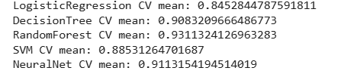
Explanation:
After training the five selected machine-learning models using 5-fold cross-validation, the average validation scores (CV mean) for each model were calculated. The results obtained from the code are as follows:

- Logistic Regression CV mean: 0.8452
- Decision Tree CV mean: 0.9083
- Random Forest CV mean: 0.9313
- SVM CV mean: 0.8853
- Neural Network CV mean: 0.9113
Based on these results, the Random Forest model achieved the highest cross-validation score (0.9313), indicating that it delivered the strongest performance among all tested models in terms of generalizing across different subsets of the training data. The Neural Network and Decision Tree models also performed well, while Logistic Regression showed the lowest performance. Overall, the cross-validation results suggest that Random Forest is the most effective model at this stage.

12\ Training the Models
In this step, we trained all the machine learning models using the scaled training data. The goal is to prepare these models so we can compare their performance later in Part 5. After training each model, we stored them together in one dictionary to make it easy to evaluate and use them in the next steps.
Code :
from sklearn.linear_model import LogisticRegression
from sklearn.tree import DecisionTreeClassifier
from sklearn.ensemble import RandomForestClassifier
from sklearn.svm import SVC
from sklearn.neural_network import MLPClassifier

# Train all models
best_log_reg = LogisticRegression(max_iter=1000).fit(X_train_scaled, y_train)
best_tree = DecisionTreeClassifier(max_depth=4).fit(X_train_scaled, y_train)
best_rf = RandomForestClassifier().fit(X_train_scaled, y_train)
best_svm = SVC(probability=True).fit(X_train_scaled, y_train)
best_nn = MLPClassifier(max_iter=500).fit(X_train_scaled, y_train)
# Store all trained models
best_model = {
"Logistic Regression": best_log_reg,
"Decision Tree": best_tree,
"Random Forest": best_rf,
"SVM": best_svm,
"Neural Network": best_nn
}

Part 4: Clustering and Dimensionality Reduction
Dimensionality reduction is important in this problem because the loan dataset contains many financial and demographic features that may be correlated or redundant. High-dimensional data can make it harder to visualize patterns, increase computational complexity, and reduce the effectiveness of clustering algorithms such as K-Means. Reducing the number of dimensions helps simplify the data structure while still preserving most of the important information.
To address this, we applied Principal Component Analysis (PCA) as our dimensionality-reduction method. PCA transforms the original correlated features into a smaller set of uncorrelated components ranked by how much variance they capture. In our case, we reduced the dataset to two principal components, which allowed us to visualize the entire dataset in a 2D space and observe meaningful structure in the data.
We then applied K-Means clustering to further explore hidden patterns. Using k = 2 clusters aligns with the two natural categories within the problem: borrowers who default and borrowers who do not. Even without using the loan_status label, K-Means was able to separate applicants into two distinct groups based on financial variables such as income, loan amount, interest rate, and credit history length.
Finally, when we visualized the K-Means cluster assignments on the two PCA components, the scatter plot showed a clear separation between the two clusters. This demonstrates that the dataset contains underlying patterns that naturally divide borrowers into different risk-related groups, even in the absence of supervised learning. The combination of PCA and clustering therefore provides valuable insights into the structure of the loan data while reducing dimensionality and improving interpretability.

13\ PCA and K-means
Code:
from sklearn.decomposition import PCA
from sklearn.cluster import KMeans
import matplotlib.pyplot as plt

# Apply PCA
pca = PCA(n_components=2)
X_train_pca = pca.fit_transform(X_train_scaled)

kmeans = KMeans(n_clusters=2, n_init=10, random_state=42)
kmeans.fit(X_train_pca)
train_clusters = kmeans.predict(X_train_pca)

plt.figure(figsize=(8,6))
plt.scatter(X_train_pca[:,0], X_train_pca[:,1], c=train_clusters, cmap='viridis', s=10)
plt.title("PCA (2D) with KMeans")
plt.xlabel("PC1")
plt.ylabel("PC2")
plt.show()

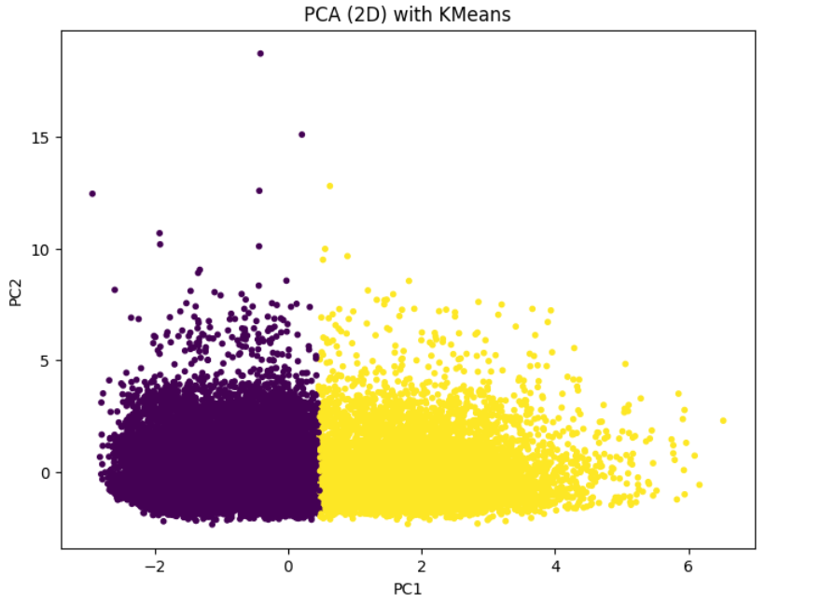
Output:

Explanation:
The plot shows the loan applicants after reducing the dataset to two PCA components. Each point represents an applicant, and the two colors indicate the clusters formed by K-Means.
The first principal component (PC1) clearly separates the two clusters, meaning most of the differences between applicants are captured along this axis. The second component (PC2) shows variation inside each cluster but does not separate them.
Overall, the plot reveals that the dataset naturally forms two distinct groups of applicants, suggesting meaningful differences in their financial characteristics even without using the loan_status label.

Part 5: Model Evaluation
After training the five machine-learning models, we will evaluat their performance using several classification metrics to understand how well each model predicts loan default cases. These metrics include accuracy, precision, recall, F1-score, ROC-AUC, and the confusion matrix. Evaluating the results using multiple metrics gives a more complete understanding of the model’s strengths and weaknesses, especially in a financial risk-prediction problem like loan defaults.

14\ Evaluation Code (Accuracy, Precision, Recall, F1, ROC-AUC, Confusion Matrix) with Confusion Matrix

Code:
from sklearn.metrics import accuracy_score, precision_score,
recall_score, f1_score, roc_auc_score, confusion_matrix, roc_curve
import matplotlib.pyplot as plt
import seaborn as sns
import numpy as np

evaluation_results = {}

for name, model in best_model.items(): # best_models contains tuned models from Part 3
y_pred = model.predict(X_test_scaled)
y_prob = model.predict_proba(X_test_scaled)[:, 1]

accuracy = accuracy_score(y_test, y_pred)
precision = precision_score(y_test, y_pred)
recall = recall_score(y_test, y_pred)
f1 = f1_score(y_test, y_pred)
roc = roc_auc_score(y_test, y_prob)

evaluation_results[name] = [accuracy, precision, recall, f1, roc]

print(f"\n------ {name} ------")
print("Accuracy :", accuracy)
print("Precision:", precision)
print("Recall :", recall)
print("F1-score :", f1)
print("ROC-AUC :", roc)

# Confusion Matrix
cm = confusion_matrix(y_test, y_pred)
plt.figure(figsize=(4,3))
sns.heatmap(cm, annot=True, fmt='d', cmap='Blues')
plt.title(f"Confusion Matrix - {name}")
plt.xlabel("Predicted")
plt.ylabel("Actual")
plt.show()

results_formatted = []
for name, metrics_list in evaluation_results.items():
results_formatted.append({"name": name, "f1": metrics_list[3]})

best = max(results_formatted, key=lambda d: d["f1"] if not np.isnan(d["f1"]) else -1)
print("\nThe Best Model:", best["name"])
best_models = best_model[best["name"]]

cm = confusion_matrix(y_test, best_models.predict(X_test_scaled))
cm

Output:
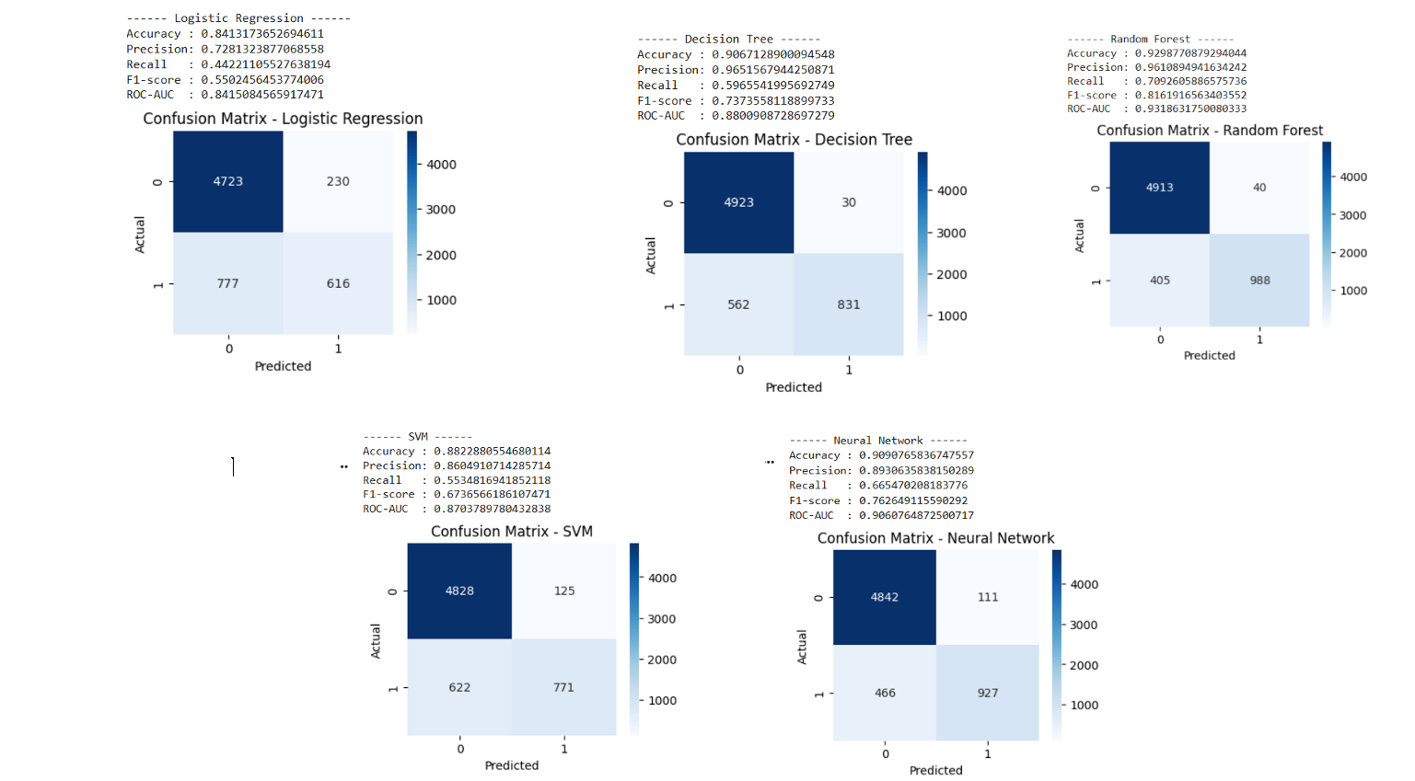

Explanation:
The five machine learning models were evaluated using accuracy, precision, recall, F1-score, ROC-AUC, and confusion matrices. The results show that Logistic Regression provided moderate performance, with accuracy around 0.84 and relatively low recall for detecting default cases. The Decision Tree improved the performance with higher precision and a better F1-score, but still produced more false negatives than desired. The SVM model achieved balanced but not outstanding performance, with good accuracy but a lower F1-score compared to the stronger models. The Neural Network demonstrated strong performance overall, achieving high accuracy (0.91), high precision, and a solid F1-score of 0.76. However, the Random Forest model clearly outperformed all other models, achieving the highest accuracy (0.93), the highest F1-score (0.82), and the best ROC-AUC (0.93). The confusion matrix also shows that Random Forest achieved the best balance between correctly identifying non-defaulters and detecting defaulters, with fewer misclassifications than the other models. For these reasons, Random Forest is considered the best-performing model, as it captures complex relationships in the data, reduces overfitting through ensemble learning, and provides the strongest overall predictive capability for loan default classification.

14\ ROC Curve
Code :
import matplotlib.pyplot as plt
import seaborn as sns
# ROC curve
if hasattr(best_models, "decision_function"):
y_scores = best_models.decision_function(X_test_scaled)
elif hasattr(best_models, "predict_proba"):
y_scores = best_models.predict_proba(X_test_scaled)[:,1]
else:
y_scores = best_models.predict(X_test_scaled)

fpr, tpr, _ = roc_curve(y_test, y_scores)
plt.figure()
plt.plot(fpr, tpr)
plt.plot([0,1],[0,1], linestyle='--')
plt.title(f"ROC Curve – {best['name']}")
plt.xlabel("False Positive Rate"); plt.ylabel("True Positive Rate")
plt.show()
plt.xlabel("False Positive Rate"); plt.ylabel("True Positive Rate")
plt.show()

Output:
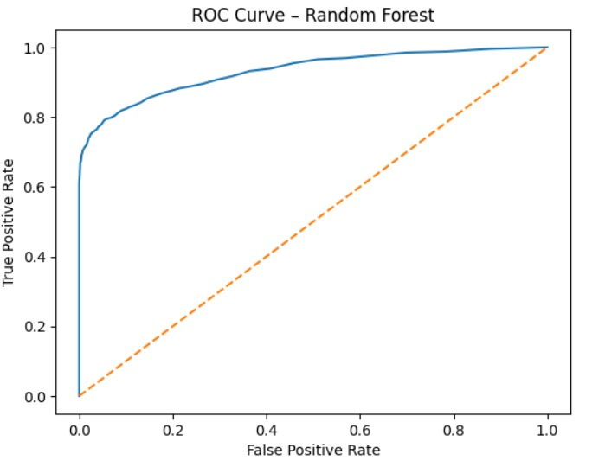
Explanation:
The ROC curve for the Random Forest model shows strong performance, with the curve staying well above the diagonal baseline and achieving a high AUC value. This indicates that the model is highly capable of distinguishing between borrowers who will default and those who will not. The confusion matrix further supports this, showing that the model correctly classifies the majority of both classes with relatively few mistakes. In the context of loan risk assessment, it is crucial to carefully consider both false positives and false negatives. A false positive (predicting that a borrower will default when they will not) may lead to rejecting or overpricing a safe loan applicant, causing unnecessary financial loss and reducing customer trust. On the other hand, a false negative (predicting a borrower will not default when they actually will) is even more critical because it directly exposes the lender to financial risk by approving loans that are likely to default. Therefore, evaluating the ROC curve and confusion matrix helps ensure that the model maintains a sensible balance between these two types of errors, which is essential for making reliable lending decisions.

Part 6: Ethical Implications and Discussion

Ethical Risks of Using Machine Learning in Loan Prediction
Using machine learning in the loan-approval process carries several ethical risks because incorrect predictions directly affect people’s financial opportunities. A false positive (predicting that a borrower will not default when they actually will) can cause financial losses for lenders and contribute to instability in the credit system. On the other hand, a false negative (predicting that a borrower will default when they actually will not) unfairly denies individuals access to credit, limiting their ability to buy homes, start businesses, or improve their quality of life. These errors can therefore lead to economic harm, reduced trust in financial institutions, and unfair treatment of applicants.

Impact of Bias in Data on Model Fairness and Performance
Bias in the dataset is another major ethical concern. If the historical loan data contains unfair patterns such as discrimination based on income level, age, gender, or geographic location—the model will learn and replicate these patterns. This may lead to biased decisions, where certain groups receive fewer approvals or worse predictions even when they are financially qualified. Such bias reduces the fairness and reliability of the model and can result in systematic discrimination. Ensuring high-quality, unbiased data and regularly auditing model decisions is essential for creating a fair and trustworthy loan-prediction system.

