MYPIXIE PROJECT DEVELOPMENT DOCUMENT
Main Notes  _____________ | Notes  __________________________________________________________________________________________  Researching AWS for back-end possibilities  AWS not possible - the usage of DB instances would incur a fee.  Most likely with other providers like Azure etc as well. Also, hosting costs.  Which database?  PostgreSQL - I saw more jobs in my search have this DB than others.  https://www.postgresql.org/  Back-end tech?  Contenders are: Node.js, PHP, Python and Java (least likely due to difficulty scale and time constraint)  Chosen: Next.js (more opportunities there and recommended by React official doc)  Front-end tech?  HTML, CSS (check anchors maybe?), React, Bootstrap / ChakraUI, Figma for designs (maybe)  Update: Looks like this will be a Next.js front-end… :o  Testing?  Jest (most likely) + SDLC (Software Dev Lifecycle) (Agile)  Next.js vs React?  React is primarily used focused on building UI components, Next.js extends React’s capabilities by providing features for server-side rendering. Next JS provides access to env variables while React does not.  Challenges:  - SSH Key for Ubuntu (Do not use sudo xd)  - Learn basic Machine Learning / AI to develop “the pixie” later on.

CHALLENGES

Main Notes  _____________ | Notes  __________________________________________________________________________________________  Challenges:  Yellow = Normal priority [In Progress]  Red = Highest Priority [In Progress]  Green = Resolved [Resolved]  - SSH Key for Ubuntu (Do not use sudo xd) [Resolved]  - Learn basic Machine Learning / AI to develop “the pixie” later on. [In Progress]  - Learn Next.js from scratch fast [In Progress]  - Write code to connect to PostgreSQL database [Resolved]  - Figuring out Primary Key being referenced w/ foreign key in posts table [Resolved]  - Resolve Python error when connecting to DB [Resolved] (Populated pwd and specified DB)  Python error: connection to server on socket "/var/run/postgresql/.s.PGSQL.5432" failed: FATAL: Peer authentication failed for user "postgres”

To-Do

Main Notes  _____________ | Notes  __________________________________________________________________________________________  Challenges:  Yellow = Normal priority [In Progress]  Red = Highest Priority [In Progress]  Green = Resolved [Resolved]  - Setup base for the project + GitHub Resolved  - Remove React app because it is the same as Next.js but Next has more features Resolved  - Connect Python to PostgreSQL Resolved  - Create Front-End (MVP) for my-pixie  - Create Form to collect input  - Use Bootstrap

Main Notes  _____________ | Notes  __________________________________________________________________________________________  Researching AWS for back-end possibilities  Next.js and React structure  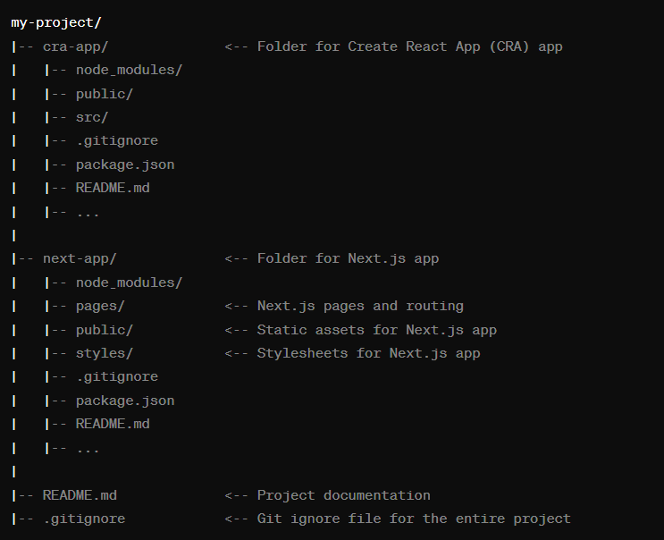  Challenges:  - SSH Key for Ubuntu (Do not use sudo xd)  - Learn basic Machine Learning / AI to develop “the pixie” later on.  - Need to learn Next.js fast enough to implement back-end + connection to PostgreSQL  ** install pg which is PostgreSQL client for Node.js (JS runtime env / server side)  varying char = varchar  varying char [] = multiple varchars in a list / array  NOTE: PostgreSQL accepts only single quotes!!!

Main Notes  _____________ | Notes  __________________________________________________________________________________________  Researching AWS for back-end possibilities  Next.js MAIN FILE – the one that helps render things  page.js & In newer versions of Next.js + App routing (if you pick it) there IS NO PAGES FOLDER.  Test PostgreSQL connection to the DB:  // pg = PostgreSQL  import {Pool} from “pg” // Pool class from pg which helps with PostgreSQL client connections  const db = new Pool({  user: “postgres”,  host: “localhost”,  database: “pixie-db”,  password: “admin”,  port: 5432, // Default PostgreSQL port  })  // test db connection  (async () => {  try {  // Attempt to connect to the database  const client = await db.connect();  console.log('Connected to the database\n');  // Release the client back to the pool  client.release();  } catch (error) {  console.error('Error connecting to the database');  } finally {  // Close the pool to close all connections  db.end();  }  })();  // (); invokes async function immediately  Challenges:  - SSH Key for Ubuntu (Do not use sudo xd)  - Learn basic Machine Learning / AI to develop “the pixie” later on.  - Need to learn Next.js fast enough to implement back-end + connection to PostgreSQL  - Designing DB schema for the posts and tying to its user

Main Notes  _____________ | Notes  __________________________________________________________________________________________  Researching AWS for back-end possibilities  Next.js MAIN FILE – the one that helps render things  a  Challenges:  - SSH Key for Ubuntu (Do not use sudo xd)  - Learn basic Machine Learning / AI to develop “the pixie” later on.  - Need to learn Next.js fast enough to implement back-end + connection to PostgreSQL  - Designing DB schema for the posts and tying to its user  - Figuring out Primary Key being referenced w/ foreign key in posts table XD  DB Schema  DB (my-pixie)  posts(postID, postTitle, postContent, userID) | users(userID, username, pwd, firstName, lastName)  users table  users table and posts table inner joined  SELECT postid, posttitle, postcontent, users.username, users.userid  FROM posts  INNER JOIN users    ON posts.userid = users.userid  INSERTING DATA INTO DB TABLES  INSERT INTO users (userid, username, user_pwd, firstName, lastName)  VALUES (1,'maciejdev', 'mypwd', 'Maciej', 'MM'),  (2,'Jon123', 'strongpwd', 'John', 'Doe'),  (3,'Jane123', 'strongpwd', 'Jane', 'Moe');  Creating FOREIGN KEY  userid int REFERENCES users(userid)  Note: be very mindful of commas, spaces, and quotes!!! Don’t use double quotes.

Main Notes  _____________ | Notes  __________________________________________________________________________________________  Researching AWS for back-end possibilities  Python issue connection to server socket – FATAL: role ‘maciej’ does not exist:

