

Green University of Bangladesh



Department of Computer Science and Engineering (CSE)

**Faculty of Sciences and Engineering Semester: (Fall, Year:2025), B.Sc. in CSE (Day)**

**Lab Report NO #01**

**Course Title: Database Lab**

**Course Code: CSE 302 Section: 232_D1**

**Lab Experiment Name:** Creating a Class Routine using HTML

**Student Details:**

|  |  |
| --- | --- |
| **Name** | **ID** |
| Majharul Islam | 232002256 |

**Lab Date : 07 .10. 2025**

**Submission Date : 10.10. 2025**

**Course Teacher’s Name : Tanpia Tasnim**

**­­­­**

[For Teachers use only: Don’t Write Anything inside this box]

**Lab Report Status Marks: ………………………………… Comments:..............................................**

**Signature:.....................**

**Date:..............................**

1. TITLE OF THE LAB EXPERIMENT

Design and develop a class routine web page using HTML and CSS to display the teacher’s weekly schedule in a tabular format.

2. OBJECTIVES

* To learn how to use HTML table elements (<table>, <tr>, <th>, <td>) to organize data.
* To apply CSS for styling and alignment of webpage content.
* To create a structured and readable class routine webpage.
* To improve understanding of webpage design and layout.

3. INTRODUCTION

In this experiment, we learned to create a structured timetable using HTML <table> elements and apply basic styling with CSS. This helps in organizing information systematically, which is a crucial part of web development. The project displays a teacher’s class schedule for different days and times.

4. PROCEDURE / ANALYSIS

1. Create a new HTML file named class_test_02.html.
2. Define the basic structure using <!DOCTYPE html>, <html>, <head>, and <body> tags.
3. Add a title “Class Routine” and details using heading tags (<h2>, <h3>, <h4>).
4. Use the <table> tag to create a grid layout with rows and columns.
5. Apply table borders, width, and alignment attributes.
6. Use <th> for headings (Time, Day) and <td> for schedule data.
7. Apply CSS to center-align text using the universal selector * { text-align: center; }.

5. IMPLEMENTATION

Code Implementation:

|  |
| --- |
| <!DOCTYPE html>  <html lang="en">  <head>  <meta charset="UTF-8">  <meta name="viewport" content="width=device-width, initial-scale=1.0">  <title>Class Routine</title>  <style>  * { text-align: center; }  </style>  </head>  <body>  <caption>  <h2>Class Routine</h2>  <h2>Green University of Bangladesh</h2>  <h3>Department of Computer Science and Engineering (CSE)</h3>  <h3>Student Name: Majharul Islam (ID: 232002256)</h3>  </caption>  <table border="1" align="center" height="300px" width="1200">  <tr>  <th>Time</th>  <th rowspan="2">08:30-10:00</th>  <th rowspan="2">10:00-11:30</th>  <th rowspan="2">11:30-01:00</th>  <th rowspan="2">01:30-03:00</th>  <th rowspan="2">03:00-04:30</th>  </tr>  <tr>  <th>Day</th>  </tr>  <tr>  <th>Sunday</th>  <td>CSE 301 <br>Web Programming<br>Room K-103</td>  <td>CSE 303 <br>Microprocessors & Embedded Systems<br>Room K-105</td>  <td>EEE 301 <br>Electrical Drives & Instrumentation<br>Room A-605</td>  <td colspan="2">CSE 308 <br>Design Project I<br>Room K-109</td>  </tr>  <tr>  <th>Tuesday</th>  <td colspan="2">CSE 302 <br>Web Programming Lab<br>Room K-102</td>  <td>CSE 301 <br>Web Programming<br>Room K-103</td>  <td>CSE 305 <br>Information System Design<br>Room A-602</td>  <td>CSE 303 <br>Microprocessors & Embedded Systems<br>Room J-101</td>  </tr>  <tr>  <th>Wednesday</th>  <td>EEE 301 <br>Electrical Drives & Instrumentation<br>Room A-602</td>  <td>CSE 305 <br>Information System Design<br>Room A-602</td>  <td></td>  <td colspan="2">CSE 304 <br>Microprocessors & Embedded Systems Lab<br>Room A-508</td>  </tr>  </table>  </body>  </html> |

6. OUTPUT

**Output Description:**  
The HTML page displays a well-structured class routine table with the course details and schedule for each weekday.

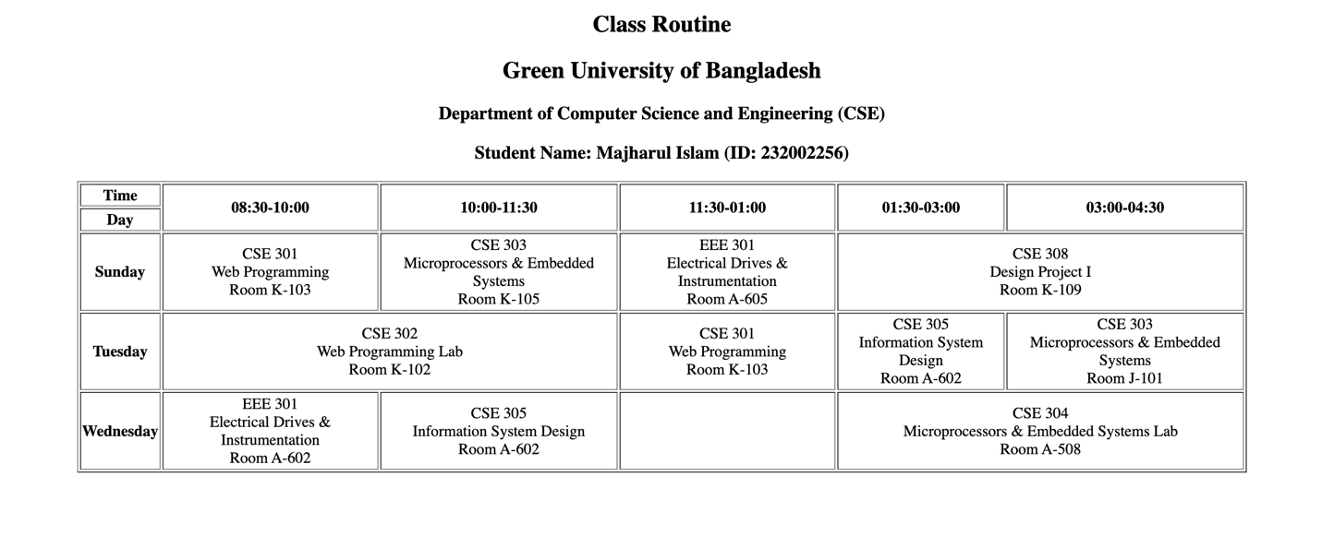

1. ANALYSIS AND DISCUSSION

* **Challenges:** Adjusting table width and aligning text properly.
* **Improvements:** Could use more advanced CSS for better visuals (e.g., background colors, hover effects).
* **Learning Outcome:** Gained hands-on experience with HTML table formatting and inline CSS.
* **Achievement of Objective:** All listed objectives were achieved — proper use of HTML and CSS for structured layout.

1. SUMMARY

In this lab, I learned how to use HTML to create a formatted class routine webpage. This experiment strengthened my understanding of HTML structure, and table management.