

Green University of Bangladesh



Department of Computer Science and Engineering (CSE)

**Faculty of Sciences and Engineering Semester: (Fall, Year:2025), B.Sc. in CSE (Day)**

**Lab Report NO # 03**

**Course Title: Database Lab**

**Course Code: CSE 302 Section: 232_D1**

**Lab Experiment Name:** Create a Photo Gallery using HTML and CSS

**Student Details:**

|  |  |
| --- | --- |
| **Name** | **ID** |
| Majharul Islam | 232002256 |

**Lab Date : 25 .10. 2025**

**Submission Date : 30.10. 2025**

**Course Teacher’s Name : Tanpia Tasnim**

**­­­­**

[For Teachers use only: Don’t Write Anything inside this box]

**Lab Report Status Marks: ………………………………… Comments:..............................................**

**Signature:.....................**

**Date:..............................**

**1. TITLE OF THE LAB EXPERIMENT**

Design and develop a **Photo Gallery** web page displaying faculty profiles of the Green University of Bangladesh using **HTML** and **CSS layout techniques**.

### ****2. OBJECTIVES / AIM****

* To create a web-based photo gallery using HTML and CSS.
* To practice using the **CSS Grid layout** for organizing images.
* To make a responsive design that adjusts based on screen size.
* To display faculty information with images, names, and designations.

### ****3. INTRODUCTION****

This experiment demonstrates how to use **HTML and CSS** to design a responsive **photo gallery**.  
The web page shows faculty members from the Department of CSE at Green University of Bangladesh.  
A total of **10 faculty images** are displayed, arranged **five per row** using the **CSS Grid layout**.  
Each faculty profile includes an image, name, and designation, all linked to the university’s official faculty webpage.

### ****4. PROCEDURE / ANALYSIS / DESIGN****

**Step-by-Step Process:**

1. Created a new HTML file named faculty-gallery.html.
2. Added structural elements like <header>, <div class="gallery">, and <footer>.
3. Used <div class="faculty"> for each faculty member to include an image, name, and designation.
4. Linked an external CSS file (styles.css) for styling and layout control.
5. Applied **CSS Grid** to display five faculty images per row.
6. Added responsive design rules using **media queries** to ensure compatibility on smaller devices.

Page Layout Structure:

|  |
| --- |
| HTML Structure: <header> (title and university name) <div class="gallery">  ├── <div class="faculty"> (Image + Name + Designation) <footer> (copyright) |

**Design Flow (CSS):**

* display: grid; used for gallery layout
* grid-template-columns: repeat(5, 1fr); for 5-column structure
* @media queries used for responsiveness

**5. IMPLEMENTATION**

HTML Code:

|  |
| --- |
| <!DOCTYPE html>  <html lang="en">  <head>  <meta charset="UTF-8">  <meta name="viewport" content="width=device-width, initial-scale=1.0">  <title>GUB CSE Faculty Gallery</title>  <link rel="stylesheet" href="styles.css">  </head>  <body>  <header>  <h1>Department of CSE – Faculty Gallery</h1>  <h2>Green University of Bangladesh</h2>  </header>  <div class="gallery">  <div class="col">  <a href="https://www.green.edu.bd/profile/Prof.%20Dr.%20Md.%20Mohammad%20Shorif%20Uddin/378">  <div class="card h-90 faculty-profile">  <div class="faculty-images">  <img src="https://siteadmin.green.edu.bd/uploads/images/faculty/11_1729479164_faculty_member.png" class="card-image-top faculty-img"  alt="Prof. Dr. Md. Mohammad Shorif Uddin">  </div>  <div class="faculty-designation">  <p class="card-text card-faculty-desi">Professor & Vice-Chancellor</p>  </div>  <div class="faculty-title">  <h5 class="card-title card-faculty-name">Prof. Dr. Md. Mohammad Shorif Uddin</h5>  </div>  </div>  </a>  </div>  <div class="col">  <a href="https://www.green.edu.bd/profile/Prof.%20Dr.%20Md.%20Saiful%20Azad/160">  <div class="card h-90 faculty-profile">  <div class="faculty-images">  <img src="https://siteadmin.green.edu.bd/uploads/images/faculty/5_1697605379_faculty_member.jpg" class="card-image-top faculty-img"  alt="Prof. Dr. Md. Saiful Azad">  </div>  <div class="faculty-designation">  <p class="card-text card-faculty-desi">Professor & Dean</p>  </div>  <div class="faculty-title">  <h5 class="card-title card-faculty-name">Prof. Dr. Md. Saiful Azad</h5>  </div>  </div>  </a>  </div>  <div class="col">  <a href="https://www.green.edu.bd/profile/Professor%20Dr.%20Md.%20Ahsan%20Habib/325">  <div class="card h-90 faculty-profile">  <div class="faculty-images">  <img src="https://siteadmin.green.edu.bd/uploads/images/faculty/2_1707048251_faculty_member.png" class="card-image-top faculty-img"  alt="Professor Dr. Md. Ahsan Habib">  </div>  <div class="faculty-designation">  <p class="card-text card-faculty-desi">Professor & Chairperson</p>  </div>  <div class="faculty-title">  <h5 class="card-title card-faculty-name">Professor Dr. Md. Ahsan Habib</h5>  </div>  </div>  </a>  </div>  <div class="col">  <a href="https://www.green.edu.bd/profile/Syed%20Ahsanul%20Kabir/11">  <div class="card h-90 faculty-profile">  <div class="faculty-images">  <img src="https://siteadmin.green.edu.bd/uploads/images/faculty/5_1697605004_faculty_member.jpg" class="card-image-top faculty-img"  alt="Syed Ahsanul Kabir">  </div>  <div class="faculty-designation">  <p class="card-text card-faculty-desi">Associate Professor (Adjunct)</p>  </div>  <div class="faculty-title">  <h5 class="card-title card-faculty-name">Syed Ahsanul Kabir</h5>  </div>  </div>  </a>  </div>  <div class="col">  <a href="https://www.green.edu.bd/profile/Dr.%20Faiz%20Al%20Faisal/180">  <div class="card h-90 faculty-profile">  <div class="faculty-images">  <img src="https://siteadmin.green.edu.bd/uploads/images/faculty/2_1700165800_faculty_member.jpg" class="card-image-top faculty-img"  alt="Dr. Faiz Al Faisal">  </div>  <div class="faculty-designation">  <p class="card-text card-faculty-desi">Associate Professor & Director of GCITS</p>  </div>  <div class="faculty-title">  <h5 class="card-title card-faculty-name">Dr. Faiz Al Faisal</h5>  </div>  </div>  </a>  </div>  <div class="col">  <a href="https://www.green.edu.bd/profile/Umme%20Ruman/181">  <div class="card h-90 faculty-profile">  <div class="faculty-images">  <img src="https://siteadmin.green.edu.bd/uploads/images/faculty/2_1700294929_faculty_member.jpg" class="card-image-top faculty-img"  alt="Umme Ruman">  </div>  <div class="faculty-designation">  <p class="card-text card-faculty-desi">Assistant Professor</p>  </div>  <div class="faculty-title">  <h5 class="card-title card-faculty-name">Umme Ruman</h5>  </div>  </div>  </a>  </div>  <div class="col">  <a href="https://www.green.edu.bd/profile/Shamima%20Akter/195">  <div class="card h-90 faculty-profile">  <div class="faculty-images">  <img src="https://siteadmin.green.edu.bd/uploads/images/faculty/2_1700543034_faculty_member.jpg" class="card-image-top faculty-img"  alt="Shamima Akter">  </div>  <div class="faculty-designation">  <p class="card-text card-faculty-desi">Assistant Professor</p>  </div>  <div class="faculty-title">  <h5 class="card-title card-faculty-name">Shamima Akter</h5>  </div>  </div>  </a>  </div>  <div class="col">  <a href="https://www.green.edu.bd/profile/Md.%20Monirul%20Islam/421">  <div class="card h-90 faculty-profile">  <div class="faculty-images">  <img src="https://siteadmin.green.edu.bd/uploads/images/faculty/2_1710909083_faculty_member.jpg" class="card-image-top faculty-img"  alt="Md. Monirul Islam">  </div>  <div class="faculty-designation">  <p class="card-text card-faculty-desi">Assistant Professor</p>  </div>  <div class="faculty-title">  <h5 class="card-title card-faculty-name">Md. Monirul Islam</h5>  </div>  </div>  </a>  </div>  <div class="col">  <a href="https://www.green.edu.bd/profile/Tanpia%20Tasnim/20">  <div class="card h-90 faculty-profile">  <div class="faculty-images">  <img src="https://siteadmin.green.edu.bd/uploads/images/faculty/5_1697606639_faculty_member.jpg" class="card-image-top faculty-img"  alt="Tanpia Tasnim">  </div>  <div class="faculty-designation">  <p class="card-text card-faculty-desi">Lecturer & PC(E)</p>  </div>  <div class="faculty-title">  <h5 class="card-title card-faculty-name">Tanpia Tasnim</h5>  </div>  </div>  </a>  </div>  <div class="col">  <a href="https://www.green.edu.bd/profile/Montaser%20Abdul%20Quader/14">  <div class="card h-90 faculty-profile">  <div class="faculty-images">  <img src="https://siteadmin.green.edu.bd/uploads/images/faculty/5_1697606406_faculty_member.jpg" class="card-image-top faculty-img"  alt="Montaser Abdul Quader">  </div>  <div class="faculty-designation">  <p class="card-text card-faculty-desi">Lecturer</p>  </div>  <div class="faculty-title">  <h5 class="card-title card-faculty-name">Montaser Abdul Quader</h5>  </div>  </div>  </a>  </div>  </div>  <footer>  <p>© 2025 Green University of Bangladesh | Department of CSE</p>  </footer>  </body>  </html> |

CSS Code:

|  |
| --- |
| * {  margin: 0;  padding: 0;  box-sizing: border-box;  }  body {  font-family: 'Segoe UI', Tahoma, Geneva, Verdana, sans-serif;  margin: 0;  padding: 0;  background-color: #f5f5f5;  color: #333;  }  header {  text-align: center;  background-color: #006633;  color: white;  padding: 30px 10px;  }  header h1 {  margin: 0;  font-size: 2rem;  }  header h2 {  margin-top: 5px;  font-weight: 400;  font-size: 1.2rem;  }  .gallery {  display: grid;  grid-template-columns: repeat(auto-fill, minmax(250px, 1fr));  gap: 30px;  padding: 50px 40px;  max-width: 1400px;  margin: 0 auto;  }  .col {  display: flex;  justify-content: center;  }  .col a {  text-decoration: none;  color: inherit;  width: 100%;  display: block;  }  .card {  background-color: #fff;  border-radius: 15px;  box-shadow: 0 4px 15px rgba(0,0,0,0.1);  overflow: hidden;  transition: all 0.3s ease;  display: flex;  flex-direction: column;  }  .h-90 {  height: 100%;  }  .faculty-profile {  text-align: center;  position: relative;  }  .card:hover {  transform: translateY(-8px);  box-shadow: 0 8px 25px rgba(0,0,0,0.15);  }  .faculty-images {  overflow: hidden;  width: 100%;  position: relative;  }  .faculty-img {  width: 100%;  height: 350px;  object-fit: cover;  display: block;  transition: transform 0.3s ease;  }  .card:hover .faculty-img {  transform: scale(1.03);  }  .faculty-designation {  background: linear-gradient(135deg, #089cc2 0%, #089cc2 100%);  color: white;  padding: 15px 20px;  position: relative;  margin: 0;  border-radius: 0 0 10px 10px;  }  .card-faculty-desi {  font-size: 1rem;  color: white;  font-weight: 500;  margin: 0;  letter-spacing: 0.3px;  }  .faculty-title {  padding: 20px 15px;  background-color: #fff;  }  .card-faculty-name {  color: #2c3e50;  font-size: 1.15rem;  font-weight: 700;  line-height: 1.4;  margin: 0;  min-height: auto;  }  /* Remove old faculty styles */  .faculty,  .faculty:hover,  .faculty a,  .faculty img,  .faculty h3,  .faculty p {  all: unset;  }  footer {  text-align: center;  background-color: #004d26;  color: white;  padding: 15px;  margin-top: 40px;  font-size: 0.9rem;  }  /* Responsive design for smaller screens */  @media (max-width: 1200px) {  .gallery {  grid-template-columns: repeat(auto-fill, minmax(230px, 1fr));  gap: 25px;  }  }  @media (max-width: 768px) {  .gallery {  grid-template-columns: repeat(auto-fill, minmax(200px, 1fr));  gap: 20px;  padding: 30px 20px;  }    .faculty img {  height: 250px;  }  }  @media (max-width: 480px) {  .gallery {  grid-template-columns: 1fr;  gap: 20px;  }    .faculty img {  height: 300px;  }  } |

**6. TEST RESULT / OUTPUT**

**Expected Output:**

1. The webpage displays **10 faculty members** in a **grid layout**.
2. On desktop: **4 images per row**.
3. On tablet: **3 images per row**.
4. On mobile: **2 images per row**.
5. Each image shows a name and designation below it.
6. Hovering on a faculty card slightly enlarges it (scale effect).
7. All links open in a new tab.
8. The layout is responsive and visually clean.

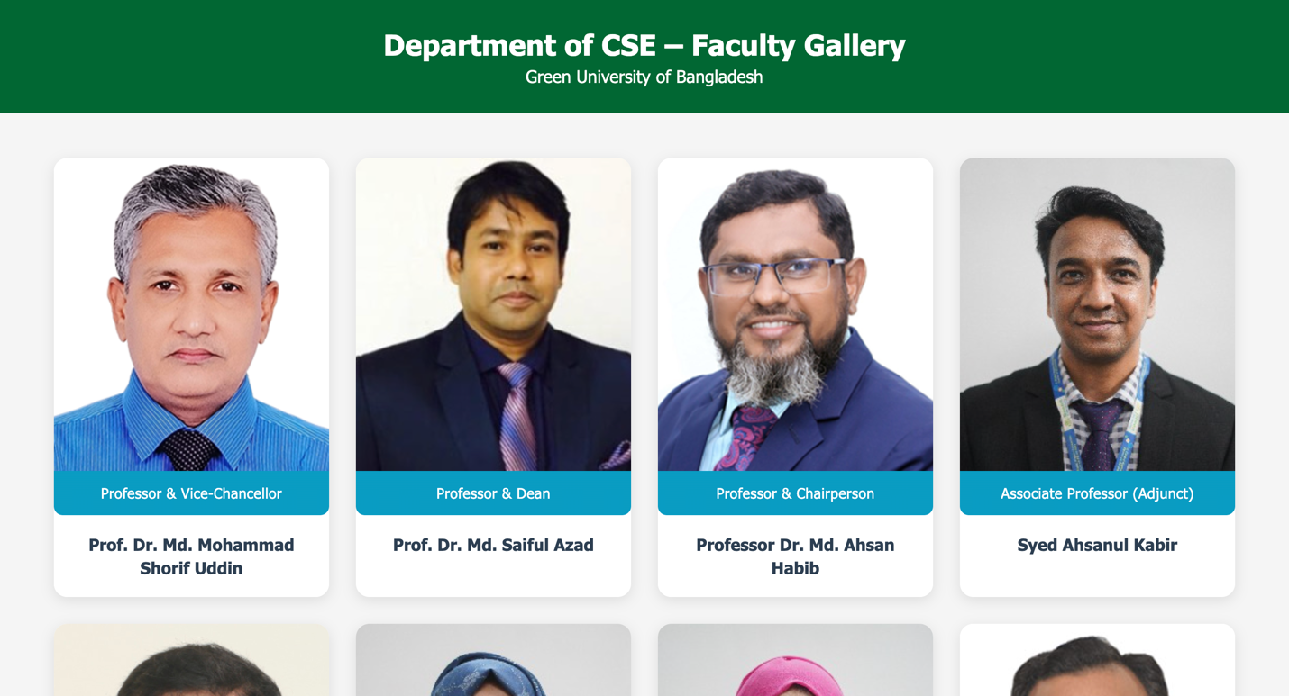

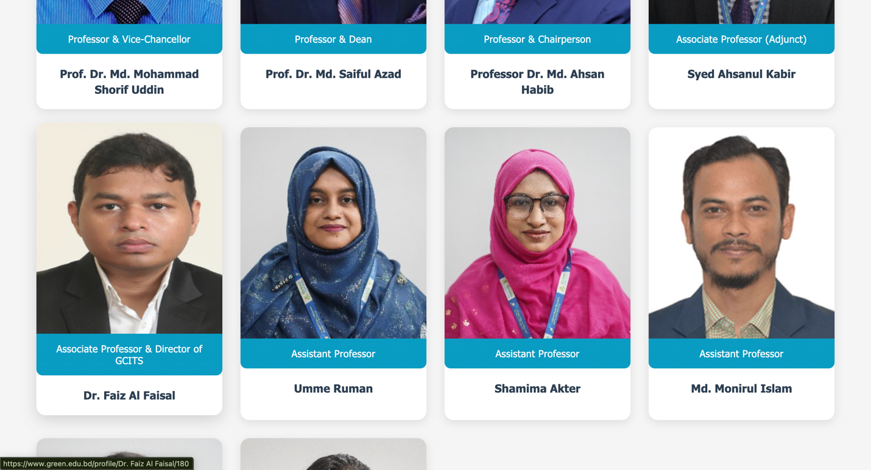

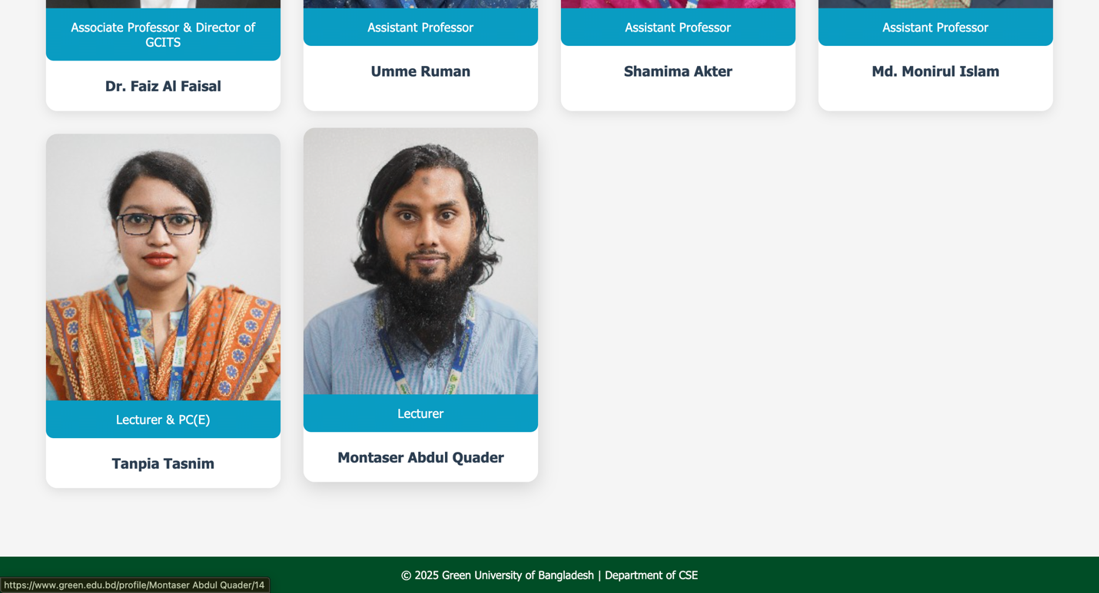

### ****7. ANALYSIS AND DISCUSSION****

* **What went well:** The grid layout worked smoothly, and responsiveness was achieved through media queries.
* **Challenges faced:** Maintaining equal image size and spacing across devices.
* **Learning outcome:**
  + Learned to use CSS Grid effectively.
  + Understood how to apply responsive web design principles.
  + Gained experience linking real data and designing clean layouts.
* **Achievement:** The gallery design met all task requirements.

### ****8. SUMMARY****

In this experiment, a **Photo Gallery webpage** was successfully developed using HTML and CSS to showcase the **CSE faculty of Green University of Bangladesh**. The project demonstrated layout structuring using **CSS Grid**, responsive design techniques, and hover animations for an engaging user interface.