COMPASS_ENABLE
COMPASS_USE

ARMING_CHECK – what checks to perform before arming.

FLTMODE_CH – channel for flight modes

Betaflight

Tab Modes
May activate modes via several ANDed/ORed channels.
May link modes – once first is activated, second is activated too.
Acro. Active by default if other is not activated.
Horizon. Like angle mode if sticks are near center. Allows flips if move sticks further.
Flip over after crush. Used when crashed upside down. After arming in this mode props.(only 2 at once) rotate in opp. dir.(to flipover drone). To rotate props use stick(no rotation after arming).
Headfree. Stick moves drone towards pilot/away from pilote/to the left or right relative to pilote. Indifferent to actual drone orientation – always towards/away/… pilote.
Headadj. Some bull shit, similar to headfree but with adjusted towards/away/… directions relative to pilote.
Failsafe. To make drone behave like radiolink disappeared(without turning off a radio) – allows to test your failsafe settings.
OSD disable. Just disables OSD(if you want clear screen).
Telemetry. Turn on/off sending back a telemetry. Now it is useless, earlier receivers could either receive comands or send telemetry.
Balckbox. If not configured – blackbox data is been written when armed. Use this mode to write blackbox when dis-armed or only some periods of flight.
FPV angle mix. Enables camera up/tilt-compensation. Connected to this:
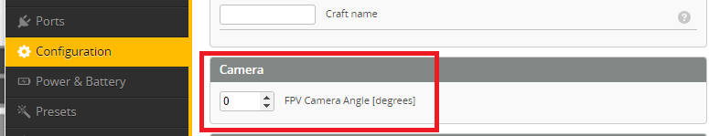
If value here is non-0 AND angle mix mode is NOT configured – up/tilt-comp. is active.

Prearm. Safeguard of arm – actually arms if pre-arm & arm are activated.
Camera control 1/2/3. Becomes meaningfull(and change lables) when some UART is set to “RunCam protocol”. These control a camera.
VTX pit mode. Makes VTX to emit at very low power(to check if channel is free). Works if transmitter supports SmartAudio.
VTX control disable. SmartAudio from flight-controller overrides buttons on VTX. Activate this mode to make FC to release control over VTX(so you may use buttons).
Paralize. After activation fully disables drone till power-cycle.
Acro trainer. Like acro but with limited roll/pitch angles.
Launch control. This for start while racing. You arm, then activate “launch control”, then tilt drone to certain angle(without take-off), then you are ready to push a throttle and start quickly.
Stick command disable. You may enter VTX menu by moving sticks in a specific position – this is stick command. This mode disables such commands(not to trigger something during flight).
Beeper mute. Temporariry disable beeper.
User mode 1/2/… Will appear after some magic with CLI.

