SMA(DO-214AC, smallest, 2.6x4.3mm), SMB(DO-214AA), SMC(DO-214AB, largest, 5.9x6.9mm)
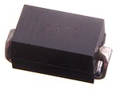

MiniMELF(DO-213AA, SOD-80, 3.5x1.6), MELF(DO-213AB, SOD-106, MMB)
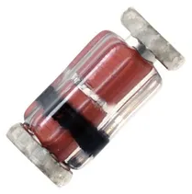

SOD-323(smaller, 1.4x1.7mm), SOD-123(1.6x2.7mm)
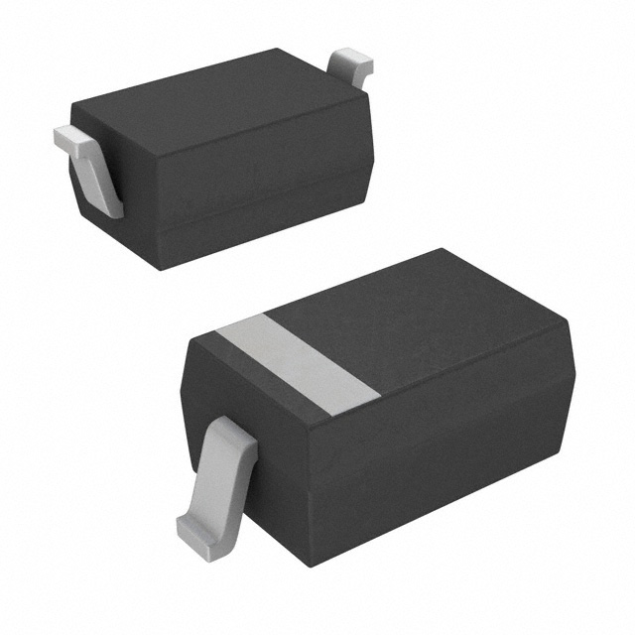

TO-252(DPAK), TO-263(D2PAK)
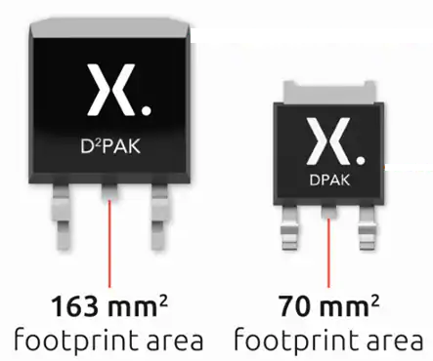

SO-8FL
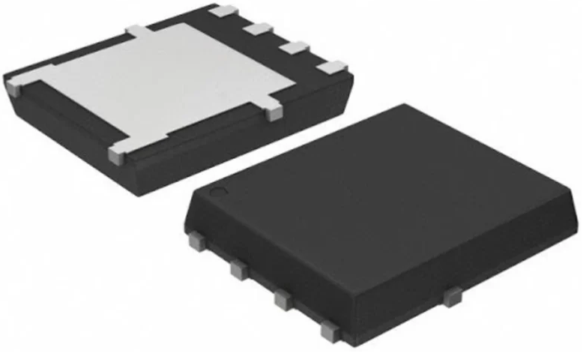

PowerDI3333-8(3.3x3.3mm)
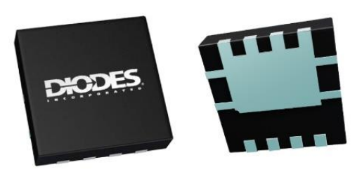

Similar but NOT equivalent 3x3mm packages
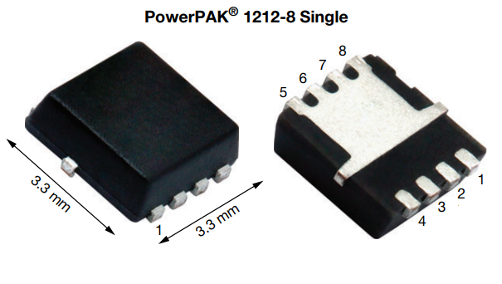
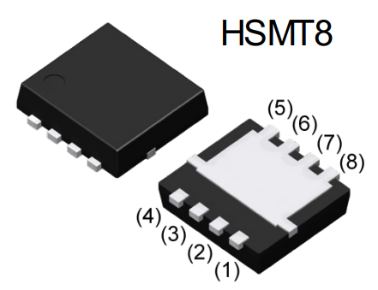

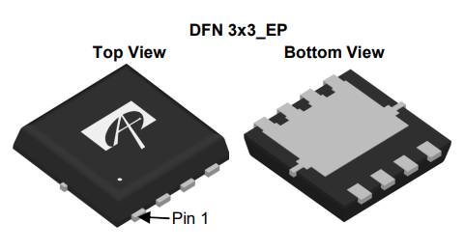
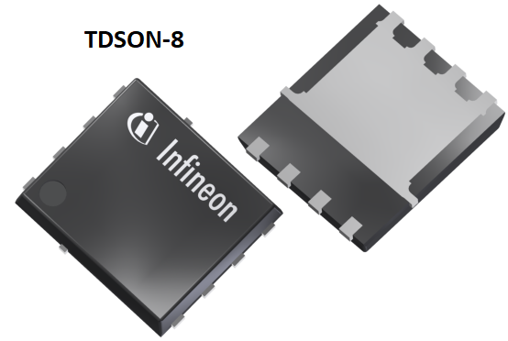

SOT-223(SC-73, 6.5x3.5mm)
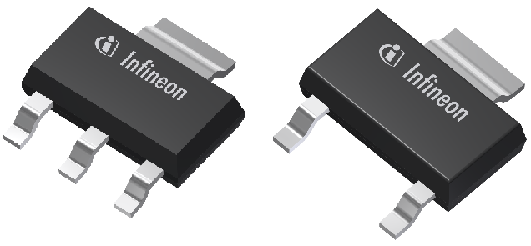

U-DFN2020-6(2x2mm)
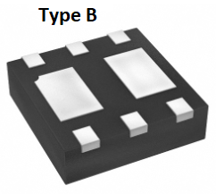
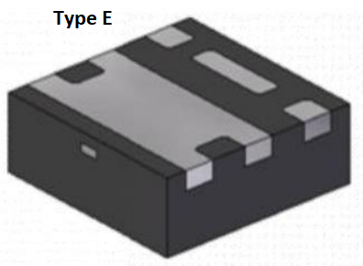
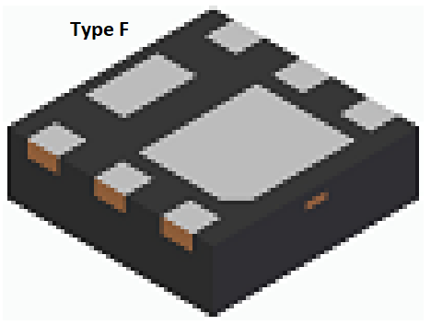
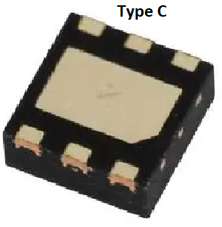

SOT-25 (SOT23-5)
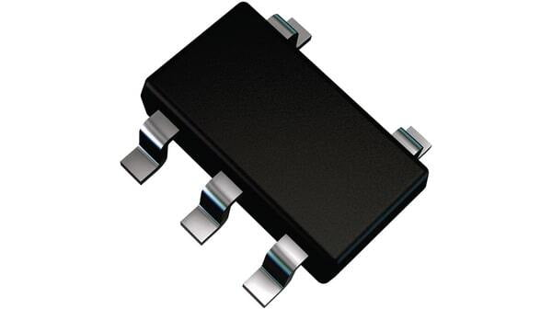

SOT-143 (TO-253-4)
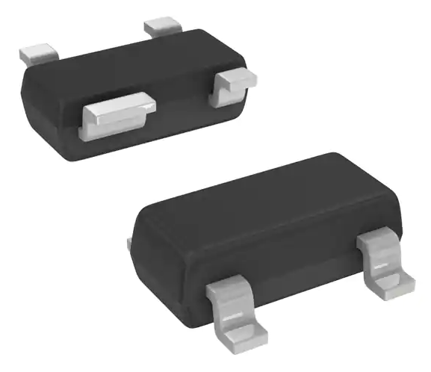

SOP(width=4.4mm, pitch=1.27mm), TSSOP(width=4.4mm, pitch=0.65mm), VSSOP(width=2.3mm, pitch=0.5mm), MSOP(width=3mm, pitch=0.65mm), TSOP(pitch 0.5 … 1.27mm)
