Постановка задачи

<https://turbmodels.larc.nasa.gov/flatplate.html>

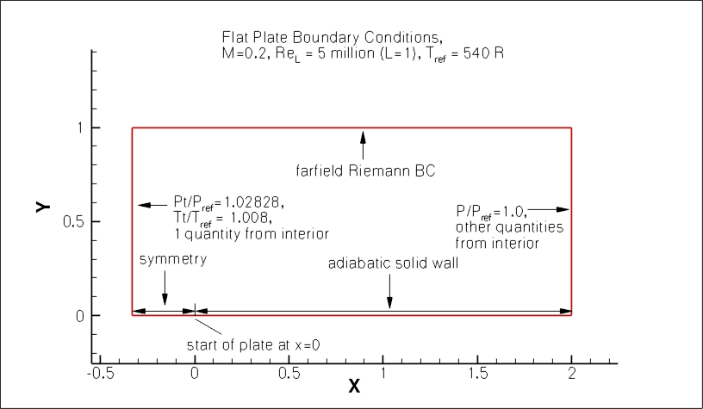

Сетки

<https://turbmodels.larc.nasa.gov/flatplate_grids.html>

Format for the structured 2D grids is PLOT3D-type, formatted, MG, 2D (nbl=1) - note that you must use double precision when reading! :

read(2,\*) nbl

read(2,\*) (idim(n),jdim(n),n=1,nbl)

do n=1,nbl

read(2,\*) ((x(i,j,n),i=1,idim(n)),j=1,jdim(n)),

+ ((y(i,j,n),i=1,idim(n)),j=1,jdim(n))

enddo

Решение Блазиуса





Re=ρv∞x/µ