**PROPERTY LISTINGS DATABASE DESIGN AND IMPLEMENTATION REPORT**

**(Project Phase 1)**

# **Project Description**

The world is changing rapidly and so is the real estate sector. Brokers and property sellers are shifting from the traditional way of doing things to embracing modern data storage and technology. For instance, home sellers and property agents have decided to use the internet to reach more clients, instead of relying on the old ways of using print and broadcast media. The world is closely connected, and people/clients depend on the internet in doing almost everything. Unlike the traditional way of buying and selling properties, listing properties online comes with many advantages. For example, it is faster to reach a large pool of potential prospects who are well informed. It also provides a more versatile way to retrieve and store data.

Therefore, in our project, we are focusing on designing and implementing a database for property listings in the United States. The database will have properties distributed across different regions such as the Pacific Region, Rocky Mountain Region, Midwest Region, Southwest Region, Southeast Region, and Northeast Region. It will store information about clients, property owners, employees, accounts, managers, loans, and the status of the specific properties, whether sold or not. Our real estate database will facilitate the way buyers and sellers communicate property information based on the factors stated above.

# E/R Diagram

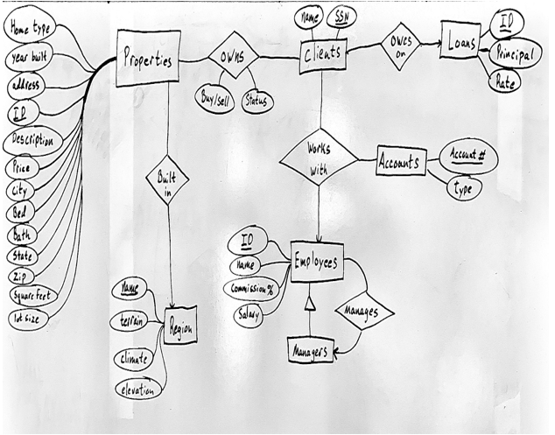

# **Relational Schema/Data** Types

-NOTE: underscores indicate key attributes.

Properties(_ID, hometype, yearbuilt, address, description, price, city, state, zip, bed, bath, square feet, lot size, RegionName)

Region(_Name, terrain, climate, elevation)

Owns(_ClientSSN, PropertyID, buyer/seller, status)

Clients(_SSN, name, LoanID)

Loans(_ID, principal, rate)

WorksWith(_SSN, _EmployeeID ,_Account#)

Accounts(_Account#, type)

Employees(_ID, name, commission%, salary, ManagerID)

**PROPERTIES:**

HOME TYPE :VARCHAR

YEAR BUILT :INT

ADDRESS :VARCHAR

ID :INT

DESCRIPTION :VARCHAR

PRICE :INT

CITY :VARCHAR

STATE :VARCHAR

ZIP :INT

BED :INT

BATH :INT

SQUARE FEET :INT

LOT SIZE :INT

**REGION:**

NAME :VARCHAR

TERRAIN :VARCHAR

CLIMATE :VARCHAR

ELEVATION :INT

**OWNS:**

BUYER/SELLER :BOOL

STATUS :VARCHAR

**CLIENTS:**

NAME :VARCHAR

SSN :INT

**LOANS:**

ID :INT

PRINCIPAL :FLOAT

RATE :DECIMAL

**ACCOUNTS:**

ACCOUNT# :INT

TYPE :VARCHAR

**EMPLOYEES:**

ID :INT

NAME :VARCHAR

COMMISSION% :DECIMAL

SALARY :INT

MANAGER ID :INT

# Possible Queries

Note: The list provided here is far from exhaustive and aims to be descriptive of potential queries.

1. Name clients that own properties in terrain regions working with a certain account type (to be specified later in the project).
2. List the property Id, price and state of properties built in the Rocky Mountain Region of the United States of America.
3. List clients who owe on loans with principals higher than a certain value (we will specify the value later in the project).
4. List property types loaned to clients with a particular interest rate (to be given later in the project)
5. Name, ID, and Commission of an employee working with client X who owns properties in more than two states with a particular elevation.
6. List of properties owned by client X whose status is sold
7. List the names of managers who also work with clients who own properties
8. Return terrains available where properties have greater than X square feet, built more recently than Y, and have a price lower than Z.

# Modifications

Note: The list provided here is far from exhaustive and aims to be descriptive of potential modifications to our database

1. Delete and create relations.
2. Add attribute ManagerClearance to relation Employees.
3. Delete attribute lot size from properties table.
4. Delete a property with property Id X.
5. Populate relations with values.
6. Update or make corrections on wrong insertions into a relation.

# **Conclusion**

Property listing with the help of the internet is one of the best ways to reach potential customers. Database management systems are the best tools to use to store data about listings and also write queries that can help manage the whole process of working with clients. Designing and implementing databases can be complex and therefore appropriate approaches are critical. In our project, we first started modeling our property listing database using a higher level data model, in this case E/R Diagram. The second step involved converting our E/R Diagram to relational databases (a schema for each of the relations.) In our first step, we give possible query descriptions that we expect to execute in later stages of our project.

# References

1. Lecture notes by Prof. Prakash Ramanan