If you're building a new ASP.NET Core project
I recommend SVG icons.
SVG Sprite is one of the most efficient ways to use SVG icons, especially in admin panels where the same icons appear many times.
What is an SVG Sprite?
Instead of having one SVG file per icon:
user.svg
building.svg
search.svg
card.svg
home.svg
...
you combine all icons into one SVG file, called a sprite.
--
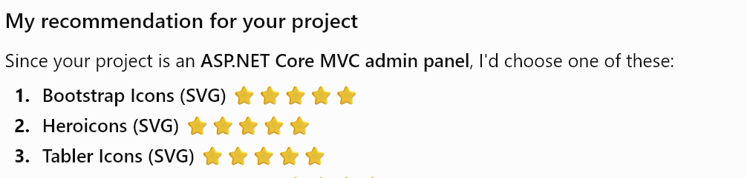
If you're building a new ASP.NET Core project
I recommend SVG icons.

