https://chatgpt.com/c/6a5dd740-63b4-83eb-8b1a-380f1f130da7
CardManagement.CardOrderCreat
var (isAdmin, companyId, _) = GetAuthenticationInfo();

a discard. It means "I don't care about this value."
Why use _?
- Makes your intent clear.
- Avoids creating an unnecessary variable.
- Improves readability.

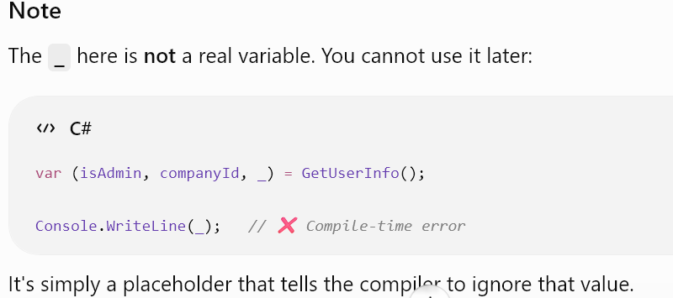Note
- The _ here is not a real variable. You cannot use it later:

