实验成绩

《数据库系统原理及应用》实验报告
实验六： SQL Server触发器
专业班级： 软件1502 姓名 学号 201516920411 完成时间：11.2
实验目的
理解触发器的作用和工作机制；熟练掌握后触发器和替代触发器的区别；熟练掌握后触发器和替代触发器的创建。
二、实验内容及要求
（使用前面实验建立的student、course和sc表实现）
创建满足下述要求的触发器（分别用前触发器和后触发器实现），并验证触发器执行情况。
三、实验结果(含运行程序和相应执行情况截图)
任务1：限制学生所在系的取值范围为｛计算机系，信息管理系，数学系，通信工程系｝。
--前触发器
CREATE TRIGGER triSdept ON Student
INSTEAD OF INSERT
AS
BEGIN
DECLARE @newSdept CHAR(20);
SELECT @newSdept=Sdept FROM inserted
IF NOT(@newSdept IN ('CS','IS','MA'))
BEGIN
PRINT 'Sdept只能是(IS,MA,CS)三种'
END
ELSE
INSERT INTO Student SELECT *FROM inserted
END
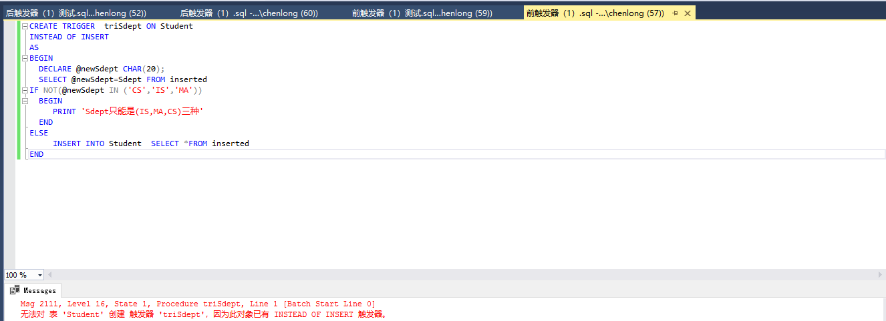
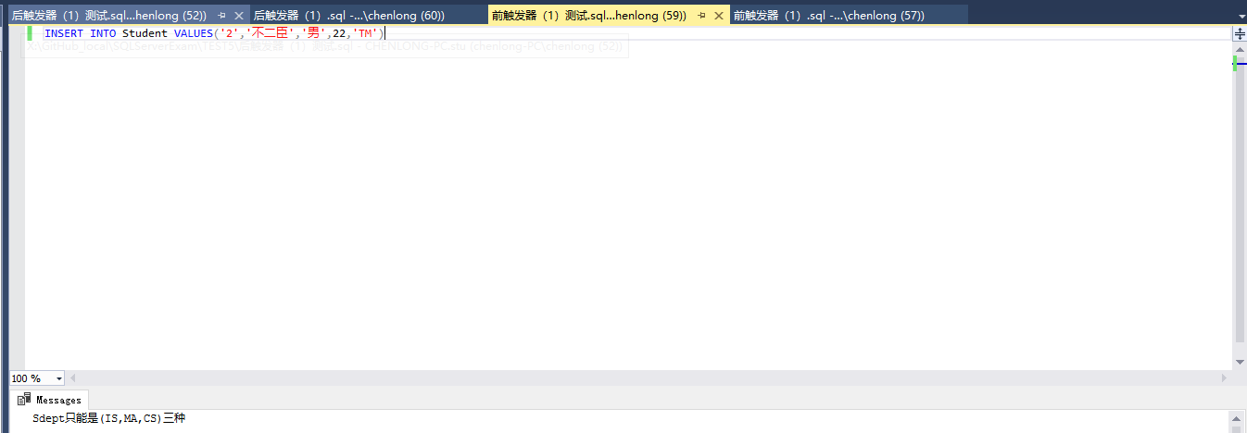
--后触发器
CREATE TRIGGER triSdept1 ON Student
AFTER UPDATE,INSERT
AS
BEGIN TRANSACTION
BEGIN
DECLARE @newSdept CHAR(20);
SELECT @newSdept=Sdept FROM inserted
IF NOT(@newSdept IN ('CS','IS','MA'))
BEGIN
PRINT 'Sdept只能是(IS,MA,CS)三种'
ROLLBACK TRANSACTION
END
END
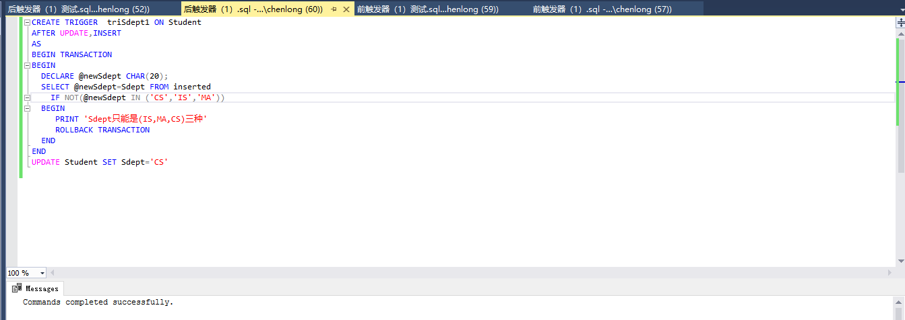
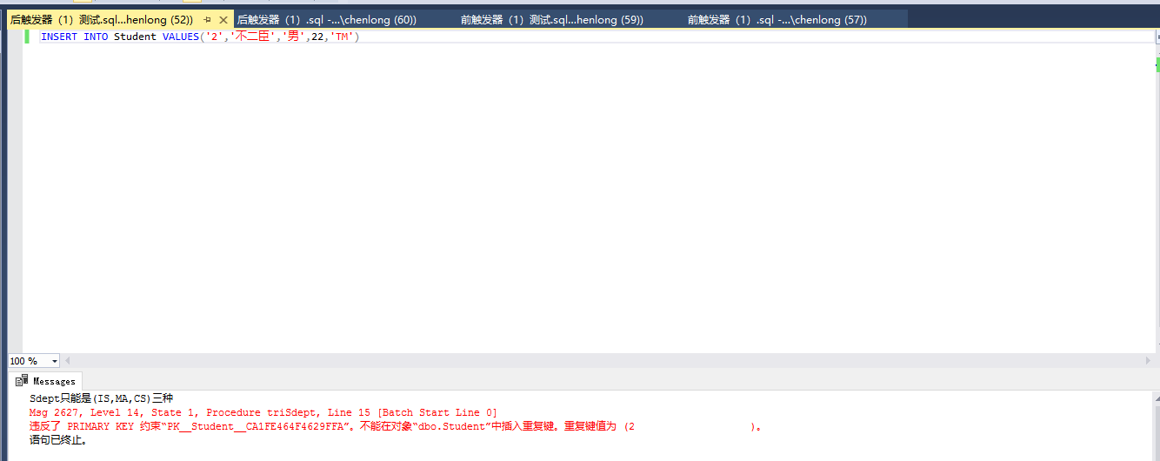

任务2：限制每个生所选修的课程总学分在20~30范围内。
--前触发器
CREATE TRIGGER triCcredit2 ON SC
INSTEAD OF INSERT,DELETE,UPDATE
AS
BEGIN
DECLARE @InsertSno CHAR(20)
DECLARE @deleteSno CHAR(20)
DECLARE @temp NUMERIC(2,1)
DECLARE @sumCredit NUMERIC(2,1)

SELECT @InsertSno=Sno FROM inserted
SELECT @deleteSno=Sno FROM deleted
SELECT @temp=Credit FROM inserted,Course
WHERE inserted.Cno=Course.Cno

SELECT @sumCredit=SUM(Credit) FROM SC,Course
WHERE SC.Cno=Course.Cno AND Sno=@deleteSno
IF (@sumCredit-@temp>=20)
BEGIN
INSERT INTO SC SELECT *FROM deleted
END
ELSE
PRINT '学生选修学分不能小于20'

SELECT @sumCredit=SUM(Credit) FROM SC,Course
WHERE SC.Cno=Course.Cno AND Sno=@InsertSno
IF (@sumCredit+@temp<=30)
BEGIN
DELETE FROM SC WHERE Sno=@deleteSno
END
ELSE
PRINT '学生选修学分不能大于30'
END
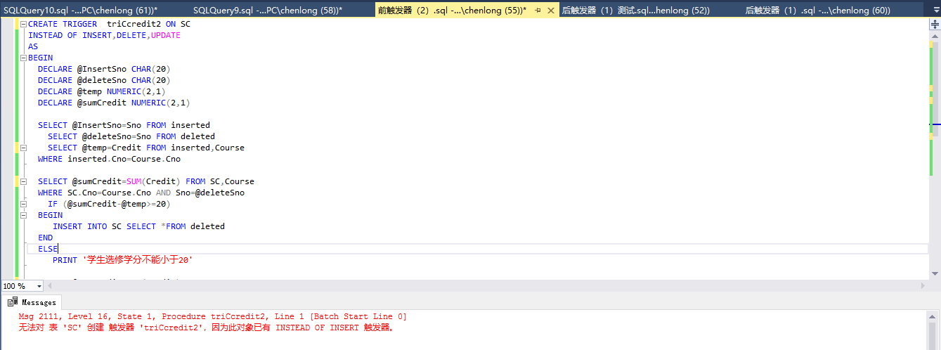
--后触发器
CREATE TRIGGER triCcredit1 ON SC
AFTER INSERT,DELETE,UPDATE
AS
BEGIN TRANSACTION
BEGIN
DECLARE @InsertSno CHAR(20)
DECLARE @deleteSno CHAR(20)
DECLARE @sumCredit NUMERIC(2,1)

SELECT @InsertSno=Sno FROM inserted
SELECT @deleteSno=Sno FROM deleted
SELECT @sumCredit=SUM(Credit) FROM SC,Course
WHERE SC.Cno=Course.Cno AND Sno=@deleteSno
IF (@sumCredit<20)
BEGIN
PRINT '学生选修学分不能小于20'
ROLLBACK TRANSACTION
END

SELECT @sumCredit=SUM(Credit) FROM SC,Course
WHERE SC.Cno=Course.Cno AND Sno=@InsertSno
IF (@sumCredit>30)
BEGIN
PRINT '学生选修学分不能大于30'
ROLLBACK TRANSACTION
END
END
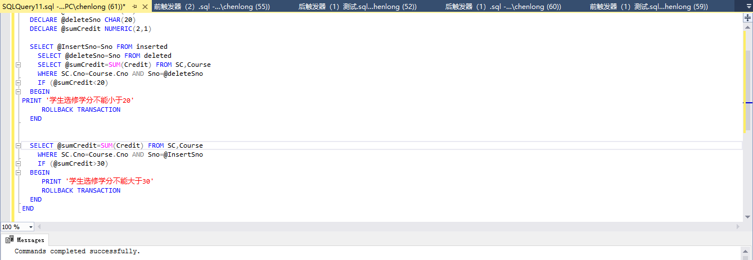
任务3：限制每个学生选课总门数不能超过6门（设只针对单行插入操作）
--前触发器
CREATE TRIGGER triSumCourse ON SC
INSTEAD OF INSERT
AS
BEGIN
DECLARE @InsertSno CHAR(20)
DECLARE @sumCourse NUMERIC(2,1)

SELECT @InsertSno=Sno FROM inserted

SELECT @sumCourse=COUNT(*) FROM SC
WHERE Sno=@InsertSno
IF (@sumCourse<6)
BEGIN
INSERT INTO SC SELECT *FROM inserted
END
ELSE
PRINT '学生选课总门数不能超过6门'
END
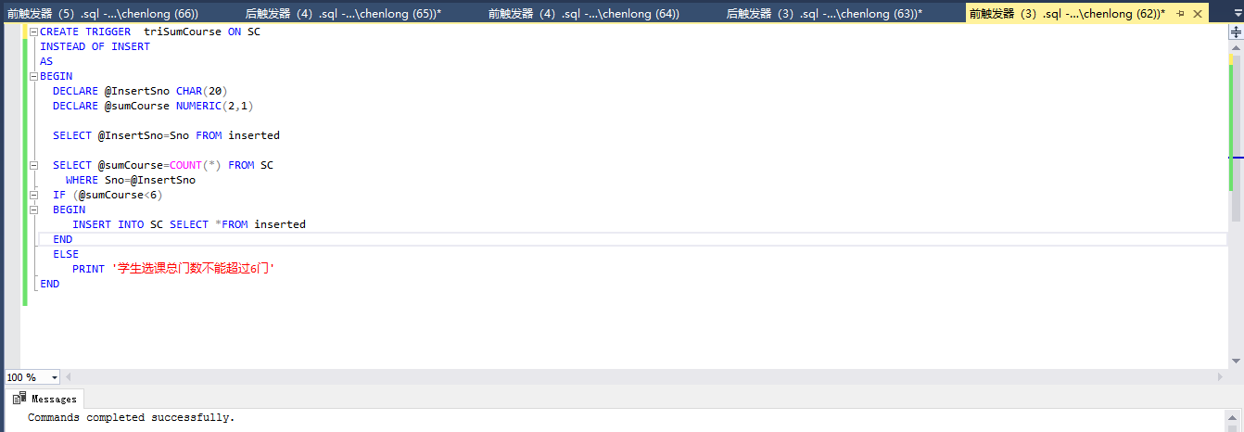
--后触发器
CREATE TRIGGER triSumCourse ON SC
AFTER INSERT
AS
BEGIN TRANSACTION
BEGIN
DECLARE @InsertSno CHAR(20)
DECLARE @sumCourse NUMERIC(2,1)

SELECT @InsertSno=Sno FROM inserted

SELECT @sumCourse=COUNT(*) FROM SC
WHERE Sno=@InsertSno
IF (@sumCourse>6)
BEGIN
PRINT '学生选课总门数不能超过6门'
ROLLBACK TRANSACTION
END
END
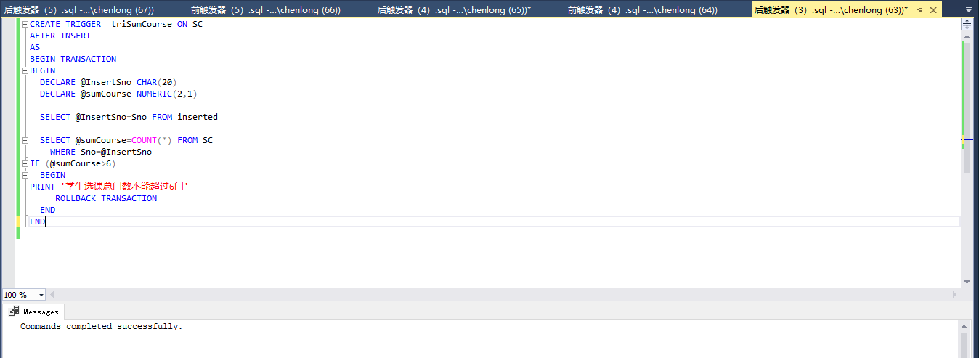
任务4：限制不能删除有人选的课程。
--前触发器
CREATE TRIGGER triDelCourse ON Course
INSTEAD OF DELETE
AS
BEGIN
DECLARE @deleteCno CHAR(20)

SELECT @deleteCno=Cno FROM deleted

IF (EXISTS( SELECT * FROM SC,Course
WHERE SC.Cno=Course.Cno AND Course.Cno=@deleteCno))
BEGIN
PRINT '不能删除有人选的课程'
END
ELSE
DELETE Course WHERE Cno=@deleteCno
END
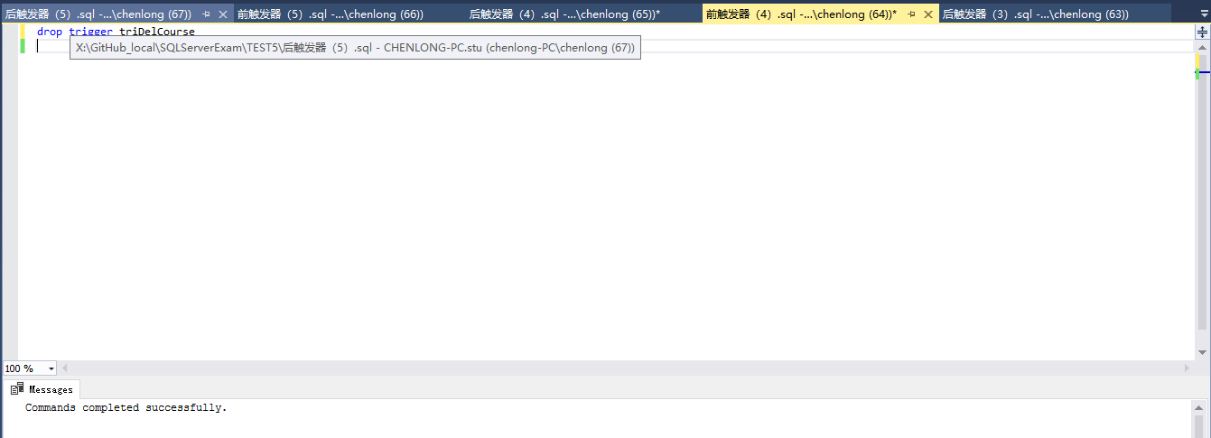
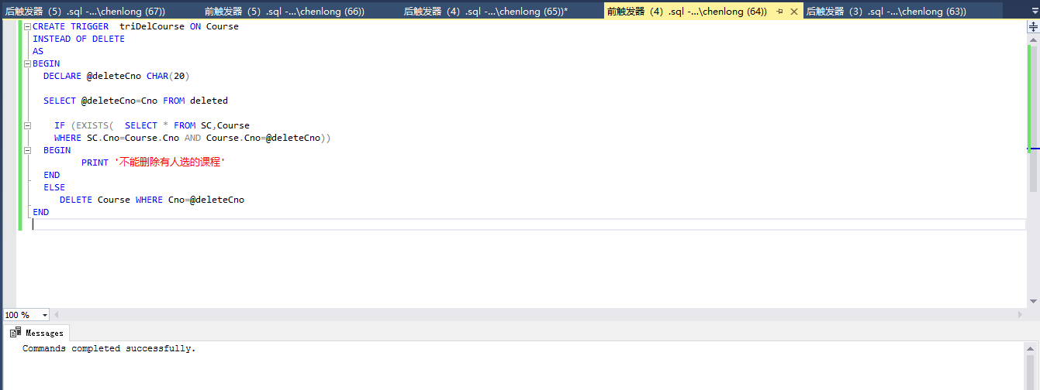
--后触发器
CREATE TRIGGER triDelCourse ON Course
AFTER DELETE
AS
BEGIN TRANSACTION
BEGIN
DECLARE @deleteCno CHAR(20)

SELECT @deleteCno=Cno FROM deleted

IF (EXISTS( SELECT * FROM SC,Course
WHERE SC.Cno=Course.Cno AND Course.Cno=@deleteCno))
BEGIN
PRINT '不能删除有人选的课程'
ROLLBACK TRANSACTION
END
END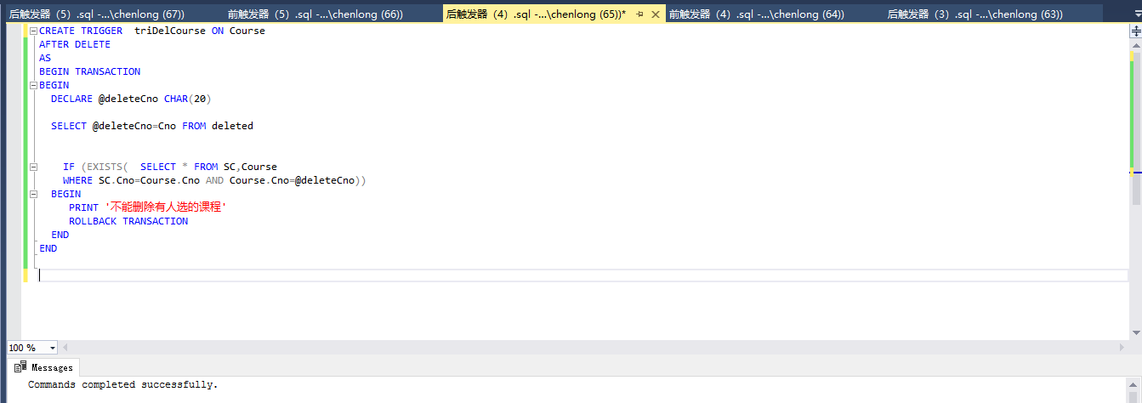
任务五：限制不能删除考试成绩不及格学生的该门课程的考试记录
--前触发器
CREATE TRIGGER triDelCourse ON SC
INSTEAD OF DELETE
AS
BEGIN
DECLARE @deleteCno CHAR(20)
DECLARE @SCgrade REAL

SELECT @deleteCno=Cno FROM deleted
SELECT @SCgrade=Grade FROM deleted
IF (@SCgrade<60)
BEGIN
PRINT '不能删除不及格的考试记录'
END
ELSE
DELETE Course WHERE Cno=@deleteCno
END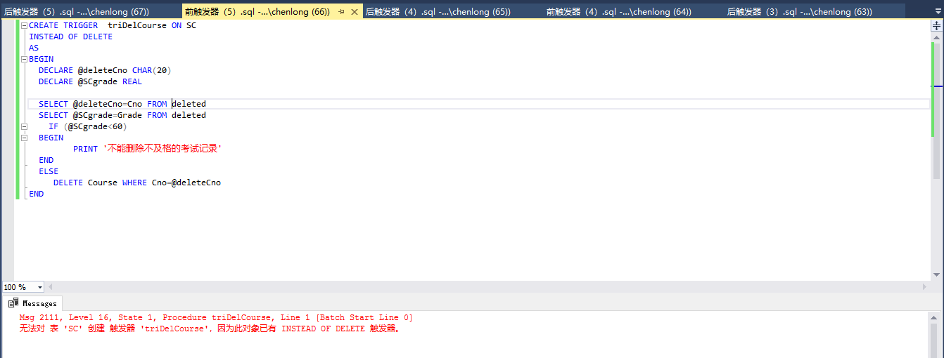
--后触发器
CREATE TRIGGER triDelCourse ON SC
AFTER DELETE
AS
BEGIN TRANSACTION
BEGIN
DECLARE @deleteCno CHAR(20)
DECLARE @SCgrade REAL

SELECT @deleteCno=Cno FROM deleted
SELECT @SCgrade=Grade FROM deleted
IF (@SCgrade<60)
BEGIN
PRINT '不能删除不及格的考试记录'
ROLLBACK TRANSACTION
END
END
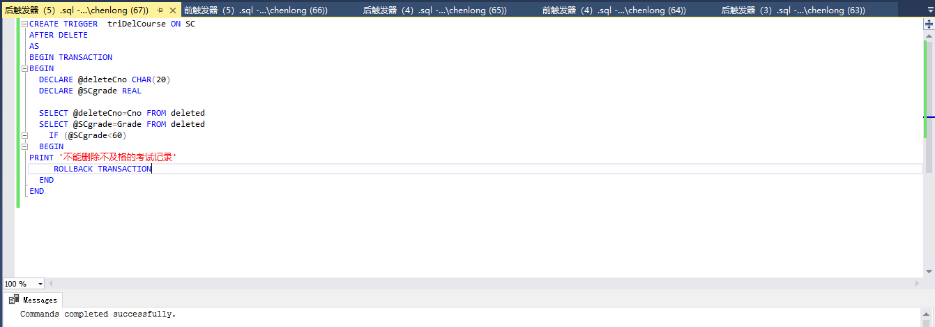
四、实验中遇到的问题及解决（或未解决）的方案
1、触发器的并存问题。

