DA6823

Mahoney, Michael

Exercise 1

1. Find the pdf image of the NCS survey booklet and go to page 134 (that is the pdf page – the actual survey page in the print version is page 130). You will see that this page has two sections – Technology and Lifestyles and the Internet. Print this page out and put it in your Appendix.

See appendix

1. Locate the question in pdf image the Technology section labeled “I’m always the first among my friends to have the latest in electronic equipment”. Then find the associated question in the excel data dictionary. Use this information to read in the five variables that correspond to the five responses for this question. Do a frequency for each of the five variables. If there are missing values you should turn those values into something numeric and useful (e.g. zeroes).

My Frequency Table on each of the five variables >> A Missing value indicates no selection and indicated by Frequency Missing = N >> Obtained from #First Freq.

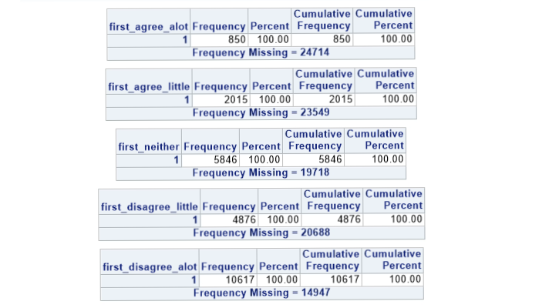

My new Frequency Table on the five variables >> The “1” indicates checked, and unchecked is indicated by “0” >> Obtained from #Binary Freq Dist

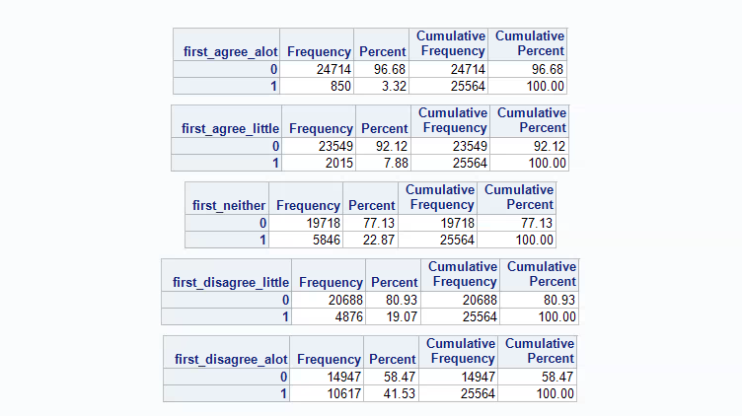

There are no missing values, because,” Frequency Missing = n” is not present for any output.

1. Check to see if any respondent checked more than one check box to this question. Show me the frequencies that back up your answer to this question. If they did check more than one box then randomly select one of the answers and modify the data to reflect that. What is your conclusion about this?

After running #Multiple Box (see appendix) >>

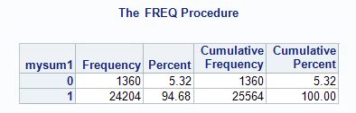

This is a sum of each ‘my_id’s response to question. A “1” indicates only one was checked and “0” indicates a missing value, but no N > 1 are present indicating multiple checkmarks. I agree with what the table provides, and I have checked that data.

1. Combine the five variables into one variable so that it is coded 5=agree a lot, 4= agree a little, 3 = neither agree nor disagree, 2 = disagree a little 1 = disagree a lot. Do a frequency of that variable. Then find a way to validate that your combining of the five variables went ok and you didn’t mess it up somewhere.

After running the first #Sniffin' Vars, I realized I made an error in coding. The weighted section ( of #Changing NA) of the equation myvar(m). I have sinced changed the error. >> The following output shows my corrected table. >>

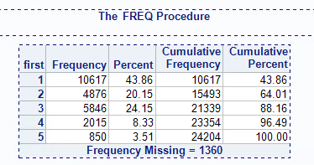

My original output was missing first = 2, and had 1 and 2 combined. After correctly adding a 2 to the weight, the updated code is correct.

1. Find another question in the Lifestyles and the Internet section that suits your fancy. Wash, rinse and repeat steps 1 through 4 above for this variable.

For this question I chose the “I love to buy new gadgets and appliances” variables >> My frequency table using the #First Freq >>

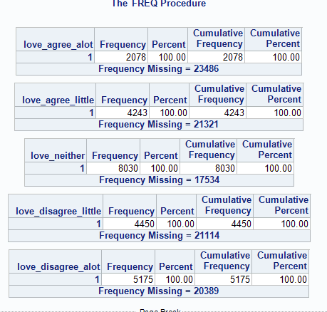

Missing variables are indicated by the “Frequency Missing = N”

After using #Change NA, I converted the data table into an array, used a loop to change all the “.” (Missing Values) into “0” >> Very useful to determine if our respondents are choosing one answer.

My new Frequency Table on the five variables from the love question>> The “1” indicates checked, and unchecked is indicated by “0” >> Obtained from #Binary Freq Dist

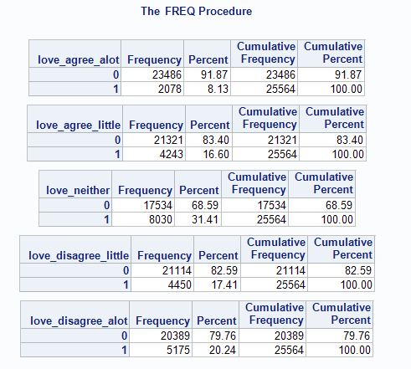

The “0” indicates no value (unchecked) and the “1” indicates that one is checked >> There are no missing values, because,” Frequency Missing = N” is not present for any output.

I then ran #Multiple Box (see appendix) >> The check if our dear old surveyors did indeed check just one box

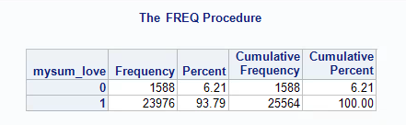

This indicates that no one checked more than one box, but 1588 participants did not check any box

Checking my work to make sure I properly put the dataset together >> #Sniffin Vars was run and no errors were made( I think not)

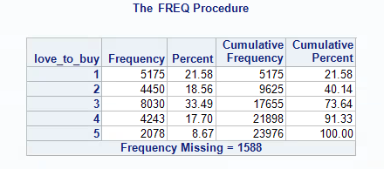

Appendix

Questions 1 – 4 >> See Program: HW1_Mahoney_Mike_Program

/* Creating library called FA12 */

libname FA12 '\\Client\C$\Users\Mike\Documents\Practicum 1';

/* Creating file called bigrec */

filename bigrec '\\Client\C$\Users\Mike\Documents\Practicum 1\FA12_Data.txt' lrecl = **65576**;

/*“I’m always the first among my friends to have the latest in electronic equipment” >> Reads 5 variables >>

Outputs a data frame with each my_id's response to each of the 5 variables

With a "1" indicating a correct choice*/

**data** first;

infile bigrec;

input my_id **1**-**7**

first_agree_alot **6825**

first_agree_little **6842**

first_neither **6876**

first_disagree_little **6893**

first_disagree_alot **6910**;

**run**;

/* #First Freq - Doing a Frequency for each of the 5 variables */

**proc** **freq** data=first;

tables

first_agree_alot

first_agree_little

first_neither

first_disagree_little

first_disagree_alot;

**run**;

/* #Change NA - Use an array to turn missing values to zeros */

**data** mycalcs;

set first;

array missy(**1**,**5**)

first_agree_alot

first_agree_little

first_neither

first_disagree_little

first_disagree_alot;

/* now make missy values 0 >> Loops through i (which is only one in our case because its one question) then

j (which is each question) >> turning the "." into "0" >> Using an if/then statement */

do i = **1** to **1**;

do j = **1** to **5**;

if missy(i,j) = **.** then missy(i,j) = **0**;

end;

end;

/*make array for 8 variable sums */

array mysum(**1**);

/*sum up the vars and make no mark or > 1 mark missing*/

/* now make each variable, meing sure to ignore zeros and larger than 1 */

do k = **1** to **1**;

mysum(k) = missy(k,**1**) + missy(k,**2**) + missy(k,**3**) + missy(k,**4**) + missy(k,**5**);

end;

/* now if the variable is not zero or greater than 1 create var */

array myvar(**1**);

do m = **1** to **1**;

if mysum(m) = **1** then

myvar(m) = (missy(m,**1**)\***5**) + (missy(m,**2**)\***4**) + (missy(m,**3**)\***3**) + (missy(m,**4**)\***2**) + (missy(m,**5**)\***1**);

else

myvar(m) = **.**;

end;

/* Changing the variable name to first */

first = myvar(**1**);

/*Creates a sum of myvar */

mysum1 = mysum(**1**);

**run**;

/* #Binary Freq Dist - Running a second freq distribution on to check if 1 - answered or 0- missing*/

**proc** **freq** data=mycalcs;

tables

first_agree_alot

first_agree_little

first_neither

first_disagree_little

first_disagree_alot;

**run**;

/* #Multiple Box - Check indicies of multiple check marks >> To see if our surveyors followed instructions*/

**proc** **freq** data=mycalcs;

tables

mysum1;

**run**;

/* #Sniffin' Vars - now sniff variables and compare - should be approx same as cell counts */

**proc** **freq** data=mycalcs;

tables

first;

**run**;

Question 5 >> See Program: HW1_Mahoney_Mike_Program Q5

/* Creating library called FA12 */

libname FA12 '\\Client\C$\Users\Mike\Documents\Practicum 1';

/* Creating file called bigrec */

filename bigrec '\\Client\C$\Users\Mike\Documents\Practicum 1\FA12_Data.txt' lrecl = **65576**;

/*“I love to buy new gadgets and appliances” >> (When my wife uses her card!)>> Reads 5 variables >>

Outputs a data frame with each my_id's response to each of the 5 variables

With a "1" indicating a correct choice*/

**data** love_to_buy;

infile bigrec;

input my_id **1**-**7**

love_agree_alot **6834**

love_agree_little **6851**

love_neither **6885**

love_disagree_little **6902**

love_disagree_alot **6919**;

**run**;

/* #First Freq - Doing a Frequency for each of the 5 variables */

**proc** **freq** data=love_to_buy;

tables

love_agree_alot

love_agree_little

love_neither

love_disagree_little

love_disagree_alot;

**run**;

/* #Change NA - Use an array to turn missing values to zeros */

**data** mycalcs_01;

set love_to_buy;

array missy(**1**,**5**)

love_agree_alot

love_agree_little

love_neither

love_disagree_little

love_disagree_alot;

/* now make missy values 0 >> Loops through i (which is only one in our case because its one question) then

j (which is each question) >> turning the "." into "0" >> Using an if/then statement */

do i = **1**;

do j = **1** to **5**;

if missy(i,j) = **.** then missy(i,j) = **0**;

end;

end;

/*make array for 8 variable sums */

array mysum(**1**);

/*sum up the vars and make no mark or > 1 mark missing*/

/* now make each variable, meing sure to ignore zeros and larger than 1 */

do k = **1**;

mysum(k) = missy(k,**1**) + missy(k,**2**) + missy(k,**3**) + missy(k,**4**) + missy(k,**5**);

end;

/* now if the variable is not zero or greater than 1 create var */

array myvar(**1**);

do m = **1**;

if mysum(m) = **1** then

myvar(m) = (missy(m,**1**)\***5**) + (missy(m,**2**)\***4**) + (missy(m,**3**)\***3**) + (missy(m,**4**)\***2**) + (missy(m,**5**)\***1**);

else

myvar(m) = **.**;

end;

/* Changing the variable name to love_to_buy */

love_to_buy = myvar(**1**);

/*Creates a sum of myvar */

mysum_love = mysum(**1**);

**run**;

/* #Binary Freq Dist - Running a second freq distribution on to check if 1 - answered or 0- missing*/

**proc** **freq** data=mycalcs_01;

tables

love_agree_alot

love_agree_little

love_neither

love_disagree_little

love_disagree_alot;

**run**;

/* #Multiple Box - Check indicies of multiple check marks >> To see if our surveyors followed instructions*/

**proc** **freq** data=mycalcs_01;

tables

mysum_love;

**run**;

/* #Sniffin' Vars - now sniff variables and compare - should be approx same as cell counts */

**proc** **freq** data=mycalcs_01;

tables

love_to_buy;

**run**;