Mahoney, Mike

DA 6823

Kilger

Module 2: Part #1 (35 points)

**Standard Error of the Estimate + Confidence Intervals + the Logic of Hypothesis Testing + Type 1 and Type II errors**

**General Instructions:** In your own words, answer each of the following questions - don’t copy (e.g. cut and paste) some definition out of a book word for word. This is not a group project – you are expected to complete this module on your own. You may refer to text books, online or other sources but not your fellow classmates. If you don’t understand the question, feel free to ask the instructor in class, in office hours or in an email.

1. Explain in your own words in a couple of sentences what a confidence interval is (4 points)

A confidence level is how much trust you have in the value/prediction. It is an equal distance boundary that hugs the value in positive or negative directions. The tighter the C.I., the more trust you have in that answer. A loose C.I., indicates you don’t have faith in the answer.

1. Imagine that you had a random sample of 150 voters and 45% of them said that they would vote for Donald Trump.
   1. Produce a 95% confidence interval around that proportion. Show your work. (6 points) – I am assuming 1 SD

Sample mean (+/-) Z-Score * (SD/√sample)

45 (+/-) 1.96 * (1/√150) >> 45 (+/-) 1.96 * (0.0816) >> 45 (+/-) 0.1599

1. Imagine that you took a random sample of 50 light bulbs and measured how long they lasted. Your experiment shows that the sample mean number of hours is 1150 and the sample standard deviation is 120 hours. Produce a 95% confidence interval around the mean. Show your work. (7 points)

Sample mean (+/-) Z-Score * (SD/√sample)

1150 (+/-) 1.96 * (120/√50) >> 1150 (+/-) 1.96 * (16.97) >> 1150 (+/-) 33.26

1. Imagine that the population mean age for UTSA students is 26 and the population standard deviation is 4. Calculate the Z score the data point 24. Show your work (4 points)

Z-score = ( data point – mean ) / SD

(24-26)/4 >> -2/4 = -0.5 == 0.3085

1. Draw a Z curve and mark off the value Z = 1.61. Using a z table what is the area to the right of z=1.61? (4 points)

1 – 0.9463 >> 0.0537 Is to the right of z = 1.61

1. Draw a Z curve and mark the point Z=-.8 What is the area to the left of this z score? (4 points)

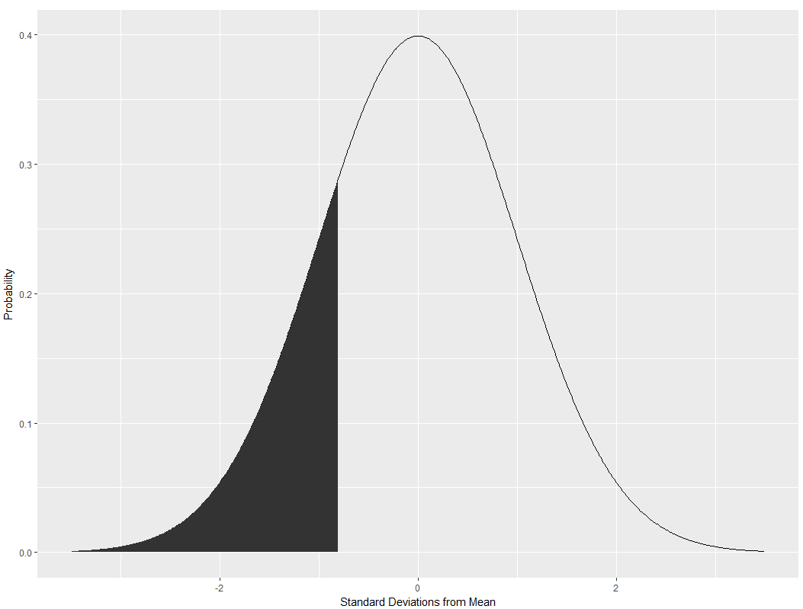

Area to the left is 0.2119

1. Draw a Z curve and mark off the Z score Z= -.34 and then mark off the Z score Z=.66 Now calculate the area under the curve between these two points. Show your work. (6 points).

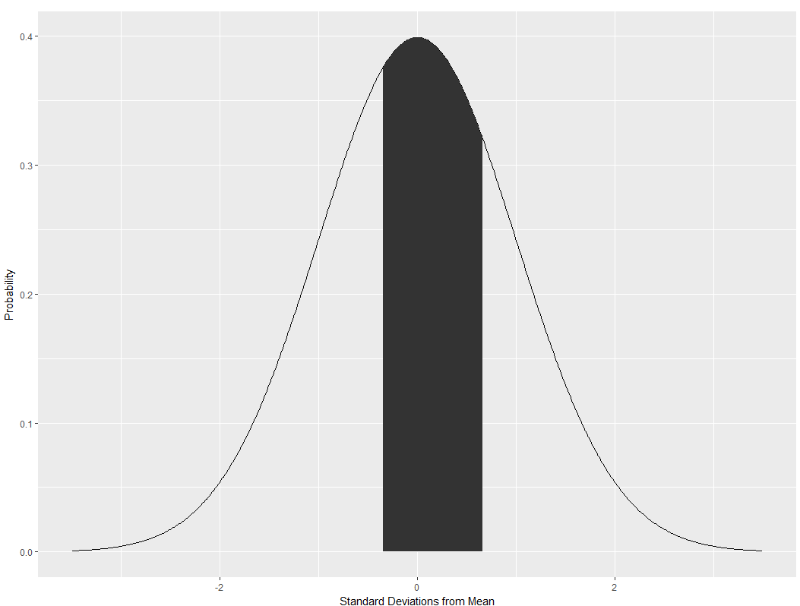

Shaded area is 0.3785

Appendix

require(ggplot2)

x <- seq(-3.49,3.49, length = 700)

y <- dnorm(x, mean=0, sd=1)

z_frame <- data.frame(x,y)

neg_8 <- z_frame[1:270,]

mid_area <- z_frame[316:417,]

normal_curve <- ggplot(z_frame, aes(x=x,y=y))+

geom_line(aes()) +

xlab(label = "Standard Deviations from Mean")+

ylab(label = "Probability")

normal_curve

shade_left <- ggplot(z_frame, aes(x=x,y=y))+

geom_line(aes()) +

geom_area(data = neg_8, aes(x=x,ymin=0, ymax=y)) +

xlab(label = "Standard Deviations from Mean")+

ylab(label = "Probability")

shade_left

shade_mid <- ggplot(z_frame, aes(x=x,y=y))+

geom_line(aes()) +

geom_area(data = mid_area, aes(x=x,ymin=0, ymax=y)) +

xlab(label = "Standard Deviations from Mean")+

ylab(label = "Probability")

shade_mid