Mahoney, Mike

DA 6823

Kilger

Module 3: Part #1 (20 points)

**Statistical Significance Versus Effect Size + Independent Samples t test**

**General Instructions:** In your own words, answer each of the following questions - don’t copy (e.g. cut and paste) some definition out of a book word for word. This is not a group project – you are expected to complete this module on your own. You may refer to text books, online or other sources but not your fellow classmates. If you don’t understand the question, feel free to ask the instructor in class, in office hours or in an email.

Here is the SAS printout for an independent samples ttest that compares advertising receptivity (scale =person has low ad receptivity, 5=person has high ad receptivity) between males (gender=1) and females (gender=0).

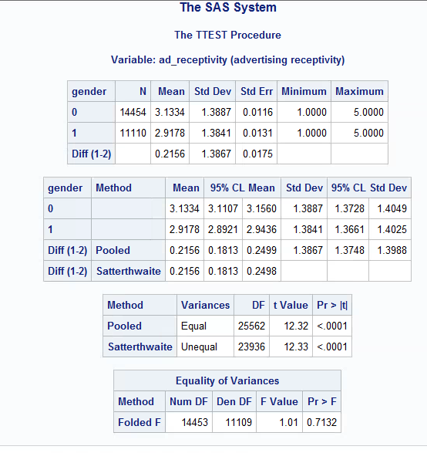

1. State the null and alternative hypotheses for the 2 independent sample t test. (4 points)

H0: Ad receptivity will be equal in the mean of both genders.

H1: Ad receptivity will not be equal in the mean of both genders.

1. Name two assumptions of the 2 independent sample t test. ( 4 points)

1: The population distribution is normal, bell shaped curve

2: The samples are random and independent

1. What is the mean ad receptivity for males? For females? (2 points)

Males = 3.13

Females = 2.92

1. Does the data suggest that the variance of ad receptivity in males versus females is to be treated as equal or unequal? What is the p value for this test? ( 4 points )

The pooled is the variances are equal P > 0.05

The Satterwaite is the variances are un equal when P < 0.05

The variances are unequal in ad receptivity, with both the Pooled and Satterwaite having P-Values below 0.001

1. What can you conclude about the differences in ad receptivity between males and females? Given the differences in the data between males and females, explain why you were able to come to the conclusion that you did. (6 points)

I have concluded that the receptivity is different in genders based on the Pooled Variance and Satterwaite test with significant p-values. Both test gives me confidence to reject the Null hypothesis.