Mahoney, Mike

DA 6823

Kilger

Module 3: Part #2 (15 points)

**Dependent Samples t test**

**General Instructions:** In your own words, answer each of the following questions - don’t copy (e.g. cut and paste) some definition out of a book word for word. This is not a group project – you are expected to complete this module on your own. You may refer to text books, online or other sources but not your fellow classmates. If you don’t understand the question, feel free to ask the instructor in class, in office hours or in an email.

Here is the SAS printout for an dependent samples ttest that compares advertising receptivity (scale =person has low ad receptivity, 5=person has high ad receptivity) before and after the person drinks a shot of tequila.

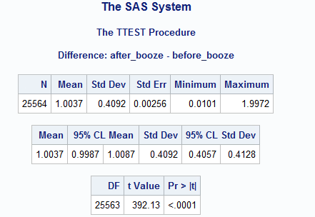

1. State the null and alternative hypotheses for the dependent sample t test. (4 points)

H0: The means are the same before and after tequila

H1: The means are different before and after tequila

1. Name one assumption of the dependent sample t test ( 2 points)

That the differences between before and after booze are normally distributed.

1. What is the difference in the before and after alcohol means? (2 points)

1.0037 – 0.9987 = 0.005

1. What can you conclude about the change in advertising receptivity due to the application of alcohol to a respondent? (4 points)

We can conclude there is a change in receptivity due to alcohol because our probability of both means being equal is below 0.001.

1. Why is this called a “paired” or dependent sample t test? (3 points)

It is called a “paired” or dependent sample t test because the values are similar. It is essentially a within group test, which gives a lower variance. In our case the respondents were the same person and so our between group variance was minimized.