Overview: This was created in C# using the XNA framework and the base menu system provided my Microsoft(Provides the menu and transition screen).

This will run on windows, and depending on which version may need to install some .net frameworks etc, but will all be done by running the provided setup or AI_project_jared file. To run the program after installing simply click the same file or navigating to start->All Programs->Jared Prather->AIProject. It is a A* search algorithm that will search from a start node to a goal node, and has support for barriers.

Tips: All related controls are displayed in the program. Start by navigating to where you want to place your start(S) and goal(G) nodes and place them. Then insert barriers(B) between said nodes(note that the search while move diagonally, therefore can move thru a diagonal 'wall'). You can delete any misplaced barriers by pressing C, and can fully reset the board after a search by pressing R
Algorithm: A* search
Language: C#
Input: Graphical, Keyboard
Ouput: Graphical, showing route

Some Search Examples
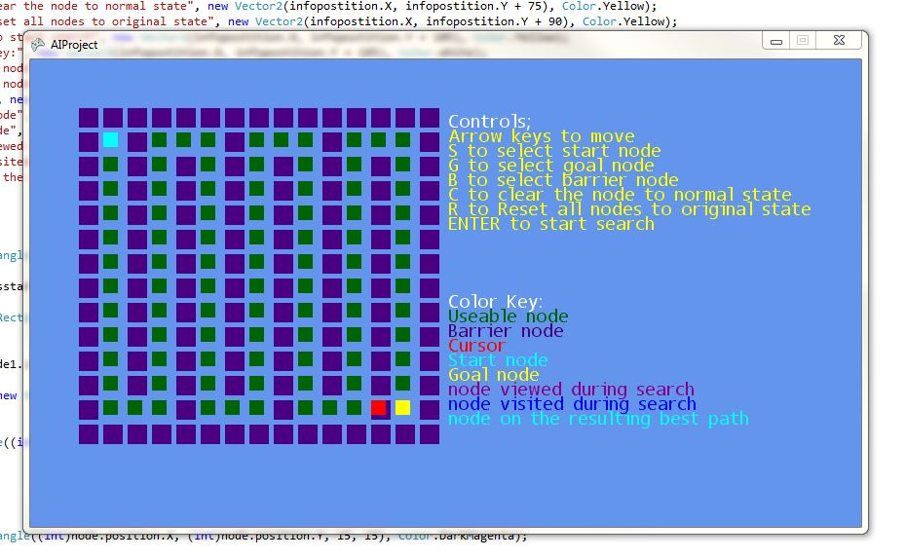
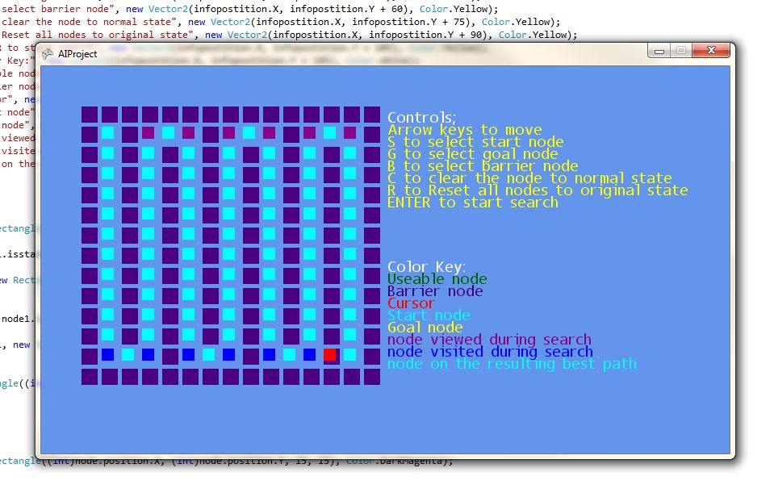

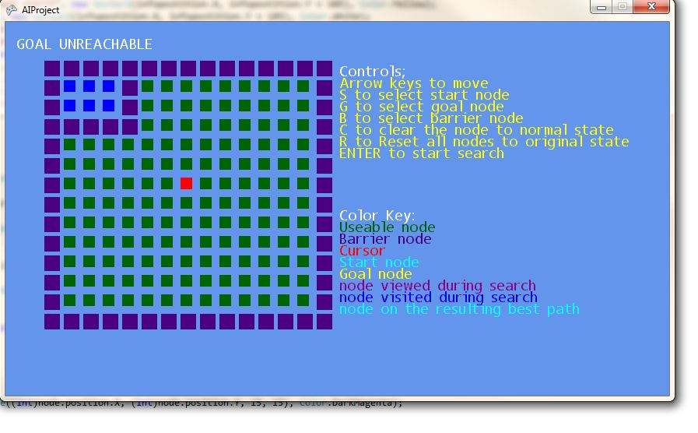

Demonstrates a unreachable goal

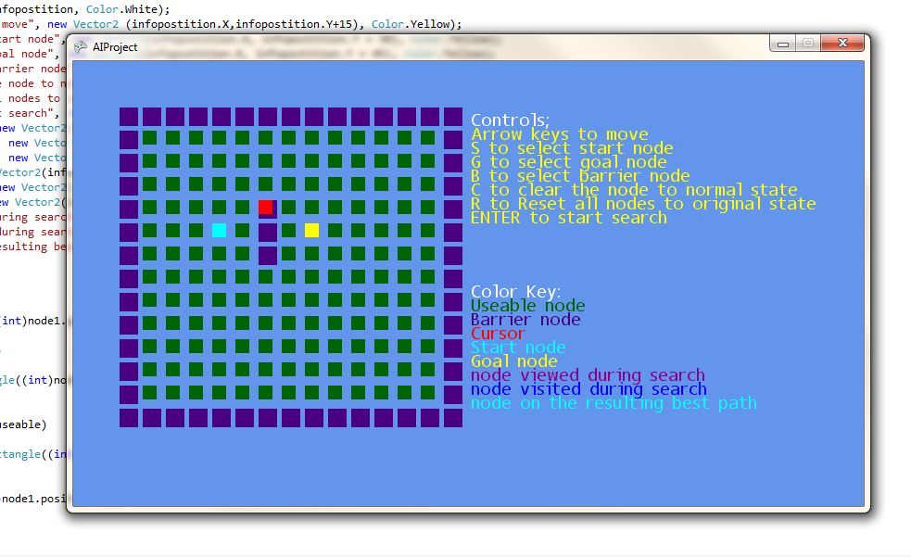
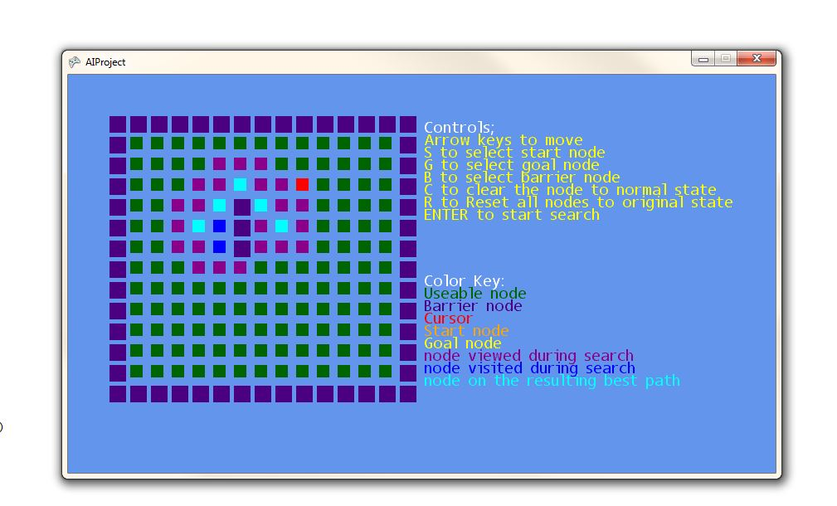
Simple search, note the magenta colored nodes are nodes that were 'viewed' or analyzed during the search, the blue were nodes that were actually moved along during the search, and finally the cyan nodes are the actual best path taken to goal.

