

PHYSICS LAB

(20147)

Experiment No. 5

Newton’s Second Law
Acceleration due to gravity

2007
Name: ……………………………………. Reg.No. ( )

Partner name:……………………………….. Class ( )

Date / / 20 Mark ( )

Acceleration due to gravity (g)

1- Objectives
______________________________________________________________________________________________________________________
2- Apparatus
______________________________________________________________________________________________________________________
3- Data
a) Complete the following table:

d = ________cm, y = __________cm, x = ___________cm, h = y-x =__________cm

No. | P₁ | P₂ | P₃ | S₁ | S₂ | t₁ | t₂ | a | g
1
2
3
Avg.=
b) Calculate the error in the average of g.
______________________________________________________________________________________________________________________
4. Questions:

1. The figure below shows three objects of different masses. They are released from rest at the same time from the same level and slide down the ground, neglect air resistance.

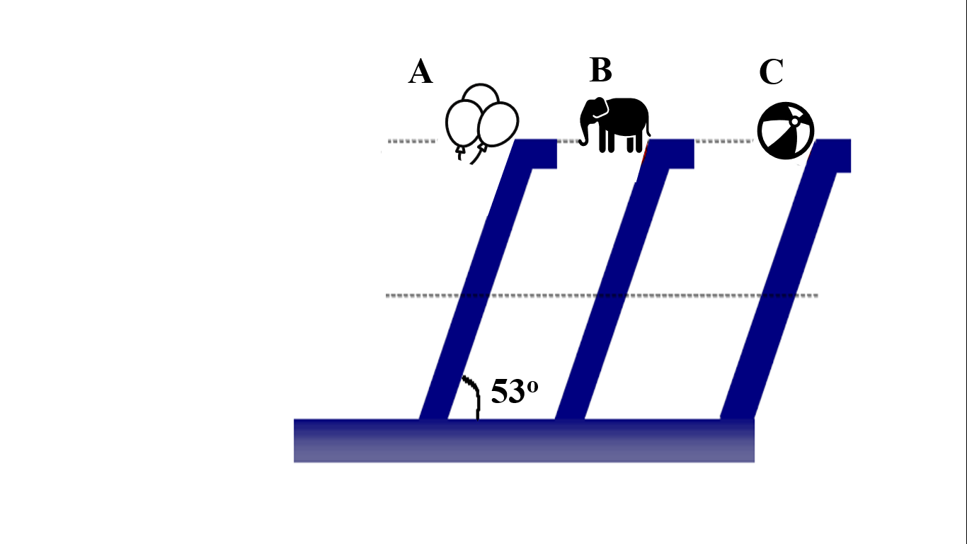
a) Which object will reach the ground first?

- Object A
- Object B
- Object C
- All will reach at the same time.

2. The three tracks A, B, and C shown in the figure below are frictionless. The animal at rest.
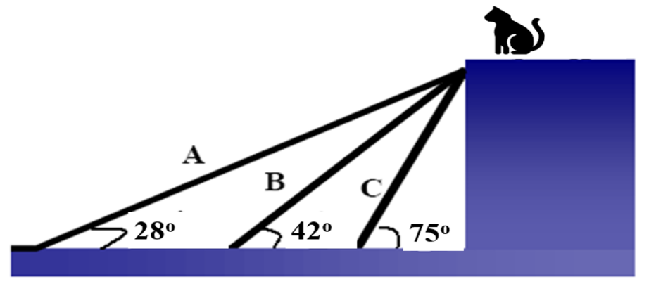

a) On which track the animal will slides faster?
- Track A
- Track B
- Track C
- Will slide in all of them with the same speed.

