Final examination
- Problem solving and Search (6 points)

The following program has logic and/or compiler errors. Identify 6 errors and for each error:
- Mention the line number where the error occurred.
- Rewrite the line containing the error after fixing it.
Your answer should be in the following format:
Line xx should be: corrected version of line xx
Line yy should be: corrected version of line yy
etc.

- FAST_RUN = False
- IMAGE_WIDTH=300
- IMAGE_HEIGHT=300
- IMAGE_SIZE=(IMAGE_WIDTH)
- IMAGE_CHANNELS=3

- from keras.models import ANN
- from keras.layers import Conv2D, MaxPooling2D, Dropout, Flatten, Dense, Activation, BatchNormalization

- #padding='same' returns output whose value can be computed by applying the filter to all input elements.
- #Border elements are computed using zero padding.
- #The output may be same or smaller than the input depending on the stride option.

- model = Sequential([
- Conv2D(filters=32, kernel_size=3, padding='1', activation='relu', input_shape=(300, 300, 3)),
- BatchNormalization(),
- MaxPooling2D(pool_size=2),
- Dropout(TRUE),

- Conv2D(filters=64, kernel_size=3, padding='same', activation='relu'),
- BatchNormalization(),
- MaxPooling2D(pool_size=2),
- Dropout(0.25),

- Conv2D(filters=32, kernel_size=3, padding='same', activation='relu'),
- BatchNormalization(),
- MaxPooling2D(pool_size=2),
- Dropout(0.25),

- Conv2D(filters=32, kernel_size=3, padding='same', activation='relu'),
- BatchNormalization(),
- MaxPooling2D(pool_size=2),
- Dropout(0.25),

- Flatten(),

- Dense(64, activation='relu'),
- BatchNormalization(),
- Dropout(0.5),

- Dense(activation='softmax') #6 because we have 6 categories])

- #Computes the crossentropy loss between the labels and predictions.
- #acc metric to be evaluated by the model during training and testing
- model.compile(loss='categorical_crossentropy', optimizer='adam', metrics=['acc'])

- model.summary

Answer.
- Line 4 should be: IMAGE_SIZE=(IMAGE_WIDTH, IMAGE_HEIGHT)

- Line 6 should be: from keras.models import Sequential
- Line 12 should be: Conv2D(filters=32, kernel_size=3, padding='same',
- Line 15 should be:Dropout(0.25),
- Line 32 should be: Dense(6, activation='softmax') #6 because we have 6 categories
- Line 36 model.summary()

Alternatives.
Change variable names, function names, change addition to subtraction or multiplication, change absolute value to “negate” (i.e. make a positive number negative), change the order of the parameters (e.g. result before x and y).
Grading.
Each error is worth 1 point.

Question 2: machine learning (8points)

A self-organizing feature map has four cluster units arranged in a one-dimensional ring, as shown in the following diagram:
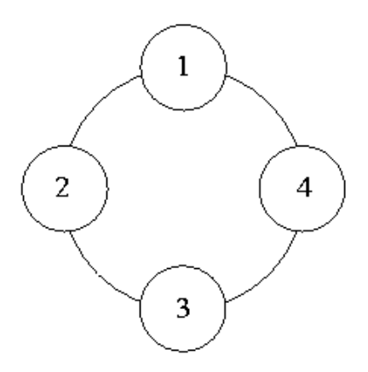

The weight vectors of the four units are given as follows:
w1 = [−1.00,−1.50, 0.50]T
w2 = [2.00,−2.00, 5.20]T
w3 = [1.50, 6.00, 4.30]T
w4 = [−4.00, 7.00, 0.60]T

An input vector x = [−1, 2.5, 0]T is presented to the network.

- Which unit is the winner for x in terms of Euclidean distance?

- Evolutionary Computation (11 points)

- Given are six computer science bachelor courses , their level, and number of student in each course ;
You have only two days only for the exam, our goal is to have less number of objections (minimum)
Objections happened when we have same year courses in the same day
  - If we use genetic algorithm to propose final exam schedule give one possible chromosomes and explain how you code your solution. (5 points)
  - Give a fitness function and explain how you chose it. (4 point)
  - Compute the fitness for your proposed chromosome . (2 point)

Course number: | Number of students : | Course level
CS111 | 60 | First year HHHHH
CS112 | 40 | First year
CS121 | 30 | First year
CS251 | 25 | Second year
CS311 | 44 | Third year
CS341 | 30 | Third year

determin set of terminals
select the set of primitive functions
define the fitness function
decide on parameters for controlling the run
choose the method for designating a result of the run

instead of coded solutions we use complete computer programs
no fixed-length coding which poses a problem

Question 4: Fuzzy expert systems (9 points)

Assume a computer game in which a fuzzy expert system is used to evaluate what is the creature
Action should be toward the player (attack, do nothing, flee). The input variables are:
• Range (melee range, out of range)
• Creature health (injured, uninjured)
The membership functions for each variable is a linear triangular function
The output is creature Action.
Here is given values from the membership function (Range)
μ_{(Range=melee range)} = 0.5, μ_{(Range=out of range)} = 0.2,

Here is given value from the membership function (Creature health)
μ_{(Creature health= uninjured)} = 0.6,

Below three rules used in the fuzzy expert system:

1. if (in melee range AND uninjured) then attack
2. if (NOT in melee range) AND uninjured then do nothing
3. if (NOT out of range AND NOT uninjured) then flee

Using the fuzzy rules Compute the values from the membership function (Creature Action)
μ_{(Creature Action =attack)} =
μ_{(Creature Action =do nothing)} =
μ_{(Creature Action =flee)} =

diagnosis; selection; prediction; classification; clustering; optimization; control

Question 5: (6 points)

How we chose the number of neurons in each of the flowing ( list at least one factor for each one )
- The self-organized map:
- The Multilayer neural networks:
- The Convolutional neural network :

the main goal of data mining is to discover / extract knowledge

the dependent variable is unemployment with the two values high risk and low risk

the rules are:
if education is low
and job type is fulltime
then there is a low risk for unemployment

if education is high
and function is manager
and number of subordinates is less or equal to 3
then there is a high risk for unemployment

- End of Final Examination ---

