City of Phoenix


City Services Bill

 WILLIAM SAMPLE
Account Number: 1111111111
Billing Date: 3/21/2017

Page 1 of 2


The 2016 Phoenix Water Quality Report is now available online at phoenix.gov/waterqualityreport. Also, the 2016 Phoenix West Anthem Water Quality Report is available online at phoenix.gov/ westanthemwaterqualityreport.

Amount Due | $81.52
Due Date | 4/11/2017
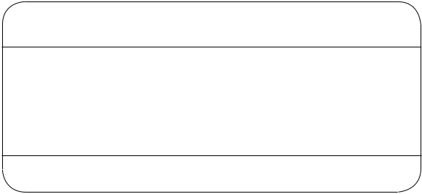

Bag and Tie your garbage and grass. This reduces odors, keeps your container clean and free from flies, rodents and other disease-spreading pests.

Please consider making a tax deductible donation to Project Assist. This program provides utility assistance to low income families and seniors in crisis.

 Account Summary as of 3/21/2017

Previous Balance | $78.87
Payments Received - Thank You | -78.87
Balance Forward | 0.00
Current Charges | 81.52

 |  |  |  |  |  |  |  |  |  |  |  |  |  |  |  |  |  |  |  |  |  |  |  |  |  |  |  |  |  |  |  |  |  | Total Amount Due |  | $81.52
Service Address: 200 W. Main St., Phoenix, AZ 85085
 |  |  |  |  |  |  |  |  |  |  |  |  |  |  |  |  |  |  |  |  |  |  |  |  |  |  |  |  |  |  |  |  |  |  | Water/Sewer Service from 2/23/2017 to 3/21/2017
Meter |  |  |  |  | Previous Meter Read |  |  |  |  |  |  |  |  |  |  | Current Meter Read |  |  |  |  |  |  |  |  |  |  | Water Used in Billing Cycle |  |  |  |  |  |  |  | Water Base Fee | 5.50
 |  |  |  |  |  |  |  |  |  |  |  |  |  |  |  |  |  |  |  |  |  |  |  |  |  |  |  |  |  |  |  |  |  |  | Water Usage Fee | 3.09
Number |  |  |  |  |  | Date |  |  |  |  | Reading |  |  |  |  | Date |  |  |  |  | Reading |  |  |  |  |  |  |  | 1 unit = 748 gallons |  |  |  |  |  | Environmental Mandates - Water | 1.96
 |  |  |  |  |  |  |  |  |  |  |  |  |  |  |  |  |  |  |  |  |  |  |  |  |  |  |  |  |  |  |  |  |  |  | City Services Tax | 1.50
13290659 |  |  |  | 2/22/2017 |  |  |  |  |  | 234 |  |  |  |  |  | 3/21/2017 |  |  |  |  | 241 |  |  |  |  |  | 7 Units |  |  |  |  |  | 5236 Gallons |  | City Services Tax
 |  |  |  |  |  |  |  |  |  |  |  |  |  |  |  |  |  |  |  |  |  |  |  |  |  |  |  |  |  |  |  |  | 5236 Gallons |  | State Mandated Jail Costs | 1.00
Your Monthly Water Usage (gallons) |  |  |  |  |  |  |  |  |  |  |  |  |  |  |  |  |  |  |  |  |  |  |  |  |  |  |  |  |  |  |  |  |  |  | State and Other Taxes | 1.39
 |  |  |  |  |  |  |  |  |  |  |  |  |  |  |  |  |  |  |  |  |  |  |  |  |  |  |  |  |  |  |  |  |  |  | Sewer Fee | 32.00
 |  |  |  |  |  |  |  |  |  |  |  |  |  |  |  |  |  |  |  |  |  |  |  |  |  |  |  |  |  |  |  |  |  |  | Environmental Mandates - Sewer | 6.90
50000 |  |  |  |  |  |  |  |  |  |  |  |  |  |  |  |  |  |  |  |  |  |  |  |  |  |  |  |  |  |  |  |  |  |  | City Sales Tax | 1.33
 |  |  |  |  |  |  |  |  |  |  |  |  |  |  |  |  |  |  |  |  |  |  |  |  |  |  |  |  |  |  |  |  |  |  | Total | $54.67
25000 |  |  |  |  |  |  |  |  |  |  |  |  |  |  |  |  |  |  |  |  |  |  |  |  |  |  |  |  |  |  |  |  |  |  | Public Works/Solid Waste from 2/23/2017 to 3/21/2017
0
0 |  |  |  |  |  |  |  |  |  |  |  |  |  |  |  |  |  |  |  |  |  |  |  |  |  |  |  |  |  |  |  |  |  |  | Solid Waste Fee | 26.80
 | Apr |  |  | May Jun |  |  |  |  | Jul Aug Sep |  |  |  |  |  |  | Oct Nov |  |  |  |  | DecJan |  |  |  |  | Feb Mar |  |  |  |  |  |  |  |  | Solid Waste Fee
 |  |  |  |  |  |  |  |  |  |  |  |  |  |  |  |  |  |  |  |  |  |  |  |  |  |  |  |  |  |  |  |  |  |  | State Landfill Disposal Fee | 0.05

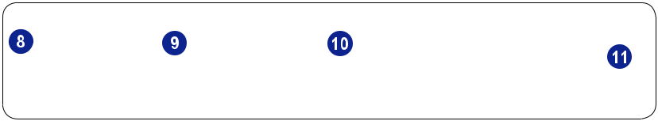




Last Year


Pay Online
phoenix.gov/payonline


Current Year | Total | $26.85
 | Total Current Charges this period | $81.52
Pay by Phone
602-262-6251
Please detach and return the portion below with your payment

Unpaid Balance DUE Now | $.00
Current Charges Due 4/11/2017 | $81.52
TOTAL DUE | $81.52


PAYMENT INSTRUCTIONS

Please make checks payable to City of Phoenix.

Do not send cash through the mail.

Please write account number on check using black or blue ink.

A Late Fee will be applied if payment is received after the Due Date

Account Number: | 1111111111


Amount Paid


$

Project Assist Donation $________ 

SN 0020170318 RT# 500001075 AN 96359700000000 TC 029100

00201611282964132400000000029100300000125351000000000000000000000000000000000

 | SEND PAYMENTS TO:
 | City of Phoenix
WILLIAM SAMPLE | P.O. Box 29100
WILLIAM SAMPLE | Phoenix, AZ 85038-9100
200 W. Main St. | Phoenix, AZ 85038-9100
PHOENIX AZ 85085-653605




How To Read Your New City Services Bill

Contact PHX Customer Services for information about your account, or any of our programs or services.

This is the name associated with the account.

Account Number - A ten-digit number.

Check this section of the bill each month, along with any inserts for important information from the City of Phoenix.

Displays the total amount due and due date.

Provides a quick summary of your previous balance, recent charges, payments and total amount due.

This is the address where service is provided.

Meter Number is tied to the account and is used for billing purposes.

Previous Meter Read Information.

Current Meter Read Information. The billable water units are calculated by subtracting the Current Meter Read from the Previous Meter Read (in this example 241 units - 234 units = 7 units).

Water Used in Billing Cycle. Water use is shown in both units and gallons; 748 gallons equals 1 unit.

Monthly Water Usage History (in gallons). This will be shown for a 13-month period.

Water and Sewer Service, Fees and Taxes. (See each item for additional info.)

Water Base Fee - Charge is based on your meter size. The Water Base Fee includes 6 units, or 4,488 gallons during the months of October – May and 10 units, or 7,480 gallons during the months of June – September.

Water Usage Fee - The charge for each unit of water that exceeds the amount included in the Base fee.

Environmental Mandates for Water and Wastewater - Charges to repay the cost of facility modifications, and operations and maintenance costs related to water or sewer services required to meet federal, state and county laws and regulations. Fees were implemented in 1992.

City Services Tax - An excise tax based on meter size, which went into effect July 19, 2014.

Sewer Fee - Charge for sewer service. The sewer fee is based on the customer’s average monthly water usage billed during the preceding January, February and March, which are typically the lowest water use months.

State Mandated Jail Costs - This fee, based on meter size, helps the city pay Maricopa County to house inmates that are arrested in Phoenix, and helps pay the costs for State mandated jail sentences.

City Sales Tax - Includes a Utility Services Tax and a Wastewater Removal Services Tax.

State and Other Taxes - Includes taxes from the State of Arizona, the County Freeway Tax, a County Jail Tax, a Statewide Education Tax, a Hazardous Waste Disposal Tax, a Stormwater Fee and is based on meter size.

Solid Waste Services and State Landfill Disposal Fee. Solid Waste Services include trash, recycling and bulk trash.

Project Assist Donation. Optional tax deductible gift to provide utility assistance to low-income families and seniors in crisis with their utility bills.

Please return this portion of the bill along with your payment each month. Be sure the payment address shows through the window of the return envelope, and write in the amount you are enclosing.

Unpaid Balance Due Now. Accounts with past due balances risk service termination and will incur a 3% Late Payment Fee.

Billing Address. The bill is mailed or emailed to this address and may be different from the service address.

Remittance Address. Send City Services payment to this P.O. Box. View back of bill for additional ways to pay.

