KPIT SPARKLE 2027
Decentralized Multi-Agent Coordination for Autonomous Logistics
DOCUMENT 01
PACT
Project Summary

A drone delivery fleet that keeps working when the hub goes dark, and never delivers a parcel twice when the radio splits it.
Purpose | Executive brief: the problem, our solution, what is new, headline results and status
For | KPIT Sparkle 2027 jury; read this first
Project | PACT: Partition-Aware Coordination for Transport
Team | Team PANGnovates · Saveetha Engineering College
Repository | github.com/MrNK2107/PACT
Version | 1.0 · 31 October 2026

PACT is a simulation prototype. Nothing in this document claims real-world flight readiness.
Contents
1 At a glance 3
2 The problem 3
2.1 What goes wrong today 4
2.2 The hidden hard problem: split-brain 4
2.3 Who is hurt 4
3 Our solution 4
3.1 A local auction for jobs 4
3.2 Fenced ownership: epochs, leases and the depot check 5
3.3 A shared order board on every drone, synced by gossip 5
3.4 A fixed partition policy 5
3.5 A safety layer that does not depend on the auction 5
3.6 Energy reserve and pad booking 5
3.7 Evidence-based failure detection 6
4 What is new 6
4.1 Defensible novelty 6
5 Key results 7
6 What we built 8
6.1 Faults we inject 9
6.2 How we know it works 9
7 Status, limitations and roadmap 9
8 Who it is for and impact 10
8.1 Why it is practical 10
9 The document set and links 11

1 At a glance
PACT (Partition-Aware Coordination for Transport) is a software framework that lets a fleet of delivery drones share out and complete jobs with no central controller. Every drone runs the same logic and talks only to the drones within its radio range. If the hub, a drone, a depot or a radio link fails, the rest of the fleet keeps delivering, and when the radio splits the fleet into groups that cannot hear each other, no parcel is ever delivered twice.
We built PACT twice: as a deterministic 3D simulator in TypeScript (sim3d), where we ran the benchmark against three kinds of baseline, and as a ROS 2 Jazzy robotics stack with Gazebo physics and real PX4 autopilot software in the loop (AeroPACT). Both are simulation; nothing has flown yet.
86.3 %  PACT on time after hub loss (central: 56.8 %) | 0  double deliveries by PACT in 240 runs with 5-minute radio splits | 17.8  double deliveries per run for a plain auction in the same test | 991  passing automated tests across both simulators

Challenge | KPIT Sparkle 2027: Decentralized Multi-Agent Coordination for Autonomous Logistics
What it is | The coordination layer of a drone delivery system: it runs on each drone's onboard computer, above the autopilot
Stage | Working prototype in simulation; hardware is the remaining step
Evidence | 100-run benchmark, 240-run partition sweep, acceptance tests on both simulators, PX4 autopilots in the loop
Code | github.com/MrNK2107/PACT (sim3d/ and aeropact/)

The one-line idea
Removing the hub is easy; the hard part is what drones may do once they stop agreeing about the world. PACT gives every parcel exactly one accountable owner, even while the radio network is split, and keeps flight safety independent of that coordination.

2 The problem
The challenge statement puts it plainly: in automated delivery, relying on a single central controller is a major risk; if the "brain" loses connection, the entire fleet stops. The task is to let a swarm of drones work together without a central command hub.

2.1 What goes wrong today
- One hub is a single point of failure. Delivery fleets are usually run by one central server. When it fails, no new jobs are dispatched, drones finish what they hold and then sit idle, and urgent cargo arrives late.
- Radios split the fleet. In a city, towers, hills, distance and storms cut radio links. The fleet breaks into groups that cannot hear each other; engineers call this a network partition.
- Split groups either stall or double-dispatch. A cautious fleet stops and waits. A naive one lets two drones, each holding an out-of-date view, both decide to fly the same parcel: wasted energy, a duplicate delivery and a confused customer.

2.2 The hidden hard problem: split-brain
Message de-duplication does not solve this. Two drones that cannot talk to each other can each be completely sure they own the same job. Exactly-once messaging is not exactly-once physical delivery. The fleet needs an ownership rule that stays correct while drones are disconnected, not one that only repairs things after they reconnect.

2.3 Who is hurt
Who | What a stall or a duplicate costs them
Delivery companies | Idle drones and missed delivery windows when the hub fails; duplicate sorties waste battery and airtime
Hospitals and medical logistics | Late urgent cargo such as blood or medicines; no tolerance for a fleet that freezes
Disaster-relief teams | Work exactly where networks are damaged and links come and go
Ports, campuses, industrial sites | Dense structures create radio dead zones; operations must continue through them
Table 1. Users of drone logistics and the cost of a central point of failure (from docs/PACT_LLM_CONTEXT.md, section 2).
Operators therefore need a fleet with no single point of failure that never delivers twice, keeps a safe gap between drones and respects battery limits, even when the hub, a charging pad or the radio is lost.

3 Our solution
Each drone runs the same coordination software on its own computer. Nothing central decides who does what. Seven mechanisms work together; the first four make up the ownership protocol that is the core of PACT.

3.1 A local auction for jobs
A free drone scores every open job by priority, distance, expected lateness against the deadline, energy cost and demand on charging pads. It may bid only if the payload fits and a pessimistic battery estimate covers the job, a trip to a charging pad and a reserve. It then broadcasts a small CLAIM message; if a nearby drone has a better bid, it backs off. An urgent job makes idle drones re-auction at once.

3.2 Fenced ownership: epochs, leases and the depot check
Every claim carries two things. An epoch is a counter on the job that goes up each time the job is reassigned; a higher epoch always wins. A lease is time-limited ownership that the owner must keep renewing with heartbeat messages.
- If the owner goes silent before pickup, its lease runs out and the job reopens at a higher epoch.
- The old owner must stop working on the job when its own lease expires, even if it cannot reach anyone (zombie-stop). Other drones wait a little longer than the owner does, so the old owner has always stopped before a new one starts.
- The depot hands the parcel only to the drone with the highest valid epoch, so a stale owner is refused at the counter.
- After pickup, ownership is sticky (a point of no return): an in-flight parcel is never handed to a second drone because of a missed heartbeat.

3.3 A shared order board on every drone, synced by gossip
Each drone and depot keeps its own copy of the job board as a CRDT (conflict-free replicated data type): a data structure whose copies can be merged in any order and still end up identical. Copies spread by gossip: each node passes recent changes to its neighbours, who pass them on, until everyone has them. A drone cut off in a dead zone keeps working from its own copy and merges back when the link returns.

3.4 A fixed partition policy
A drone that is cut off from part of the fleet follows one rule, chosen per deployment, about what new work it may still claim. Jobs already owned carry on under every policy.
Policy | New work a cut-off drone may claim | Trade-off
STRICT | Only jobs in map areas (shards) whose lease is held by a drone on its own side | Safest; some areas wait
QUORUM | Only while a strict majority of the fleet is reachable | Safe; an even split stops new claims
OPTIMISTIC_BOUNDED | As QUORUM, plus at most one low-priority claim without a majority; never urgent jobs | Most available; depot check backstops
Table 2. The three partition policies (results/sweep/sweep.md; docs/03_solution_approach.md section 3.5).

3.5 A safety layer that does not depend on the auction
Drones share their intended paths in heartbeats, and conflicts are settled by one fixed give-way rule that every drone evaluates the same way. Onboard sensing keeps separation working with the radio switched off. The safety code never imports the coordination code, and this rule is checked by an automated test.

3.6 Energy reserve and pad booking
A battery model keeps a reserve on every plan: no claim is made unless the battery covers the job, reaching a pad and the reserve. Charging pads are booked ahead, and a pad-demand term in the bid stops every drone heading for the same pad.

3.7 Evidence-based failure detection
A silent drone may only be out of range. PACT declares a drone lost only on evidence: a quorum of peers that should have heard it report silence, or the silence lasts longer than the drone could physically stay airborne. Only then is its in-flight parcel re-ordered. In the benchmark this takes a median of 3.7 s from the failure to the declaration, against the 60 s fixed timeout used by the baselines.

4 What is new
We do not claim the auction as new: consensus-based auctions (CBBA) are the standard method for multi-robot task allocation, and gossip, CRDTs, leases and fencing come from distributed databases. What PACT adds is how these pieces are combined and applied to physical parcels with batteries, depots and broken radios.
Typical approach | PACT
Swarm auction that assumes drones can always talk, or hides a central planner | Built for links that break: every drone acts on its own copy of the board and talks only to drones in range
Ownership by messages alone, repaired after reconnect | Ownership fenced by epoch, lease, zombie-stop and a depot check, correct during the split
No stated behaviour for a cut-off drone | An explicit partition policy, with its availability cost measured in a 240-run sweep
Safety handled by the same coordination logic | Separate safety layer that works with the network off and never imports coordination code
Happy-path demo | Fault-injection scenarios, three kinds of baseline on the same seeds, published numbers including a failing gate
Table 3. PACT compared with typical swarm and central approaches (docs/03_solution_approach.md 3.11, docs/06_landscape_and_risks.md 6.3).

4.1 Defensible novelty
- A layered ownership protocol (fenced leases, shard leases, point of no return, depot arbitration) designed for parcel logistics under radio partitions.
- A tunable partition policy with a measured trade-off between keeping work moving and the risk of duplicates.
- Energy- and charging-aware allocation built into ownership, not bolted on.
- An open, deterministic fault-injection benchmark: the same seed always gives the same event log hash.
- Strict separation of safety from coordination, verified with the network disabled.
What we do not claim
We do not claim the first decentralised drone delivery, optimal allocation, or real-world readiness. A central planner that never fails is treated honestly as the upper bound in healthy conditions.

5 Key results
All systems ran on the same maps, seeds, workloads and faults. The headline measure is the on-time rate: of the jobs that fell due during the run, the share delivered by their deadline. Numbers are means over the runs; 95 % confidence intervals are in the evaluation report.
Test (sim3d) | PACT | Comparison | Source
Hub killed at 180 s: on-time rate | 86.3 % (0 % drop) | Central fleet 86.3 % → 56.8 % | results/summary.md
Hub killed: deliveries per run | 20.0 | Central fleet 20.2 → 7.6 | results/summary.md
Healthy fleet: on-time rate | 86.3 % | Central planner that never fails 86.3 % | results/summary.md
240-run sweep, 5-min radio splits: double deliveries | 0 (every policy) | Plain auction up to 17.8 per run | results/sweep/sweep.md
Same sweep: zombie pickups, refused pickups | 0, 0 | — | results/sweep/sweep.md
Drone killed while carrying: kill → replacement claimed | 9.9 s (median) | Baselines 61.7–67.9 s | results/summary.md
Loss of safe separation (100-run bench) | 0 | — | results/summary.md
Table 4. Headline results. Bench: 5 seeds × 900 s simulated, 100 runs. Sweep: 30 seeds × 900 s, 240 runs, acceptance test AT-12 passed.
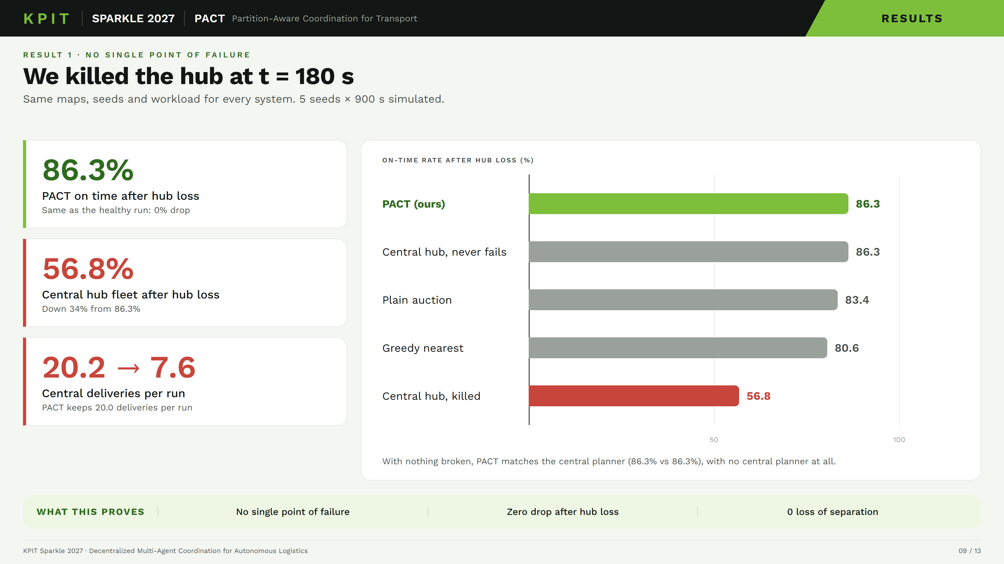
Figure 1. Hub loss at t = 180 s: PACT keeps its healthy on-time rate; the central fleet falls to 56.8 % (results/summary.md, s1_hub_loss).
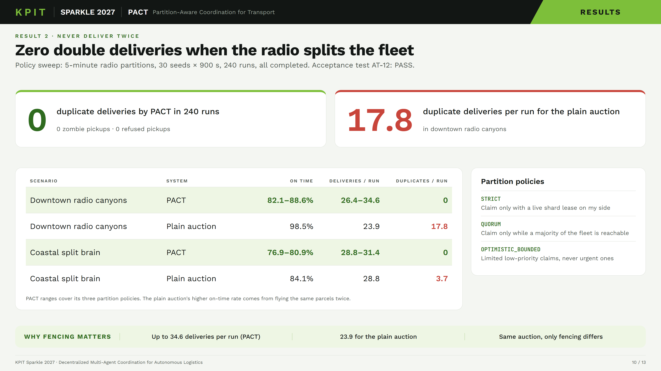
Figure 2. The 240-run partition sweep: PACT makes no double deliveries under any policy; the same auction without fencing makes up to 17.8 per run (results/sweep/sweep.md).
The plain auction's higher on-time rate in the canyon scenario (98.5 %) comes from flying the same parcels twice: it completed only 23.9 distinct deliveries per run against up to 34.6 for PACT.
An honest caveat
Our own acceptance test AT-05 asks that the central fleet lose more than 40 % of its on-time rate when the hub dies. Over the 900 s window it loses 34 % (86.3 → 56.8 %), so the gate fails narrowly on the central side; over the longer 1800 s window it passes. We report this rather than retune the gate (docs/DECISIONS.md, Decision 13).

The second implementation agrees. In AeroPACT's own benchmark (90 runs of 1500 s with ROS 2 nodes), the central planner fell to 20 ± 2 % on time when its hub died at 240 s while PACT with the QUORUM policy held 67 ± 6 %, and every PACT run held every invariant (aeropact/README.md).

6 What we built
Part | What it is | Scale
sim3d | Deterministic 3D simulator in TypeScript; browser viewer and headless runs | 8 maps (2–12 km), ~30 fault scenarios
AeroPACT | ROS 2 Jazzy C++ components, Gazebo physics, PX4 v1.16 SITL autopilots | 12 packages, one container per drone
Tests | Unit, property and acceptance tests on both stacks, CI on both | 991 passing (391 sim3d, 600 AeroPACT)
Benchmark | Scenario × system × seed runner; metrics only from the event log | 100-run bench, 240-run sweep, plots
Table 5. Components of the prototype (README.md, aeropact/README.md, NIGHT_NOTES_2026-10-31.md).
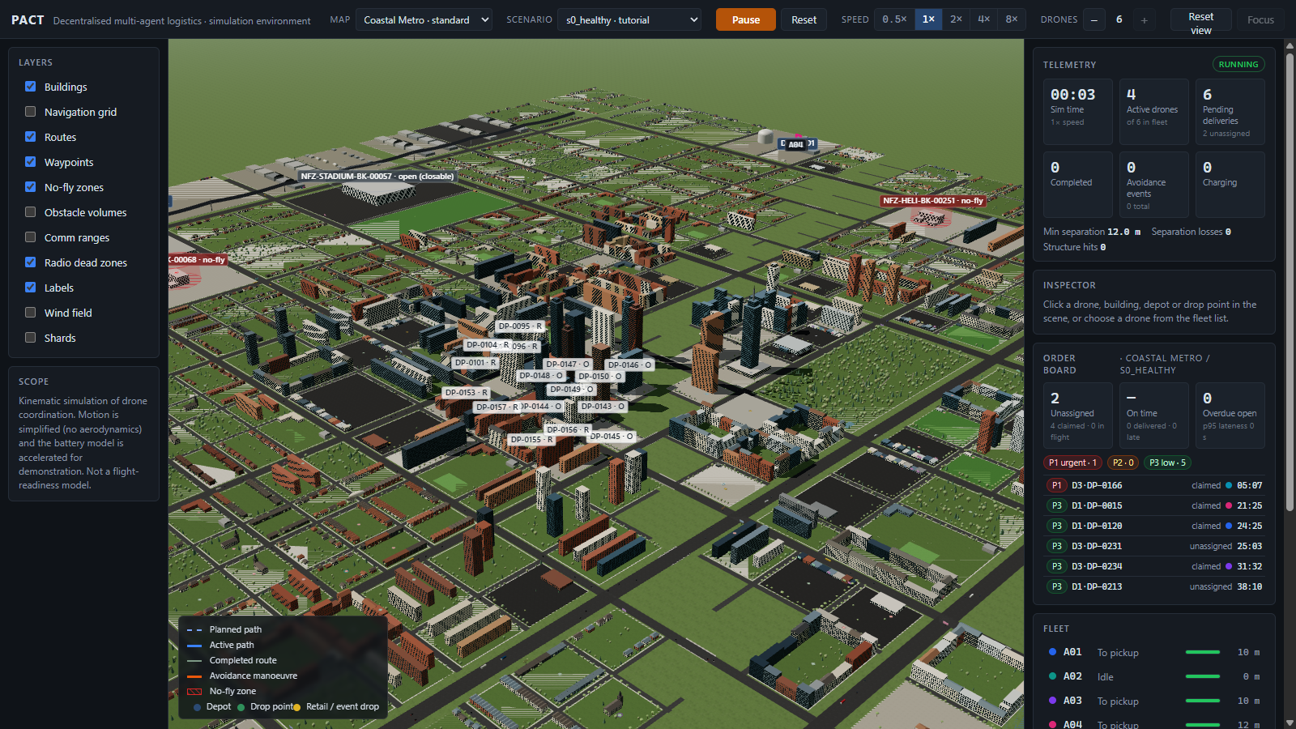
Figure 3. The sim3d viewer on the coastal_metro map, with telemetry, the order board and the fleet list.

6.1 Faults we inject
Hub loss, drone loss, radio partitions, one-way link loss, clock drift, pad and depot outages, battery drain, closed airspace, storm cells and weather fronts, altitude ceilings and urgent job bursts. Each drone plans an A* route around buildings and no-fly zones and replans when a zone closes.

6.2 How we know it works
- Determinism. A fixed 20 Hz time step, seeded random numbers and ordered iteration: two runs with the same scenario and seed produce the same event log hash.
- Invariants. No double delivery (I1), epochs only increase (I2), zombie-stop (I3), safety with the network off (I4), energy reserve (I5) and copies converge after a split heals (I6) are checked by tests.
- Acceptance. sim3d's scenario suite passes 75 of 75; AeroPACT passes 9 of 9 acceptance scenarios on the full ROS 2 graph and 4 of 4 with real PX4 autopilots in the loop, including a motor failure handled as PX4 flight termination.
- Security of the radio link. AeroPACT's mesh transport authenticates every frame (HMAC-SHA256) and rejects replays.

7 Status, limitations and roadmap
Stage | Status | What it covers
1 Simulation prototype | Done | Auction, fenced ownership, safety, energy, baselines, benchmark
2 Truly shared state | Done | CRDT copies, gossip, partition policies, failure detector
3 Robotics stack | Done in simulation | AeroPACT: ROS 2, Gazebo physics, PX4 SITL autopilots
4 Hardware | Next | A small indoor or tethered hardware trial
Table 6. Roadmap (docs/PACT_LLM_CONTEXT.md section 9).
Limitations we state openly
Simulation only. Nothing has flown. sim3d uses simplified kinematics, a simple battery model, a disc-shaped radio model with dead zones and 2.5D planning. AeroPACT runs real autopilot software, but only against simulated vehicles.
No real radios yet. Gossip has run over a simulated radio and over a UDP mesh on one machine, not over field radios.
Depot backhaul assumed. Depots are assumed to have a wired or cellular link to each other; without it, the QUORUM policy stalls on maps where depots are out of radio range of each other.
Fleet size capped at one drone per charging pad in sim3d (a scenario asking for 12 drones runs 6).
AT-05 passes only over the longer 1800 s window (section 5).

Removing a central controller does not remove the need for accountable operators, safety procedures and airspace approval. Any real deployment would follow the hardware-in-the-loop and flight-test ladder in aeropact/docs/HARDWARE_DEPLOYMENT.md and need an operational authorisation first.

8 Who it is for and impact
PACT is the coordination layer of a larger drone delivery system. It sits on each drone's companion computer above the autopilot, sensors and depots, and is meant for anyone who cannot afford a fleet that freezes when one server or one link fails.
- Delivery firms: keep dispatching through a hub outage, without paying for duplicate sorties.
- Hospitals: urgent medical cargo keeps moving; urgent jobs trigger an immediate re-auction and are never claimed optimistically.
- Disaster relief: works where networks are damaged and links come and go.
- Ports, campuses and industrial sites: dense structures and radio shadows are the normal case, not the exception.

8.1 Why it is practical
- Hardware-agnostic: runs above any autopilot; AeroPACT drives PX4 through its standard offboard interface.
- Low compute and small messages: in the benchmark PACT used 74–76 messages per drone per minute besides beacons, within a budget of 120.
- Scales by adding drones: there is no central server to size up; the 12 km stress map is set up for 30 drones.
- Open and fair to test: the same seed gives the same run, and every system is measured on the same maps and faults.
Closing line
No hub. No double delivery. No stall.

9 The document set and links
This summary is the first of four documents. Each can be read on its own; together they let a reviewer check every claim.
File | What it covers
PACT_01_Project_Summary.docx | This brief: problem, solution, novelty, headline results, status and roadmap
PACT_02_Technical_Design_Document.docx | Architecture, message and data design, the ownership protocol, partition policies, safety layer, failure detection and both implementations in detail
PACT_03_Evaluation_and_Results_Report.docx | Method, baselines, metrics, full benchmark and sweep tables with confidence intervals, recovery times, caveats
PACT_04_Setup_and_Reproduction_Guide.docx | How to install, run the viewer and demo, and reproduce every number with the make targets on both simulators
Table 7. The PACT reviewer document set.
Repository | github.com/MrNK2107/PACT
Video | Demo video: link to be added
Team | Team PANGnovates, Saveetha Engineering College
Reproduce headline numbers | make bench (results/summary.md) and make sweep (results/sweep/sweep.md)

PACT is a simulation prototype. Nothing in this document claims real-world flight readiness, field trials or hardware flights.

