KPIT SPARKLE 2027
Decentralized Multi-Agent Coordination for Autonomous Logistics
DOCUMENT 02
PACT
Technical Design Document

Architecture, ownership protocol, shared state, partition policies, safety isolation and correctness invariants of a fleet that coordinates with no central controller.
Purpose | Explain how PACT works and why each mechanism is needed, so that the soundness and originality of the design can be judged.
For | Technical reviewers: robotics, embedded and distributed-systems engineers.
Project | PACT: Partition-Aware Coordination for Transport
Team | Team PANGnovates · Saveetha Engineering College
Repository | github.com/MrNK2107/PACT
Version | 1.0 · 31 October 2026

PACT is a simulation prototype. Nothing in this document claims real-world flight readiness.
Contents
1 Introduction 4
1.1 Scope 4
1.2 Design goals and principles 4
1.3 Terminology 5
2 Assumptions and operating model 6
2.1 Failures considered 6
3 System architecture 8
3.1 Why the depot is not a hub 9
3.2 One agent step 9
4 Task allocation 10
4.1 Score 10
4.2 Hard constraints 10
4.3 CLAIM, back-off and consensus 11
5 Fenced ownership 12
5.1 Task states and epochs 12
5.2 Single-writer rule 12
5.3 Leases and zombie-stop 13
5.4 Point of no return 13
5.5 Depot arbitration 14
5.6 Why no parcel is delivered twice 14
6 Shared state 15
6.1 Replicated objects and merge rules (sim3d) 15
6.2 The AeroPACT task merge: a product lattice 15
6.3 Gossip and anti-entropy 16
7 Partition policies 16
7.1 What a cut-off drone may do 17
7.2 Membership: the roster, not recent contacts 17
7.3 Shard leases 17
8 Safety layer 18
8.1 Separation and the give-way rule 18
8.2 Isolation in the two implementations 18
8.3 AeroPACT supervisor precedence 19
9 Energy management 19
9.1 Battery model 19
9.2 Reserve and pad booking 20
10 Failure detection 21
11 Correctness invariants 22
12 Messages and interfaces 23
12.1 Envelope 23
12.2 Replicated records 24
12.3 PRD interfaces in each implementation 24
12.4 Configuration defaults 24
13 Determinism and reproducibility 25
14 Implementations 26
14.1 sim3d: TypeScript simulator 26
14.2 AeroPACT: ROS 2 Jazzy, Gazebo and PX4 27
15 Key design decisions 27
16 Known limitations and risks 28
16.1 Risks and mitigations 29
16.2 Path to hardware 29

1 Introduction
PACT (Partition-Aware Coordination for Transport) lets a fleet of delivery drones share out parcels, recharge and recover from failures with no central controller, and keeps every parcel to exactly one accountable owner when the radio network splits. This document describes how that is done and why each mechanism is there.

1.1 Scope
The document covers the coordination protocol and the two implementations that run it: sim3d, a deterministic TypeScript simulator with a 3D viewer, and AeroPACT, a ROS 2 Jazzy system with Gazebo physics and PX4 SITL autopilots. It describes the design and its correctness argument. Other questions are answered in the sibling documents:
- PACT_01_Project_Summary: the problem, the idea and the headline outcomes in brief.
- PACT_03_Evaluation_and_Results_Report: benchmark method, baselines, every measured number and its confidence interval.
- PACT_04_Setup_and_Reproduction_Guide: how to install, run the tests, the scenarios and the benchmarks.
Where this document quotes a number it is a design parameter or a figure from the decision log that explains a design choice. Only the two headline results appear here, and both are reported in full in PACT_03.
Headline results (details in PACT_03_Evaluation_and_Results_Report)
Hub loss: with the central hub killed, PACT stays at 86.3 % of parcels on time while the centralized baseline that loses its hub falls to 56.8 %. PACT has no hub to lose.
Radio split: in a 240-run sweep of partitioned scenarios, the fenced PACT policies delivered no parcel twice, while a plain auction without fencing averaged up to 17.8 double deliveries per run.

1.2 Design goals and principles
The PRD (docs/04_agent_first_PRD.md) sets three functional goals that shape this design: decentralized allocation that is aware of energy, deadlines and charging (G1); an ownership protocol with near-zero duplicate dispatch under partitions (G2); and graceful degradation under link loss, drone failure and hub loss (G3). Five principles from docs/03_solution_approach.md section 3.1 decide the trade-offs:
- Safety is local. No flight-safety action needs network agreement.
- Ownership before optimality. A slightly worse but unambiguous assignment beats an optimal but contested one.
- Degrade, don't stall. Every failure maps to a defined, less capable mode, never to waiting for a hub.
- Make the trade-off explicit. Availability against duplicate risk is a tunable policy with a measured cost.
- Be honest about baselines. A centralized planner with full information is the upper bound in healthy conditions.
PACT does not claim a new allocation algorithm: the auction is a simplified form of the Consensus-Based Bundle Algorithm (CBBA). The claimed contribution (docs/06 section 6.3) is the layered ownership protocol, the tunable partition policy, energy-aware allocation tied to ownership, the fault-injection benchmark and the strict separation of the safety layer.

1.3 Terminology
Term | Meaning in PACT
Node | Anything with a radio that runs the protocol: every drone and every depot. There is no other kind of node.
Replica | A node's own copy of fleet state (tasks, drone status, shard leases, tombstones). Agents read only their own replica.
CRDT | Conflict-free replicated data type. Merging two replicas is commutative, associative and idempotent, so replicas that have seen the same updates agree in any delivery order.
Gossip | Spreading replica changes peer to peer: periodic delta pushes of changed records, plus digest exchanges (anti-entropy) that repair what loss removed.
Partition | A split of the network into groups that cannot hear each other (range, terrain, interference or a scripted fault). Each side keeps running on its own replica.
Epoch | A per-task counter that rises on every re-assignment. It is the fencing token: the depot serves only the newest epoch, so a stale owner is refused.
Lease | Time-limited right of the owner to act on a task before pickup (default 20 s), renewed every quarter lease while the origin depot acknowledges it.
Zombie-stop | The rule that an owner stops acting on a task when its own lease, timed on its own clock, has lapsed, even when it cannot reach anyone (invariant I3).
Re-open | Writing a task back to UNASSIGNED at epoch + 1 after its lease expired. Only the task's origin depot may do it.
Point of no return | After pickup ownership is sticky: the lease no longer expires on silence.
Depot arbitration | The origin depot hands each parcel over once, to the owner at the newest epoch, and answers anyone else with TASK_TAKEN.
Shard, shard lease | The map is a 500 m hex grid (ids H-q-r). A shard lease, granted by the shard's catchment depot, is the right to claim new tasks in that shard (STRICT policy).
Partition policy | What a node may claim when it cannot see the whole fleet: STRICT, QUORUM or OPTIMISTIC_BOUNDED.
Reachable set | Drones whose status reached this node (directly or relayed) within the last 3 s of local time, plus itself.
Fleet roster | Every drone id the scenario launches, known to every node at boot, minus drones this node has declared failed. QUORUM needs a majority of it.
Phi-accrual | A failure-suspicion score from heartbeat inter-arrival statistics, used instead of a fixed timeout.
DECLARED_FAILED | The only failure state that lets the fleet re-order a lost parcel. It needs physical evidence, not just silence.
Local clock, drift | Each node's monotonic clock, allowed to run fast or slow against true time (tested up to 1 %). There is no shared clock.
Backhaul | Wired or cellular link between depots. It carries the same gossip the depots send by radio and is not a controller.
Ledger | sim3d only: a read-only, omniscient merge of all replicas used by the viewer and the metrics. No agent reads it.
Table 1. Terms used throughout this document.

2 Assumptions and operating model
docs/02_assumptions.md tags every assumption and states what happens if it is wrong. The ones that shape the protocol are below. The most important are about what PACT does not assume: reliable communication, synchronized clocks, that a silent drone is dead, that a leader exists, or that coordination prevents collisions.
ID | Assumption | How the design uses it
T3 | Peer links are lossy (0–60 %), delayed (50 ms–5 s), possibly asymmetric, range-limited and bandwidth-limited. | Every message may be lost, duplicated or reordered; replicas tolerate all three. Default model: 1500 m range, 50–800 ms latency.
T4 | No global time. Each drone has a monotonic local clock with bounded drift (default ±100 ppm, configurable up to 1 %). GPS time is not relied on for safety. | Leases carry durations, never absolute times. Owner and observer bounds differ by a drift margin (Chapter 5).
T5 | Position, battery and health are self-sensed with noise (position 1–3 m, SOC about 5 %). | Energy estimates are pessimistic (sigma margin) and keep a reserve.
T6 | Messages are authenticated with pre-provisioned keys; confidentiality is not modelled. | sim3d stubs it; AeroPACT authenticates every frame (HMAC-SHA256 or per-node Ed25519, Chapter 14).
T7 | Fleet of 3–50 drones, 1–8 depots, 1–3 pads per depot. | Benchmarks target up to 30 drones; message budget 120 msgs/drone/min.
T9 | Pickup happens at a depot whose local arbiter hands a parcel to one drone at a time. | The depot is the physical backstop of ownership.
T10 | Drones broadcast short-range beacons even when long-range links fail. | Heartbeats feed avoidance; on-board sensing covers the case with no radio at all.
T12 | Depots are linked by a backhaul that can fail and that partitions can cut. | Joins radio islands for gossip; drones never use it directly.
O5 | After pickup a drone has a point of no return. | Ownership becomes sticky until delivery, safe-drop or declared failure.
Table 2. Technical and operational assumptions that the protocol depends on (docs/02_assumptions.md).

2.1 Failures considered
The fault injector covers the four drone failure modes of assumption O3 (battery depletion, motor fault, link failure, sensor degradation) plus infrastructure and environment faults. Each is a scripted entry in a scenario file, so every run is reproducible.
Fault | What it models | What PACT must do
kill_drone | Sudden death, no distress call | Detect with physical evidence, re-order the parcel once
partition {groups, until} | Radio split between groups of drones and depots | No double claim; each side keeps working within its policy
link_loss {id, dir} | One node deaf, mute or both (asymmetric link) | Owner stops before anyone takes over (zombie-stop)
clock_drift {id, ppm} | A node's clock runs fast or slow | No lease-safety break up to 1 % drift
kill_service(central_hub) | Loss of a central server | Nothing: PACT has none (only the central baseline reacts)
backhaul_cut | Depot-to-depot link outage | Fall back to radio gossip
battery_drain, pad / depot outage | Energy stress, charging infrastructure down | Never plan below reserve; re-book pads
close_zone, storm, ceiling | Airspace closes during flight | Re-plan around it
urgent_job_burst | Many priority-1 orders at once | Event-driven re-auction
Table 3. Faults the protocol is designed and tested against (REQ-SIM-004, sim3d/README.md).

3 System architecture
Every drone runs the same software stack and every depot runs a thin depot node. There is no central node: the order-management system, if there is one, only submits orders to depots, and losing it stops new external orders but not the coordination of existing ones (docs/03 section 3.9).
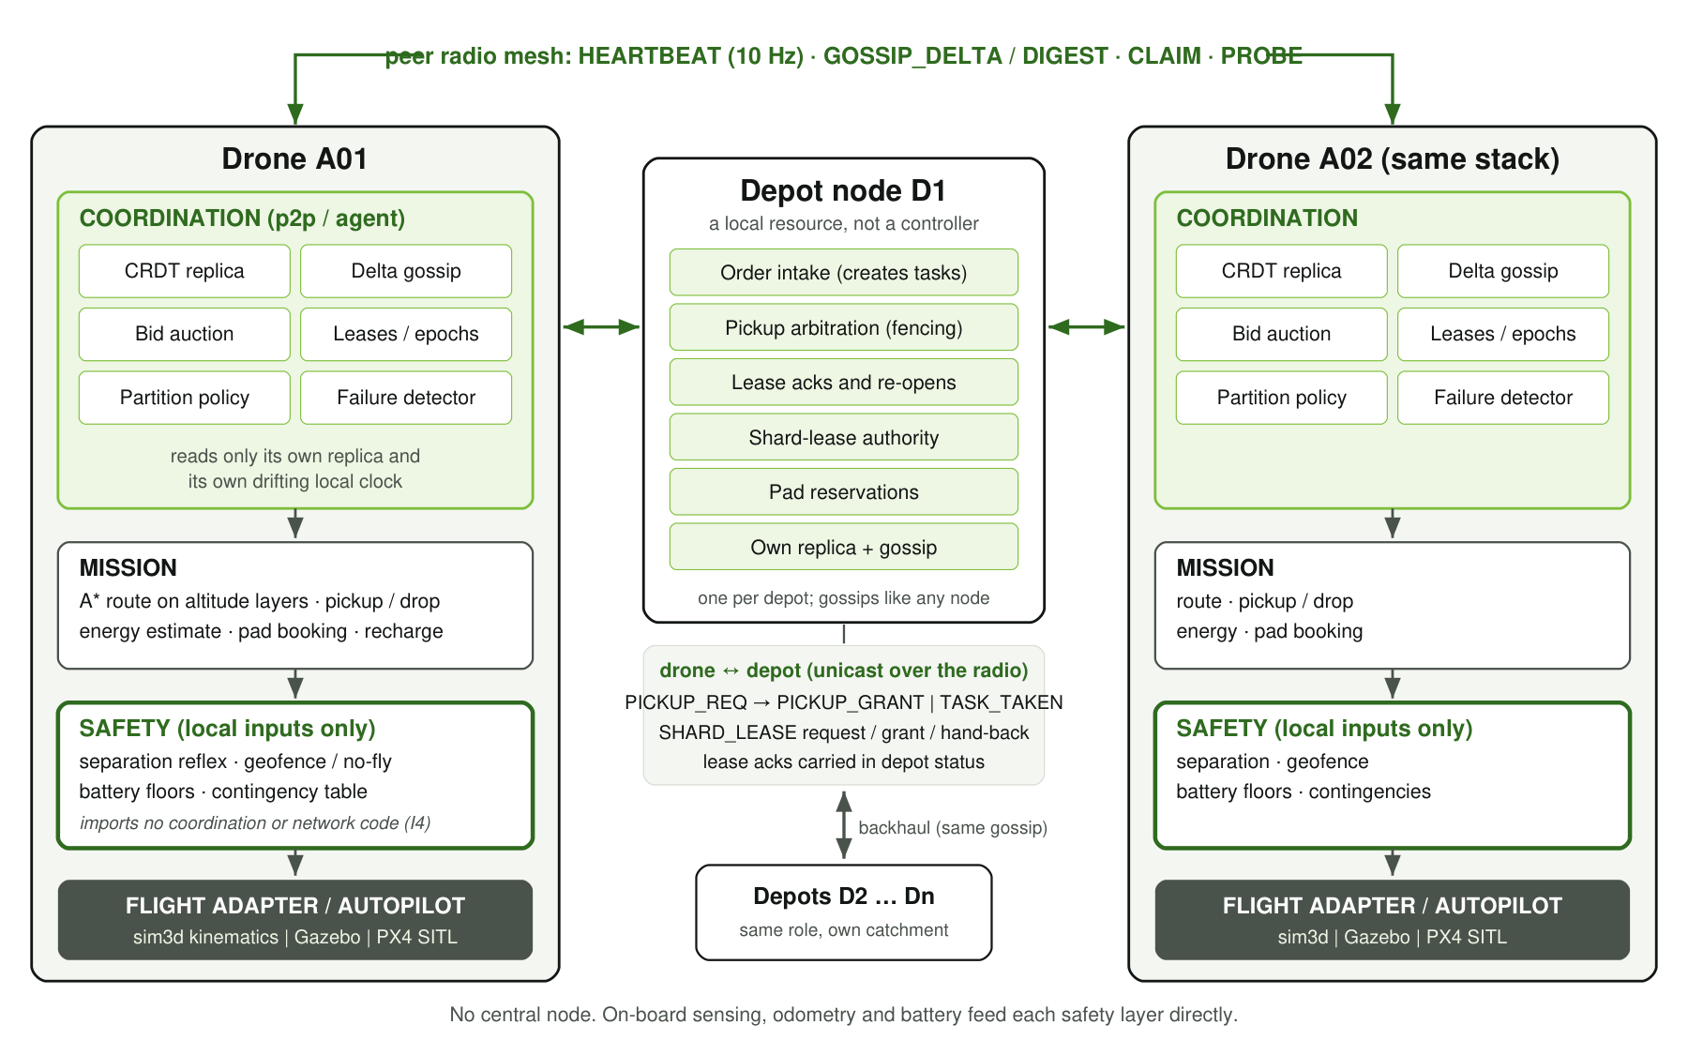
Figure 1. Per-node architecture and message flow. Drones and depots are peers on the radio mesh; depots also share a backhaul. Arrows inside a drone are the command path; the safety layer reads only local sensors.
Layer | Responsibility | May depend on
Coordination | Replica and gossip, auction, leases and epochs, partition policy, failure detector, shard leases | Its own replica, its local clock, received messages
Mission | Routes (A-star on altitude layers), pickup and drop, energy estimates, pad booking, recharge | Coordination decisions
Safety | Separation reflex, geofence and no-fly, battery floors, contingency actions; can veto the mission layer | Local sensors only: odometry, battery, on-board proximity sensing
Flight adapter | Executes velocity or waypoint commands: sim3d kinematics, Gazebo, or PX4 offboard control | Safety layer output
Depot node | Order intake, pickup arbitration, lease acknowledgements and re-opens, shard-lease authority, pad reservations, failure declaration for its own parcels | Its own replica and the bay's local sensing
Table 4. Layers and what each may depend on (docs/03 section 3.2, aeropact/docs/ARCHITECTURE.md section 1).

3.1 Why the depot is not a hub
A depot holds authority only over its own parcels and its own shards, and only because it physically holds the parcels: it creates the tasks it will hand over, grants each pickup once, and is the single writer of re-opens for its own tasks (Chapter 5). It never assigns a drone to a task, never sees the whole fleet's plan, and losing one depot affects only the parcels stored there. Intake falls back to any live depot (AeroPACT D-11). This is the sense in which the depot is a resource, not a controller.

3.2 One agent step
The PRD (section 10) fixes the order of work in a drone's tick. Safety always runs first and needs nothing from the network:
agent_tick():
safety.step() # always first, local inputs only
failure_detector.update()
ownership.expire_leases(now_local) # zombie-stop on the owner's own clock
gossip.step()
if urgent_event or auction_period elapsed:
for claim in auction.build_bundle(view, me):
if partition_policy.may_claim_new(claim.task, view, me): ownership.claim(claim)
ownership.commit_ready() # CLAIMED -> COMMITTED after T_commit
energy.insert_recharge_if_needed()
mission.step() # the safety layer may veto

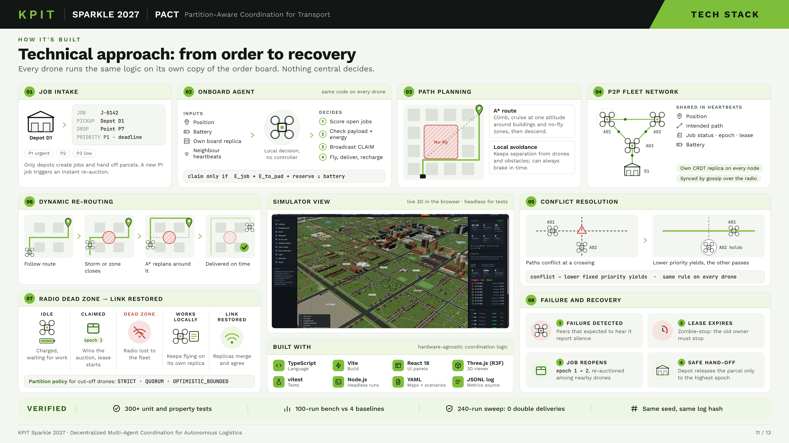
Figure 2. The life of an order in the sim3d prototype, from intake at a depot to recovery after a failure (deck slide 11).

4 Task allocation
Allocation is a market among neighbours. Each idle drone scores the open tasks it can see in its replica, broadcasts a CLAIM for the best one, and backs off if a neighbour bids better. The auction is a CBBA-style bundle auction (docs/03 section 3.4) with logistics terms; the ownership protocol, not the auction, guarantees that a task ends up with one owner.

4.1 Score
For drone d and task t, the score is a priority reward minus penalties. The sim3d form (scoreTask in sim3d/src/sim/AgentCoordinator.ts) is:
score = w_pri·(4 − priority) − w_dist·km(pos→pickup→drop) − w_late·lateness_min
− w_energy·(energy_need_% / 100) − w_pad·0.25·(neighbours returning or charging)

Term | Weight (sim3d) | Measured as | Purpose
Priority | w_pri = 2.0 | 4 − priority (P1 urgent gives 3, P3 low gives 1) | Urgent and medical jobs first
Distance | w_dist = 1.0 | Kilometres from the drone to the pickup and on to the drop | Prefer the nearest capable drone
Lateness | w_late = 1.5 | Minutes by which the estimated arrival misses the deadline | Protect deadlines
Energy | w_energy = 1.0 | Pessimistic battery share the whole trip needs | Spread load, keep reserve
Pad contention | w_pad = 0.5 | Neighbours heading to or sitting on a pad | Avoid everyone charging at once
Route risk | w_risk (AeroPACT only) | No-fly or zone crossings on the route | Prefer routes that avoid restricted airspace
Table 5. Score terms and weights. sim3d values from sim3d/src/sim/config.ts; the AeroPACT bundle score adds a route-risk term (aeropact/docs/ARCHITECTURE.md section 5).

4.2 Hard constraints
A task is not scored at all, rather than scored low, when any hard constraint fails. These checks are what make invariant I5 hold:
Constraint | Check in code
Payload | weight_kg ≤ drone capacity
Airspace | Neither pickup nor drop lies in an active no-fly zone (closable zones included)
Energy | Battery ≥ pessimistic need for pickup leg + loaded leg + return to the home pad + hover time, plus soc_reserve (20 %)
Deadline | Soft: a late arrival is penalised in the score, not excluded
Table 6. Hard constraints of the bid (REQ-AUC-001, scoreTask).

4.3 CLAIM, back-off and consensus
- Bid. The drone picks its best feasible task and broadcasts CLAIM {taskId, cost = −score}. Ties go to the lower task id, so the choice is deterministic.
- Claim window. It listens for rival CLAIMs for claimWait = max(0.5 s, latency upper bound + one step), which is 0.85 s for the default 50–800 ms radio. The window is long enough that the later of two concurrent bidders always hears the earlier bid (Decision 16).
- Back-off. If a neighbour bids a lower cost for the same task (ties to the lower drone id), the drone drops it and re-bids next round. A CLAIM from a peer that its failure detector does not see as ALIVE does not count: a suspect gets no new work (Decision 18).
- Write. The winner writes CLAIMED(owner = me, epoch + 1, bid, lease) into its replica and pushes it by gossip at once.
- Consensus by merge. Two drones out of radio range of each other can still claim the same task. Their records then meet in some replica, and the merge order keeps exactly one (Chapter 6). The loser learns it lost when the winning record arrives, drops the task and logs duplicate_resolved at stage pre_pickup.
- Commit. The owner moves CLAIMED → COMMITTED after T_commit = 3 s on its local clock if it still owns the record.
A missed better bid can give a suboptimal winner, never a duplicate: duplicates are excluded by ownership, not by the auction. A priority-1 order triggers an immediate re-auction instead of waiting for the 2 s auction period (REQ-AUC-003).
Bundle length differs between implementations
The PRD default is a bundle of B = 3 tasks with CBBA bundle repair. AeroPACT implements the bundle phase with insertion scoring and releases every task queued after a lost one. sim3d scores and holds one task at a time (B = 1, noted in chooseTask and the bundle field of its status record), although its scenario default still carries bundle_len: 3. The central baseline uses the same scoreTask, so every system ranks tasks identically.

5 Fenced ownership
Ownership is the core of PACT. Its job is to make sure that, whatever the network does, a parcel has one accountable owner and is handed over once.
The mechanisms are layered from cheap to strict (docs/03 section 3.5): epochs as fencing tokens, leases with a zombie-stop rule, a point of no return at pickup, and physical arbitration at the depot. Each layer covers a failure the previous one cannot.

5.1 Task states and epochs
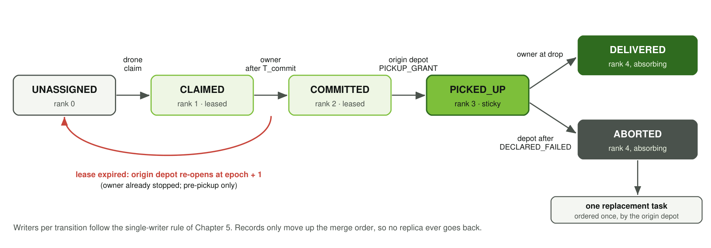
Figure 3. Task lifecycle. Each transition is written by exactly one kind of node. Records only rise in the merge order, so a replica never moves backwards.
Task state rank is UNASSIGNED(0) < CLAIMED(1) < COMMITTED(2) < PICKED_UP(3) < DELIVERED | ABORTED(4). Terminal states absorb. A re-open is not a regression: it writes UNASSIGNED at epoch + 1, and the merge compares the epoch first. Every claim also raises the epoch, so the epoch is a fencing token: a resource that has seen epoch e+1 refuses anything presented at epoch e.

5.2 Single-writer rule
Comparing the epoch first creates a hazard found by the first property tests: a replica that never saw a pickup could write a re-open at e+1 that out-ranks PICKED_UP at e and re-dispatch a parcel already in the air. sim3d therefore gives every epoch-raising write except a claim exactly one writer (docs/P2P_DESIGN.md section 6, Decision 16):
Write | Writer
Claim (CLAIMED, epoch + 1) | A drone, and only over a record it sees as UNASSIGNED
Commit, renew, release before pickup, DELIVERED | The owner
Give a parcel back (ABORTED at the same epoch) | The carrier; the origin depot then orders the one replacement
PICKED_UP, lease re-open, ABORTED + replacement, shard-lease grant | The task's origin depot
Table 7. Single-writer rule (sim3d).
Drones never claim over a CLAIMED or COMMITTED record, even one whose lease looks expired in their view; they wait for the origin depot's re-open. Without a single re-opener, observers that had missed a confirmed renewal re-opened early in 427 of 3 937 test cases, which is why the rule exists (Decision 16). AeroPACT solves the same hazard differently, with a split fencing token in the merge itself (Section 6.2).

5.3 Leases and zombie-stop
Before pickup the owner holds a lease of lease_ttl_s = 20 s and renews it every quarter lease (5 s) by raising the record's renew counter. A renewal counts only when the origin depot has acknowledged that task's (epoch, renew) in its own status record (acks). The owner's lease runs from the local time at which it wrote its newest confirmed renewal, which is never later than the moment anyone else could have seen it.
Side | Rule | Clock
Owner | Valid while now_local − t_write(last confirmed renewal) ≤ TTL; afterwards stop acting and release locally (zombie-stop) | Owner's own drifting clock
Origin depot (observer) | May re-open when now_local − seenAt ≥ TTL·(1 + drift_margin) + grace | Depot's own drifting clock
Defaults | TTL 20 s, renew every 5 s, drift_margin 0.02, grace 2 s (PRD section 15) | —
Table 8. Owner and observer lease bounds.
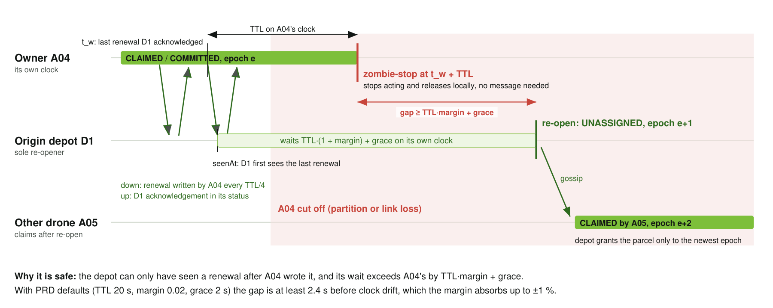
Figure 4. Why the old owner always stops first. The depot's wait starts no earlier than the owner's and lasts longer by TTL·margin + grace, so A04 has stopped before D1 re-opens and A05 claims.
The asymmetry is load-bearing. The ownership property tests isolate the owner at a random time with ±1 % and ±2 % drift, 0–40 % loss and 0–3 s delay; with the asymmetric rule there were no unsafe re-opens, while the naive symmetric rule (no margin, no grace) broke in 673 of 2 000 trials (Decision 16). A drone that loses contact therefore needs no message to behave correctly: its own clock tells it to stop.

5.4 Point of no return
Only the origin depot writes PICKED_UP, as part of a pickup grant. From then on the lease never expires on silence. The task ends DELIVERED, written by the owner at the drop, or ABORTED, written by the origin depot after the carrier is DECLARED_FAILED (Chapter 10), which also creates the single replacement. This stops in-flight parcels from flapping between owners when links are poor.

5.5 Depot arbitration
A drone at the hand-off bay sends PICKUP_REQ {task record, epoch} to the origin depot and waits in loading; it resends after 2 s and abandons the pickup after a lease period without an answer. The depot merges the carried record into its replica and then decides (depotPickup in sim3d/src/p2p/ownership.ts):
Outcome | Condition
PICKUP_GRANT | The record is CLAIMED or COMMITTED, the requester is its owner, and the requested epoch equals the depot's epoch
TASK_TAKEN: stale_epoch | The requested epoch is lower than (or unknown to) the depot's
TASK_TAKEN: not_owner | Someone else owns the current epoch
TASK_TAKEN: already_picked_up | The parcel has been granted before (from the depot's grant memory) or is held by another drone
TASK_TAKEN: not_claimed, terminal | The task was re-opened, delivered or aborted
TASK_TAKEN: wrong_depot, unknown_task | The request reached a depot that does not hold the parcel
Table 9. Depot pickup decisions (REQ-OWN-003).
As a backstop the depot keeps a per-task grant memory {owner, epoch} outside the merge. If any record ever out-ranks a pickup it granted, it answers with a PICKED_UP fence record at the higher epoch, and a carrier with the parcel on board re-asserts its state. In AeroPACT the bay also checks the drone's ground-truth position (in deployment, the position from authenticated heartbeats, D-25), so a drone must be physically there.

5.6 Why no parcel is delivered twice
The argument for invariant I1 is a chain in which each link has its own enforcement and test:
- A parcel leaves a depot only through a PICKUP_GRANT, and the origin depot grants each task once (grant memory).
- A grant needs the requester to own the task at the depot's newest epoch. A drone holding a stale claim is refused, wherever it has been.
- A pre-pickup owner that lost contact stops before the depot can re-open the task (Section 5.3), so it does not compete with the next owner.
- After pickup the owner never times out. A replacement is ordered only on DECLARED_FAILED with physical evidence, only by the origin depot, and only once.
- If a carrier that was declared failed turns out to be alive and delivers, the replacement is cancelled while still before pickup. If the replacement is already in flight, the lower-priority holder returns its parcel and the event is logged as DUPLICATE_RESOLVED (the one exception I1 allows).
The cost of a rare conflict is bounded
Even if two drones both believe they own a task, only one can collect the parcel. The loser receives TASK_TAKEN and is redirected locally, so a conflict costs at most one wasted sortie, never two parcels (docs/03 section 3.5e). The radio-split sweep in PACT_03 measures this directly.

6 Shared state
Every drone and every depot keeps its own replica and merges what it hears. No node reads another node's memory, and nothing is ever deleted that late gossip could resurrect.

6.1 Replicated objects and merge rules (sim3d)
Object | CRDT | Merge rule
Task record | Max under a total order | Compare in turn: epoch (higher wins), state rank (higher; DELIVERED ranks 4.5 so it beats ABORTED), owner (lower id; null last), renew (higher). Remaining ties break on bid, then lease, so merge is commutative on any input.
Drone status | Last-writer-wins by seq | Higher sequence number wins; one writer per record (the drone; depots publish their own)
Shard lease | LWW by (epoch, renew) | Higher epoch, then higher renewal count
Pad reservation | OR-set with expiry | Union minus expired or removed entries (AeroPACT; sim3d books pads at the depot's PadBook)
Tombstones | Grow-only set | Terminal task ids with the local time they became terminal; pruned from gossip after 120 s but kept in the replica
Table 10. Replica contents and merge rules (docs/P2P_DESIGN.md section 4, sim3d/src/p2p/replica.ts).
Because the task merge is the maximum under a total order, it is a join on a lattice and therefore commutative, associative and idempotent by construction. AT-02 checks it: 10 000 random shuffles of a message set, with duplicates, all end in the identical replica, equal to the plain fold, and the epoch never decreases along the way (I2). Each replica also keeps a private seenAt per task, the local time it first saw the current (epoch, renew); it is never gossiped and is what the observer lease bound is timed from.

6.2 The AeroPACT task merge: a product lattice
AeroPACT found that the PRD merge (higher epoch first, then state rank) cannot satisfy both I2 and the point of no return when any node may re-open (D-2). It splits the fencing token in two: epoch is a high-water mark merged by max, and claim_epoch is the epoch at which this version was written. The winning version is chosen by
(progress class, claim_epoch, state rank, bid, lower owner id, lease_seq, state code)
progress class: 0 before pickup, 1 picked up, 2 aborted, 3 delivered
epoch = max(a.epoch, b.epoch)

A picked-up parcel therefore out-ranks any concurrent re-open, terminal states absorb, and epoch still never decreases. Because epoch is not part of the order, the merge is a product of two semilattices; the property test checks the laws on 20 000 random triples. Depots fence on both fields: a request below epoch is stale, and owner checks use claim_epoch. The two implementations reach the same guarantee by different routes: sim3d restricts who may write, AeroPACT restricts what a write can override.

6.3 Gossip and anti-entropy
Mechanism | sim3d behaviour
Delta push | Every gossip period (1 s) a node broadcasts GOSSIP_DELTA with every record whose merge key changed since its last push: its own writes and records it learned (epidemic relay across a multi-hop mesh). Empty deltas are not sent; urgent writes (claims, pickups, priority-1 intake) push at once.
Digest pull | Every 5 s a node broadcasts GOSSIP_DIGEST, a map of task id to merge key. Up to two named peers answer with a unicast delta of what is newer and a want list of what they lack; one round trip converges a pair.
Settle window | Changes younger than 1.5 s are reported in digests with their previous key, so a digest that crosses a push costs no reply.
Pruning | Terminal records drop out of deltas and digests after 120 s, but a peer that names one with an older key is still answered.
Send times | Offset per node by a hash of its id, not by a random draw, so determinism is kept.
Table 11. Gossip in sim3d (docs/P2P_DESIGN.md sections 5 and 10, Decisions 16 and 17).
The radio is a broadcast medium, so the PRD's fan-out of 3 becomes "every neighbour in range". AeroPACT uses the same delta push and replaces digests with a full-state broadcast every full_sync_period; a node re-publishes its own status only on meaningful change, so a quiet fleet sends little beyond heartbeats.
Document and code differ on the gossip period floor
docs/P2P_DESIGN.md section 5 describes an adaptive period that halves down to 0.25 s, and P2P_DEFAULTS.gossipMinPeriodS is 0.25. The integration settings (P2P_DESIGN section 10, Decision 17) pin the minimum period to the 1 s base period to meet the message budget. This document follows the integrated behaviour.

7 Partition policies
A partition policy answers one question: may this node claim a new, unowned task when it cannot see the whole fleet? Tasks already committed or picked up proceed under every policy. The policy is a scenario setting (policy.partition, default QUORUM), so the trade-off between availability and duplicate risk is explicit and measurable.
Policy | May claim a new task when | Duplicate risk | Availability
STRICT | The task's shard lease is held, unexpired in my view, by a drone in my reachable set | About zero | Lowest: shards whose holder is cut off wait
QUORUM | My reachable set is more than half the fleet roster (minus drones I have declared failed) | About zero: only a majority side claims | Medium: a minority side claims nothing new
OPTIMISTIC_BOUNDED | QUORUM holds, or the task has priority 2 or 3 and I hold fewer than 1 claim made without quorum. Priority-1 tasks are never claimed optimistically | Low and bounded; depot arbitration is the backstop | Highest
Table 12. Partition policies (docs/03 section 3.5f, mayClaimNew in sim3d/src/p2p/ownership.ts).

7.1 What a cut-off drone may do
Situation of the drone | STRICT | QUORUM | OPTIMISTIC_BOUNDED
Carrying a parcel | Deliver it | Deliver it | Deliver it
Owns a task before pickup, origin depot unreachable | Fly on until its own lease lapses, then zombie-stop | Same | Same
New task, my side holds its shard lease | Claim | Only with majority | Claim
New task, my side is a minority | Only in shards my side holds | Wait | At most one priority-2/3 task
New task whose origin depot I cannot hear | Wait | Wait | Wait
Table 13. Behaviour of a drone cut off from part of the fleet.
The last row comes from the integration (docs/P2P_DESIGN.md section 10): a task is claimable only if its origin depot's status reached the drone within the reach window, because that depot must acknowledge the lease and arbitrate the pickup; without it the claim would lapse anyway.

7.2 Membership: the roster, not recent contacts
reachable counts drones whose status with a newer sequence number arrived (directly or relayed) within 3 s of local time. The denominator matters as much. An earlier version counted the drones heard in the last 60 s; a minority side partitioned for longer than that, or from boot, then counted itself a majority and claimed, which is split brain under the policy meant to prevent it. Since Decision 19 the denominator is the configured fleet roster minus drones this node has declared failed. A killed drone stays in the roster until it is declared; an operator removal is a reconfiguration and takes it out.
This has a real cost that was kept rather than tuned away: a fleet whose resting radio mesh has no majority component cannot claim anything under QUORUM, because no drone ever flies to connect it. The design answer is the depot backhaul (assumption T12, Decision 20). Drone statuses already travel by epidemic relay, so depots joined by a wired or cellular link relay them across radio islands with no change to the protocol, and reachable spans islands joined by depots.

7.3 Shard leases
Each 500 m hex shard belongs to its nearest depot, which grants the shard lease (ShardLease(shard, epoch, holder, renew, lease_s = 30 s)) when the current lease is free or expired in its view, using the same observer bound as task leases. The holder renews every 10 s and needs the depot's acknowledgement to keep it, so a side cut off from the depot loses the lease on its own clock before the depot can grant it again. A holder that is charging or leaves its home catchment hands its leases back with one SHARD_LEASE {handBack}, so the next requester gets them within one renewal period instead of a full lease (REQ-OWN-005, Decision 18).
AeroPACT variant
In AeroPACT, renewal confirmation also follows the policy (D-4): a majority for QUORUM, a majority or the shard holder for STRICT, and always for OPTIMISTIC_BOUNDED (depot arbitration is its backstop). Re-opening an aged-out foreign lease is itself gated by the policy (D-5), so a minority side cannot take work from an owner alive in the majority. With a majority, the lowest-id reachable drone acquires shard leases for shards with open work; shard size is 150 m on its 1.2 km maps (D-11).

8 Safety layer
Flight safety must not depend on the network or on agreement with anyone (principle 1, invariant I4). The safety layer therefore reads only local inputs, and it may override the mission layer at any time.

8.1 Separation and the give-way rule
Conflicts are resolved without negotiation. Both drones in a conflict evaluate the same total order, higher priority holds course, ties go to the lower drone id, so exactly one yields and neither needs to send a message to agree (beats in AgentCoordinator.ts). Moving obstacles always have right of way. Paths are shared, not negotiated: every heartbeat (10 Hz) carries position, velocity and the intended pre-avoidance velocity, like ADS-B intent, so neighbours can predict a conflict before it develops. Vehicles also cruise on separate altitude layers (28/37/46/55 m in sim3d, 32–50 m by id in AeroPACT) to reduce conflicts in the first place.
Heartbeats are a radio input, so they cannot be the only one. When drones collided inside radio dead zones, Decision 10 added on-board sensing: each tick a drone receives the drones within 45 m with their observed position and velocity, independent of the radio, and treats any it has not heard as a neighbour. The id tie-break still gives the two drones complementary roles without a message. With a working radio nothing changes.

8.2 Isolation in the two implementations
Aspect | sim3d | AeroPACT
Where it runs | Inside each drone's controller: reactive avoidance (computeAvoidance), on-board sensing, battery return threshold | A separate lifecycle component, safety_supervisor, the only component that commands the vehicle
Inputs | Own body state, sensed drones within 45 m, received heartbeats | Odometry, battery, on-board proximity contacts, the flight manager's requests
Isolation check | sim/PathPlanner.ts imports only world and obstacle modules; src/p2p must not import safety code | test_independence.cpp fails the build if the package, CMake or sources reference coordination packages or a radio topic
Network-off test | sim/radio.test.ts: separation without a radio | AT-08 safety-isolation scenario
Contingency table | Return-to-pad below a battery threshold | safety_policy.yaml maps geofence breach, low and critical SOC, command timeout and link loss to HOLD, RTL, LAND_NEAREST, LAND_NOW or CONTINUE_COMMITTED; every change of action logged
Table 14. How the safety layer is kept independent (REQ-SAF-001 to 004).
sim3d's safety logic is not a separate process
In sim3d the network-free behaviour lives in the per-drone controller, and SimulationEngine.updateSafety is a monitor that counts losses of separation and structure hits; it does not command drones. docs/P2P_DESIGN.md section 2 names updateSafety as the safety layer, which overstates it. The PRD's separate safety runtime (REQ-SAF-001) is realised fully in AeroPACT.

8.3 AeroPACT supervisor precedence
Each 20 Hz step the supervisor chooses one action in this order (aeropact/docs/ARCHITECTURE.md section 8):
- Autopilot override (PX4 backend): if PX4 left offboard mode on its own (failsafe, pilot, ground station), stand down and report AUTOPILOT; never contest it (D-23, D-29).
- Endurance and battery floors: measured discharge rate gives time to empty; compare with the time to land here (LAND_NOW) and to reach the nearest clear safe site (LAND_NEAREST, ×1.5 margin). Fixed SOC floors remain a backstop (D-15).
- Geofence or static no-fly breach predicted: RTL.
- Stale mission command (older than 1 s): hold, then RTL after 20 s.
- Otherwise the mission command, filtered in every airborne mode by the separation reflex: a deterministic search over heading changes, speed reductions and climb or descend escapes, with the id tie-break choosing complementary vertical escapes.
Two benchmark findings hardened it: no descent within 3 m above a parked aircraft in any mode (D-27), and contingency landings that pick a site no sensed aircraft occupies (D-28). Both use local sensing only, so I4 still holds. Contingencies latch until touchdown; a latched contingency puts the coordinator in SAFETY_OVERRIDE, which releases pre-pickup work and reports a parcel on board as ABORTED so its depot re-orders it. A safety landing is not a failure: the vehicle keeps heartbeating (D-8).

9 Energy management
Energy enters the design in three places: as a hard constraint on every bid (I5), as a scored cost, and as a physical bound that the failure detector uses to tell a dead drone from a silent one.

9.1 Battery model
sim3d uses an electrical power model with speed, payload and wind terms (REQ-ENG-001, sim3d/src/sim/Battery.ts):
P_cruise = 60 W + 170 W · (airspeed / cruise)² + 60 W/kg · payload
P_hover = 240 W + 60 W/kg · payload
airspeed = ground speed + head-wind component (100 m wind field)
drain_% = P · dt / 3600 / battery_Wh · 100 · demoScale

Parameter | Value | Note
Battery capacity | 120 Wh | Scenario fleet.battery_wh
Cruise speed | 15 m/s | Scenario fleet.speed_mps
Pessimistic margin | sigma = 0.15 | Estimates are multiplied by 1.15
Estimate | Legs sampled every 100 m against the wind field, plus 14 s of hover-power climb and descent per leg | estimatePct
Reserve | soc_reserve = 0.20 | Added on top of the pessimistic need
Demo scale | 3 | Accelerates drain so charging shows in a short run; applied equally to drain and estimates
Endurance bound | SOC over the minimum draw (60 W) | Upper bound on time aloft, published as endurance_s
Table 15. Energy model parameters (sim3d).
The model is deliberately simple and is not an aerodynamic model. What matters for correctness is that planning and execution use the same model and that estimates are pessimistic. AeroPACT goes further: its vehicle plant drains with coefficients that deliberately differ from the planner's model, and the coordinator learns a consumption factor online (observed over modelled use) and applies it to every bid, feasibility check and advertised endurance (D-15). Its feasibility rule adds a +15 % estimate margin and a sensing margin.

9.2 Reserve and pad booking
A bid is feasible only if the battery covers the pessimistic trip plus the reserve (Table 6). Pads are scarce, one drone each. In sim3d the depot's PadBook arbitrates reservations, outages displace drones to other working pads, and scenarios may add public pads. The pad-contention term in the score discourages every drone from heading to the same pad. In AeroPACT pads are booked over the radio (PadRequest / PadResponse), held as an OR-set, freed from ground truth when the holder has left or never arrived within 300 s (D-18) and, at a real site, from pad occupancy sensors that can veto a grant (D-31). When the nearest pad is about to become unreachable the coordinator diverts there (ENERGY_DIVERT) before the supervisor must intervene, choosing a pad nobody has reserved where possible (D-27).
Nearest pad or home pad
docs/03 section 3.4 states the reserve rule as "reach the nearest pad". sim3d's scoreTask budgets the return leg to the drone's home pad, which is at least as conservative when the home pad is farther; AeroPACT uses the nearest pad as specified.

10 Failure detection
A drone that stops answering may be dead or merely out of range. Treating silence as death would re-order parcels that are still being delivered; ignoring silence would strand parcels on crashed drones. PACT separates suspicion, which is cheap and reversible, from declaration, which needs physical evidence (docs/03 section 3.6).
State | Entered when | Effect
ALIVE | Heartbeats arriving, or a fresh gossiped status | Normal
SUSPECT | phi ≥ 5 (about 0.5 s of silence at 10 Hz beacons) | No new work for the peer: its CLAIMs do not outbid or reserve; up to 3 neighbours are probed
UNREACHABLE | phi ≥ 9 and no alive probe answer | Its pre-pickup leases lapse naturally; a parcel it carries is held, not re-assigned
DECLARED_FAILED | Distress, or an expected-observer quorum, or silence beyond the endurance bound (Table 17) | Origin depot aborts its parcel and orders one urgent replacement; the drone leaves the QUORUM roster
Table 16. Peer health states (phi-accrual detector, window 100, minimum deviation 0.1 s, acceptable pause 0.5 s).
Evidence | Rule
Distress | The peer's own DISTRESS broadcast
Expected-observer quorum | Two distinct observers (depots vote too) report it UNREACHABLE with no alive evidence since, and each expected to hear it: every position the peer can have reached since it was last located (a ball of radius 1.5 × cruise speed × age) lies within 0.8 × the expected range from the observer. The expected range uses nominal range and the map's static radio zones, never live link state.
Endurance bound | Silence for at least T_failed = 60 s and past the endurance the peer last published; a drone that never published one gets the full-battery bound
Table 17. Evidence that can declare a drone failed (docs/P2P_DESIGN.md section 7, Decision 18).
The expected-observer condition is what makes a quorum meaningful: a drone that flies out of range or into a mapped radio shadow gets no vote, while a drone that goes silent abruptly well inside coverage, which is the signature of a crash, gets one from everyone around it. Before this rule, sparse meshes and radio shadows produced dozens of false declarations per run; after it, none in the healthy scenarios (Decision 18). Only the origin depot of an in-flight parcel acts on a declaration, so a replacement is never ordered twice. The replacement is priority 1 with a fresh delivery window of the original length (at least 60 s), so it is re-auctioned at once.
AeroPACT differences
Quorum declarations require a majority view (D-17): a minority side cannot tell death from a partition, so only distress and the endurance bound declare there. Probes go through k = 2 relays, the detector uses a 0.5 s minimum deviation and 1 s acceptable pause (D-9), and the replacement keeps the customer deadline. The decentralized baselines are made partition-unaware on purpose (D-22), otherwise they would already contain half of PACT.
aeropact/docs/ARCHITECTURE.md section 7 says a quorum may declare "after 30 s of silence"; the code (quorum_min_age_s = 60 s in aeropact_core/failure_detector.hpp) and D-17 use 60 s.

11 Correctness invariants
Six invariants (PRD section 8, docs/03 section 3.13) are non-negotiable: a change that risks one starts with a failing test (AGENTS.md rule 6). The scenario suite checks I1 and I3 on every scenario, in every difficulty tier, and the benchmark exits non-zero if a fenced system ever breaks them.
ID | Invariant | Enforced by | Tested by
I1 | No double delivery: at most one parcel per job, except logged DUPLICATE_RESOLVED events | Single grant per task at the origin depot, epoch fencing, grant-memory fence, re-order only after declaration, replacement cancellation | Every scenario (suite invariant), AT-03 STRICT split brain, AT-12 sweep (240 runs), bench gate
I2 | Epoch monotonicity: a task's epoch never decreases in any replica | Merge is a max under a total order with epoch first (sim3d) or an epoch high-water mark (AeroPACT) | AT-02: 10 000 shuffles with duplicates; AeroPACT: 20 000 random triples
I3 | Zombie stop: no pickup by a drone after its own lease expired | Owner clock from confirmed renewals, longer observer bound, single re-opener, depot refuses stale epochs | Ownership property tests (drift, loss, delay), AT-04 zombie stop, AT-09 1 % drift, suite invariant
I4 | Safety independence: interventions occur with the network disabled | Safety reads only local inputs; on-board sensing; no imports from coordination | sim3d radio.test.ts; AeroPACT test_independence.cpp and AT-08
I5 | Energy: no plan commits below reserve under the pessimistic estimate | Hard constraint in the bid, pessimistic margin, recharge insertion, energy divert, time-based failsafe | AT-07 (AeroPACT), drained-battery gates in the scenario tiers
I6 | Convergence: after a heal with no new events, replicas agree within T_converge | Delta gossip with epidemic relay, digest anti-entropy, tombstones | AT-10 (replica_converged within 10 s in sim3d), gossip tests at 40 % loss
Table 18. Invariants, their enforcement and their tests.
Two properties are engineered so that a test can observe them. replica_converged is logged by sim3d at the first tick after a heal at which every live replica holds the ledger key of every task, accepting the previous key for changes younger than 3 s, because renewals never stop in a live run. AeroPACT defines convergence on ownership state and excludes the renewal counter (D-20), and its gate is 60 s from the heal.

12 Messages and interfaces
Messages are small, versioned and validated on receipt; unknown fields are ignored (NFR-3, AGENTS.md rule 8). sim3d's contracts live in sim3d/src/p2p/contracts.ts and changing them needs a decision-log entry; AeroPACT's are typed ROS 2 messages in aeropact_interfaces.

12.1 Envelope
Field | Type | Meaning
v | 1 | Protocol version. AeroPACT drops frames with a newer major version.
type | enum | One of the types in Table 20
src | node id | Sender (drone A01.., depot D1..)
dst | node id or * | Unicast target or broadcast
seq | integer | Per-sender sequence number
t_send | seconds | Sender's local clock at send time (durations, not absolute times, cross the network)
payload | object | Type-specific content
Table 19. Message envelope (PRD section 9.1).
Type | Direction | Payload | Purpose
HEARTBEAT | broadcast, 10 Hz | pos, vel, intent, priority, phase, site, stage | Neighbour discovery, avoidance, liveness
CLAIM | broadcast | taskId, cost | Auction bid
GOSSIP_DELTA | broadcast / unicast | tasks[], status[], shards[], optional want | Replica changes
GOSSIP_DIGEST | broadcast | task id → key, shard → (epoch, renew), ask | Anti-entropy
PICKUP_REQ | drone → origin depot | task record, epoch | Ask for the parcel
PICKUP_GRANT / TASK_TAKEN | depot → drone | task_id, epoch, resulting record, reason | Arbitration verdict
SHARD_LEASE | both ways | shards, handBack, leases, t_req | Shard-lease request, grant, return
PROBE / PROBE_ACK | unicast | target; alive, since | Indirect liveness check
DISTRESS | broadcast | reason | Self-declared failure
Table 20. Message types in sim3d.
AeroPACT's RadioFrame carries exactly one payload: GossipDelta, Heartbeat, Probe, ProbeAck, Distress, Suspicion, PadRequest or PadResponse. It has no CLAIM message, because claims are replica writes and consensus is the merge itself. Its heartbeat carries the lease and shard-lease acknowledgements (ack_task_ids, ack_epochs, ack_lease_seqs) and max_endurance_s. Hand-off uses ROS 2 services on the depot's short-range link (request_pickup, reserve_bay). The radio medium forwards frames serialized, without decoding them.

12.2 Replicated records
Record | Fields | Merge key
TaskRecord | task_id (D1:hlc:nonce), origin_depot, pickup, drop, priority 1–3, deadline, weight_kg, shard, state, epoch, owner, bid, renew, lease_s, created_at; immutable extras dropId, type, scripted, reorderOf | (epoch, rank, owner, renew)
DroneStatusRecord | drone_id, seq, pos, soc, mode (CONNECTED / DEGRADED / PARTITIONED / SOLO), bundle, t_local; depots add acks, drones add suspects and endurance_s | seq
ShardLeaseRecord | shard, depot, epoch, holder, renew, lease_s | (epoch, renew)
Table 21. Gossiped records (sim3d). AeroPACT's TaskRecord adds claim_epoch, lease_seq, replaces and abort_reason.
Validation. Every incoming record passes a type guard (isTaskRecord, isStatusRecord, isShardLeaseRecord) that checks the type of each required field and the allowed values (for example, priority must be 1, 2 or 3). A record that fails is skipped; extra fields are ignored. Size. The simulator measures payload size as the length of the JSON encoding and reports it per node and message type; the measured message load is in PACT_03. For scale, the example task record of PRD section 9.1 serialises to about 320 bytes and a drone status to about 160 bytes; the gossip delta carries only records that changed.

12.3 PRD interfaces in each implementation
PRD 9.2 interface | sim3d | AeroPACT
FlightAdapter | AgentController.update() returns a velocity Command that the engine integrates | FlyRoute action and flight/* topics; PX4 through vehicle_interface
AllocationPolicy | scoreTask / chooseTask plus the claim protocol | core::Auction
PartitionPolicy.may_claim_new | PartitionPolicy.mayClaimNew(task, view) | core::PartitionPolicy
Clock.now_local | LocalClock.nowLocal: base + elapsed · (1 + ppm·10⁻⁶), rebased on a drift fault | core::LocalClock
Table 22. Stable PRD interfaces and where they live (AeroPACT mapping from D-1).

12.4 Configuration defaults
Parameter | Default | Source
Gossip period / digest | 1 s / every 5 s | PRD 15, Decision 16
Auction period, claim window | 2 s; 0.85 s at 50–800 ms latency | PRD 15, Decision 16
Lease TTL, renewal, commit | 20 s, every 5 s, T_commit 3 s | PRD 15
Drift margin, grace | 0.02, 2 s | PRD 15
Reach window | 3 s | P2P_DESIGN section 6
Partition policy | QUORUM | PRD 15
Shard size, shard lease | 500 m hex (AeroPACT 150 m), 30 s | PRD 15, D-11
phi suspect / unreachable | 5 / 9 | PRD 15
Failure quorum, T_failed | 2 observers, 60 s | PRD 15, Decision 18
Tombstone TTL, T_converge | 120 s, 10 s (AeroPACT 60 s) | P2P_DESIGN, D-20
soc_reserve | 0.20 | PRD 15
Backhaul | on, 10–40 ms, no loss | Decision 20
Table 23. Defaults (sim3d/src/scenario/defaults.ts, sim3d/src/p2p/contracts.ts).

13 Determinism and reproducibility
A result that cannot be reproduced cannot be checked. sim3d is built so that a run is a pure function of scenario, system and seed (REQ-SIM-001, AT-01); AeroPACT keeps determinism where it is achievable and judges the rest statistically.
Mechanism | How
Fixed step | SimulationEngine advances in fixed 0.05 s steps (20 Hz); simulation time is SimulationEngine.time, never the wall clock
Seeded randomness | All draws come from the seeded Rng in src/world/rng.ts. The network owns a separate stream (seed ^ 0x6e657477), so packet loss cannot perturb the workload or the world
Fixed draw order | One loss draw then one latency draw per (message, receiver) pair, messages in send order, receivers sorted by id; delivery queue ordered by (deliverAt, sendSeq, receiver)
Ordered iteration | Maps and sets are iterated in sorted or insertion order only (AGENTS.md rule 2); neighbour tables are sorted by id
No random timing | Gossip send offsets come from a hash of the node id, not from a random draw
Event log | Structured JSONL (t, agent, type, data) and a hash of the whole log; two runs with the same seed must give the same hash
Golden pins | World and event hashes are pinned in tests; every change that moves a pin is logged in DECISIONS.md
Replay | Replay is re-simulation: seeking re-runs the fixed step, and loading a saved log re-simulates and compares line by line (Decision 21)
Table 24. Determinism mechanisms in sim3d.
Hash function
PRD AT-01 specifies a SHA-256 of events.jsonl. sim3d's eventHash is a 32-bit FNV-1a of the exported log. It detects divergence between runs, which is what AT-01 needs, but it is not a cryptographic digest.

A ROS 2 graph of many processes is not byte-reproducible, because executor scheduling and DDS delivery order vary between runs (D-3). AeroPACT therefore tests determinism exactly where it holds: the middleware-free core library, the world generator (byte-identical output) and every random stream. The full system is judged by acceptance gates and multi-seed benchmarks with confidence intervals.

14 Implementations
The protocol is implemented twice. The two share the design, the defaults and the acceptance tests, but not code. A protocol change in one is checked against the other (AGENTS.md). sim3d is where the protocol is developed and measured at scale; AeroPACT shows it running as an industrial ROS 2 system against a real autopilot stack in simulation.

14.1 sim3d: TypeScript simulator
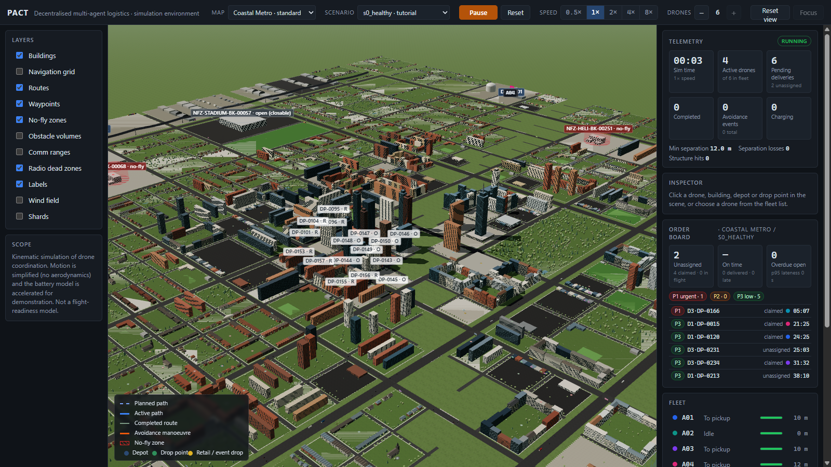
Figure 5. sim3d viewer on the coastal_metro map: 3D city, routes and no-fly zones, with telemetry, order board and fleet panels.
Module | Role
src/world/* | Seeded, pure-data world: city layout, depots with bays and pads, drop points, no-fly zones, wind, radio zones, terrain, shards
src/scenario/* | YAML scenario loading, validation, PRD defaults; acceptance scenarios
src/net/Network.ts, Clock.ts | Environment side: envelopes, latency queue, loss, range, partitions, asymmetric link loss, backhaul, per-node drifting clocks
src/p2p/* | Agent side: replica, gossip, ownership and policies, failure detector, DepotNode, P2PNode, ReplicaBoard. Must not import the engine, safety code or network internals
src/sim/* | Engine (fixed 20 Hz step), controller FSM, auction, path planner (windowed A-star on altitude layers), battery, pad book, workload, faults, baselines
src/eval/* | Metrics from the event log only, bench runner, policy sweep, SVG plots
src/render, src/ui, src/app | React Three Fiber viewer, panels, replay bar, scripted demo
Table 25. sim3d layout (sim3d/README.md, docs/P2P_DESIGN.md section 2).
Under system: pact each drone's controller sees a ReplicaBoard, an implementation of the same TaskBoardView interface backed by its own replica, local clock and partition policy, so the controller code is shared with the baselines. The baselines (central_full, central_hub_loss, greedy_nearest, and cbba_plain, which is defined by having no fencing) run on a global board but on the same network model, so their messages see the same latency and partitions.

14.2 AeroPACT: ROS 2 Jazzy, Gazebo and PX4
All runtime nodes are rclcpp lifecycle components with typed interfaces, YAML parameters and explicit QoS (D-1). The algorithms live in a middleware-independent C++ library, aeropact_core, that is unit and property tested; the nodes adapt it to ROS. Each vehicle runs in its own component container, so a vehicle is a separate process as it would be a separate computer.
Process | Contents
/<id>/computer (one per vehicle) | coordinator, flight_manager, safety_supervisor; with PX4 also vehicle_interface
/depots/depot_container | One DepotNode per depot
/sim/sim_container | Radio medium, vehicle plant (ground-truth battery, payload, collisions), proximity sensor, workload, fault injector
Physics | Gazebo Harmonic (four MulticopterMotorModel rotors per vehicle) or a kinematic backend for CI and benchmarks
lifecycle_manager, event_recorder | Ordered bring-up (simulation time held until ready, D-16); /fleet/events to events.jsonl
/hub/hub_container | Central planner, baseline only
Table 26. AeroPACT processes (aeropact/docs/ARCHITECTURE.md section 2).
Autopilot in the loop. With backend:=px4 each vehicle flies a PX4 v1.16 SITL autopilot. The vehicle_interface turns the supervisor's velocity and enable commands into offboard setpoints, arming and mode commands over uXRCE-DDS, and turns PX4's EKF2 estimate into the fleet's odometry on the site's WGS84 tangent plane. Its OffboardArbiter never contests a mode change made by the autopilot (D-23) and never undoes an autopilot disarm without a fresh request (D-29). Payload release goes through PX4's gripper or winch commands (D-32).
Authenticated mesh. For deployment and rehearsal, mesh_radio_bridge replaces the simulated radio: frames travel over UDP, authenticated with HMAC-SHA256 under a fleet key (D-24) or with per-node Ed25519 signatures checked against a public-key roster (D-30), with a 64-entry replay window. A frame is published only if the authenticated sender equals its src, so under Ed25519 a compromised node can speak only as itself. A site runs one launch file per computer (vehicle.launch.py, depot.launch.py) and no central server.

15 Key design decisions
Both implementations keep a decision log (docs/DECISIONS.md, numbered; aeropact/docs/DECISIONS.md, prefixed D-). The decisions below shaped the protocol most; several were forced by a failing test or a benchmark finding rather than chosen up front.
ID | Decision | Rationale
10 | On-board sensing (45 m) supplements heartbeats for separation | Drones collided in radio dead zones; I4 requires safety without the radio
14 | cbba_plain = the same auction on an unfenced board | A fair reference that isolates what fencing buys
16 | Single-writer rule; depot is the only re-opener | Epoch-first merge let a re-open out-rank a pickup; property tests showed early re-opens without it
16 | Claim window ≥ latency upper bound + one step | The later of two concurrent bidders always hears the earlier bid
17 | Per-node replicas; global board becomes a read-only ledger | Agents must read only what reached them over the radio
18 | Failure declaration needs physical evidence (expected observers, endurance bound) | Silence and naive quorums declared out-of-range drones dead
19 | QUORUM over the fleet roster, not recent contacts | A long-cut-off minority counted itself a majority: split brain
20 | Depot backhaul joins radio islands | Without it QUORUM could never claim on maps with sparse resting meshes
21 | Replay by re-simulation | A run is a pure function of scenario and seed; recordings become verifiable
D-2 | Product-lattice task merge with claim_epoch | Satisfies I2 and the point of no return at once
D-3 | Statistical acceptance for the ROS system | A multi-process ROS graph is not byte-reproducible
D-4 | Lease renewals count only when acknowledged | Unilateral renewals would let an isolated owner renew forever
D-17 | Quorum declarations need a majority view | A minority declared a majority-side drone failed and the job was delivered twice
D-22 | Decentralized baselines are partition-unaware | Sharing PACT's detector made the baseline half of PACT
D-23 | PX4 arbiter never contests the autopilot | Autopilot failsafes, pilots and ground stations keep authority
D-30 | Per-node Ed25519 signatures on the mesh | A shared HMAC key authenticates membership, not identity
Table 27. Decisions that shaped the design (numbers: docs/DECISIONS.md; D-: aeropact/docs/DECISIONS.md).

16 Known limitations and risks
PACT is simulation software. It makes no claim of flight readiness, regulatory compliance or optimal allocation, and it has not flown on hardware. The limits below are the ones a reviewer should weigh.
Area | Limitation
Physics | sim3d is kinematic with an accelerated toy battery (demo scale 3), 2.5D planning on altitude layers and a disc radio model degraded by loss and dead zones. Drones still clip buildings on some runs because path corners are tighter than the turning radius (Decision 10). AeroPACT adds Gazebo physics and PX4, still in simulation.
Availability under partition | QUORUM's minority side claims nothing new; STRICT stalls shards whose holder is cut off; OPTIMISTIC_BOUNDED never claims priority-1 tasks without quorum, so urgent jobs may go late. These costs are measured, not hidden (PACT_03).
Infrastructure | Partition tolerance on sparse maps relies on the depot backhaul (T12). It is not a controller, but losing it on such maps reduces QUORUM to the radio islands.
Allocation | sim3d holds one task per drone (B = 1); the auction is a CBBA simplification and makes no optimality claim. The central planner is a greedy assignment, not Hungarian.
Safety in sim3d | Network-free avoidance lives in the controller, not a separate runtime; the separate supervisor exists in AeroPACT.
Security | sim3d does not model authentication. Under AeroPACT's HMAC mode a stolen fleet key lets an attacker join the protocol; Ed25519 limits a compromised node to its own identity. Confidentiality is not addressed.
Reproducibility | The ROS system is judged statistically, not by log hash (D-3).
Regulation | Commercial drone delivery needs an operational authorisation (DGCA in India; Part 135 and BVLOS approvals in the US; SORA in the EU), accountable operators and a safety case. Removing a central tactical controller does not remove any of these.
Table 28. Known limitations (docs/06_landscape_and_risks.md, sim3d/README.md, aeropact docs).

16.1 Risks and mitigations
Risk | Mitigation in the design
Subtle lease and clock bugs | Property tests with drift injection up to 2 %, determinism, explicit owner/observer asymmetry
"Just CBBA" | The contribution is the ownership protocol, measured by the policy sweep and the unfenced reference
Simulator not credible | Documented model limits; second implementation on Gazebo and PX4 SITL
False failure declaration causing duplicate parcels | Expected-observer quorum, endurance bound, majority view (AeroPACT), sticky ownership after pickup, replacement cancellation
Gossip message blow-up | Delta-only gossip, settle window, digests answered by two peers, measured message budget
Table 29. Design risks from the risk register (docs/06 section 6.5).

16.2 Path to hardware
aeropact/docs/HARDWARE_DEPLOYMENT.md sets out how the software could move from simulation to a site, with each step required before the next. Only the first four steps run in this repository; steps 5 to 9 have not been carried out.
Step | What | Pass criteria
1 Unit / property | make test | All green
2 Fleet SIL | Scenario suite and benchmark (kinematic) | Acceptance gates, invariants I1–I6
3 Autopilot SITL | Scenarios with PX4 SITL | Invariants hold; autopilot logs reviewed
4 Distributed rehearsal | Deployment launch files over the authenticated mesh | Deliveries complete; no rejected frames without an injected attack
5 Hardware in the loop | Real flight controller and companion on the bench | Link-loss and reboot drills end in the configured PX4 failsafe
6–7 Single vehicle | Tethered, then open field with a depot computer | Arming arbitration, override, a full delivery cycle
8 Two vehicles | Crossing routes, shared depot, partition drill | No loss of separation, no duplicate delivery
9 Fleet | Scale up under an operational authorisation | Site KPIs
Table 30. Verification ladder (aeropact/docs/HARDWARE_DEPLOYMENT.md). Steps 5–9 are future work.
Known gaps before any first flight are a payload release driver for the chosen airframe, a site DDS discovery setup, pad charging hardware and pad occupancy sensors, and a hazard analysis (FHA / SORA) with an operations manual.

