KPIT SPARKLE 2027
Decentralized Multi-Agent Coordination for Autonomous Logistics
DOCUMENT 03
PACT
Evaluation and Results Report

What was measured, how it was measured, and where PACT does and does not win: a 100-run benchmark, a 240-run partition-policy sweep, failure recovery, and the AeroPACT ROS 2 / Gazebo / PX4 checks.
Purpose | Lets a reviewer check every result claim against its source file and re-run it.
For | KPIT Sparkle 2027 reviewers checking that the results are real, fairly measured and reproducible.
Project | PACT: Partition-Aware Coordination for Transport
Team | Team PANGnovates · Saveetha Engineering College
Repository | github.com/MrNK2107/PACT
Version | 1.0 · 31 October 2026

PACT is a simulation prototype. Nothing in this document claims real-world flight readiness.
Contents
1. Summary of findings 3
1.1 Key findings 3
1.2 Where PACT does not win 3
2. Evaluation method 5
2.1 Questions asked 5
2.2 Simulator and determinism 5
2.3 Runs, windows and seeds 5
2.4 Metrics from the event log only 6
2.5 Confidence intervals 6
3. Systems compared 6
4. Scenarios and fault model 8
4.1 Fault catalogue 8
4.2 What the matrix does not cover 8
5. Metric definitions 9
6. Results: benchmark 10
6.1 Healthy and hub loss 10
6.2 Battery crunch and urgent burst 11
6.3 AT-05: recorded as FAIL, and why 11
6.4 Hypotheses H1-H4 12
7. Results: radio-split policy sweep (AT-12) 12
8. Results: failure recovery 14
9. Results: message load and compute cost 15
10. AeroPACT (ROS 2 + Gazebo + PX4) results 17
10.1 Benchmark 17
10.2 Acceptance and tests, as recorded on 31 October 2026 18
11. Verification and tests 19
11.1 Acceptance tests AT-01 to AT-12 19
12. Threats to validity and limitations 21
12.1 Internal validity 21
12.2 External validity 21
12.3 What is not tested 21
13. How to reproduce every number 22

1. Summary of findings
PACT keeps delivering when the central hub dies and never delivers a parcel twice in any fenced run. It costs nothing measurable in on-time rate against an ideal central planner at this fleet size, and it pays for that in radio messages. One acceptance check fails as recorded, on the baseline's side, and this report explains why.
86.3 %  PACT on time after hub loss (healthy: 86.3 %) | 56.8 %  central baseline on time after hub loss | 0  duplicate deliveries in 260 fenced runs | 17.8  duplicates per run, unfenced CBBA, canyon partition

All figures are from the sim3d simulator (TypeScript, fixed step, seeded) unless marked AeroPACT. Simulation only: nothing here is a flight test, a field trial or a claim of real-world readiness.

1.1 Key findings
- Hub loss. In s1_hub_loss the hub is killed at 180 s. PACT's on-time rate is 86.3 % [81.1, 93.1], identical to its healthy run (drop 0.0 %). central_hub_loss falls from 86.3 % to 56.8 % [53.4, 59.4] and its deliveries from 20.2 to 7.6 per run (Table 7).
- Ownership correctness. Every fenced run had 0 duplicate deliveries and 0 zombie pickups: 80 fenced runs of the 100-run benchmark and 180 PACT runs of the 240-run policy sweep. The unfenced cbba_plain reference produced 15 duplicate deliveries in its 20 benchmark runs, and 3.67 and 17.80 duplicates per run in the two sweep scenarios (Tables 6-9, 11).
- Cost of decentralisation, healthy fleet. PACT equals the always-up central planner on s0_healthy (86.3 % both) and sits 1.8 points below it on s6_battery_crunch (55.0 % vs 56.8 %) and 0.3 points below on s7_urgent_burst (75.0 % vs 75.3 %), all inside overlapping 95 % CIs.
- Failure recovery. After a carrier is killed, PACT's depot declares it failed after a median 3.7 s from physical evidence, and the replacement is claimed 9.9 s after the kill (median). The baselines use a fixed 60 s stand-in for detection, so their kill-to-claim median is 61.7-67.9 s. Once a failure is declared, the central planners re-assign faster (1.6 s vs 6.2 s), and one of PACT's 8 runs never recovered (Table 12).
- Policy trade-off (AT-12). No partition policy dominates. STRICT is best in the canyon partition (88.6 %) and worst in the split-brain testbed (76.9 %). All 240 sweep runs completed with 0 fenced violations, so AT-12 passes (Table 11).
- Message load. PACT sends 73.7-76.2 messages per drone per minute (beacons excluded) on the benchmark scenarios, under the 120 budget of AT-11, plus about 142-143 backhaul copies per depot per minute. Per-tick compute p95 is at most 0.14 ms per run on this machine (Table 14).

1.2 Where PACT does not win
A reviewer should be able to see the losses as easily as the wins. These are all of them in the recorded results:
- AT-05 is recorded as FAIL. PACT's side passes (drop 0.0 %, gate ≤ 15 %); the central baseline drops 34.1 %, below the > 40 % gate. Section 6.3 explains it; the gate was not changed.
- central_full beats PACT on on-time rate in s6_battery_crunch (56.8 % vs 55.0 %) and s7_urgent_burst (75.3 % vs 75.0 %). Both gaps are inside the CIs.
- greedy_nearest delivers more parcels than PACT in every scenario (for example 21.2 vs 20.0 in s0_healthy, 14.2 vs 12.2 in s6_battery_crunch) and more after the hub fault (18.0 vs 16.8). It wins on volume by ignoring priorities and deadlines, which costs it on-time rate (35.0 % in s6).
- In the policy sweep the unfenced cbba_plain has a higher on-time rate than every PACT policy (84.1 % and 98.5 %). It buys that with duplicate deliveries and, in the canyon scenario, about 9-11 fewer distinct deliveries per run.
- Once a failure is declared, the central planners re-assign the parcel faster than PACT (median 1.6 s vs 6.2 s); in one PACT run of 8 the replacement was never claimed.
- PACT is the only system with a material message load (about 76 msgs/drone/min vs 0.0-0.3 for the baselines), because the baselines' coordination runs on a shared global board that the radio model does not charge for.
- Two losses of separation (two airborne drones closer than 3 m) were logged in the sweep, both under PACT STRICT on dm_canyon_partition (seeds 31002 and 31003). They are in results/sweep/sweep.csv; sweep.md does not show that column.

2. Evaluation method

2.1 Questions asked
The evaluation plan (docs/05_evaluation_plan.md, section 5.1) fixes six questions before any benchmark was run. Each is answered in a later chapter:
# | Question | Answered in
1 | Does PACT keep delivering when the hub disappears? (resilience) | Chapter 6
2 | How often do partitions cause duplicate or conflicting dispatch? (ownership correctness) | Chapters 6, 7
3 | What does decentralisation cost in healthy conditions? (efficiency gap) | Chapter 6
4 | How fast does the fleet recover from failures? (recovery) | Chapter 8
5 | What do the partition policies trade off? (availability vs duplicate risk) | Chapter 7
6 | Does it scale in compute and messaging? (practicality) | Chapter 9
Table 1. Evaluation questions (docs/05_evaluation_plan.md section 5.1).

2.2 Simulator and determinism
All headline numbers come from sim3d, the TypeScript simulator in sim3d/. A run is a pure function of scenario, system and seed:
- Fixed step. The engine advances in steps of dt = 0.05 s (20 Hz, sim3d/src/sim/config.ts). Simulation time comes from the engine, never from the wall clock.
- Seeded randomness. World generation, workload, radio loss and latency draw from seeded generators (src/world/rng.ts); maps and sets are iterated in sorted or insertion order (AGENTS.md rule 2).
- Paired seeds. Run i of a cell uses scenario.seed + i, so every system sees the same world, workload and fault script on the same seed (src/eval/bench.ts).
- Event-hash check. Every row of results/results.csv carries a hash of its event log (32-bit FNV-1a over the JSONL export, eventHash(); the PRD names SHA-256, so this is a weaker fingerprint). AT-01 runs every suite scenario twice and requires the same hash; the replay viewer re-simulates a saved log and compares it event by event (Decision 21).

2.3 Runs, windows and seeds
Experiment | Matrix | Runs | Window | Source
Benchmark (make bench) | 4 scenarios × 5 systems × 5 seeds | 100 | 900 s | results/summary.md, results.csv, bench.json
AT-12 policy sweep (make sweep) | 2 scenarios × (3 PACT policies + cbba_plain) × 30 seeds | 240 | 900 s | results/sweep/sweep.md, .csv, .json
Recovery (AT-06 measure) | at06_drone_failure × 5 systems × 8 seeds | 40 | to recovery | results/recovery.json
Scenario acceptance (make scenarios) | every suite scenario + AT-03/04/06/09/10/11 | 75 | ≤ 900 s (AT-11: 1 h) | run for this report, Chapter 11
Table 2. Experiments behind this report.
The plan asks for at least 30 seeds per cell (section 5.5). The sweep meets that; the benchmark uses 5 seeds per cell, the runner's default. This is a deviation and it widens the benchmark CIs; Chapter 12 returns to it.

2.4 Metrics from the event log only
Every metric is computed after the run from the structured event log (src/eval/metrics.ts), never from internal state the system under test could misreport. The same code scores every system. An event-log line has a simulation time, an agent and a type; the metric code reads only the types task_created, delivered, zombie_stop, claimed, picked_up, lease_expired, task_taken, loss_of_separation and battery_depleted, and ignores events after the window.

2.5 Confidence intervals
Values are means over seeds with a 95 % percentile bootstrap CI in brackets: 2000 resamples of the per-seed values, drawn from a seeded generator, so the brackets themselves are reproducible (bootstrapMean in src/eval/bench.ts). A cell shows no bracket when all seeds gave the same value. Counts (duplicates, zombie pickups, losses of separation) are summed over the cell's runs, not averaged.
Paired, but not tested for significance
The seeds are paired across systems, but the report gives CIs per cell and no paired significance test. Where two CIs overlap, this report calls the difference "inside the CIs" and does not claim a winner.

3. Systems compared
Five systems run on identical worlds, workloads, fault scripts and seeds (src/sim/systems.ts). The bench runner overrides the scenario's system: field per run, so the system is the only thing that changes.
System | What it is | Why it is a fair comparison
pact | Decentralised bid / claim / back-off over the simulated radio. Every drone and depot keeps its own CRDT replica, synchronised by gossip; epoch-fenced leases on local clocks; depot pickup arbitration; the scenario's partition policy; failure detection from physical evidence. Depots also talk over a wired / cellular backhaul (Decision 20). | System under test.
central_full | A central hub runs a global greedy assignment every auction period with global knowledge, no radio limits, and never fails. | Upper bound. It uses the same bid score and hard constraints as PACT (scoreTask, factored out unchanged), so a PACT shortfall is the price of decentralisation, not a scoring difference.
central_hub_loss | The same hub; kill_service(central_hub) stops all new dispatches. Drones finish their current task and fly home. | The realistic central system the hub-loss question is about.
greedy_nearest | Decentralised; each drone takes the nearest feasible task, with no priorities, deadlines or bids. | The simplest decentralised fleet. In sim3d it keeps the board's fencing, so it shows the value of the auction, not of the ownership protocol.
cbba_plain | The PACT radio auction on an unfenced board: no atomic claim, no leases, no depot arbitration; every claimant is handed a parcel. | Isolates what fencing buys. Duplicates are expected and are not gated. It only resolves conflicts before the claim, so it is a pessimistic CBBA (night notes 2026-10-24).
Table 3. Systems under test (results/summary.md, Decisions 13 and 14).
Two points of fairness a reviewer should know. First, every system except cbba_plain keeps the board's epoch fencing, lease expiry and depot arbitration, so the zero-duplicate result for greedy_nearest and the central systems in sim3d is a property of that shared board, not of their algorithms. Second, the central planner is a global greedy assignment, not the Hungarian algorithm the plan mentions (Decision 13).
For the AT-12 sweep, pact runs once per partition policy (STRICT, QUORUM, OPTIMISTIC_BOUNDED) and cbba_plain once per scenario as the unfenced reference:
- STRICT: claim only under a live shard lease held on my side (REQ-OWN-005).
- QUORUM: claim only while a strict majority of the fleet roster is reachable.
- OPTIMISTIC_BOUNDED: QUORUM, or at most one priority ≥ 2 claim without it; never priority 1.

4. Scenarios and fault model
A scenario is one YAML file (sim3d/scenarios/<map>/<name>.yaml) that fixes the fleet, workload, network, policy and fault script; the map fixes size, geography and depot layout. Faults are scenario inputs, so they apply equally to every system.
Scenario | Map | Setup | Fault script | Used in
s0_healthy | coastal_metro, 4 × 4 km | 3 depots × 2 pads; 12 drones requested, 6 fly (one per pad); 2.5 orders/min | none | Bench
s1_hub_loss | coastal_metro | as s0 | kill_service(central_hub) at 180 s (20 % of the window) | Bench, AT-05
s6_battery_crunch | coastal_metro | 1 pad per depot; 4 orders/min; wind 6 m/s | battery_drain × 1.5 on every drone from 120 s | Bench
s7_urgent_burst | coastal_metro | 2 orders/min | 10 priority-1 hospital jobs within 60 s at 600 s | Bench
at03_split_brain_strict | coastal_testbed, 2 km | 6 drones, 3 depots × 2 pads, 6 orders/min | partition {D1, A01, A04} | {D2, D3, A02, A03, A05, A06}, 120-420 s | Sweep, AT-03
dm_canyon_partition | dense_metro_core, 2.5 km | 8 drones; radio range 450 m; canyon dead zones (range × 0.2, +30 % loss); 5 % loss | radio blackout 600-900 s; partition {D1, D4, A01, A04, A05, A08} | rest, 300-600 s | Sweep
at06_drone_failure | coastal_testbed | 8 drones, 3 depots × 3 pads, 2 orders/min | the first carrier after 120 s is killed 10 s after pickup (no distress) | Recovery, AT-06
Table 4. Scenarios and faults used for the results in this report.
Priority sets the delivery deadline (src/scenario/defaults.ts): priority 1 has 240-480 s, priority 2 600-1200 s and priority 3 1200-2400 s. This matters for reading the on-time rate in a 900 s window (Section 5.1 and 6.3).

4.1 Fault catalogue
The simulator supports kill_service, kill_drone, partition (with until), link_loss, clock_drift, battery_drain, urgent_job_burst, radio_blackout, backhaul_cut, zone closures, pad outages and weather fronts. Every injection is logged; an unsupported target logs fault_kill_service_failed or fault_unsupported, and the suite fails if a due fault never fires.

4.2 What the matrix does not cover
The plan's matrix (section 5.3) also lists S2 lossy network (20/40/60 % loss), S4 repeated partitions, S8 clock drift, S9 combined stress and S10 scale. In sim3d these are exercised by the scenario suite and acceptance tests (for example AT-09 clock drift, AT-11 at N = 30), not by the benchmark matrix, so they have no benchmark rows with CIs. The ablation study (PACT minus leases, fencing, arbitration and so on) has not been run.

5. Metric definitions
Metric | Exact definition (sim3d) | Source
On-time rate % | Tasks that fell due inside the window and were delivered by their deadline, divided by the tasks that fell due. Tasks not yet due at the end of the window count neither way. | Decision 13; metrics.ts
Delivered | Distinct tasks delivered inside the window (any lateness). | delivered events
Delivered after first fault | Deliveries after the first injected fault's time (0 when the scenario has no fault). | metrics.ts
Mean lateness s | Total seconds past the deadline divided by all deliveries (on-time deliveries count as 0). | metrics.ts
Duplicate deliveries | Deliveries of a task that was already delivered (I1). Summed over the cell's runs. | delivered events
Zombie pickups | A pickup by a drone after it logged zombie_stop for that task and before it claimed it again (I3). | zombie_stop, picked_up
Loss of separation (LoS) | Two airborne drones closer than 3 m in 3-D (SIM.hardCollisionDist), counted once per encounter. | loss_of_separation
Msgs / drone / min | Radio messages sent per drone per minute, beacons excluded (the 10 Hz position beacons). | msgsPerDroneMin
Backhaul copies / depot / min | Depot-to-depot message copies carried by the wired / cellular backhaul, per depot per minute. | backhaulPerDepotMin
Tick p95 ms | 95th percentile of wall-clock compute per simulation step in one run; the table shows the largest value across a cell's runs. Machine-dependent. | bench.ts
Refusals | Pickups the depot refused (task_taken): a wasted sortie. | sweep only
Violations (sweep) | Duplicate deliveries + zombie pickups per run. | sweep.md
Table 5. Metric definitions.

5.1 How small the on-time denominator is
Because deadlines are 240 s to 2400 s, only a few tasks fall due inside a 900 s window: 4-7 per run in s0_healthy (28 over its 5 seeds), 6-11 in s6_battery_crunch (41) and 4-10 in s7_urgent_burst (30), against 35-76 tasks released (results/results.csv, columns released and due). One task more or less on time moves a single run by 9-25 points, which is why the benchmark CIs are wide. The Delivered column, which counts every delivery, is the steadier companion measure.

6. Results: benchmark
100 runs: 4 scenarios × 5 systems × 5 seeds, 900 s each (results/summary.md). The PACT row is highlighted. Means with 95 % bootstrap CIs; Dup. is the count of duplicate deliveries summed over the 5 runs. Zombie pickups and losses of separation were 0 in all 100 runs, so those columns are omitted. Lateness is the mean lateness in seconds. Message and compute columns are in Chapter 9.
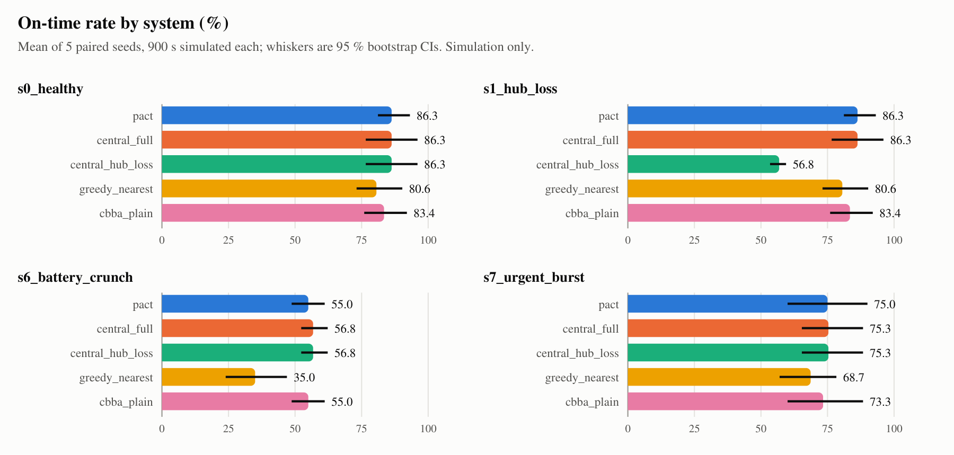
Figure 1. On-time rate by system and scenario, mean of 5 paired seeds with 95 % bootstrap CIs (results/plots/bench_on_time.svg).

6.1 Healthy and hub loss
System | On time % [95 % CI] | Delivered | After first fault | Lateness s | Dup.
pact | 86.3 [81.1, 93.1] | 20.0 [18.8, 21.2] | 0.0 | 0.5 [0.0, 1.6] | 0
central_full | 86.3 [76.6, 96.0] | 20.2 [19.2, 21.2] | 0.0 | 1.0 [0.0, 3.1] | 0
central_hub_loss | 86.3 [76.6, 96.0] | 20.2 [19.2, 21.2] | 0.0 | 1.0 [0.0, 3.1] | 0
greedy_nearest | 80.6 [73.1, 90.3] | 21.2 [20.0, 22.2] | 0.0 | 0.7 [0.0, 2.1] | 0
cbba_plain | 83.4 [76.0, 92.0] | 19.6 [18.2, 21.0] | 0.0 | 1.8 [0.0, 4.2] | 4
Table 6. s0_healthy: no faults (results/summary.md).
System | On time % [95 % CI] | Delivered | After first fault | Lateness s | Dup.
pact | 86.3 [81.1, 93.1] | 20.0 [18.8, 21.2] | 16.8 [16.2, 17.4] | 0.5 [0.0, 1.6] | 0
central_full | 86.3 [76.6, 96.0] | 20.2 [19.2, 21.2] | 16.6 [16.0, 17.4] | 1.0 [0.0, 3.1] | 0
central_hub_loss | 56.8 [53.4, 59.4] | 7.6 [7.0, 8.4] | 4.0 [3.4, 4.6] | 0.0 | 0
greedy_nearest | 80.6 [73.1, 90.3] | 21.2 [20.0, 22.2] | 18.0 [16.4, 19.4] | 0.7 [0.0, 2.1] | 0
cbba_plain | 83.4 [76.0, 92.0] | 19.6 [18.2, 21.0] | 16.2 [15.2, 17.2] | 1.8 [0.0, 4.2] | 4
Table 7. s1_hub_loss: kill_service(central_hub) at 180 s (results/summary.md).
PACT has no hub, so the fault is logged with affected: false and its numbers are identical to s0_healthy (the event hashes differ only by that log line). central_full is the same planner with a hub that never fails. central_hub_loss keeps the parcels it dispatched before 180 s and then dispatches nothing: 4.0 deliveries after the fault against PACT's 16.8.

6.2 Battery crunch and urgent burst
System | On time % [95 % CI] | Delivered | After first fault | Lateness s | Dup.
pact | 55.0 [48.7, 61.1] | 12.2 [12.0, 12.6] | 11.0 [10.4, 11.6] | 2.8 [0.1, 6.0] | 0
central_full | 56.8 [52.3, 62.3] | 11.6 [11.2, 12.0] | 10.4 [9.6, 11.0] | 2.3 [0.0, 6.1] | 0
central_hub_loss | 56.8 [52.3, 62.3] | 11.6 [11.2, 12.0] | 10.4 [9.6, 11.0] | 2.3 [0.0, 6.1] | 0
greedy_nearest | 35.0 [23.9, 46.9] | 14.2 [13.6, 14.8] | 12.8 [11.8, 13.6] | 0.0 | 0
cbba_plain | 55.0 [48.7, 61.1] | 11.2 [10.0, 12.0] | 9.8 [8.4, 10.8] | 0.3 [0.0, 1.0] | 2
Table 8. s6_battery_crunch: one pad per depot, 4 orders/min, battery drain × 1.5 from 120 s (results/summary.md).
Here central_full is ahead of PACT on on-time rate by 1.8 points and PACT's mean lateness is higher (2.8 s vs 2.3 s); both inside the CIs. PACT delivers slightly more parcels (12.2 vs 11.6). greedy_nearest delivers the most (14.2) and has the worst on-time rate (35.0 %): it takes the nearest task, not the most urgent one. No run in any system depleted a battery.
System | On time % [95 % CI] | Delivered | After first fault | Lateness s | Dup.
pact | 75.0 [60.0, 90.0] | 18.6 [16.6, 20.6] | 6.8 [5.4, 7.8] | 0.1 [0.0, 0.2] | 0
central_full | 75.3 [65.4, 88.3] | 19.2 [17.8, 20.4] | 7.2 [6.2, 8.0] | 0.0 | 0
central_hub_loss | 75.3 [65.4, 88.3] | 19.2 [17.8, 20.4] | 7.2 [6.2, 8.0] | 0.0 | 0
greedy_nearest | 68.7 [57.0, 78.3] | 19.8 [18.2, 21.6] | 7.6 [6.2, 8.6] | 0.3 [0.0, 0.8] | 0
cbba_plain | 73.3 [60.0, 88.3] | 18.0 [16.2, 20.0] | 6.6 [5.2, 7.8] | 0.2 [0.0, 0.5] | 5
Table 9. s7_urgent_burst: 10 priority-1 jobs within 60 s at 600 s (results/summary.md).
PACT and the central planner are effectively equal (75.0 % vs 75.3 %); the central planner delivers 0.6 more parcels per run. s1's kill does not apply here, so central_hub_loss behaves as central_full.

6.3 AT-05: recorded as FAIL, and why
AT-05 as recorded in results/summary.md
AT-05: FAIL — on-time rate, healthy → hub loss: pact 86.3 → 86.3 % (drop 0.0 %, gate ≤ 15 %); central_hub_loss 86.3 → 56.8 % (drop 34.1 %, gate > 40 %).
PACT's half of the check passes. The check fails because the baseline did not degrade by more than 40 %.

The PRD gate (section 11) has two halves: PACT must lose at most 15 % of its healthy on-time rate, and the central_hub_loss baseline must lose more than 40 %. The second half is a check that the scenario actually stresses a central design; it says nothing about PACT. It fails here for a measurable reason:
- The on-time rate only counts tasks that fall due inside the 900 s window (Section 5.1). Many of those were created, and often delivered, before the hub died at 180 s, so the baseline keeps credit for them.
- By deliveries the baseline collapses far more: 20.2 → 7.6 per run (−62 %), and 4.0 deliveries after the fault against PACT's 16.8.
- Over a longer window the same gate passes. Decision 13 (recorded 2026-10-20) ran make bench WINDOW=1800 on s0/s1 × pact/central_hub_loss with 5 seeds: PACT 75.4 → 75.4 %, central_hub_loss 73.4 → 22.7 % (a 69 % drop). That run predates the network model and depot backhaul (Decisions 16-20) and has not been regenerated, so it is supporting evidence, not a current result.
Was the gate revised? No. docs/DECISIONS.md Decision 13 states that the gate and metric were fixed before these runs and not tuned, and that the default window stays 900 s to match the scenario suite; Decision 20 re-confirms "AT-05 FAIL only on the central side" after the backhaul change. The night notes of 2026-10-20 and 2026-10-24 record the window choice as left open to the user. docs/05_evaluation_plan.md has no revised gate. make bench therefore exits 0 (it fails only on an I1 / I3 break) and make bench --strict fails on AT-05.
Two further deviations from the PRD wording: the PRD's AT-05 kills the hub at t = 600 s, while sim3d's s1_hub_loss kills it at 180 s (20 % of the run, per the plan's S1 row). The plan's hypothesis H1 (central retains ≤ 60 % of its healthy rate) is also not met at 900 s: it retains 65.8 % (56.8 / 86.3). AeroPACT, which runs 1500 s, uses a different AT-05 gate and passes it (Chapter 10).

6.4 Hypotheses H1-H4
H | Pre-registered hypothesis (plan 5.5) | Result
H1 | Under hub loss PACT retains ≥ 85 % of its healthy on-time rate; central_hub_loss retains ≤ 60 %. | PACT half met (100 %). Central half not met at 900 s (65.8 %); met at 1800 s in Decision 13 (31 %) and in AeroPACT (34 %).
H2 | PACT STRICT / QUORUM duplicate rate ≤ 0.5 %; cbba_plain and greedy_nearest materially higher under partitions. | Met for PACT (0) and cbba_plain (3.67 and 17.80 per run). Not shown for greedy_nearest in sim3d, which keeps fencing; AeroPACT shows 3.2-4.7 % for it.
H3 | Healthy: PACT within 10 % of central_full on total distance and on-time rate. | On-time rate met (gaps 0.0, 1.8, 0.3 points). Total distance is not reported by the bench: not evaluated.
H4 | Ablating leases / fencing increases duplicates and zombies; ablating arbitration increases wasted sorties. | Not evaluated: no ablation runs exist. cbba_plain removes all three at once and shows the duplicates.
Table 10. Pre-registered hypotheses against the recorded results.

7. Results: radio-split policy sweep (AT-12)
240 runs: 2 scenarios × (3 PACT partition policies + cbba_plain) × 30 seeds × 900 s (results/sweep/sweep.md). Violations are duplicate deliveries plus zombie pickups per run. Pareto marks cells not dominated within their scenario on on-time rate (up) and violations (down).
Scenario | System / policy | On time % [95 % CI] | Delivered | Duplicates / run | Pareto
at03 split brain | pact STRICT | 76.9 [70.2, 83.4] | 28.8 [26.4, 30.9] | 0.00
 | pact QUORUM | 80.8 [75.9, 85.7] | 30.0 [28.3, 31.6] | 0.00
 | pact OPTIMISTIC_B. | 80.9 [75.7, 86.0] | 31.4 [29.7, 33.1] | 0.00 | yes
 | cbba_plain unfenced | 84.1 [78.9, 89.0] | 28.8 [27.1, 30.6] | 3.67 [3.13, 4.17] | yes
dm canyon partition | pact STRICT | 88.6 [83.7, 93.0] | 33.2 [31.9, 34.5] | 0.00 | yes
 | pact QUORUM | 82.1 [75.9, 87.6] | 26.4 [25.0, 27.7] | 0.00
 | pact OPTIMISTIC_B. | 82.1 [75.7, 88.5] | 34.6 [33.4, 35.8] | 0.00
 | cbba_plain unfenced | 98.5 [96.6, 100.0] | 23.9 [22.9, 24.9] | 17.80 [17.10, 18.43] | yes
Table 11. AT-12 policy sweep, 30 seeds per row (results/sweep/sweep.md). OPTIMISTIC_B. = OPTIMISTIC_BOUNDED. Zombie pickups and refusals were 0.00 per run in every row; no run depleted a battery.
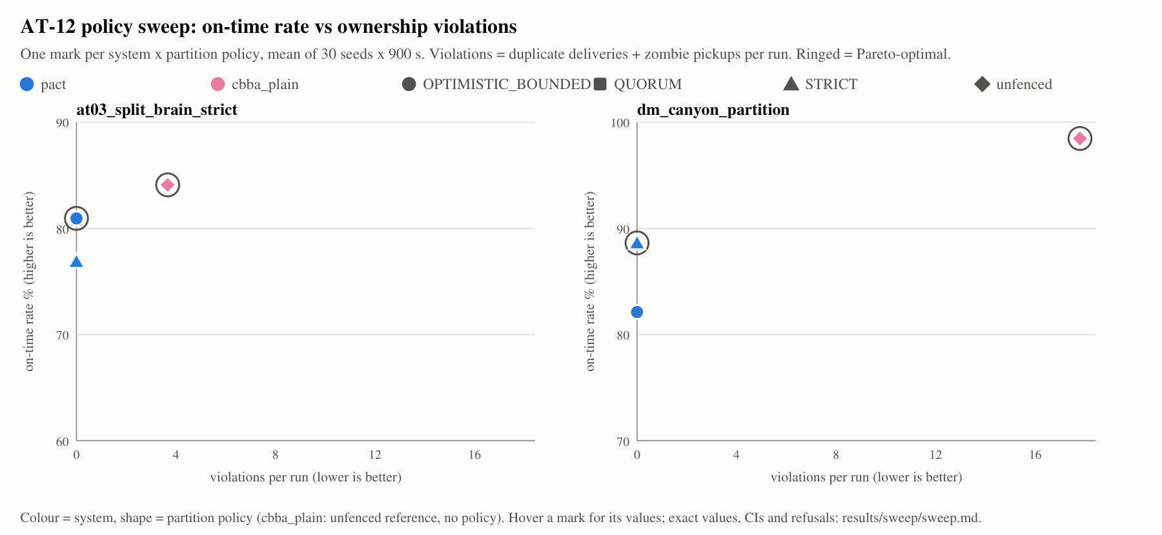
Figure 2. AT-12: on-time rate against ownership violations per run, one mark per system × policy; ringed marks are Pareto-optimal (results/plots/sweep_pareto.svg).

Reading the sweep
- Fencing holds under partition. 180 PACT runs across both partitions: 0 duplicate deliveries, 0 zombie pickups, 0 refusals. AT-12: PASS, 240/240 runs completed.
- The unfenced reference is faster and wrong. cbba_plain has the highest on-time rate in both scenarios, but delivers 3.67 (split-brain) and 17.80 (canyon) duplicate parcels per run. In the canyon it also completes about 9-11 fewer distinct deliveries than PACT STRICT or OPTIMISTIC_BOUNDED (23.9 vs 33.2 and 34.6), because duplicate flights use up the fleet. It is on the Pareto front only because no fenced cell beats its on-time rate.
- No policy dominates. STRICT is worst in the split-brain testbed (76.9 %) and best in the canyon (88.6 %). QUORUM delivers least in the canyon (26.4), consistent with radio shadow often leaving no majority reachable. OPTIMISTIC_BOUNDED delivers most in both scenarios; it never claims priority-1 work without quorum, and Decision 19 attributes its lower canyon on-time rate to urgent jobs going late for that reason.
- Two losses of separation. results/sweep/sweep.csv records one loss of separation in each of two PACT STRICT runs on dm_canyon_partition (seeds 31002, 31003). Separation is a flight-layer property, not part of the ownership protocol, but it is a safety-relevant event and the sweep table does not surface it. The benchmark had none in 100 runs.
Earlier sweep designs
Before the network model existed, AT-12 swept policy.soc_reserve instead of the partition policy (Decision 14, 2026-10-24) and later ran 360 and 540 runs on other scenarios. Those numbers are superseded by the 240-run partition-policy sweep above (Decisions 19 and 20) and are not used in this report.

8. Results: failure recovery
Scenario at06_drone_failure, 8 seeds per system: the first drone to pick up a parcel after 120 s is killed 10 s later, with no distress message (results/recovery.json, summarised in results/summary.md). Detection is kill → declaration: for PACT the origin depot's peer_failed, for the baselines a fixed 60 s stand-in (SIM.tFailed). Recovery is declaration → replacement claimed by another drone. Every system re-orders the lost parcel as priority 1 with a fresh window (Decision 19).
System | Runs | Detection median s | Recovery median s | Kill → claimed median s | Not recovered
pact | 8 | 3.7 | 6.2 | 9.9 | 1
central_full | 8 | 60.0 | 1.6 | 61.7 | 0
central_hub_loss | 8 | 60.0 | 1.6 | 61.7 | 0
greedy_nearest | 8 | 60.0 | 6.3 | 66.3 | 0
cbba_plain | 7 | 60.1 | 7.8 | 67.9 | 0
Table 12. Recovery after a carrier failure, medians over the runs where the victim still carried its parcel (results/summary.md, results/recovery.json).
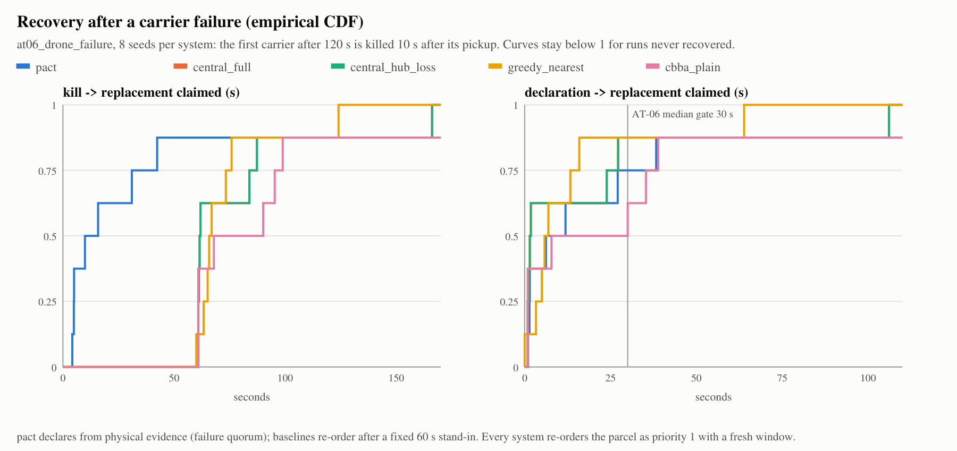
Figure 3. Empirical CDF of kill → replacement claimed (left) and declaration → replacement claimed (right), 8 seeds per system; the AT-06 median gate is 30 s (results/plots/recovery_cdf.svg).
Seed | 20240611 | …612 | …613 | …614 | …615 | …616 | …617 | …618
Detection s | 3.2 | 3.4 | 3.9 | 3.7 | 3.5 | 3.9 | 3.6 | 4.1
Recovery s | 1.0 | 1.5 | 27.1 | 6.2 | none | 11.9 | 1.4 | 38.3
Kill → claimed s | 4.2 | 4.9 | 31.0 | 9.9 | none | 15.8 | 5.0 | 42.4
Table 13. PACT per seed (results/recovery.json). Seed 20240615: declared after 3.5 s, replacement never claimed in the window.

Reading the recovery result
- PACT's advantage is detection: 3.2-4.1 s from physical evidence against the baselines' 60 s. The 60 s figure is a fixed modelling stand-in, not a measured detector, so the kill-to-claim comparison depends on that choice. A baseline given a faster timeout would close most of the gap.
- After declaration the central planners are faster (median 1.6 s vs 6.2 s): a global planner re-assigns at its next auction period, while PACT waits for a drone with the energy for the leg to bid and claim.
- PACT's recovery median, 6.2 s over the 7 recovered runs, is inside the AT-06 gate of 30 s. Two runs took 27.1 s and 38.3 s and one was not recovered: recovery waits for a drone with enough energy, which the failure layer cannot shorten (Decision 18).
- The AT-06 scenario test (Chapter 11, run for this report) uses the same 8 kills and reports a median of 9.0 s, because it counts the unrecovered seed as infinite instead of excluding it. Both medians are inside the 30 s gate.

9. Results: message load and compute cost
Scenario | PACT msgs / drone / min | Backhaul copies / depot / min | Tick p95 ms (max of runs) | Baselines msgs / drone / min
s0_healthy | 76.0 [75.3, 76.9] | 142.8 [142.5, 143.2] | 0.13 | 0.0-0.3
s1_hub_loss | 76.0 [75.3, 76.9] | 142.8 [142.5, 143.2] | 0.13 | 0.0-0.3
s6_battery_crunch | 73.7 [72.6, 75.4] | 142.4 [142.3, 142.6] | 0.10 | 0.0-0.3
s7_urgent_burst | 76.2 [74.9, 77.5] | 142.9 [142.8, 143.1] | 0.14 | 0.0-0.3
Table 14. Message load and compute per scenario, beacons excluded (results/summary.md; tick p95 from results/results.csv).
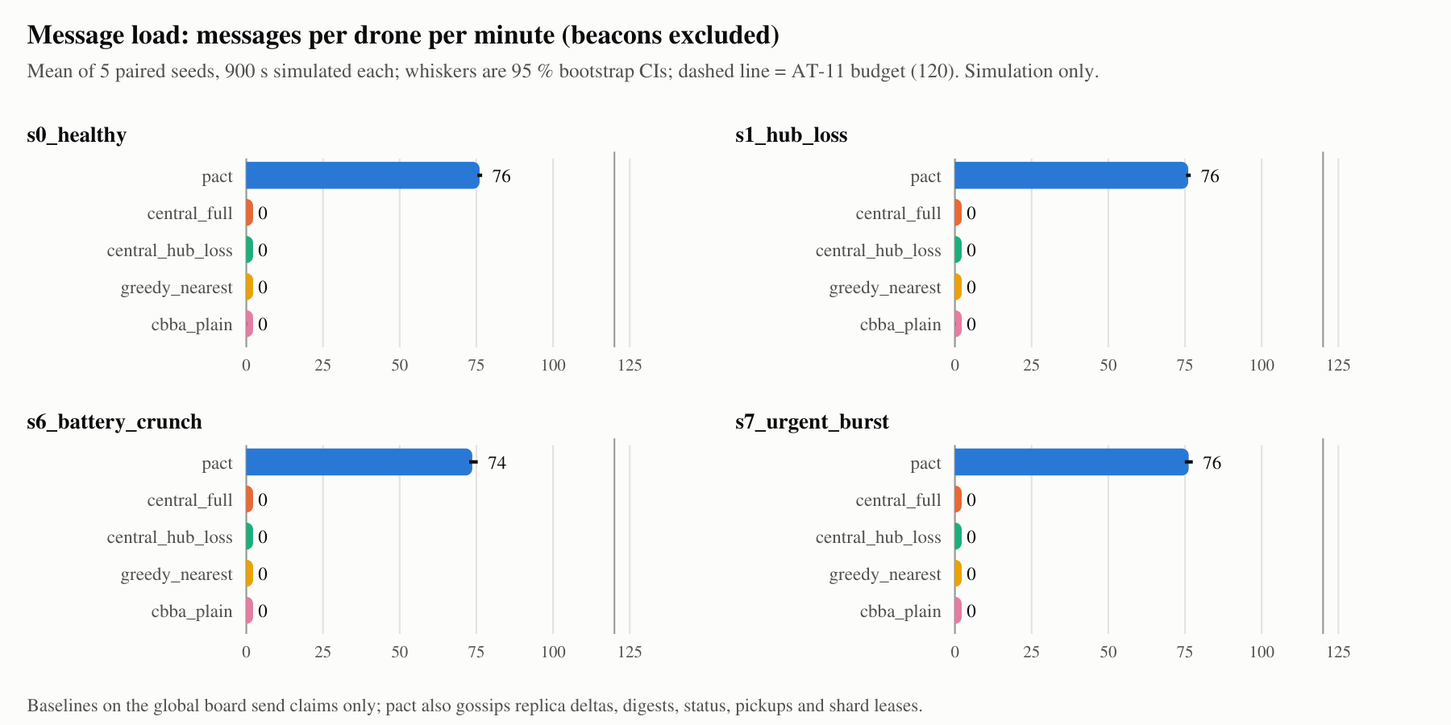
Figure 4. Messages per drone per minute, beacons excluded, mean of 5 seeds; the AT-11 budget is 120 (results/plots/message_load.svg).
- PACT sits at 61-64 % of the AT-11 budget of 120 messages per drone per minute in all four benchmark scenarios. In the sweep, the canyon partition raises it to 100.7-109.7 (computed from results/sweep/sweep.csv).
- The comparison is not like for like: the baselines coordinate through a shared board that the radio model does not charge for, so their 0.0-0.3 is their claim traffic only. PACT pays for everything it sends.
- The depot backhaul carries about 143 copies per depot per minute, about 3.5 KB/s per depot on coastal_metro (backhaulBytesPerDepotS, 3482.6 B/s mean for s0_healthy PACT).
- Per-tick compute p95 is at most 0.14 ms in the benchmark and 0.32 ms in the sweep, far under AT-11's 50 ms. These are wall-clock times on the machine that ran the bench and are the only machine-dependent numbers here.
- At scale, AT-11 (N = 30 drones, 1 h, s10_scale on harbour_metro_xl with 6 added public pads) measured 88.6 msgs/drone/min with QUORUM and 94.3 with STRICT, tick p95 19.2 / 15.6 ms, 155 / 144 deliveries, and about 500 backhaul copies per depot per minute, in the npm run scenarios run for this report. Decision 20 recorded the same message counts with tick p95 12.1 / 10.2 ms; only the machine-dependent tick time differs.

10. AeroPACT (ROS 2 + Gazebo + PX4) results
AeroPACT is the second implementation of the same protocol: ROS 2 Jazzy lifecycle components, a kinematic backend, Gazebo Harmonic physics and PX4 v1.16 SITL autopilots (aeropact/). It needs Ubuntu 24.04 with ROS 2 and was not re-run for this report. The numbers below are copied from its documentation and labelled with their date.

10.1 Benchmark
From aeropact/results/summary.md (in the repository as of 30 October 2026): 3 scenarios × 6 systems × 5 seeds, 90 runs of 1500 s on the kinematic backend, 6 drones on a 1.2 km district, about 30 jobs per run. Mean on-time rate with 95 % CI half-width. AeroPACT runs each partition policy as its own system, and central is central_full without a hub fault and central_hub_loss with one.
Scenario | central | pact_quorum | pact_strict | pact_optimistic | cbba_plain | greedy_nearest
healthy | 59.3 ± 5.3 | 69.7 ± 9.5 | 70.9 ± 9.6 | 66.7 ± 6.6 | 65.6 ± 12.0 | 26.4 ± 7.6
hub dies at 240 s | 20.2 ± 2.1 | 66.8 ± 5.8 | 67.0 ± 1.7 | 68.5 ± 5.0 | 65.6 ± 5.9 | 30.4 ± 13.9
5-min split brain | 63.0 ± 11.5 | 67.4 ± 13.3 | 65.0 ± 11.4 | 68.6 ± 9.6 | 55.4 ± 6.7 | 31.8 ± 7.9
duplicate rate | 0.0 % | 0.0 % | 0.0 % | 0.0 % | 0.0 % | 3.2-4.7 %
runs, all invariants | 15/15 | 15/15 | 15/15 | 15/15 | 15/15 | 0/15
Table 15. AeroPACT on-time rate % (aeropact/results/summary.md and aeropact/README.md; not re-run for this report).
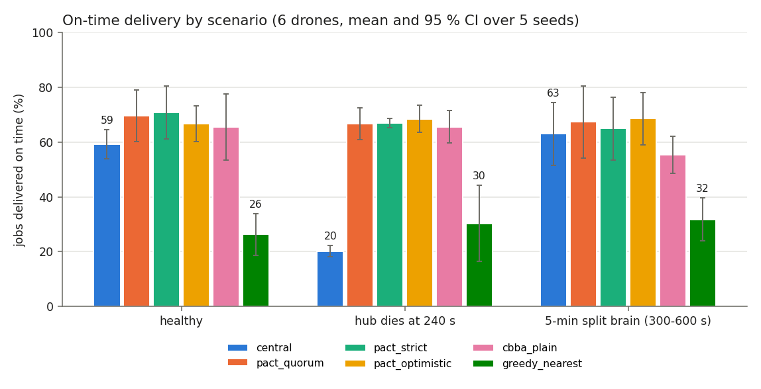
Figure 5. AeroPACT on-time delivery by scenario, 6 drones, mean and 95 % CI over 5 seeds (aeropact/docs/img/on_time_by_scenario.png).
- Hub loss: the central planner drops from 59.3 % to 20.2 % (it keeps 34 % of its healthy rate) while every PACT policy stays at 66.8-68.5 %. Over 1500 s the hub-loss effect is far larger than in sim3d's 900 s window, consistent with Section 6.3.
- Here the central planner is not an upper bound: it is below PACT even when healthy. That differs from sim3d, where central_full ties or leads; the two simulators do not agree on the healthy gap, and this report does not claim either as the true one.
- AeroPACT's cbba_plain shows 0 duplicate deliveries, unlike sim3d's. Its cost shows instead in the split brain: 55.4 % on time and a median recovery of 674 s, using a naive 30 s failure timeout (AeroPACT D-22). Within CIs, PACT and the central planner are not separable in the split brain (63.0 ± 11.5 vs 65.0-68.6).

10.2 Acceptance and tests, as recorded on 31 October 2026
From NIGHT_NOTES_2026-10-31.md (the run after AeroPACT moved into this repository):
Check | Recorded result | Covers
colcon test (unit, property, static) | 692 tests, 0 failures, 92 skipped | merge join laws, I2, zombie stop under ±1 % drift, policies, auction, energy, failure detector, planner, safety supervisor, arbiters, lint
Kinematic acceptance (make scenarios) | 9 / 9 passed | AT-03 split brain, AT-04 zombie stop, AT-05 hub kill, AT-06 drone failure, AT-07 energy, AT-08 safety isolation, AT-09 clock drift, AT-10 heal and converge, s0 healthy
PX4 SITL acceptance (make scenarios-px4) | 4 / 4 passed, about 45 min | healthy; drone failure through PX4 flight termination; authenticated mesh transport; split brain; real PX4 v1.16 autopilots in simulation
Table 16. AeroPACT verification as recorded on 31 October 2026 (NIGHT_NOTES_2026-10-31.md).
AeroPACT's AT-05 gate is formulated differently from the PRD's: PACT ≥ 70 % on time and ≥ 25 points above the central baseline after hub loss (aeropact/docs/EVALUATION.md). AT-01 is replaced there by deterministic core and generator tests (AeroPACT D-3), because a multi-process ROS 2 graph is not byte-deterministic. PX4 SITL runs real autopilot software against simulated vehicles; it is not a hardware flight.

11. Verification and tests
The sim3d commands below were run for this report on 31 October 2026 on the development machine (Windows 11, Node via npm; make is not installed there, so the npm equivalents were used).
Command | Result (31 October 2026)
npm test (make test) | 28 test files passed; 391 tests passed, 1 skipped (392); 63.2 s
npm run scenarios (make scenarios) | 2 test files passed; 75 tests passed (75): every suite scenario meets its tier gate and is deterministic (AT-01), plus AT-03/04/06/09/10/11; 1029 s, of which AT-11 took 992 s
npm run typecheck (make lint) | clean (tsc --noEmit, exit 0)
Table 17. sim3d test commands run for this report.
The 391 tests include unit tests and seeded-random property tests written by hand on the project's Rng (no external property-testing library). The property tests that guard the invariants are:
- AT-02 / I2 (src/p2p/replica.test.ts): 10 000 random permutations of messages with duplicates give the identical final replica, and epochs never decrease. Merge commutativity, associativity and idempotence over random records.
- I2 (src/p2p/ownership.test.ts): every legal ownership transition yields a strictly greater record over random walks.
- I1 backstop (ownership.test.ts): at most one depot pickup grant per task under random interleavings.
- I3 / I6 (src/p2p/integration.test.ts, nodes.test.ts): no I1 / I2 / I3 break across partitions, ±1 % clock drift and failures; replicas converge within T_converge after a heal.
- I4 (src/sim/radio.test.ts): separation holds with no radio at all, from on-board sensing only (Decision 10).

11.1 Acceptance tests AT-01 to AT-12
AT | PRD pass condition (short) | sim3d check | sim3d result | AeroPACT (31 Oct)
AT-01 | Same seed → identical event log | every suite scenario run twice (suite.scenarios.ts); sim.test.ts; replay | PASS (every suite scenario) | replaced (D-3)
AT-02 | 10k permutations → same replica | replica.test.ts | PASS (npm test) | property tests
AT-03 | 5-min partition, STRICT → 0 duplicates, I1 | acceptance.scenarios.ts | PASS: 34 jobs during the partition, 0 duplicates, 0 zombies | PASS
AT-04 | Isolated owner never picks up (I3) | acceptance.scenarios.ts | PASS: zombie_stop +18.9 s, re-open +21.7 s, old owner never picks up | PASS
AT-05 | Hub kill: PACT ≤ 15 % drop; central > 40 % drop | make bench | FAIL (central side, 34.1 %) | PASS (own gate)
AT-06 | Replacement only after DECLARED_FAILED; median ≤ 30 s | acceptance.scenarios.ts, 8 seeds | PASS: median 9.0 s (8 seeds) | PASS
AT-07 | Low battery → pad visit or abort; no SOC < floor | no dedicated test; tier gates require 0 drained batteries | not a separate AT | PASS
AT-08 | Network off: safety reflexes fire (I4) | radio.test.ts (I4) | PASS (npm test) | PASS
AT-09 | 1 % drift → no I3 violation | acceptance.scenarios.ts | PASS: 0 zombie pickups, 0 duplicates | PASS
AT-10 | Converge within T_converge (I6) | acceptance.scenarios.ts | PASS: converged 2.0 s after the heal (bound 10 s) | PASS
AT-11 | N = 30, 1 h: tick p95 ≤ 50 ms, ≤ 120 msgs/drone/min | acceptance.scenarios.ts | PASS: 88.6 / 94.3 msgs, p95 19.2 / 15.6 ms | s10_scale (12 drones); no N = 30 result recorded
AT-12 | 3 policies × 30 seeds, Pareto data, no crash | make sweep | PASS (240/240) | policies in make bench, 5 seeds
Table 18. Acceptance tests: PRD section 11 against both implementations.

12. Threats to validity and limitations
Simulation only
Every result in this report comes from simulation: sim3d, or AeroPACT on kinematic, Gazebo or PX4 SITL backends. No hardware flight, field trial or real radio measurement has been made, and nothing here claims real-world flight readiness.

12.1 Internal validity
- Small due sets. The 900 s on-time rate rests on 4-11 due tasks per run (Section 5.1). One task moves a run by 9-25 points; most benchmark differences between systems are inside the CIs.
- Five seeds in the benchmark. The plan asks for ≥ 30 per cell; the benchmark has 5 (the sweep has 30).
- Shared fenced board. In sim3d the central and greedy baselines inherit the board's fencing, so their 0 duplicates do not measure their own algorithms.
- Detection stand-in. The baselines' 60 s failure detection is a fixed constant, which sets most of the recovery gap.
- Uncharged baseline traffic. Baselines' coordination is not carried over the radio model, so message-load comparisons favour them.
- Fleet capped by pads. The benchmark scenarios request 12 drones, but only one drone per pad flies (logged as fleet_capped): s0, s1 and s7 have 6 pads, s6 has 3. Results at larger fleets come only from AT-11.
- Window choice. AT-05 passes at 1800 s and fails at 900 s; the window was not tuned, but the result depends on it.

12.2 External validity
- Synthetic maps and workloads. Procedurally generated cities, Poisson orders over demand-weighted drop points, and simplified wind and energy models.
- Radio model. A range disc with configurable loss and latency, plus scripted dead zones and partitions; no multipath, interference or measured RF propagation. Results may not transfer to real RF environments (plan 5.6).
- Idealised depots. The backhaul is lossless by default (10-40 ms); depots never crash in the benchmark.
- No perception. Drones sense neighbours within 45 m directly from simulator state; there is no sensor model or obstacle detection pipeline.
- 2.5-D planning in sim3d (altitude layers); some runs clip buildings (structure_hit, Decision 10).

12.3 What is not tested
Ablations (H4); total distance and energy per delivery (H3); lossy-network, flapping-partition and combined-stress benchmark rows (S2, S4, S9); a fleet-size sweep of message load; Byzantine nodes in sim3d (AeroPACT signs frames with Ed25519, D-30); depot failure during arbitration; and any real hardware.

13. How to reproduce every number
Installation, toolchains and the AeroPACT Ubuntu setup are in PACT_04 Setup and Reproduction Guide. With sim3d installed (cd sim3d && npm install), these commands regenerate everything in Chapters 6-9 and 11. The root Makefile targets forward to the npm scripts.
make test # npm test unit + property tests
make scenarios # npm run scenarios scenario suite + AT-01/03/04/06/09/10/11
make lint # npm run typecheck tsc --noEmit
make bench # npm run bench 100 runs + recovery -> results/
make sweep # npm run sweep 240 runs -> results/sweep/
make plots # npm run plots SVG plots -> results/plots/

# AT-05 over an 1800 s window (Decision 13)
npm run bench -- --window=1800 --scenarios=s0_healthy,s1_hub_loss \
--systems=pact,central_hub_loss --recovery=0 --out=../results_1800
# also fail the command on AT-05
npm run bench -- --strict --out=../results_strict

Report item | Produced by | File
Tables 6-9, AT-05, Figure 1 | make bench, make plots | results/summary.md, results/results.csv, results/plots/bench_on_time.svg
Due-set sizes (5.1), tick p95, LoS | make bench, make sweep | results/results.csv, results/sweep/sweep.csv
Table 11, Figure 2 | make sweep, make plots | results/sweep/sweep.md, results/plots/sweep_pareto.svg
Tables 12-13, Figure 3 | make bench (recovery step, 8 seeds) | results/recovery.json, results/plots/recovery_cdf.svg
Table 14, Figure 4 | make bench, make plots | results/summary.md, results/plots/message_load.svg
Tables 15-16, Figure 5 | AeroPACT make bench, make scenarios, make scenarios-px4 | aeropact/results/summary.md, NIGHT_NOTES_2026-10-31.md
Tables 17-18 | npm test, npm run scenarios, npm run typecheck | console output (run 31 October 2026)
1800 s AT-05 result | as above | docs/DECISIONS.md Decision 13
Table 19. Where each number in this report comes from.

Checking a re-run
- The runs are deterministic, so a re-run on the same commit should reproduce results.csv exactly (this report did not re-run the bench), including the eventHash column (for example s0_healthy, pact, seed 42: ae0bd518). Only tickP95Ms varies with the machine.
- Bootstrap CIs are seeded, so the brackets also reproduce exactly.
- The figures in this document were rasterised from the committed SVGs with the light-theme colours inlined; the data are unchanged.

