**SERIS**

Solar Energy Research Institute Singapore



Cloud Based Realtime Analytical Monitoring of Photovoltaic Systems and Weather Parameters Project

System Test Plan

|  |  |
| --- | --- |
| Filing Reference | /SE25PT7SERIS/SERIS/MGMT/QUALITY/STP |
| Document Title | System Test Plan |
| Version | Draft |
| Prepared by | Nay Lin Aung |
| Date Created | 14/08/2018 |

|  |  |  |
| --- | --- | --- |
| **Approved by:** | | |
| Name | Designation | Date |
| Treza Bawm Win | System Architect | 16/08/2018 |
| **Authorized by:** | | |
| Name | Designation | Date |
| Kaung Myat Bo | Project Manager | 18/04/2018 |

1. **History**

|  |  |  |  |
| --- | --- | --- | --- |
| **Revision** | **Date** | **Author/Editor** | **Reason** |
| Draft | 18/08/2018 | NayLA | Initial version |
|  |  |  |  |
|  |  |  |  |
|  |  |  |  |
|  |  |  |  |
|  |  |  |  |
|  |  |  |  |

|  |
| --- |
| 1. Table of Contents |
| 1. History …………………………………………………………………………………...2 |
| 1. Table of Contents ………………………………………………………………………..3 |
|  |
| 1. Scope ……………………………………………………..………………………………3 |
|  |
| * 1. Test Object .…………………………………………………………………………………4   2. Test Automation .……………………………………………………………………………4   3. Test Items/Levels …………………………….....………………………………………….4   4. Test Stakeholders ………………...………………………………………………………...4   5. Related documents ………………………………………………………………………....4 |
|  |
| 1. Test Approach ……………………………………………………..…………………….5 |
| * 1. Test Goal …………………………………………………………………………………...5      1. Software System Test Entry Criteria ……………………………………………………………5      2. Software System Test Exit Criteria ……………………….………………………………….5      3. Test Acceptance Criteria ………………………………………………………………………….6 |
| * 1. Assumptions and Constraints ……………………..……………………………………....6 |
| * 1. Risks …………………………………………………………………………………….….7   2. Test Cases …………………………………………………………………………………………8   3. Test Effort Estimate ………………………………………………………………………………8 |
| * 1. Test Strategy …………………………………………………………………………….….9 |
|  |
| * + 1. Software System Test Level ……………………………………………………………...10 |
| * + 1. Customer Required Tests ………………………………………………………………..10 |
| * + 1. Regression Test ……………………………………………………………………….….10 |
|  |
| 1. Software Validation and Error Management ……………...…………………..…10 |
| * 1. Stakholders ……………………………………………………………………………11 |
| * 1. Reviewers of error reports …………………………………………………………………11 |
| * 1. Software Error Management Activities …………………………………………………….11   2. Test Metrics…………………………………………………………………………………………12 |
|  |
| 1. Document Planning ……………………………………………………………………12 |
| * 1. Reference Documents………………………………………………………………..…….12 |
| * 1. Test Documents ……………………………………………………………………………12 |
|  |
| 1. Test Platform ………………………….………………………………….…………12 |
| * 1. Hardware Tools …………………………………………………………………………….12 |
| * 1. Software Tools ……………………………………………………………………………..12 |
| Appendix: |

1. **Scope**

This test plan describes the testing approach and overall framework that will drive the testing of the SERIS project. The agreements within this document are obligatory for all testers. Changes are only possible by an agreement of Software Test Manager and the reason must be documented.

The purpose of this test is to make sure critical defects are removed before the next levels of testing can start.

The Software Test Manager must take care that all test team members and all other stakeholders have access to the current Software System Test Plan and that they are familiar with the content of this document. The Software Test Manager ensures that all stakeholders (the responsible) will be informed if there are changes in the System Test Plan.

* 1. **Test Object**

Short description of the objects under test:

Describe the objects and test cases to be automated and the one to be tested manually.

* 1. **Test Automation**

Provide short descriptions of the test automation process, tools and environment.

* 1. **Test Items/Levels**

All components and their functionalities of the software system will be tested and verified with the requirenments.

* 1. **Test Stakeholders**

|  |  |  |
| --- | --- | --- |
| **Stakeholder Name of Role** | **Concerned Test Level** | **Name /Dept** |
| Nay Lin Aung, Quality Manager | Software System Test | Nay Lin Aung,  Kaung Myat Bo,  Gao Zhiyu,  Narasimhan Balasubramanian |
|  |  |  |
|  |  |  |
|  |  |  |

* 1. **Related Documents**

Use cases and test specifications for the system, file versions under test and test logs shall be added in “SWSYS_TS.xlsx”. Template is available at *SE25PT7SERIS/SERIS /MGMT/QUALITY/FORMS /*.

1. **Test Approach**

The test approach includes the planning of resources and the definition of the test strategy defining the test methods and the test depth/coverage to be achieved, the test criteria according to the test goal, prioritizing tests and specifying the schedule for the test activities.

* 1. **Test Goal**

The objective of the test is to verify that the functionality of the software system for SERIS works according to the specifications. This document describes the implementation of the system verification and validation according to the strategy outlined and defined in the following sections. The test will execute and verify the test scripts, identify, fix and retest all high and medium severity defects per the entrance criteria, prioritize lower severity defects for future fixing via Change Request. With the definition of test goal, a certain quality of the system under test with respect to its criticality should be achieved. Like:

* Specific functionalities
* Complete interface coverage
* Specific time measurement (response time for some specific function)
* Robustness

When the test goal is reached, the test is completed. The decision on when the test can be ended is made according to system test exit criteria.

* + 1. **Software System Test Entry Criteria**

• Partially or complete testable code is available.

• Requirements are approved and defined

• Test plan is available.  
• Testing tools are ready.  
• Availability of sufficient desired test data.  
• Test cases are ready and developed.  
• Other necessary resources such as tools and devices are available and test environment have been set-up.

* + 1. **Software System Test Exit Criteria**

• Successful execution of system tests has been performed.  
 • All specified functional/business requirements have been met.  
 • The priority bugs have been fixed and closed.  
 • With supported hardware and software, system’s compatibility.

* + 1. **Test Acceptance Criteria**

1. Approved Functional Specification document, Use case documents must be available prior to start of test design phase.

2. Test cases approved and signed-off prior to start of test execution

3. Development completed, unit tested with pass status and results shared to testing team to avoid duplicate defects

4. Test environment with application installed, configured and ready to use state

* 1. **Assumptions and Constraints**
* Production like data required and be available in the system prior to start of System Testing
* Exploratory Testing would be carried out once the build is ready for testing
* Performance testing is not considered for this estimation.
* All the defects would come along witha snapshot JPEG format
* The Test Team assumes all necessary inputs required during Test design and execution will be supported by Development/client appropriately
* Test case design activities will be performed by QA Group
* Test environment and preparation activities will be owned by Development Team
* The system will be treated as a black box
* Development team will provide Defect fix plans based on the Defect meetings during each cycle to plan.
* The same will be informed to Test team prior to start of Defect fix cycles
* Any defect fixes planned will be shared with Test Team prior to applying the fixes on the Test environment
* Project Manager/client will review and sign-off all test deliverables
  1. **Risks**

All possible risks related to the test are described according to registered risks as below.

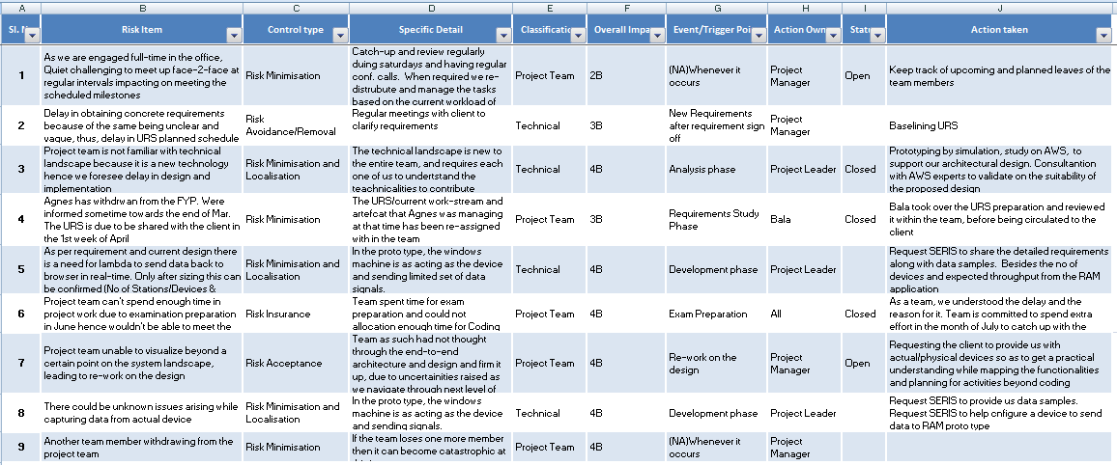

* 1. **Test Cases**

Test cases to be performed for system test are described in the below test specification:



* 1. **Test Effort Estimate**

This document lists out all the activities that have to be performed by the QA team and estimates how many man-hours each activity is going to take.

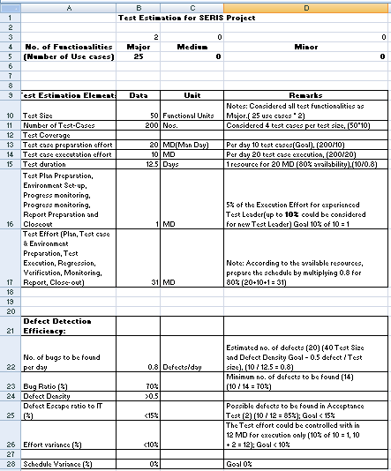

* 1. **Test Strategy**

According to the impact analysis of development of made fixes a specific test set is defined for this test run.

At least 100% of failed test cases will be retested.

The test strategy defines guideline for specifying, implementing, scheduling and executing the tests. It has to be defined according to the test goal, risks, budget, and time. There is a differentiation in the test depth depending on the risks.

Additionally, the test strategy depends on the customer demands. If the software releases have to be delivered in short intervals, appropriate test strategy has to be used.

Establish what and how is to be tested and in what depth testing is to be carried out. Describe the test techniques chosen and the test cases are specified.

It is recommended to detail the test strategy in specific test plan/spec for the different test levels.

Also write down what has to be done if testing cannot be carried out completely (test goal is not fulfilled e.g, when testing has to be stopped because of serious bug or instable software) and how testing is resumed after that.

A priority of 1 to 3 is assigned to each test case. Not all test cases will be performed for every release.The testing depth depends on the quantity and severity of modifications implemented.

The test will be specified so that, by executing only test cases with priority of 1, a basic level of functionality is ensured. The following priorities have to be applied during the test case design and are valid for all test levels with the following definition for the test execution:

1. execute all test cases with priority
2. execute all test cases with priority 1 and 2
3. execute all test cases with priority 1, 2 and 3.

|  |  |
| --- | --- |
| **Priority** | **Test Case Relavance** |
| 1 | Basic functionality |
| 2 | Standard functionality |
| 3 | Extended functionality |

It has to be ensured that at least once the complete test scope is performed during a single test execution, i.e. all test cases of priority 1, 2 and 3 are executed all at once. For regression test, it has to be ensured that at least all priority 1 test cases have to be executed for one regression test.

* + 1. System Test Level

Define for which samples Software System Test have to be performed. The detailed planning of the Software System Tests has to be defined within Software System Test Plan.

* + 1. Customer Required Tests

Special tests required by the customer to verify specific issues.

Often the test specifications for these tests are written by the customer, refer them in related documents.

* + 1. Regression Test

Consider regression testing (renewed testing in the future changes to verify that modifications have not caused unintended effects and that the software still complies with the requirements): Reuse all test information as much as possible.

Due to budget, time and resource limitations, it is often necessary to define a strategy for selecting an adequate subset of tests for retesting.

It is always necessary to check the test specification if

1. new test cases have to be defined
2. existing test cases have to be modified
3. existing test cases have to be added

to ensure an adequate test coverage. After major changes, it is necessary to check the test plan as well.

Define a suitable regression test strategy considering the different test levels. Use the test case priorities to define an appropriate regression test scope. Ensure that at least all priority 1 test cases have to be executed for one regression test cycle.

1. **Software Validation and Error Management**

* It is expected that the testers execute all the scripts in each of the cycles. However it is recognized that the testers could also do additional testing if they identify a possible gap in the scripts.
* If a gap is identified, the scripts and traceability matrix will be updated and then a defect logged against the scripts.
* It is the responsibility of the tester to open the defects, link them to the corresponding script, assign an initial severity and status, retest and close the defect.
* It is the responsibility of the technical team to review the defects, ask for details if necessary, fix the defect, communicate to the Quality Manager when the fix is done, implement the solution per the Quality Manager request.
* Defects found during the testing will be categorized according to the bug-report.
  1. Stakeholders

The below table describes the list of stakeholders of Validation and Error Management activities.

|  |  |  |  |
| --- | --- | --- | --- |
| **Stakeholder** | **Name/Organization** | **Involvement/Task** | **Activity** |
| Soe Pyae | SERIS | Source for error reports | <e.g. error trend, status of error reports> |
| Gao Zhuyi/ Kaung Myat Bo | SE25PT7 | Verification of fixed errors |  |
| Quality Manager | SE25PT7 | Defect Management |  |
|  |  |  |  |
|  |  |  |  |

* 1. Reviewers of error reports

Project manager and QA manager are reviewers of the error reports.

* 1. Software Error Management Activities

Define Software Error Management activities based on

1. customer regulations
2. information demands of the stakeholders

Define which kind of errors is managed according to these definitions, e.g. based on severity of errors and relevance for customer.

|  |  |
| --- | --- |
| **Severity** | **Impact** |
| 1 (Critical) | * This bug is critical enough to crash the system, cause file corruption, or cause potential data loss * It causes an abnormal return to the operating system (crash or a system failure message appears). * It causes the application to hang and requires re-booting the system. |
| 2 (High) | * It causes a lack of vital program functionality with workaround. |
| 3 (Medium) | * This bug will degrade the quality of the System. However there is an intelligent workaround for achieving the desired functionality - for example through another screen. * This bug prevents other areas of the product from being tested. However other areas can be independently tested. |
| 4 (Low) | * There is an insufficient or unclear error message, which has minimum impact on product use |
| 5 (Cosmetic) | * There is an insufficient or unclear error message that has no impact on product use |

* 1. Test Metrics

Test metrics to measure the progress and level of success of the test will be developed and shared with the project manager for approval. The below are some of the metrics:

|  |  |  |
| --- | --- | --- |
| **Report** | **Description** | **Frequency** |
| Test preparation & Execution Status | To report on % complete, %WIP, % Pass, % Fail Defects severity wise Status – Open, closed, any other Status | Weekly / Daily (optional) |
| Daily execution status | To report on Pass, Fail, Total defects, highlight Showstopper/ Critical defects | Daily |
| Project Weekly Status report | Project driven reporting (As requested by PM) | Weekly – If project team needs weekly update apart from daily and there is template available with project team to use. |

1. **Document Planning**
   1. Reference Documents

List of the documents needed for the SW test activities are dexcribed below:

* SE25PT7SERIS/SERIS/TECH/ANALYSIS/UCMS/TUCMS.docx
* SE25PT7SERIS/SERIS/TECH/DESIGN/HLD/BASELINE/HLD.docx
* SE25PT7SERIS/SERIS/SPEC/REQUIREMENT/UIS/BASELINE/UIS.docx
  1. Test Documents

List of the documents needed for the SW test activities are dexcribed below:

* SE25PT7SERIS/SERIS/SPEC/REQUIREMENT/URS/BASELINE/RAM_TURS.docx
* SE25PT7SERIS/SERIS/ TECH/TEST/ST/BASELINE/SWSYS_TS.xlsx

1. **Test Platform**

AWS cloud-based IoT core and it relavant facilities will be used as backend server.

Real data from client’s existing system will be provided via IoT device gateway/hub.

**Appendix:**