**Nguyễn Thanh Thuận**

**21080071**

**LAB 3**

1. **Tạo BucketA computer screen with text boxes

   AI-generated content may be incorrect.**
2. **Tắt bucket all public accessA screenshot of a computer

   AI-generated content may be incorrect.**

=> Kết quả create bucket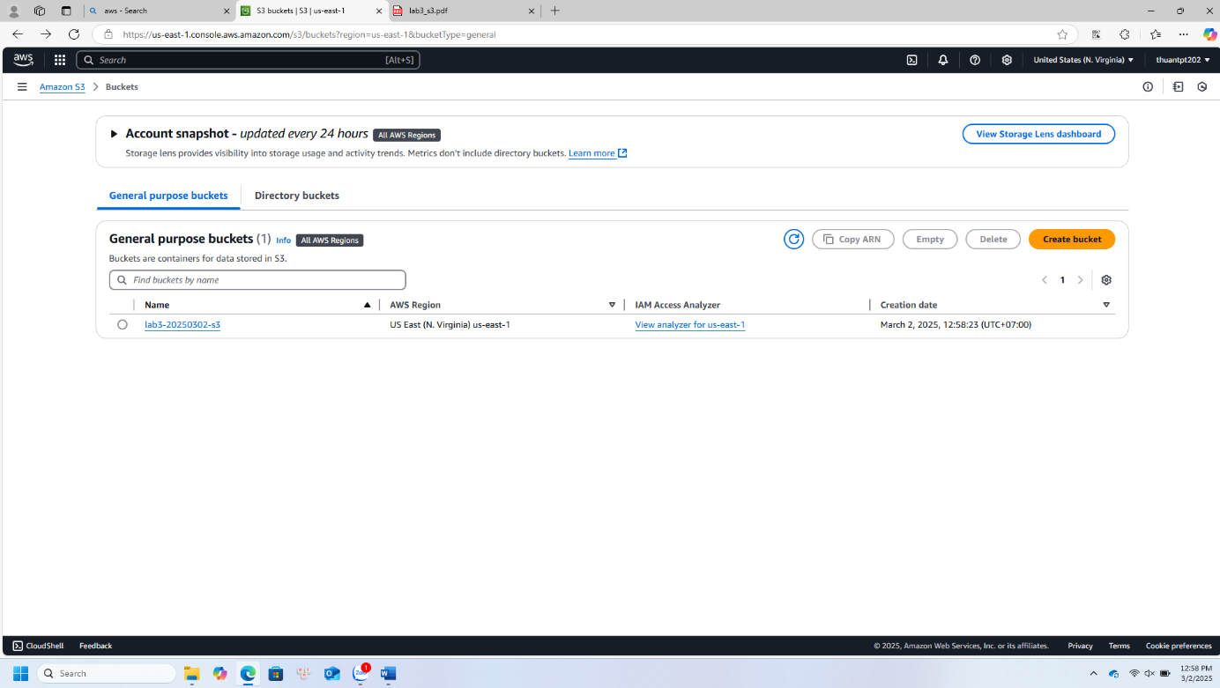

1. **Upload file hoặc folder**

* Chọn file, add vào để uploadA computer screen with text

  AI-generated content may be incorrect. lab3-s3.pdf
* A screenshot of a computer

  AI-generated content may be incorrect.Chọn Grant public-read access
* A computer screen with a green and white box

  AI-generated content may be incorrect.Kết quả upload fille

1. **Upload web tĩnh, folder (tương tự trên)**

* Chỉnh quyền thành read

