Hello Professor!

This is my rendition of the Activity 4. I went and completely redone the project because felt like it would be a fun project to mess around the orientation.

The program is over 12MB, because of pictures. I’m going to be sending a GitHub. If it cannot be accessed or anything weird, I’ll fix it asap. However, it should be a public github.

I’ll do my best to write out the reasoning as to why.

There are 3 Total classes I’ve made.

1. SuperHero: the basis of the project
2. HeroesAssemle: Instead of an ArrayList, I decided to go with a List. As the ArrayList is depreciated now.
3. FileAccessSystem: Wanted to take a shot at C# Json, wanted to create even more custom objects for the SuperHero class, but I’m not too familiar with serializing custom objects just yet in C#.

I’ll now explain everything as we go on.

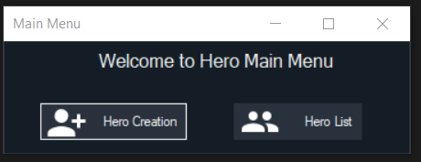

Pretty basic main menu, there are a total of 4 Forms in this project. Didn’t realize we had to transfer some data between forms, so that’s why instead of just having 3 there are a total of 4.

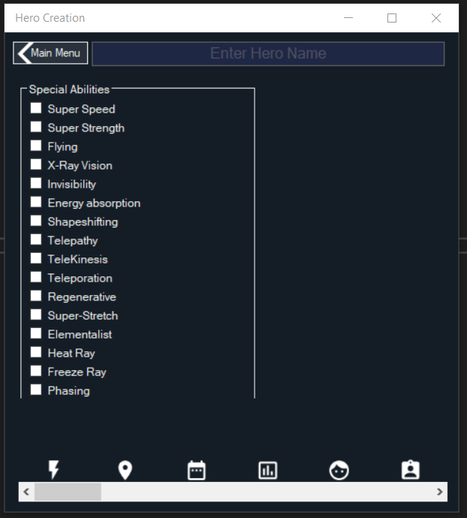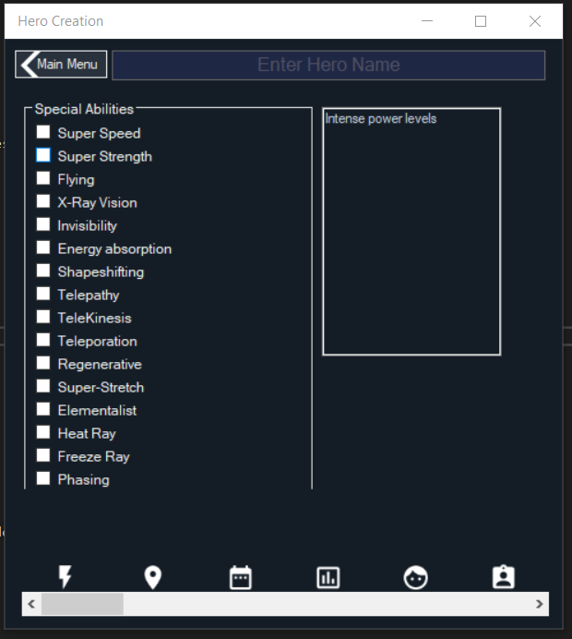

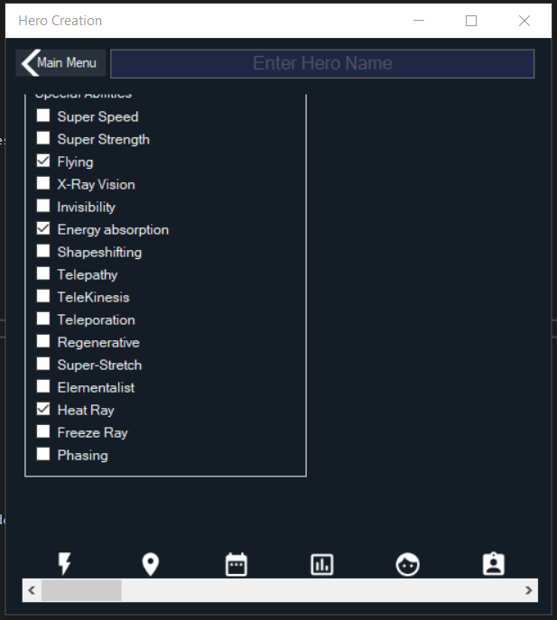First “page” of the Hero Creation. This is the Special abilities tab. The special abilities is scrollable, and controlled entirely by a String[]. It can be easily added on to programmatically. Plus decided to have some fun and also added a “hint” by hovering over a ability the hint shows up. Screenshot on the right shows that. Bottom picture shows the checkmarks being able to be used. User HAS to select at least one power, or else the creation screen will show user what needs to be done

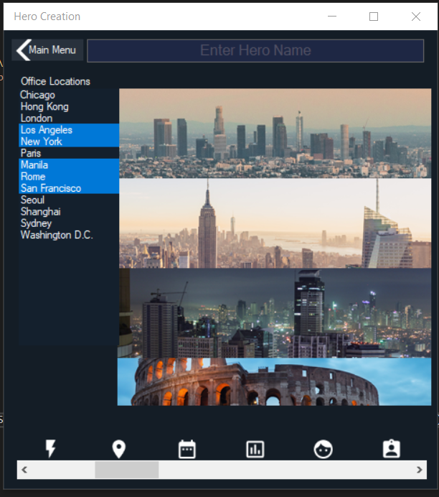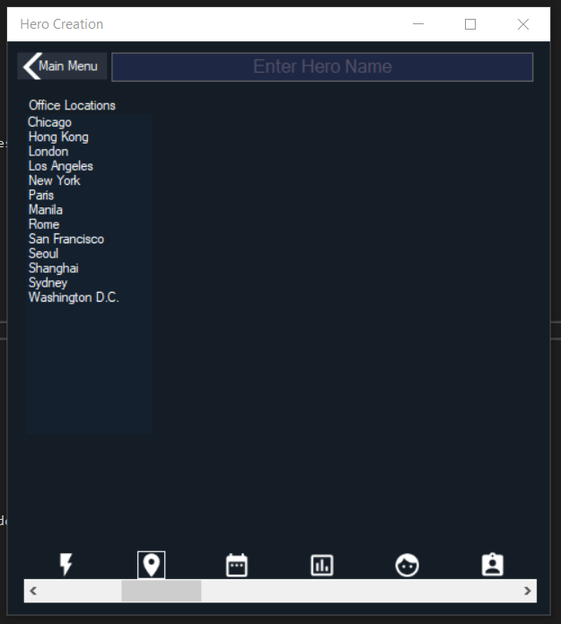This is the second page, which is the locations. The bottom HScroll is controlled per page. Also clicking on the bottom icons also moves the HScroll. As you can tell, picking cities with also show pictures of those selected cities. Not too much to write out about this page. Similar to the first page, user has to select at least ONE or the creation screen will notify the user.

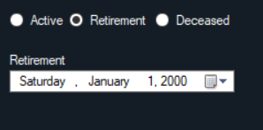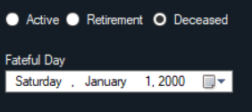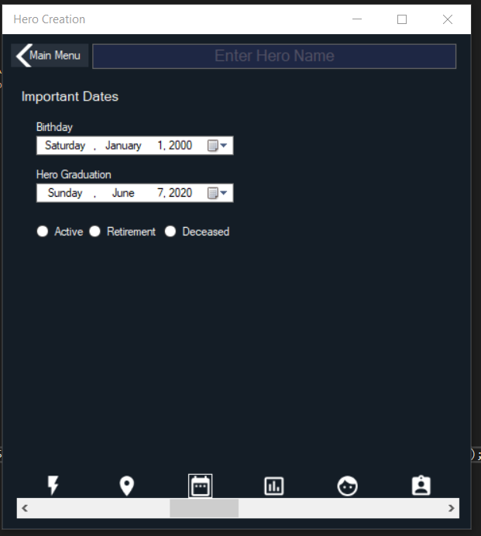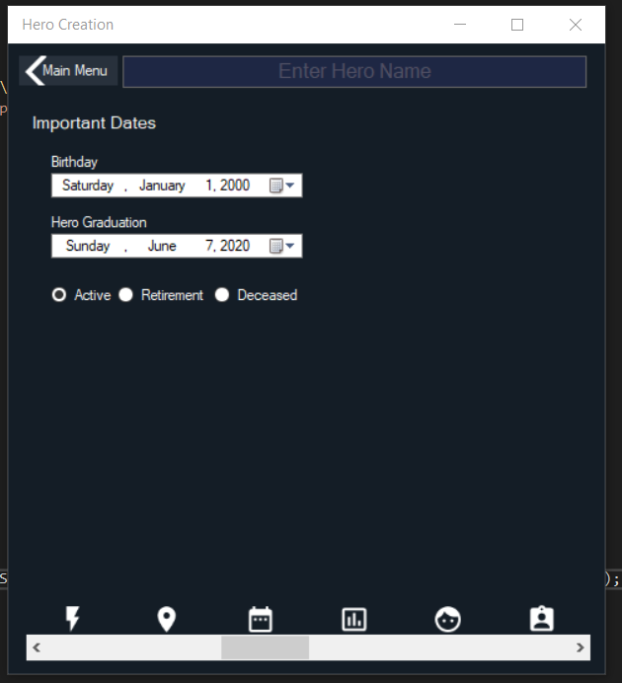 This is the third page which is the Date system. The top two are priority dates. This will assume that the hero is graduated and is either, Active member, Retired hero or is deceased .

If Picking either Retired or deceased will change the label according to the situation. If they’re currently active the last date will not show up.

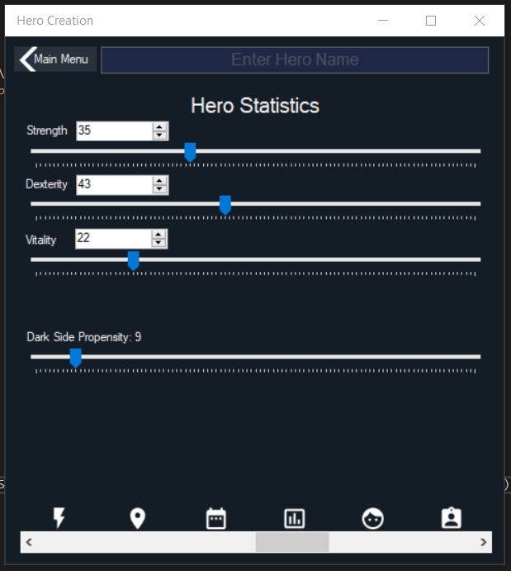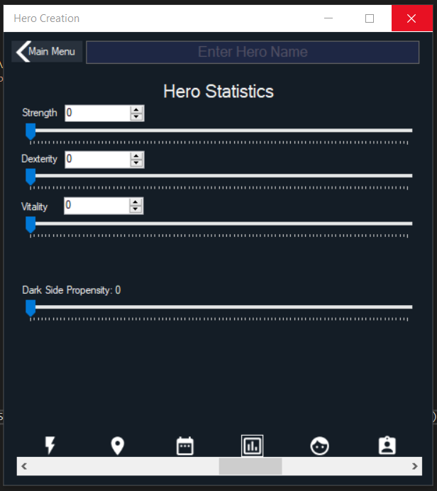

Had a lot of fun making this page. The major design choice from the example is I’ve changed it from an Hscroll to a Trackbar. It just made sense to a design standpoint, and also altered the challenge to it being reflected on the numberupdown control. Got rid of the Years experience as well. Anyways, I have a comment out on this page, its on method “StatBoundaries”. If you uncomment it the trackbar maximum will reflect how much change is left. On a functionality level, it was annoying. However, I did still include it just incase. In this current form, the user CANNOT increase ANY of the three main statistics. It can only lower now at this point. Also, on a design standpoint, didn’t include a numberupdown for the darkside because it isn’t dependent on any other variable like the other 3. Also, Str, Dex, vit Track and Number will reflect accurately each other. Change one the other will follow suit. I know the challenge said to show a warning, on here, the user is limited that they won’t be able to pass the 100 mark anyways.

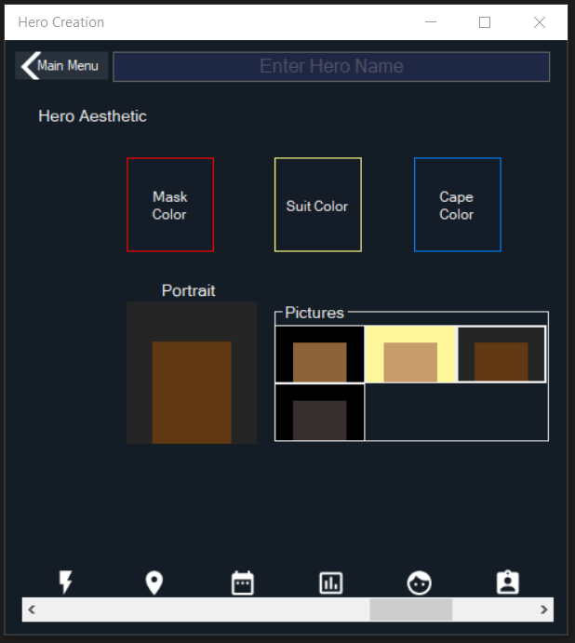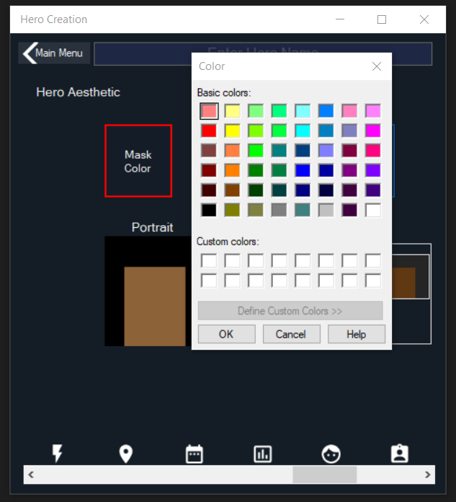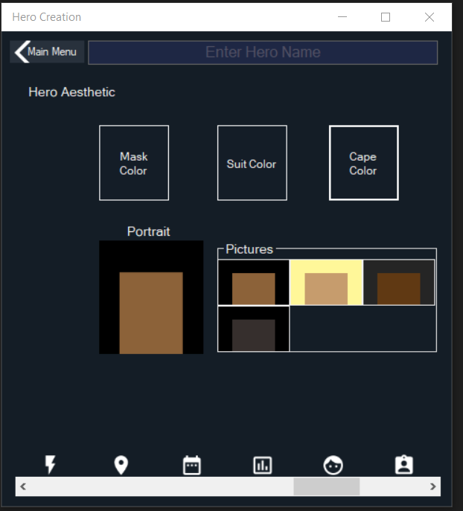

This was also fun to mess around with. Clicking any of the Buttons with Color will bring up the color menu. Then the border will reflect the selected color. The Pictures panel on the corner is also progmatically controlled as well. If there are more pictures in the directory the pictures will change size and shift. Clicking any of the pictures will change the portrait . The user does not have to explicitly change any of these values.

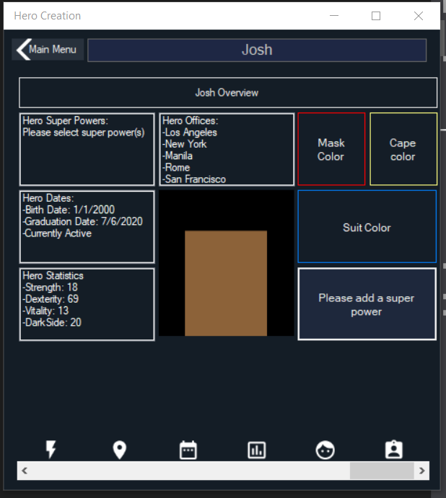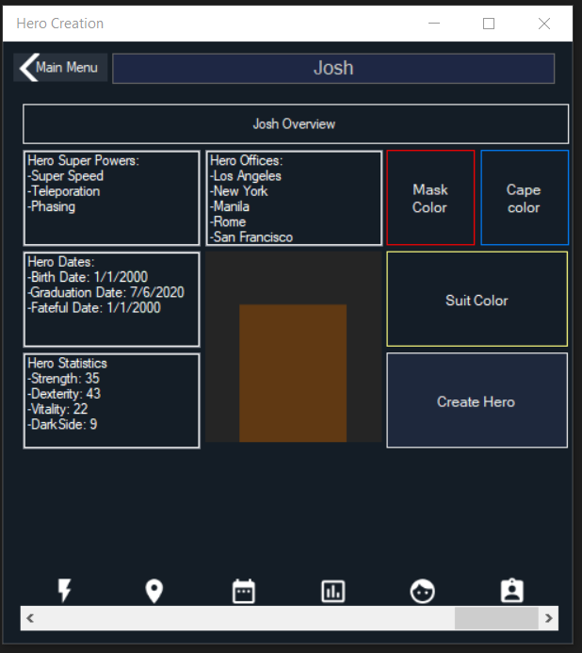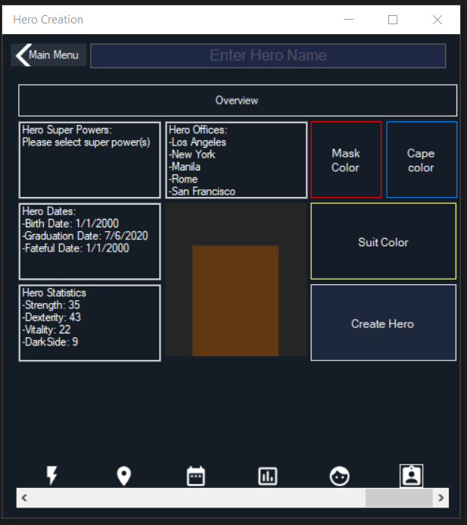This is the final screen of the hero creation! It is the overview of the entire hero. I closed the program earlier that’s why the super powers is empty on the first screenshot. I added some powers on the second screenshot. Also have not mentioned it yet, but the hero name on the top constantly has a hint for the user to enter a hero name. Entering one will alter the Overview portion as well. If any of the Boxes show an error, like how the power has. The create hero button will reflect to the user what has to be done. Did not realize the date was stuck on fateful day the entire time. Also accidentally closed the program while screenshotting that’s why the 3rd picture is a little off.

Anyways it still shows the user what needs to be added to be able to create a hero.

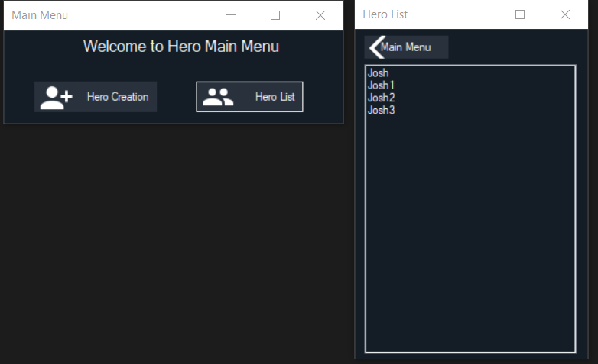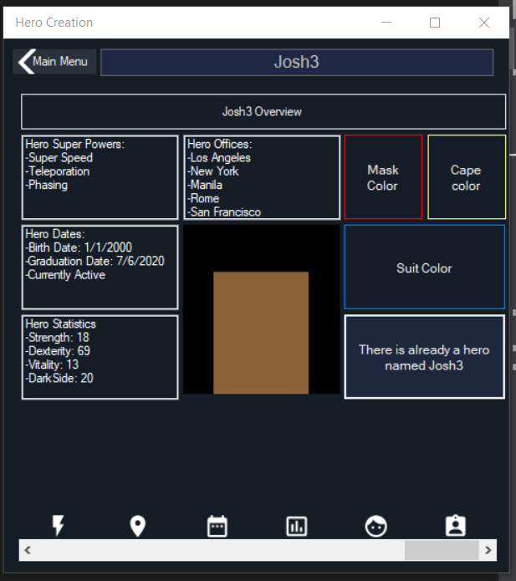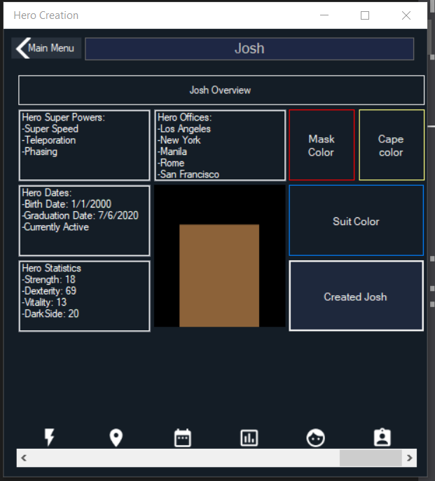So after all of the requirements are met, clicking the button will create the hero. The hero is saved on a Txt file as a JSON. I also created a Josh 1, 2 and 3. Attempting to create a hero with the same name will notify the user that it is not allowed. Bottom screenshot shows the Hero List, after clicking the hero list in the main menu. User isn’t allowed to open up more than one hero creation or hero list at one time.

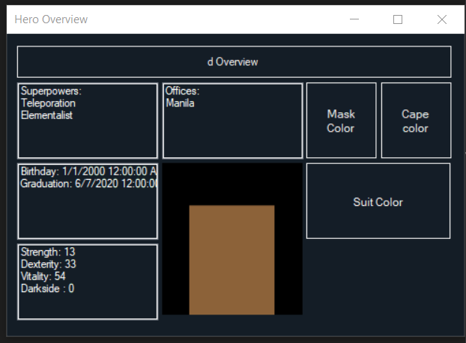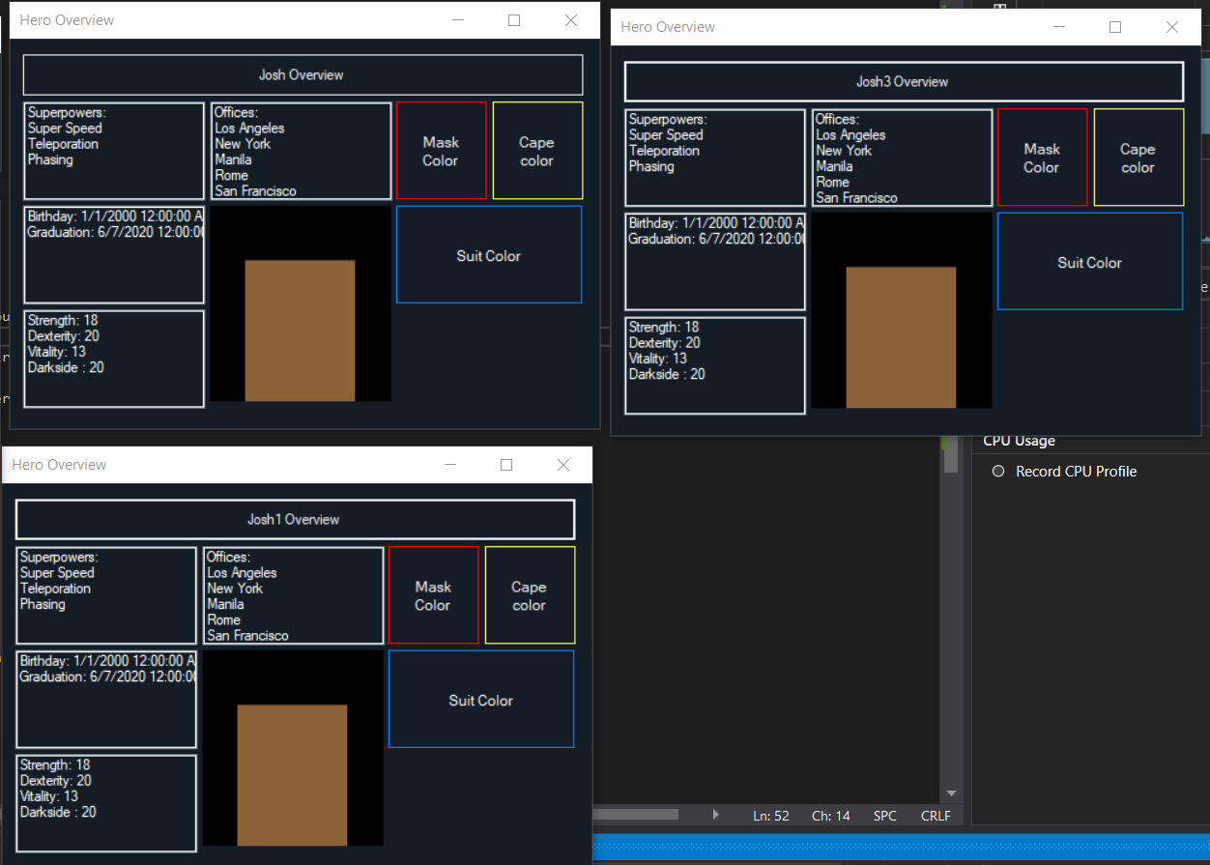Kind of self explanatory here, it passes the variable hero to these forms and it just shows the overview. It’s the same panel too. Just on a new form that receives the information. Also the user cannot open more then 3 of these panels. Decided to make it so just in case a user would like to compare heroes. Not sure why but there it is.

Didn’t realize this until it was later on, accidentally made the dexterity reflect the darkside in the saving portion. Fixed it just now. Anyways, in the stats page, the user has to equal to 100 in order to create the hero.

If anything broke in the program. I would love to know about it!